Outdoor Bluetooth LoRa Gateway
English Product Documentation
A cast-aluminum weather-resistant gateway combines Bluetooth and LoRa, with Ethernet backhaul and optional 4G variants. Collect personnel location data, environmental readings and equipment status.
Jinju Intelligence (Beijing) Technology Co., Ltd. | zydc0915@gmail.com

Selection Notes
Overview and specification-table figures differ for power, sensitivity and maximum range. Confirm any explosion-protection certification and its scope separately.

Product Specifications
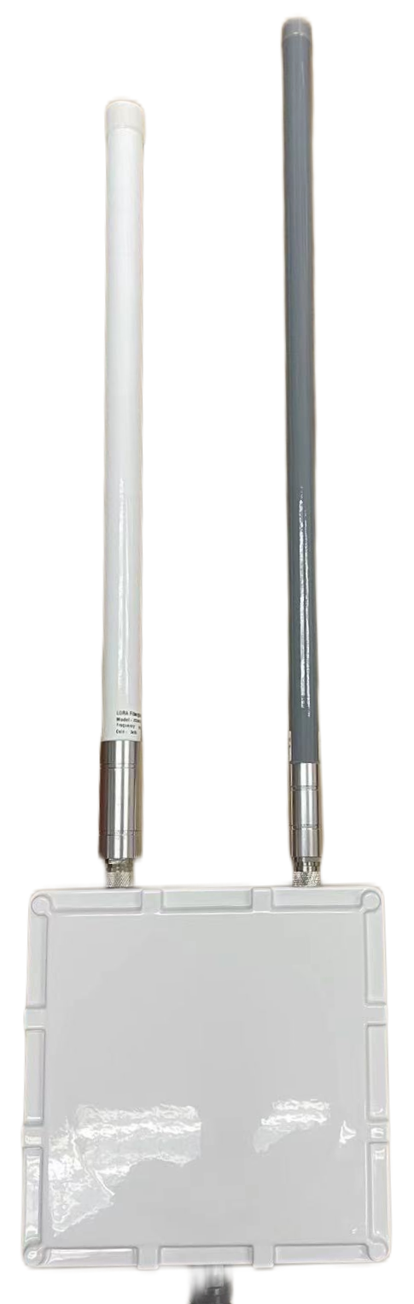
Product: Smart Outdoor Bluetooth LoRa Positioning and Data Station
Model: JJ-IS40BLOP
Jinju Intelligence Beijing Technology Co Ltd
This document describes current general specifications and provides no guarantee of suitability for a particular use, function or merchantability. The company may change product functions, specifications, warranty information and this document without notice.

Product Introduction
Developed by Jinju Intelligence, this Bluetooth/LoRa gateway provides a front-end solution for wide-area IoT. Its software is optimized for common BLE and LoRa applications. DC-powered hardware supports eight physical RX channels and one TX channel. The overview specifies sensitivity down to -147 dBm and transmit power up to 27 dBm, with configurable power and frequency. Full-duplex operation uses an integrated cavity duplexer, a single antenna connector and a standard high-gain fiberglass antenna.
Applications include industrial positioning, temperature and humidity sensing, hazardous-chemical leak monitoring, equipment status, and low-power wide-area smart-city data collection for environmental, fire and traffic monitoring.

Product Images

Product Features
Coverage: Tested line-of-sight range up to 10 km depending on terminal type; typical coverage radius 1000 m.
Concurrency: Eight independent physical channels provide capacity for multiple devices.
Adaptive data rates: Simultaneous SF7 to SF12 reception without configuration.
Bidirectional communication: Full duplex with separate transmit and receive frequencies.
Flexible configuration: Adjustable transmit power and channel frequencies.
Receiver sensitivity: Down to -147 dBm in the overview.
Backhaul options: Ethernet or 4G.
Industrial design: The source describes water, dust and explosion protection, isolated interfaces and electromagnetic-interference resistance.

Specifications
Physical Specifications | Dimensions | 216*216*70
Physical Specifications | Color | White
Physical Specifications | Weight | Main unit: 1.5 kg
Physical Specifications | Material | Cast aluminum
Physical Specifications | Ingress protection | IPX7
Technical Specifications | Power supply | Waterproof RJ45 PoE connector; DC 12 V / 1 A adapter with 5.5 mm x 2.5 m connector dimensions as printed in the source; or DC 12 V / 1 A terminal block
Technical Specifications | Total power | 2W
Technical Specifications | Main MCU | 32-bit ARM M4
Technical Specifications | Operating frequency | 2.4GHz
Technical Specifications | Transmit power | Bluetooth: 10 dBm; LoRa: 25 dBm
Technical Specifications | Protocol | Bluetooth 5.0; LoRa
Technical Specifications | Receiver sensitivity | BLE: < -100 dBm; LoRa: < -142 dBm
Technical Specifications | Transmission range* | BLE: 300 m line of sight; LoRa: 1000 m
Technical Specifications | Encryption | AES encryption supported
Technical Specifications | Network connection | 10/100 Mbps LAN or 4G for model JJ-IS40BL4GOP
Technical Specifications | Network addressing | DHCP or static IP
Technical Specifications | Network transport | UDP/MQTT
Technical Specifications | Antenna | External fiberglass antenna
Technical Specifications | Antenna connector | N-type female
Configuration Functions | Destination IP | Domain name or IP address supported
Configuration Functions | Over-the-air update | OTA supported
Configuration Functions | Configuration method | Bluetooth mini program or ACServer
Operating Environment | Operating temperature | -20℃—60℃
Operating Environment | Operating humidity | Up to 95% RH, non-condensing

Packing List
Accessory | JJ-IS40BOP | JJ-IS40BLOP | JJ-IS40B4GBOP | JJ-IS40BL4GBOP
Accessory | Outdoor Bluetooth | Outdoor Bluetooth LoRa | Outdoor Bluetooth 4G | Outdoor Bluetooth LoRa 4G
Main unit | √ | √ | √ | √
Waterproof RJ45 Ethernet connector | √ | √ | √ | √
Pole mounting clamps | √ | √ | √ | √
Bluetooth fiberglass antenna, 2400 to 2500 MHz | √ | √ | √ | √
LoRa fiberglass antenna, 470 to 510 MHz |  | √ |  | √
4G fiberglass antenna, 1700 to 2700 MHz |  |  | √ | √

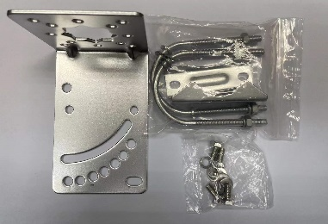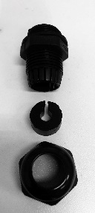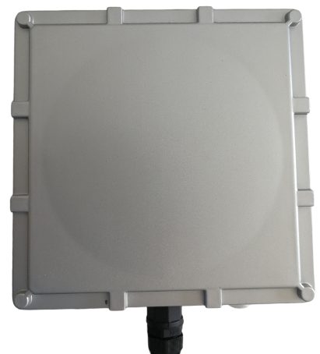
Main unit; waterproof RJ45 Ethernet connector; pole mounting clamps

Quality Assurance
All units pass testing before shipment. A certificate of conformity and factory test report can be supplied.

