UWB AoA Positioning Station
English Product Documentation
The PY-U360 series combines UWB positioning with Bluetooth gateway functions. It measures tag elevation, azimuth and range; a server-side engine calculates coordinates for the application platform. Ceiling or side-bracket mounting supports personnel, asset and vehicle applications.
Jinju Intelligence (Beijing) Technology Co., Ltd. | zydc0915@gmail.com

Selection Notes
The brochure identifies Shenzhen Pengyue Technology Co., Ltd. as the manufacturer; Jinju provides product selection enquiries on this site. Its overview states 30cm–1m, while the functional table states 0.5–1m unobstructed; the functional table uses the latter. 4G, Wi-Fi, speaker and alarm functions depend on model or order. IP66 is not an explosion-protection certification. UWB AoA does not establish TDoA or PDoA compatibility.
1 / 3
1 / 3

UWB Positioning Station Product Brochure
Models: PY-U360A / B / C
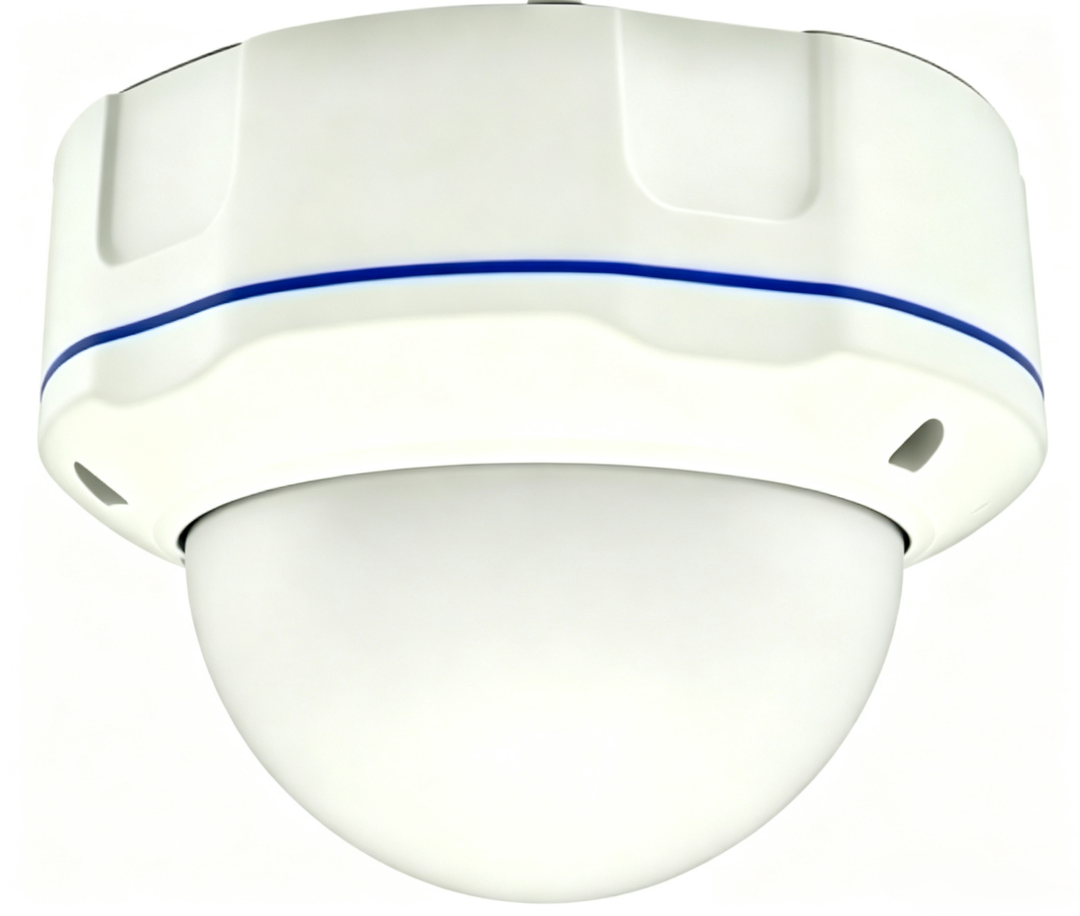
Shenzhen Pengyue Technology Co Ltd

1 Product Overview and Features
Shenzhen Pengyue Technology's UWB positioning station combines a UWB chipset with low-power Bluetooth and Bluetooth gateway functions. The source states compliance with applicable national requirements. The station offers flexible configuration and straightforward installation.
Features
One station supports 1D and 2D positioning without requiring three UWB stations, reducing device count, cabling and on-site calibration work.
A single station covers a radius of up to 20 m in open areas, reducing equipment and installation requirements.
The overview specifies 30 cm to 1 m positioning accuracy and describes improved accuracy and stability relative to Wi-Fi and Bluetooth.
Maintenance: Phone mini-program configuration and centralized AC management.
Ceiling and side-bracket mounting simplify installation.
Power: Standard 48 V PoE carries power and return data over Ethernet, reducing cabling requirements.
The 6 to 8 GHz UWB band is separated from the Wi-Fi and Bluetooth bands described in the source, which states that this avoids interference with nearby equipment.
IP66 dust and water protection supports outdoor and demanding indoor environments.
Bluetooth gateway functionality carries data from nearby positioning tags.

2 Positioning Principle
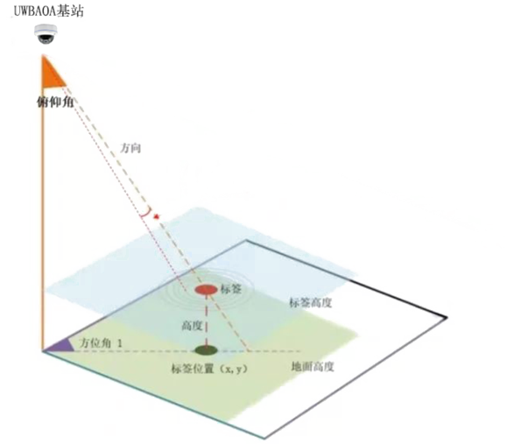
The station measures a tag's elevation, azimuth and distance relative to the station and sends these observations to the server-side positioning engine. The engine calculates tag coordinates and sends them to the business platform for map display and other location applications.

2 Product Appearance

3 Applications
Indoor and outdoor personnel, asset and vehicle tracking for construction sites, chemical plants, campuses, airports, power stations, forklift proximity applications, coal mines and warehouses.

4 Detailed Technical Specifications

4.1 Electrical Specifications
Item | Specification
Power supply | POE48V
Rated power | 3W
Operating temperature | -30℃—70℃
Operating humidity | 0 to 95%, non-condensing

4.2 Technical Specifications
Item | Specification
Main MCU | ARM M4F 64MHz
Flash | 512KB
RAM | 128KB
Frequency | BLE：2.4GHz；UWB：6-8 GHz
Protocol | UWB
Transmit power | BLE：8dBm UWB：-6dBm
Receiver sensitivity | BLE:<-101dBm UWB: <-110dBm
Encryption | Hardware AES encryption supported

4.3 Physical Specifications
Item | Specification
Dimensions | 137*137*101mm
Color | White
Weight | 900g
Housing material | ABS cover with cast-aluminum base
Ingress protection | IP66

4.4 Additional Specifications
Network connection | 10/100 Mbps LAN port
Network addressing | DHCP or static IP
Network transport | UDP
Antenna | On-board antenna array

4.5 Configuration Functions
Destination IP | Domain name or IP address supported
Over-the-air update | OTA supported
Configuration method | WeChat mini program or AC

4.6 UWB Functions
Coverage | 20 m radius in open areas
Positioning accuracy | 0.5 to 1 m in unobstructed conditions
Bluetooth data transmission support | Yes
Optional functions | Wi-Fi module, 4G module, speaker, audible and visual alarm

5 Packaging
6 units per carton

6 Packing List
Accessory | PY-U360A/B/C
Accessory | Integrated positioning badge tag
Main station | 1 piece
PoE power module | 1 piece
Certificate of conformity | 1 copy

7 Ordering Information
Product name | Model | Main functions | Notes
UWB positioning station | PY-U360A | UWB positioning and Bluetooth gateway
UWB positioning station | PY-U360B | UWB AoA positioning, Bluetooth gateway, 4G or Wi-Fi backhaul
UWB positioning station | PY-U360C | UWB AoA proximity ranging, Bluetooth gateway, audible and visual alarm


Manufacturer address: Room 305, Building 42, Area B, Yuanshan Industrial Zone, Shangcun Community, Gongming Subdistrict, Guangming District, Shenzhen, China
Manufacturer website: www.szpykeji.com
Manufacturer contact: +86 18822892243

