

IT342- G6
System Integration and Architecture

System Design Document (SDD)

Project Title: QuickBite System
Prepared By: Belia, Jhon Zydney T.

Version: 1
Date: 2/21/2026
Status: Final

REVISION HISTORY TABLE
Version | Date | Author | Changes Made | Status
0.1 | 2/21/2026 | Belia, Jhon Zydney | Executive Summary, Introduction, Functional Requirments | Final
0.2 | 3/26/2026 | Belia, Jhon Zydney | Updated Introduction up to Restaurant & Menu Endpoints | Final
0.3 | 4/11/2026 | Belia, Jhon Zydney | ERD Diagram | Final
0.4 | 5/7/2026 | Belia, Jhon Zydney | Added UI/UX designs | FInal
0.5 | [Date] | [Your Name] | Incorporated feedback | Revised
0.6 | [Date] | [Your Name] | Final review and corrections | Final
1 | [Date] | [Your Name] | Baseline version for development | Approved

TABLE OF CONTENTS
Contents
EXECUTIVE SUMMARY 4
1.0 INTRODUCTION 5
2.0 FUNCTIONAL REQUIREMENTS SPECIFICATION 5
3.0 NON-FUNCTIONAL REQUIREMENTS 8
4.0 SYSTEM ARCHITECTURE 9
5.0 API CONTRACT & COMMUNICATION 10
Authentication Endpoints 11
User Registration 11
User Login 11
6.0 DATABASE DESIGN 13
7.0 UI/UX DESIGN 14
8.0 PLAN 17

EXECUTIVE SUMMARY
1.1 Project Overview
QuickBite is a simple food ordering application that allows users to browse nearby restaurants, select meals, and place food orders online. The system includes a backend API, a web application, and a mobile app to provide a fast and convenient ordering experience.
1.2 Objectives
- Develop a basic food ordering application with user authentication
- Allow users to browse menus and place food orders
- Implement a simple three-tier architecture (backend, web, mobile)
- Provide a smooth and easy-to-use user interface
Support order tracking from placement to completion
1.3 Scope
Included Features:
- User registration and login
- Restaurant and menu listing
- Food ordering and cart management
- Checkout process with shipping information collection
- Order placement and confirmation
- Order status tracking
Excluded Features:
- Online payment gateway
- Delivery rider tracking (GPS)
- Push notifications
- Reviews and ratings
- Promo and discount system

1.0 INTRODUCTION
1.1 Purpose
This document provides a comprehensive description of the system architecture, components, database design, and overall structure of the QuickBite Food Ordering System. It serves as the official blueprint for system development and implementation.

2.0 FUNCTIONAL REQUIREMENTS SPECIFICATION
2.1 User Authentication
- The system shall allow users to register using name, email, and password.
- The system shall validate user input during registration.
- The system shall allow users to log in using valid credentials.
- The system shall encrypt user passwords using BCrypt.
- The system shall allow authenticated users to access protected resources.
- The system shall allow users to log out securely.
2.2 User Profile
- The system shall allow authenticated users to view their profile.
- The system shall retrieve user details via a protected API endpoint.
2.3 Restaurant & Menu
- The system shall display a list of available restaurants.
- The system shall allow users to view menu items of a selected restaurant.
- The system shall retrieve menu data from the backend database.

2.Feature List (MoSCoW)
MUST HAVE
1. User Registration
- The system shall allow new users to create an account using name, email, and password.
- The system shall validate all input fields before submission.
- The system shall encrypt user passwords using BCrypt before storing them.
- The system shall store user data securely in the database.
- The system shall display a confirmation message upon successful registration.
- The system shall display an error message and return to the form if input is invalid.
2. User Login
- The system shall allow users to log in using registered email and password.
- The system shall verify user credentials against stored data.
- The system shall generate an authentication token upon successful login.
- The system shall redirect users to the dashboard after login.
- The system shall display an error message if credentials are invalid.
3. View Profile
- The system shall allow authenticated users to view their profile information.
- The system shall retrieve user data using the /api/user/me endpoint.
- The system shall restrict access to this feature to authenticated users only.
4. Get Menu for Restaurant
- The system shall allow users to view menu items of a selected restaurant.
- The system shall retrieve menu data using /api/restaurants/{id}/menu.
- The system shall display menu items in a structured format.
- The system shall display a message if no menu items are available.

SHOULD HAVE
- The system should allow users to update their profile information.
- The system should allow users to search for restaurants.
- The system should display restaurant categories or filters.
- The system should provide user-friendly error messages.

COULD HAVE
- The system could allow users to upload profile pictures.
- The system could include ratings and reviews for menu items.
- The system could implement menu item sorting (price, popularity).
- The system could include a “favorite restaurants” feature.

WON'T HAVE
- The system will not include online payment processing in this version.
- The system will not include real-time order tracking.
- The system will not include delivery logistics integration.

2.4 Detailed Feature Specifications
Feature: User Authentication
- Description: Allows new users to create an account.
- Actors: User
- Preconditions: User must not have an existing account

- Main Flow:
  - User enters name, email, and password
  - System validates input fields
  - System encrypts password
  - System stores user data in database
  - System confirms successful registration
- Alternate Flow:
  - If input is invalid → display error message and return to form
- Postconditions: User account is created
Feature: User Login
- Description: Authenticates user access.
- Actors: User
- Preconditions: User must be registered
- Main Flow:
  - User enters email and password
  - System verifies credentials
  - System generates authentication token
  - User is redirected to dashboard
- Alternate Flow:
  - Invalid credentials → show error message
- Postconditions: User session is active

Feature: View Profile
- Description: Displays user information.
- Actors: Authenticated User
- Preconditions: User must be logged in
- Main Flow:
  - User accesses profile page
  - System calls /api/user/me
  - System returns user data
  - Profile is displayed
- Postconditions: User information is visible

Feature: Get Menu for Restaurant
- Description: Retrieves menu items for a selected restaurant.
- Actors: User
- Preconditions: Restaurant exists
- Main Flow:
  - User selects a restaurant
  - System sends request to /api/restaurants/{id}/menu
  - Backend retrieves menu data
  - System displays menu items
- Alternate Flow:
  - No menu items → display “No items available”
- Postconditions: Menu list is shown

2.5 Acceptance Criteria
AC-1: User Registration
- User can enter full name, email, and password.
- Email must be unique in the system.
- Password must be encrypted before being stored in the database.
- System displays confirmation message upon successful registration.
- If email already exists, the system displays an appropriate error message.
AC-2: User Login & Authentication
- User can log in using email and password.
- System validates credentials against stored records.
- Upon successful login, a JWT token is generated.
- JWT token is required to access protected endpoints.
- Invalid credentials display an error message.
- Expired or invalid tokens deny access to protected resources.

AC-3: View Food Menu
- Users can view a list of available food items.
- Each item displays name, price, description, and availability status.
- Only active/available food items are shown to customers.
- Menu loads within acceptable response time (≤ 3 seconds).

AC-4: Add to Cart
- Authenticated users can add items to cart.
- Users can specify quantity.
- If item already exists in cart, quantity updates accordingly.
- Cart total price is automatically calculated.
- Cart persists until order is placed or cleared.

AC-5: Place Order
- User must be authenticated.
- User must have at least one item in cart.
- System records order details in database.
- Order includes items, quantities, total amount, and timestamp.
- Cart is cleared after successful order placement.
- User receives confirmation message.

AC-6: View Order History
- Users can view a list of their past orders.
- Each order shows:
  - Order ID
  - Date
  - Items ordered
  - Total amount
  - Order status
- Users cannot view other users’ orders.

AC-7: Admin Menu Management
- Admin can create new food items.
- Admin can update food item details.
- Admin can delete or deactivate food items.
- Only users with ADMIN role can access management endpoints.
- Unauthorized users receive access denied response.

AC-8: System Security
- Only authenticated users can access protected endpoints.
- Only ADMIN users can access admin routes.
- All passwords are encrypted using secure hashing algorithm.
- API returns HTTP status codes correctly (200, 401, 403, 404, etc.).

3.0 NON-FUNCTIONAL REQUIREMENTS
3.1 Performance Requirements
- The system shall respond to API requests within 3 seconds under normal load (up to 100 concurrent users).
- User login and authentication shall complete within 2 seconds.
- The food menu page shall load within 3 seconds.
- Order placement shall be processed within 5 seconds.
- Database queries shall be optimized to prevent performance bottlenecks.
3.2 Security Requirements
- All user passwords shall be encrypted using a secure hashing algorithm (e.g., BCrypt).
- The system shall implement JWT-based authentication for protected endpoints.
- Only authenticated users shall access protected resources.
- Role-Based Access Control (RBAC) shall restrict admin features to ADMIN users only.
- The system shall validate all user inputs to prevent SQL injection and malicious input.
- Tokens shall expire after a defined session period (e.g., 1 hour).

3.3 Scalability Requirements
- The system architecture shall support horizontal scaling if user demand increases.
- The backend shall follow RESTful principles to allow integration with mobile applications.
- Database design shall support expansion (e.g., adding payment module in future).

3.4 Reliability Requirements
- All user passwords shall be encrypted using a secure hashing algorithm (e.g., BCrypt).
- The system shall implement JWT-based authentication for protected endpoints.
- Only authenticated users shall access protected resources.
- Role-Based Access Control (RBAC) shall restrict admin features to ADMIN users only.
- The system shall validate all user inputs to prevent SQL injection and malicious input.
- Tokens shall expire after a defined session period (e.g., 1 hour).

3.5 Compatibility Requirements
- The web application shall be compatible with modern browsers (Chrome, Edge, Firefox).
- Backend APIs shall be accessible via REST clients (Postman, mobile apps).
- The system shall support integration with future Android mobile application.

3.6 Usability Requirements
- The user interface shall be simple and intuitive.
- Users shall be able to register, log in, browse menu, and place orders without training.
- Error messages shall be clear and user-friendly.
- Navigation between pages shall be consistent and responsive.

3.7 Availability Requirements
- The system shall be available at least 95% uptime during operational hours.
- The backend server shall handle unexpected failures gracefully.
- The database shall maintain data consistency during transactions.

3.8 Maintainability Requirements
- The backend shall follow layered architecture (Controller, Service, Repository).
- Code shall follow clean coding standards and proper documentation.
- APIs shall be documented for future development.
- System components shall be modular for easier updates and debugging.

4.0 SYSTEM ARCHITECTURE
4.1 Component Diagram
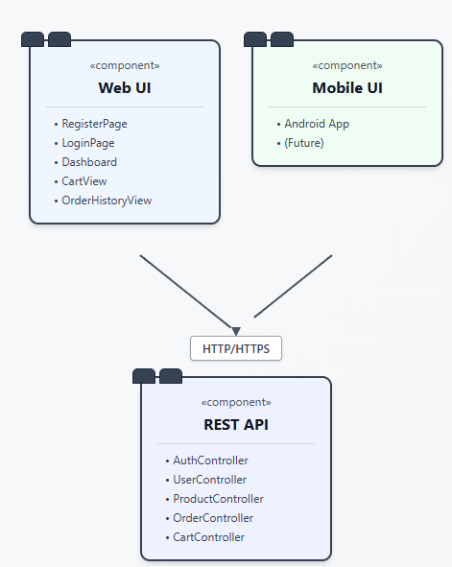
Note: This should be a component diagram

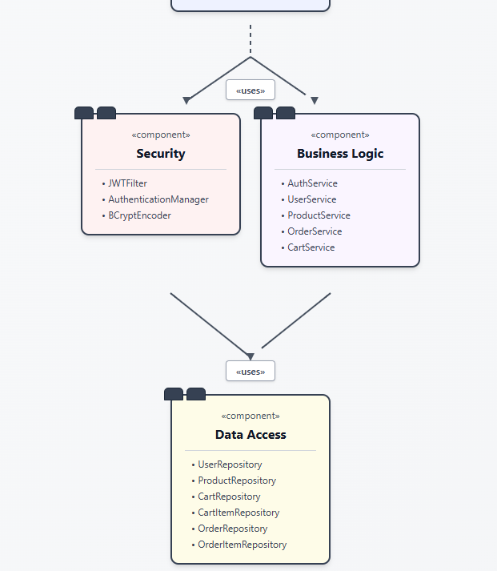

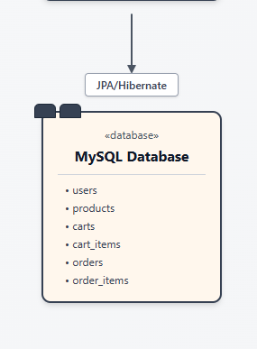
Technology Stack:
- Backend: Java 17, Spring Boot 3.x, Spring Security, Spring Data JPA, Maven
- Database: PostgreSQL 14+
- Web Frontend: React 18, TypeScript, Tailwind CSS, Axios
- Mobile: Kotlin, Jetpack Compose, Retrofit, Room
- Build Tools: Maven (Backend), npm/yarn (Web), Gradle (Android)
- Deployment: Railway/Heroku (Backend), Vercel/Netlify (Web), APK (Mobile)

5.0 API CONTRACT & COMMUNICATION
5.1 API Standards
Base URL | Base URL: https://[server_hostname]:[port]/api/v1
Format | JSON for all requests/responses
Authentication | Bearer token (JWT) in Authorization header
Response Structure | {  "success": boolean,  "data": object,  "error": object,  "timestamp": "ISO 8601 string"  }
Protocol | HTTPS
Encoding | UTF-8

5.2 Endpoint Specifications

Authentication Endpoints

User Registration
Description | Register a new user
API URL | /auth/register
HTTP Request Method | POST
Format | JSON for all requests/responses
Authentication | None
Request Payload | {  "email": "user@example.com",  "password": "securePassword123",  "firstname": "John",  "lastname": "Doe"  }
Response Structure | {  "success": true,  "data": {  "user": {  "email": "user@example.com",  "firstname": "John",  "lastname": "Doe"  },  "accessToken": "<jwt_token>",  "refreshToken": "<refresh_token>"  },  "error": null,  "timestamp": "2026-02-28T15:30:00Z"  }

User Login
Description | Authenticate user and issue JWT
API URL | /auth/login
HTTP Method | POST
Format | JSON for all requests/responses
Authentication | None
Request Payload | {  "email": "user@example.com",  "password": "securePassword123"  }
Response Structure | {  "success": true,  "data": {  "user": {  "email": "user@example.com",  "firstname": "John",  "lastname": "Doe",  "role": "CUSTOMER"  },  "accessToken": "<jwt_token>",  "refreshToken": "<refresh_token>"  },  "error": null,  "timestamp": "2026-02-28T15:30:00Z"  }

Restaurant & Menu Endpoints
Description | List active restaurants
API URL | /restaurants
HTTP Method | GET
Format | JSON for all requests/responses
Authentication | Optional
Request Payload | None
Response Structure | {  "success": true,  "data": [  {  "id": 1,  "name": "Pizza Place",  "description": "Best pizza in town",  "location": "123 Main St",  "status": "active"  }  ],  "error": null,  "timestamp": "2026-02-28T15:35:00Z"  }

Get Menu for Restaurant
Description | List menu items for a specific restaurant
API URL | /restaurants/{restaurantId}/menu
HTTP Method | GET
Format | JSON for all requests/responses
Authentication | Optional (Required for personalized features)
Request Payload | None
Response Structure | {  "success": true,  "data": [  {  "id": 101,  "name": "Margherita Pizza",  "description": "Tomato, mozzarella, basil",  "price": 8.99,  "availability": true  }  ],  "error": null,  "timestamp": "2026-02-28T15:35:00Z"  }

5.3 Error Handling
HTTP Status Codes
- 200 OK - Successful request
- 201 Created - Resource created
- 400 Bad Request - Invalid input
- 401 Unauthorized - Authentication required/failed
- 403 Forbidden - Insufficient permissions
- 404 Not Found - Resource doesn't exist
- 409 Conflict - Duplicate resource
- 500 Internal Server Error - Server error
Error Code Examples
Example Error Response (Invalid Credentials) | {  "success": false,  "data": null,  "error": {  "code": "AUTH-001",  "message": "Invalid credentials",  "details": "Email or password is incorrect"  },  "timestamp": "2026-02-28T15:39:00Z"  }
Example Error Response (Validation Failed) | {  "success": false,  "data": null,  "error": {  "code": "VALID-001",  "message": "Validation failed",  "details": {  "email": "Email is required",  "password": "Must be at least 8 characters"  }  },  "timestamp": "2026-02-28T15:39:00Z"  }

Common Error Codes
- AUTH-001: Invalid credentials
- AUTH-002: Token expired
- AUTH-003: Insufficient permissions
- VALID-001: Validation failed
- DB-001: Resource not found
- DB-002: Duplicate entry
- BUSINESS-001: Insufficient stock
- SYSTEM-001: Internal server error

6.0 DATABASE DESIGN
6.1 Entity Relationship Diagram
Note: This should be an ERD (Database Schema)
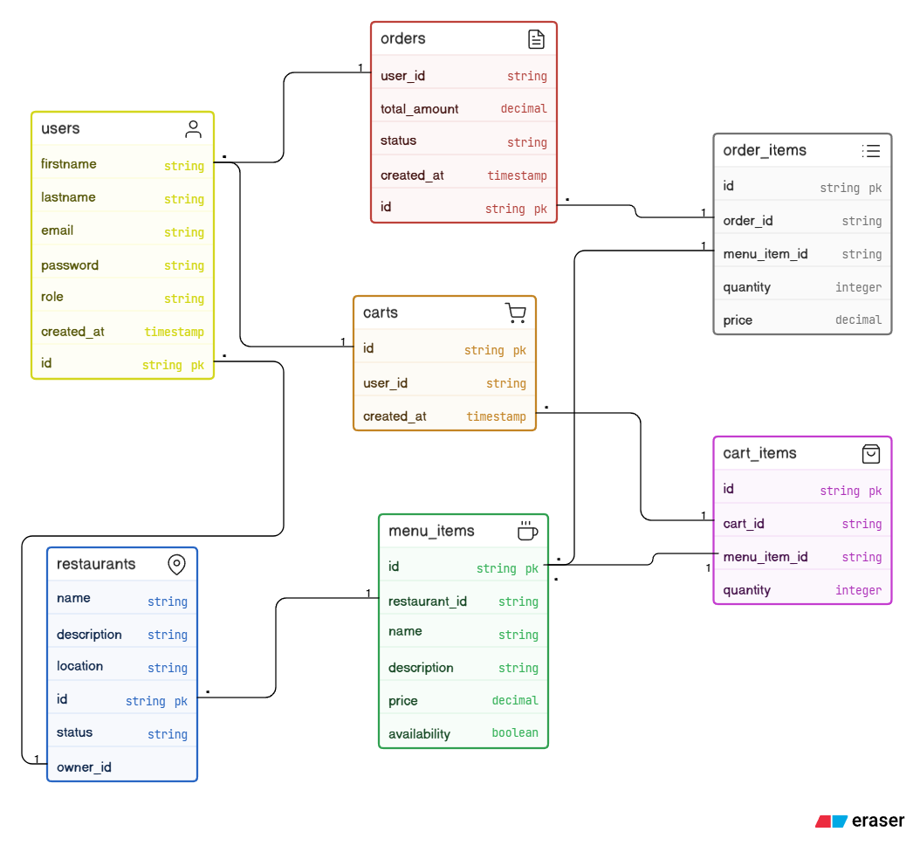

Detailed Relationships:
- One-to-One: User ↔ Cart (Each associated with exactly one cart)
- One-to-Many: User → Orders (User can place multiple orders)
- One-to-Many: User → Restaurants(A user (restaurant manager) can manage multiple restaurants)
- One-to-Many: Cart → CartItems (A cart can contain multiple cart items)
- One-to-Many: Order → OrderItems (An order can contain multiple order items)
- Many-to-One: OrderItems→ MenuItems (Order items reference menu items)
- One-to-Many: Restaurant→ MenuItems (A restaurant can have multiple menu items)
- Many-to-One: CartItems → MenuItems (Order items reference menu items)
Key Tables:
- users – Stores user account and authentication details
- restaurants – Stores restaurant information
- menu_items – Stores food/menu details for each restaurant
- carts – Stores shopping cart per user
- cart_items – Stores items inside the cart
- orders – Stores order transactions
- order_items – Stores items included in each order
- refresh_tokens – Stores JWT refresh tokens for authentication Table Structure

Table Structure Summary:
users
- id (Primary Key)
- firstname
- lastname
- email (Unique)
- password_hash
- role (CUSTOMER, ADMIN, RESTAURANT_MANAGER)
- created_at

restaurants
- id (Primary Key)
- owner_id (Foreign Key → users.id)
- name
- description
- location
- status (active/inactive)

menu_items
- id (Primary Key)
- restaurant_id (Foreign Key → restaurants.id)
- name
- description
- price
- availability (true/false)
carts
- id (Primary Key)
- user_id (Foreign Key → users.id)
- created_at

cart_items
- id (Primary Key)
- cart_id (Foreign Key → carts.id)
- menu_item_id (Foreign Key → menu_items.id)
- quantity

orders
- id (Primary Key)
- order_number
- user_id (Foreign Key → users.id)
- total_amount
- status (PLACED, PREPARING, DELIVERED)
- created_at
order_items
- id (Primary Key)
- order_id (Foreign Key → orders.id)
- menu_item_id (Foreign Key → menu_items.id)
- menu_item_name
- quantity
- price
refresh_tokens
- id (Primary Key)
- user_id (Foreign Key → users.id)
- token
- expiry_date

7.0 UI/UX DESIGN
7.1 Web Application Wireframes
Note: This should be wireframes from Figma
Login page
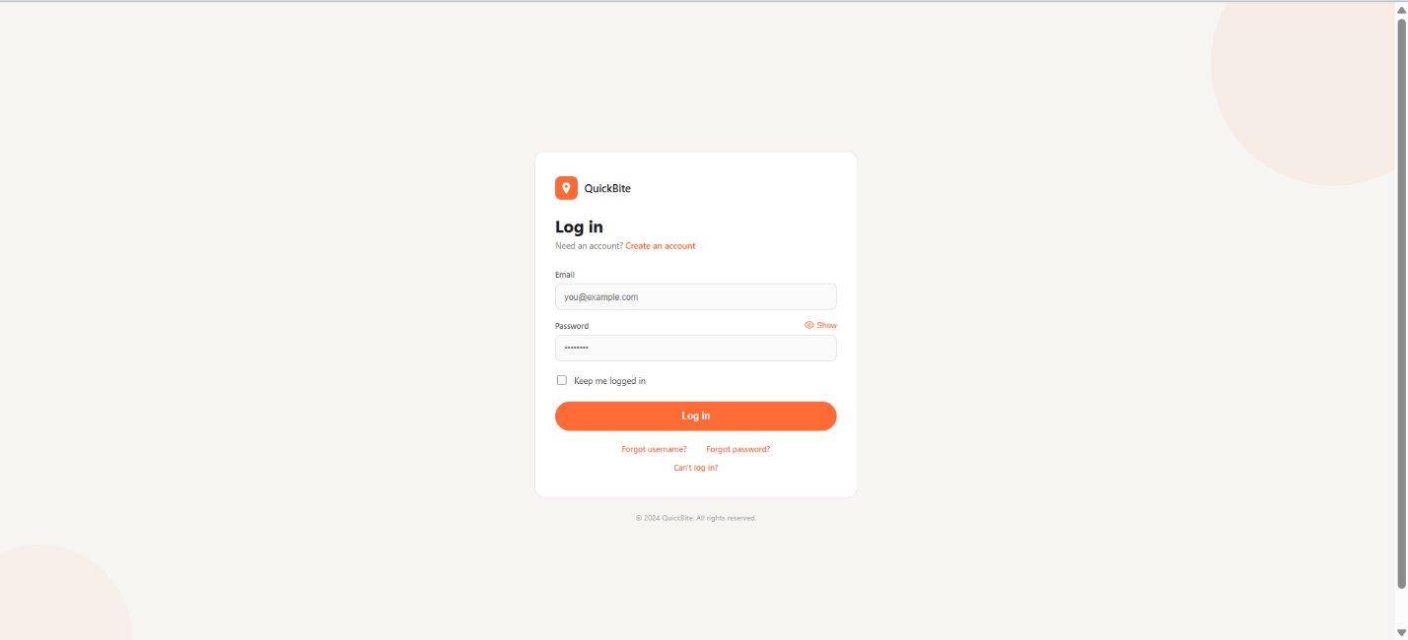

Customer Dashboard (restaurants, Menu, Cart, My orders)
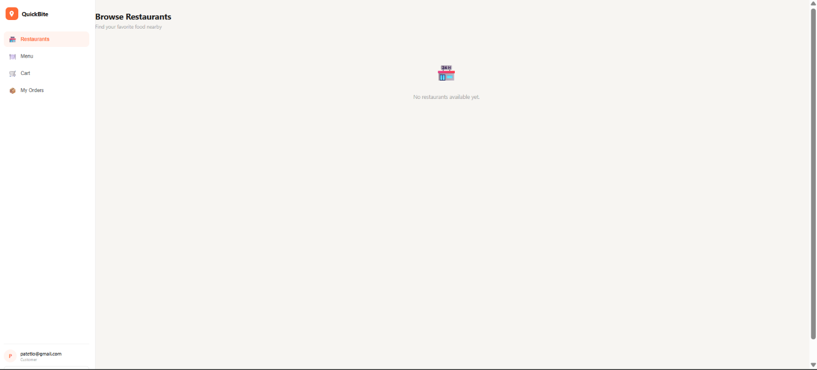
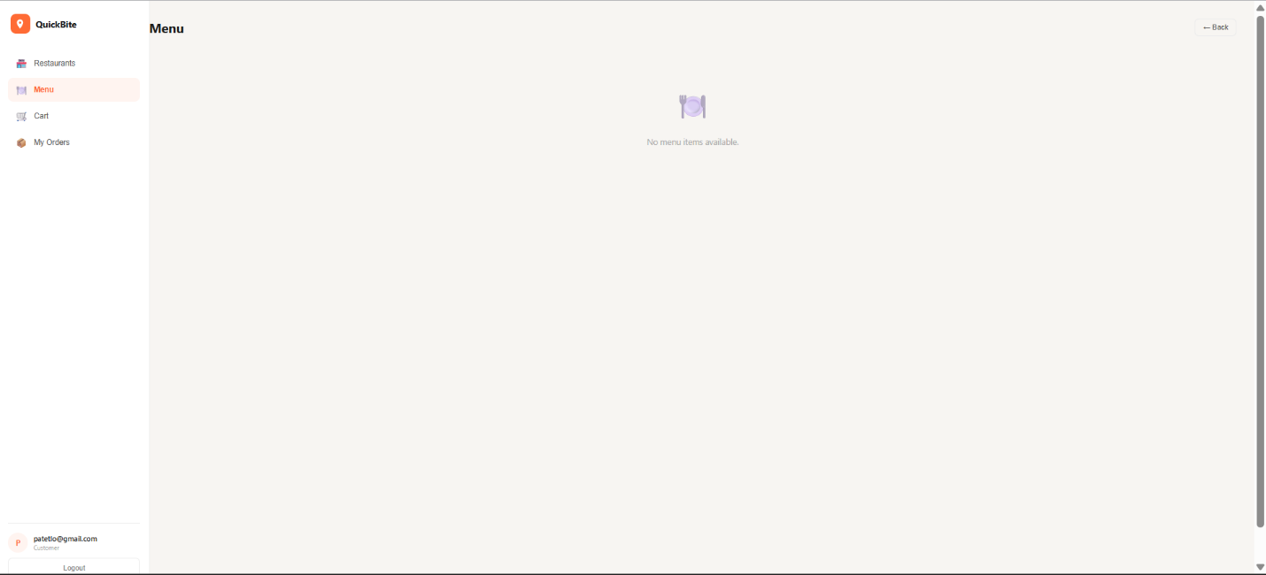
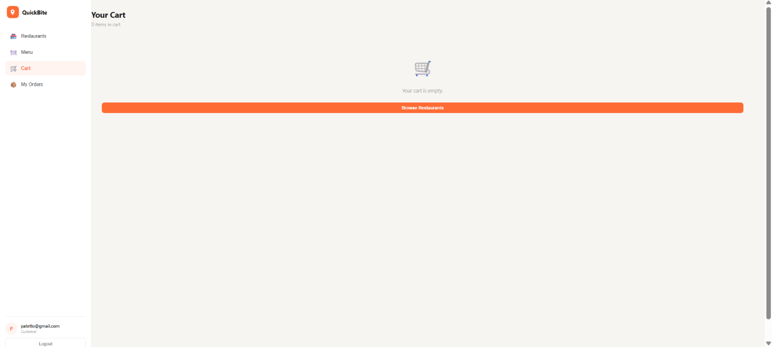
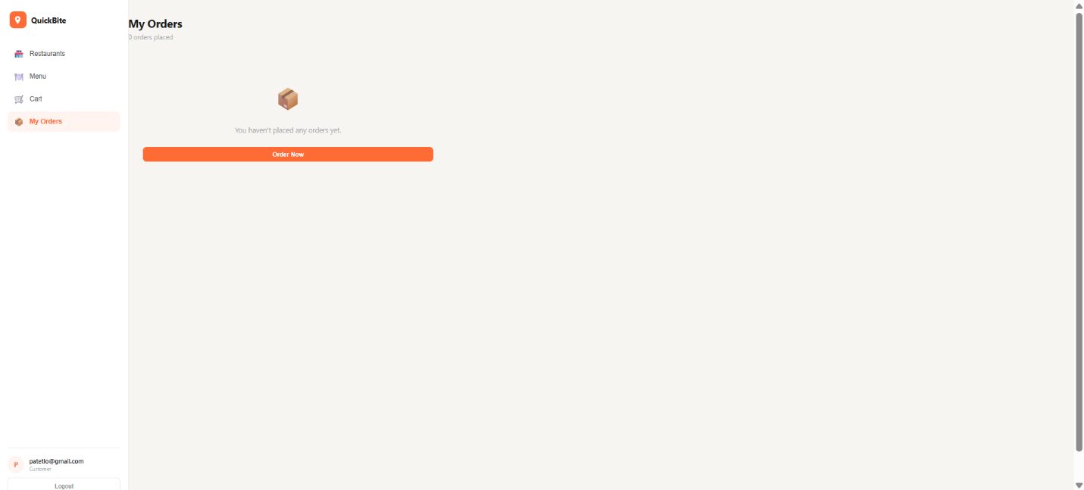
Admin Dashboard ( Manage Users, Restaurants, Orders)
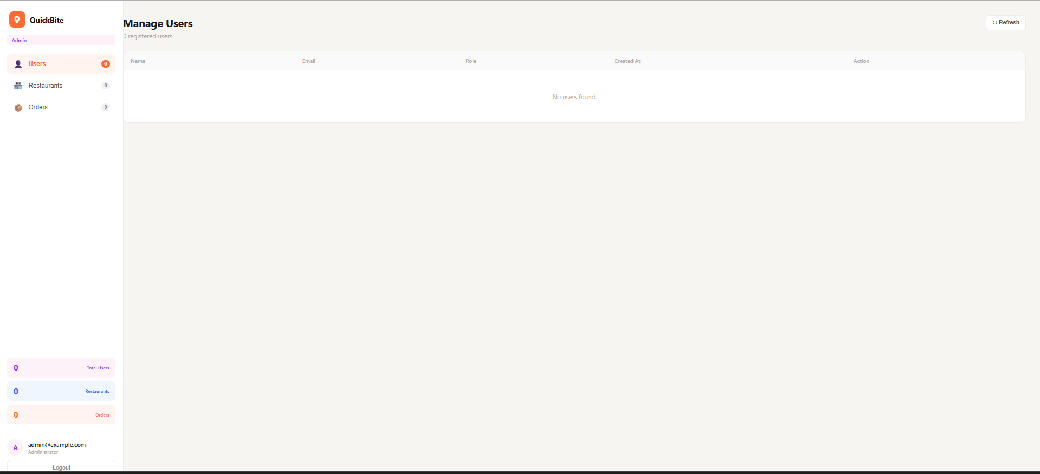
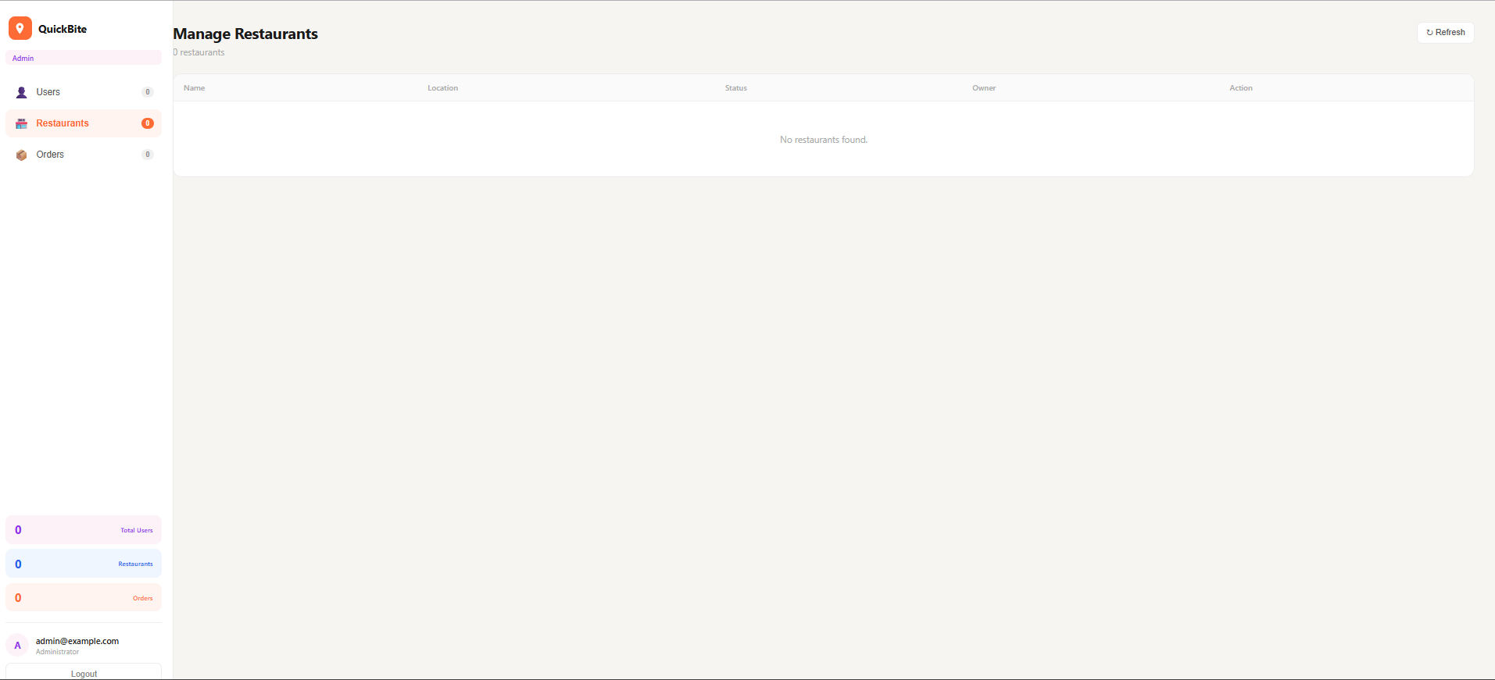
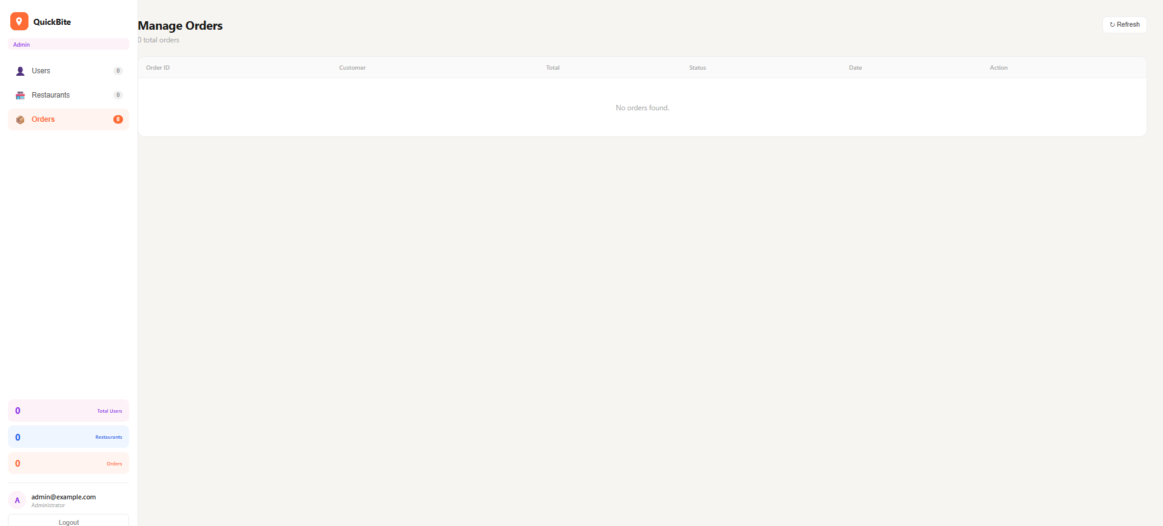
Manager Dashboard( Manage Orders)
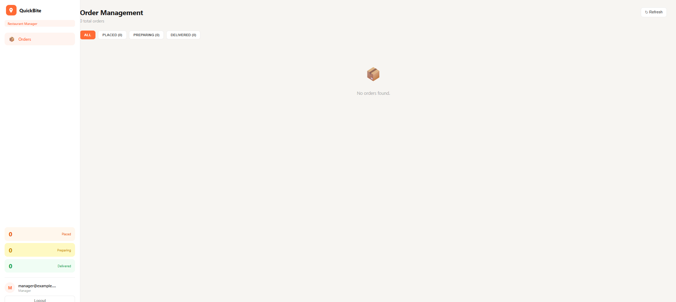
Cart Title
List of Cart Items (Image, Name, Quantity, Price, Remove)
Order Summary: Subtotal, Shipping, Tax, Total
"Continue Shopping" and "Proceed to Checkout" buttons

Checkout Page
Shipping Address Form
Order Review (Items, Prices, Totals)
"Place Order" button
Terms and Conditions note

Admin Dashboard
Sidebar Navigation: Dashboard, Products, Orders, Users
Product Management: Add New button, Product list with Edit/Delete
Order Management: Order list with status filters

7.2 Mobile Application Wireframes
Note: This should be wireframes from Figma
Bottom Navigation
[🏠 Home] [🔍 Search] [🛒 Cart] [👤 Profile]
Home Screen
Search Bar
Product Grid (2 columns)
Swipe gestures for quick actions
Pull to refresh

Product Detail Screen
Back arrow
Product image (swipeable gallery)
Product info
Quantity selector
"Add to Cart" fixed bottom button

Cart Screen
Edit mode for quantity updates
Swipe to remove items
Order summary sticky bottom
Checkout button

Checkout Flow
Step indicator: Cart → Shipping → Payment → Confirm
Address form (auto-complete)
Order summary
Place order button
Mobile-Specific Features:
- Touch-optimized buttons (min 44x44px)
- Gesture support (swipe, pull-to-refresh)
- Offline caching for product images
- Bottom navigation for main actions
- Simplified forms for mobile input
Design System:
- Colors: Primary (#2563EB), Secondary (#7C3AED), Success (#10B981), Error (#EF4444)
- Typography: Inter font family, responsive sizing
- Spacing: 8px grid system
- Components: Consistent buttons, inputs, cards, modals
- Responsive: Mobile-first approach, breakpoints at 640px, 768px, 1024px

8.0 PLAN
8.1 Project Timeline
Phase 1: Planning & Design (Week 1-2)
Week 1: Requirements & Architecture
Day 1-2: Project setup and documentation
Day 3-4: Complete FRS and NFR
Day 5-7: System architecture design

Week 2: Detailed Design
Day 1-2: API specification
Day 3-4: Database design
Day 5-6: UI/UX wireframes
Day 7: Implementation plan finalization

Phase 2: Backend Development (Week 3-4)
Week 3: Foundation
Day 1: Spring Boot setup with dependencies
Day 2: Database configuration and entities
Day 3: JWT authentication implementation
Day 4: User management endpoints
Day 5: Product CRUD operations

Week 4: Core Features
Day 1: Cart functionality
Day 2: Order management
Day 3: Search and filtering
Day 4: Error handling and validation
Day 5: API documentation and testing

Phase 3: Web Application (Week 5-6)
Week 5: Frontend Foundation
Day 1: React setup with TypeScript
Day 2: Authentication pages (login, register)
Day 3: Product listing page
Day 4: Product detail page
Day 5: Shopping cart implementation

Week 6: Complete Web Features
Day 1: Checkout flow
Day 2: Order history and confirmation
Day 3: Admin dashboard
Day 4: Responsive design polish
Day 5: API integration and testing

Phase 4: Mobile Application (Week 7-8)
Week 7: Android Foundation
Day 1: Android Studio setup and project structure
Day 2: Authentication screens
Day 3: Product browsing
Day 4: Shopping cart
Day 5: API service layer

Week 8: Complete Mobile App
Day 1: Checkout flow
Day 2: Order management
Day 3: UI polish and animations
Day 4: Testing on emulator/device
Day 5: APK generation and documentation

Phase 5: Integration & Deployment (Week 9-10)
Week 9: Integration Testing
Day 1: End-to-end testing across platforms
Day 2: Bug fixes and optimization
Day 3: Security review
Day 4: Performance testing
Day 5: Documentation updates

Week 10: Deployment
Day 1: Backend deployment (Railway/Heroku)
Day 2: Web app deployment (Vercel/Netlify)
Day 3: Mobile APK distribution
Day 4: Final testing
Day 5: Project submission
Milestones:
- M1 (End Week 2): All design documents complete
- M2 (End Week 4): Backend API fully functional
- M3 (End Week 6): Web application complete
- M4 (End Week 8): Mobile application complete
- M5 (End Week 10): Full system deployed and integrated
Critical Path:
- Authentication system (Week 3)
- Product catalog API (Week 3-4)
- Shopping cart functionality (Week 4)
- Checkout process (Week 6)
- Cross-platform testing (Week 9)
Risk Mitigation:
- Start with simplest working version of each feature
- Test integration points early and often
- Keep backup of working versions
- Focus on core functionality before enhancements

