Investigation of how the specificity of 8-17 DNAzyme changes with or without HTDC signal amplification system

**Table of Contents**

I. Introduction 4

A. Background 4

1. DNAzyme 4

2. 8-17 DNAzyme 5

3. HTDC cascading cycle 6

B. Research significance 7

C. Chemical concerns 7

II. Methodology 8

A. Sequences design 8

B. Experimental procedure 8

C. Data collection 9

III. Results 9

IV. Discussion 9

V. Conclusion 9

VI. References 9

**Abstract**

# Introduction

## Background

### DNAzyme

DNAzyme is a newly developed biosensor that comes from the recent discovery of catalytically active DNAs. These catalytically active DNAs could function as enzymes and cleave other DNA strands at certain points, called cleavage sites. They have the advantages of being simple, stable, and cost-effective. Thus, they are potential alternatives to proteins and ribozymes in biochemical and pharmaceutical applications. Jing Li and Yi Lu designed a functional DNAzyme that could detect lead ions Pb2+ with a range from 10nM to 4µM and a selectivity of >80-fold for Pb2+ [1]. In their research, they used fluorescence signals to determine the DNAzyme’s selectivity for heavy metal ions and experimented the intensity of the fluorescent signals on different wavelengths.

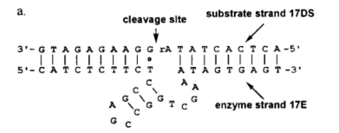

**Figure I.1** Jing Li and Yi Lu’s 8-17 DNAzyme design and specificity [1]

The use of DNAzyme to detect heavy metal ions has advantages of being fast, cheap, and simple compared to traditional methods such as atomic absorption spectrometry or inductively coupled plasma mass spectrometry. In addition, the lead level in blood that is considered toxic is when it is >=480nM, so DNAzyme’s sensitivity is adequate.

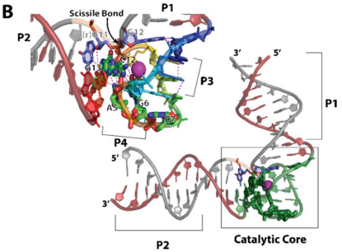

**Figure I.2** DNAzyme 3D geometry [3]

The three main methods of showing DNAzyme activity are through fluorescence, color, and electrochemical changes [2]. Fluorescence has the advantages of having high sensitivity and fast kinetics in Pb2+ detection, so it has been extensively applied. Color change has the advantage of eliminating or minimizing the extra costs associated with fluorescence detection as the color change can be observed by naked eye. However, both methods could not be applied to environmental water samples with color because it would produce a strong background signal and affect DNAzyme’s catalyzed H2O2-mediated oxidation of the substrates. Electrochemical methods have been widely applied on detecting environmental water samples on-site for pollutions because of its high sensitivity, low cost, simple instrumentation, and rapid response time.

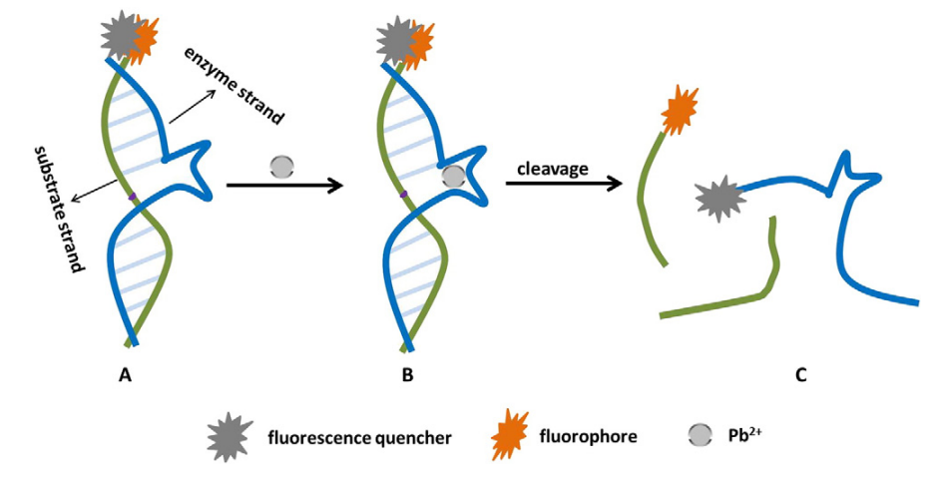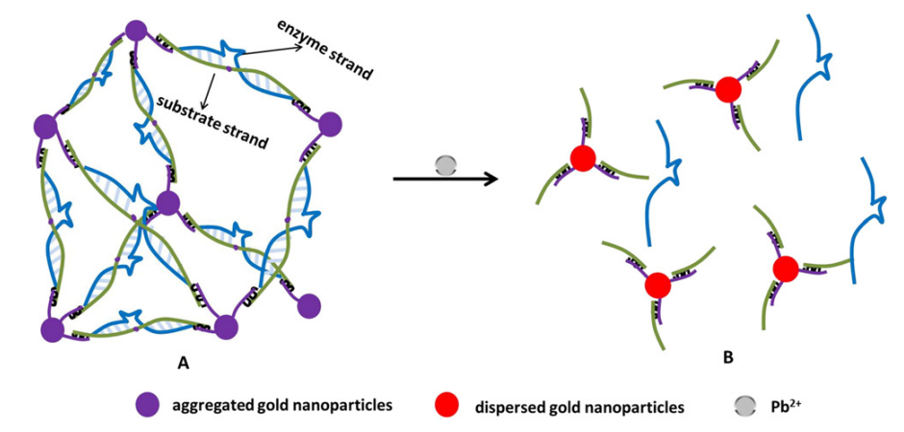

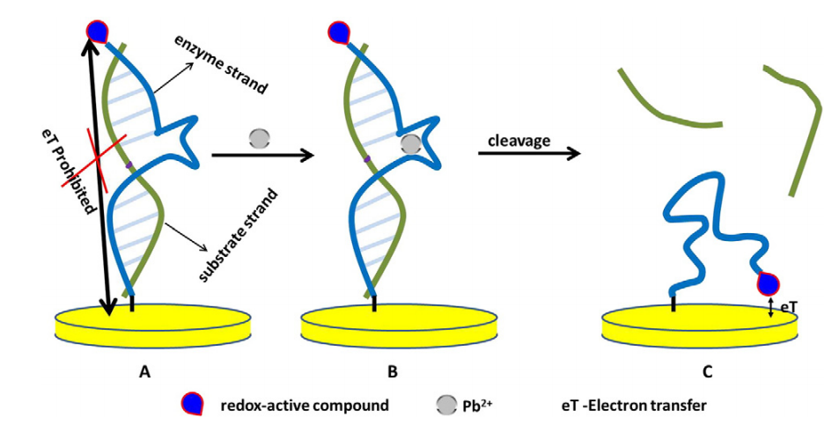

**Figure I.3** Fluorescent, color, and electrochemical signaling methods of DNAzyme [2]

The fluorescent signaling pathway is selected because of its cost-effectiveness and simple detection.

### 8-17 DNAzyme

8-17 DNAzyme is an enzyme that catalyzes the cleaving of the substrate strand in the presence of heavy metal ions with the selectivity of Pb2+ > Zn2+ > Mg2+ [3]. Na+ ions increase the rate linearly with concentration above 0.1 M.

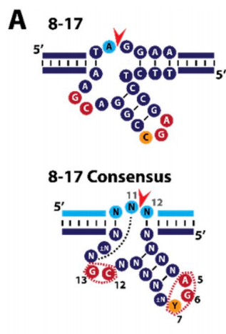

**Figure I.4** 8-17 DNAzyme design and consensus [3]

This figure shows a typical 8-17 sequence design and the general consensus of 8-17 DNAzyme. The actual sequence design is further demonstrated in the **Sequence design** section.

### HTDC cascading cycle

HTDC cascading cycle is an enzyme-free and ultrasensitive fluorescence assay for the detection of nucleic acids. Its functions as shown in the figure below.

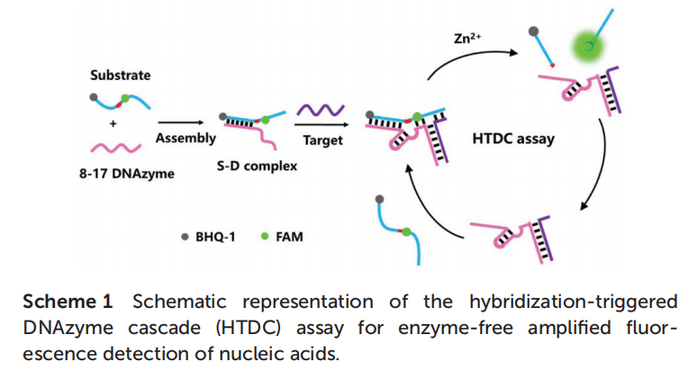

**Figure I.5** HTDC cascading cycle graphical representation [5]

At first, the substrate strand and the 8-17 DNAzyme forms the S-D complex. Then, the target strand combines to start the HTDC assay. In the cycle, the complex cleaves the substrate at the cleavage site. After cleavage, the DNAzyme and the target strand remains together and retains the ability of cleaving, so this complex continues to cleave substrate strands in a fast way.

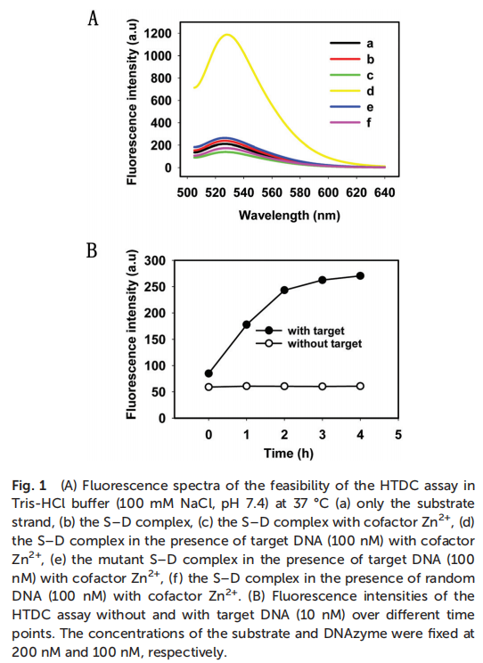

**Figure I.6** Huizhen Wang et al and their HTDC cascading cycle results [5]

In their research, Huizhen Wang et al examined the amplification ability of the HTDC cascade assay by comparing the fluorescent signals both by time and by wavelength. It can be demonstrated that the existence of the HTDC cascading cycle is able to magnify the fluorescent signals of the DNAzyme to a considerable extent, proving it to be a valid signal amplification system.

Other fluorescent magnification methods include CRISPR-Cas12a [4], Toehold switch [7], and TO-DNAs [6]. CRISPR-Cas12a uses a similar method as HTDC, there is a target strand that combines to the guide DNA and activates the continuous cleaving. Toehold switch and TO-DNA both have a trigger DNA that opens the geometry of the DNA and enables transcription and translation of GFP. Comparing the cost and efficacy of the signal amplification systems, the HTDC cascading assay is chosen.

## Research significance

The purpose of this research is to investigate the relationship between using the HTDC signal amplification pathway and the 8-17 DNAzymes’ sensitivity to heavy metal ions, including Pb2+, Cu2+, and Fe3+, with temperature as a supplemental factor. Although being a promising biosensor for fast and cheap heavy metal ion detection, little research has been done in the area of investigating the specificity of certain DNAzymes under differing temperatures and with or without a signa amplification system, and this research hope to guide the optimal usage of the available tools regarding 8-17 DNAzyme.

## Chemical concerns

Some potentially hazardous chemicals used in the experiment, including PbCl2, CuCl2, and FeCl3, are all selected for providing the heavy metal ion source in the solutions. The solutions of the reactions would be carefully treated according to chemical procedures to ensure no chemical and biological pollutions are made to the environment.

# Methodology

## Sequences design

The following sequence designs considers the 8-17 consensus and a few other specific DNAzyme and substrate strands [3][5].

**Table 1: Sequences**

|  |  |
| --- | --- |
| 8-17 DNAzyme | ATCATCTTCTCCGAGCCGGTCGAAATAGAGAATGTAACTG |
| HTDC target | AATCAACTGGGAGAATGTAACTG |
| substrate strand | CAGTTACATTCTCTATrAGGAAGATGAT |
| HTDC 8-17 | ATCATCTTCTCCGAGCCGGTCGAAATACCAGTTGATT |

* rA represents the RNA nucleotide adenine

## Experimental procedure

The fundamental principle of this experiment is to test how the variations of 8-17 DNAzyme respond to different heavy metal ions under different temperatures, finding out the optimal usage of 8-17 DNAzyme in the aspect of heavy metal ion detection. There are three factors in this experiment: 1) the type of DNAzyme (standard 8-17 DNAzyme or HTDC three-part 8-17 DNAzyme); 2) the different types of heavy metal ions (Pb2+, Cu2+, Fe3+); 3) the different temperature setups (20°C, 40°C, 60°C, 80°C). Lead, copper, and iron ions are chosen because 8-17 DNAzyme demonstrates inherently different specificities to these heavy metals, enabling the experiment to cover a range of different conditions. In particular, 8-17 DNAzyme has the highest sensitivity to Pb2+ lead ions. The only dependent variable of this experiment is the fluorescent light emitted by the FAM fluorescent group attached to the substrate strand, which has an absorption wavelength of 492nm and an emission wavelength of 518nm. The experiment would be measured for 10 minutes.

In the data collecting process, a 96-well plate would be used to mix the primers and the ion solutions. The chosen aqueous solutions are PbCl2, CuCl2, and FeCl3, all having acceptable solubility in ddH2O. The concentrations of the heavy metal ions would be 300μM to create easily measurable results. The DNAzymes’ concentrations would be 0.5μM, the target strand concentration would also be 0.5μM, and the substrate strand would be 1μM to supply enough substrate for fluorescent signal. All solutions would be measured to be at 50μL and mixed in the wells, making a total solution volume of 200μL, which would fit properly within the well’s volume of 360μL. A BioTek-Gen5 microplate reader in the school laboratory would be applied to measure the fluorescent signal over time and a total of 2(DNAzyme type) * 3(metal ions) * 4(temperature variations) = 24 wells would be needed to conduct the experiment.

After the data is collected through testing different conditions, a chi-squared test would be employed to assess whether the specificities to different metal ions are impacted by the different types of DNAzymes with different temperatures. This would be the final conclusion of the experiment.

## Data collection

// Some data

# Results

// some results

# Discussion

// discussion

# Conclusion

// conclusion

# References

[1] Li, J., & Lu, Y. (2000). A Highly Sensitive and Selective Catalytic DNA Biosensor for Lead Ions. Journal of the American Chemical Society, 122(42), 10466–10467. doi:10.1021/ja0021316

[2] Liang, G., Man, Y., Li, A., Jin, X., Liu, X., & Pan, L. (2017). DNAzyme-based biosensor for detection of lead ion: A review. Microchemical Journal, 131, 145–153. doi:10.1016/j.microc.2016.12.010

[3] Zimmermann, A. C., White, I. M., & Kahn, J. D. (2020). Nucleic acid-cleaving catalytic DNA for sensing and therapeutics. Talanta, 211, 120709. doi:10.1016/j.talanta.2019.120709

[4] Chen, J. S., Ma, E., Harrington, L. B., Da Costa, M., Tian, X., Palefsky, J. M., & Doudna, J. A. (2018). CRISPR-Cas12a target binding unleashes indiscriminate single-stranded DNase activity. Science, 360(6387), 436–439. doi:10.1126/science.aar6245

[5] Wang, H., He, D., Wu, R., Cheng, H., Ma, W., Huang, J., … Wang, K. (2018). A hybridization-triggered DNAzyme cascade assay for enzyme-free amplified fluorescence detection of nucleic acid. The Analyst. doi:10.1039/c8an01796d

[6] Jiao, K., Zhu, B., Guo, L., Zhou, H., Wang, F., Zhang, X., … Fan, C. (2020). Programming switchable transcription of topologically constrained DNA. Journal of the American Chemical Society. doi:10.1021/jacs.0c01962

[7] Green, A. A., Silver, P. A., Collins, J. J., & Yin, P. (2014). Toehold Switches: De-Novo-Designed Regulators of Gene Expression. Cell, 159(4), 925–939. doi:10.1016/j.cell.2014.10.002