Day1
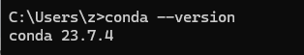
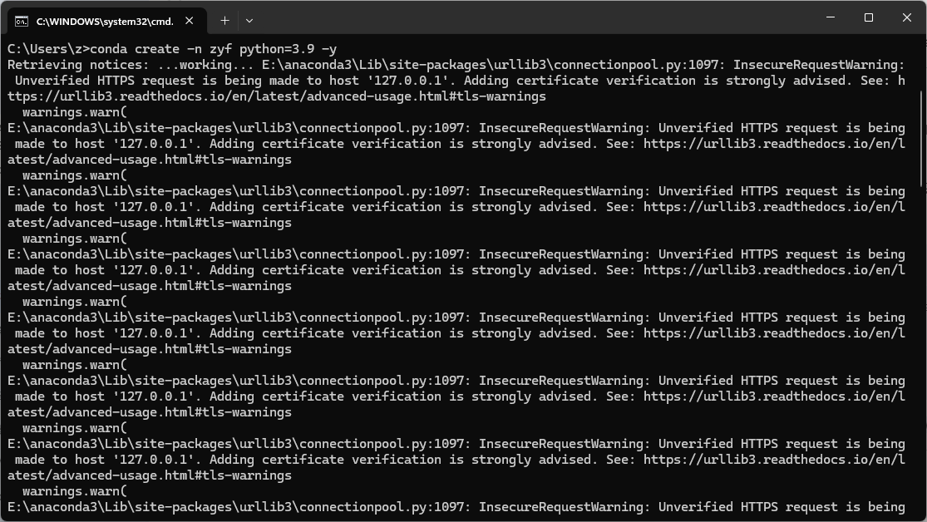
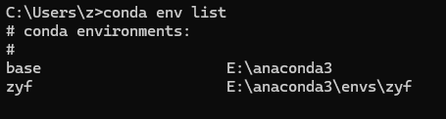
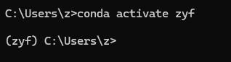
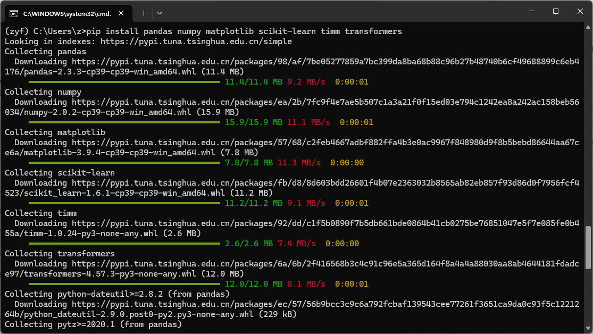
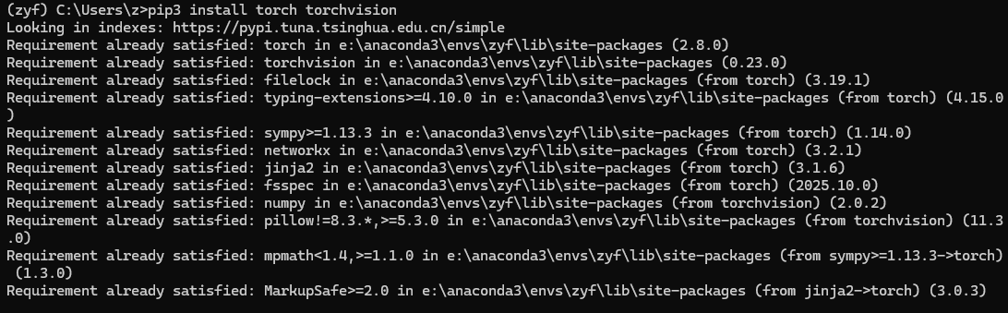
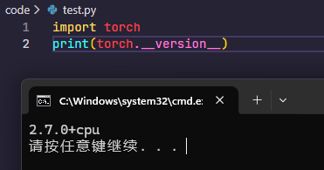
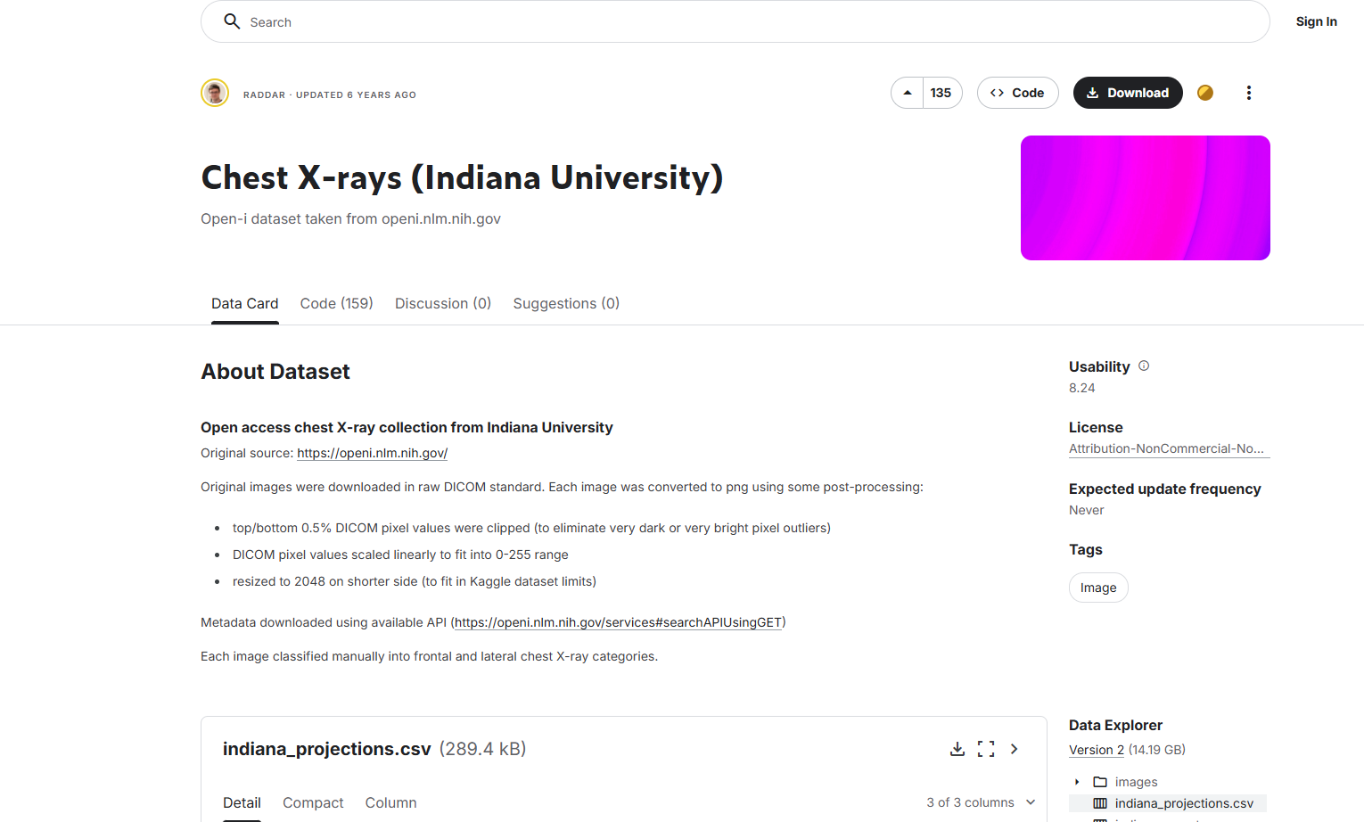
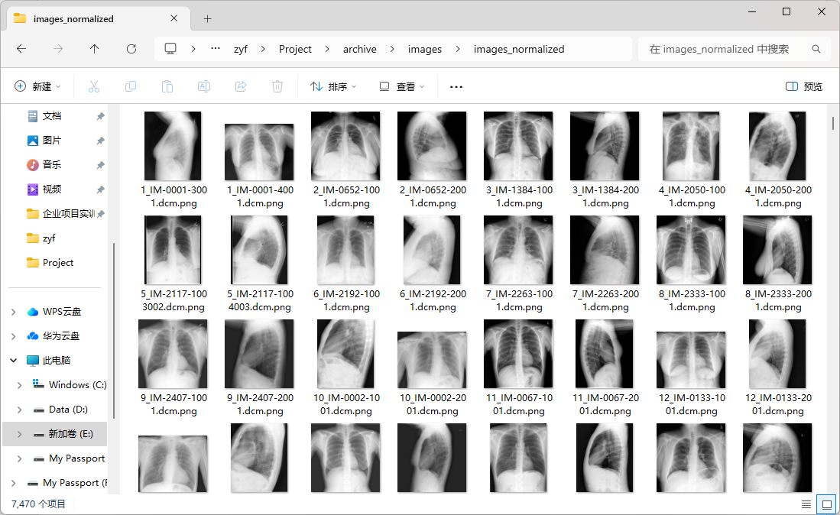
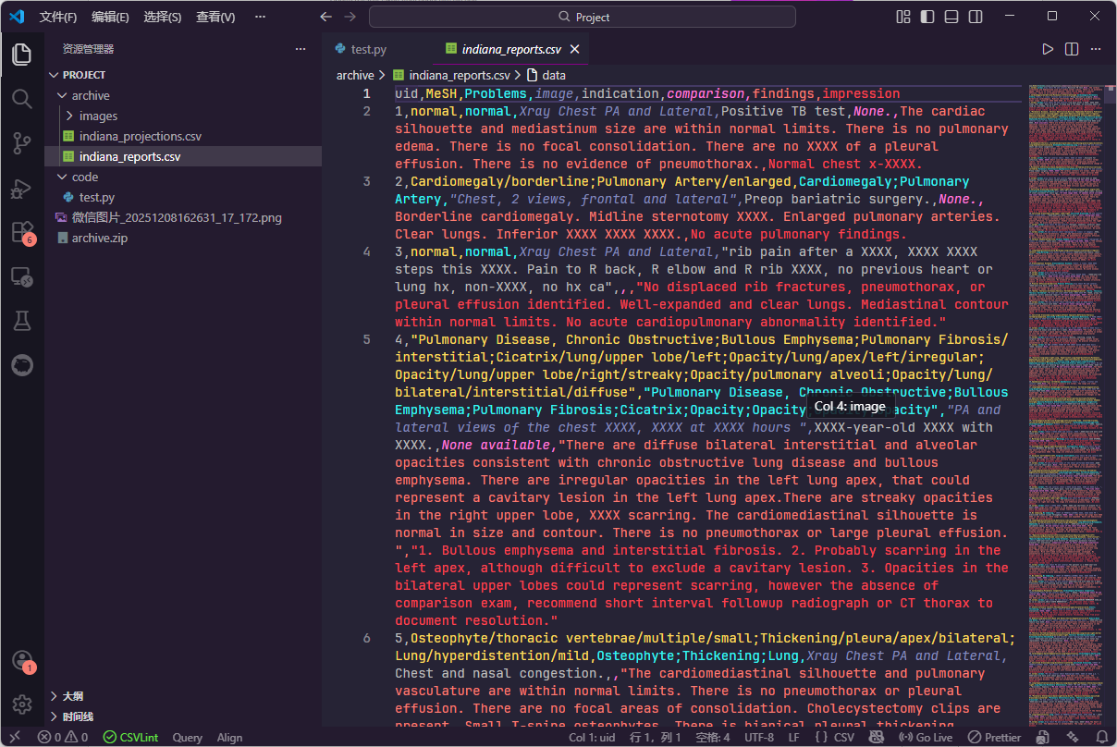

Day6
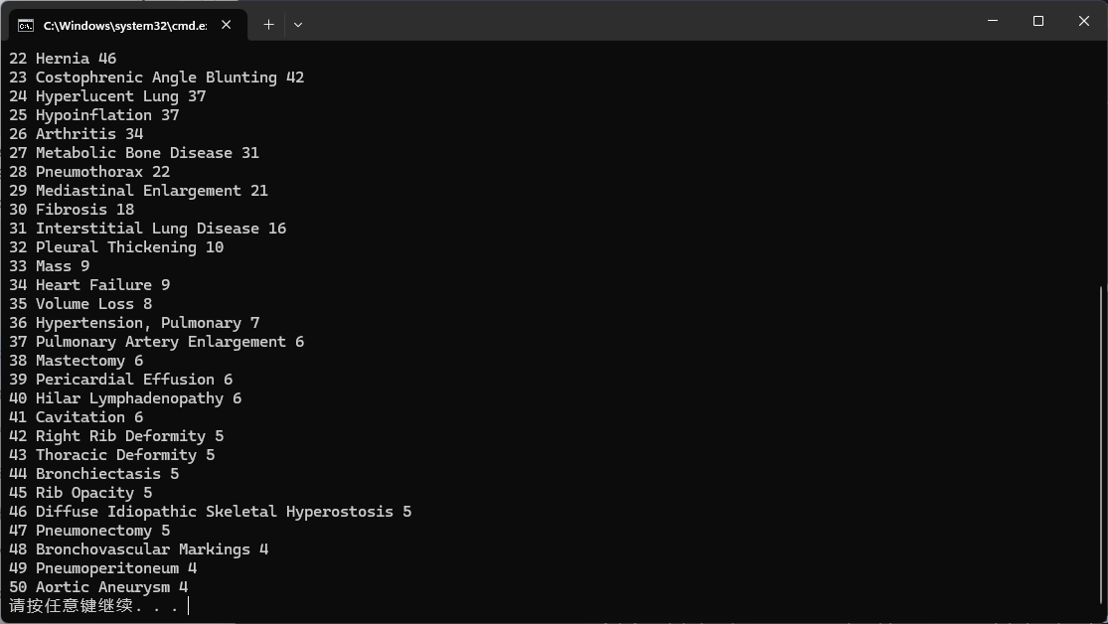

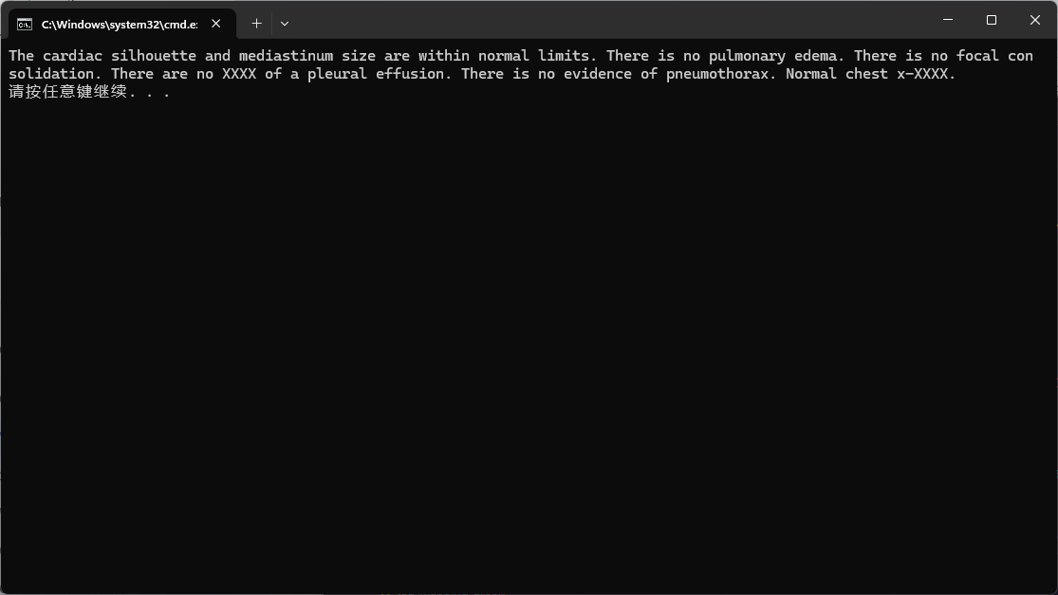
https://github.com/EmilyAlsentzer/clinicalBERT
https://huggingface.co/emilyalsentzer/Bio_ClinicalBERT
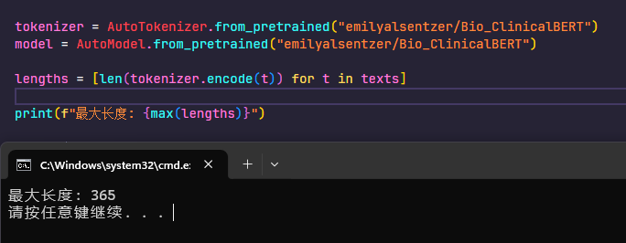
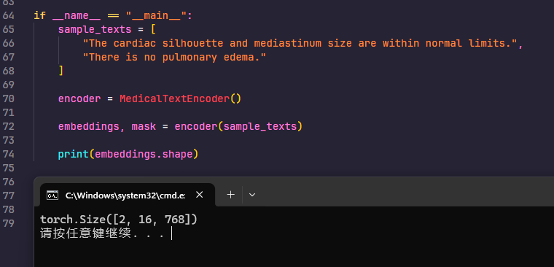

https://huggingface.co/google/vit-base-patch16-224

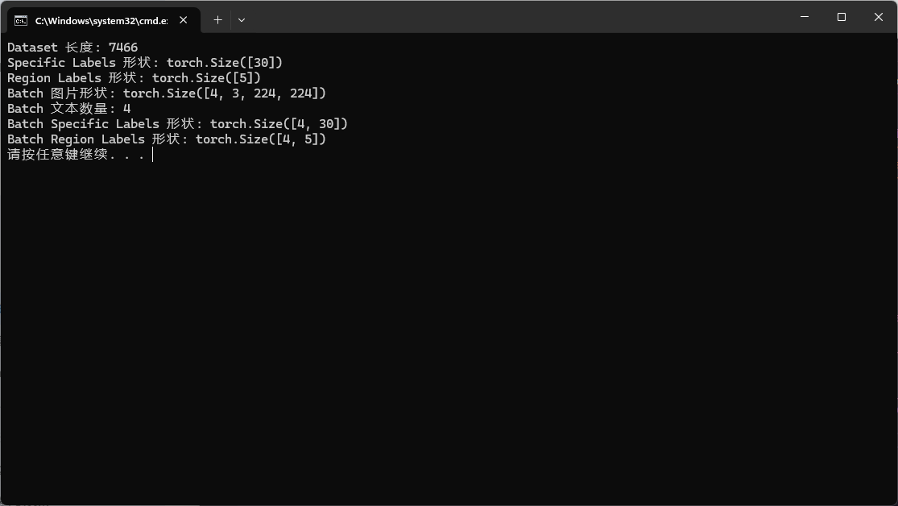

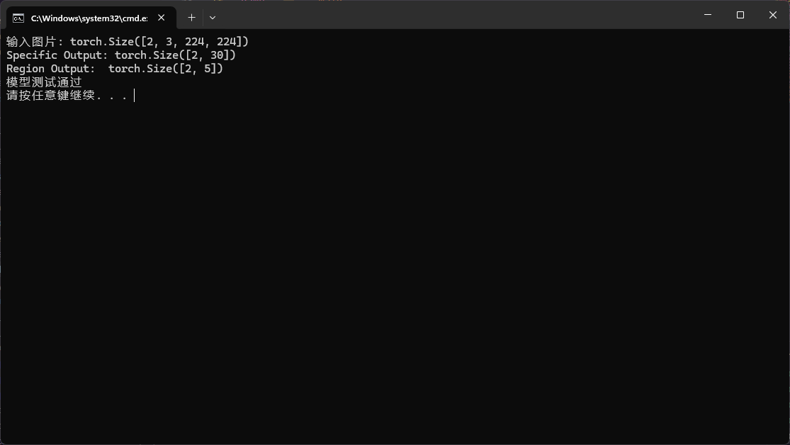

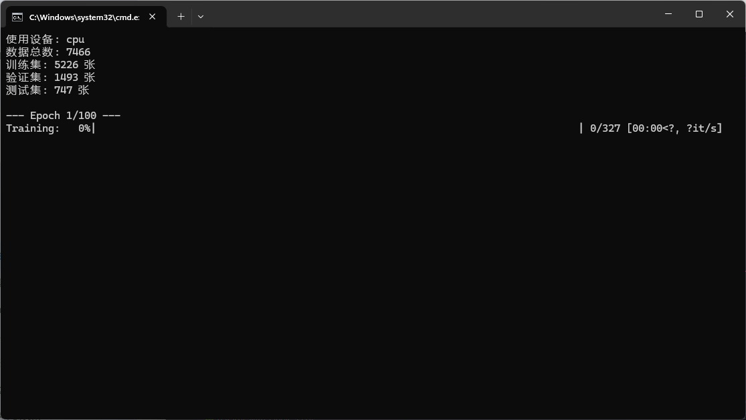

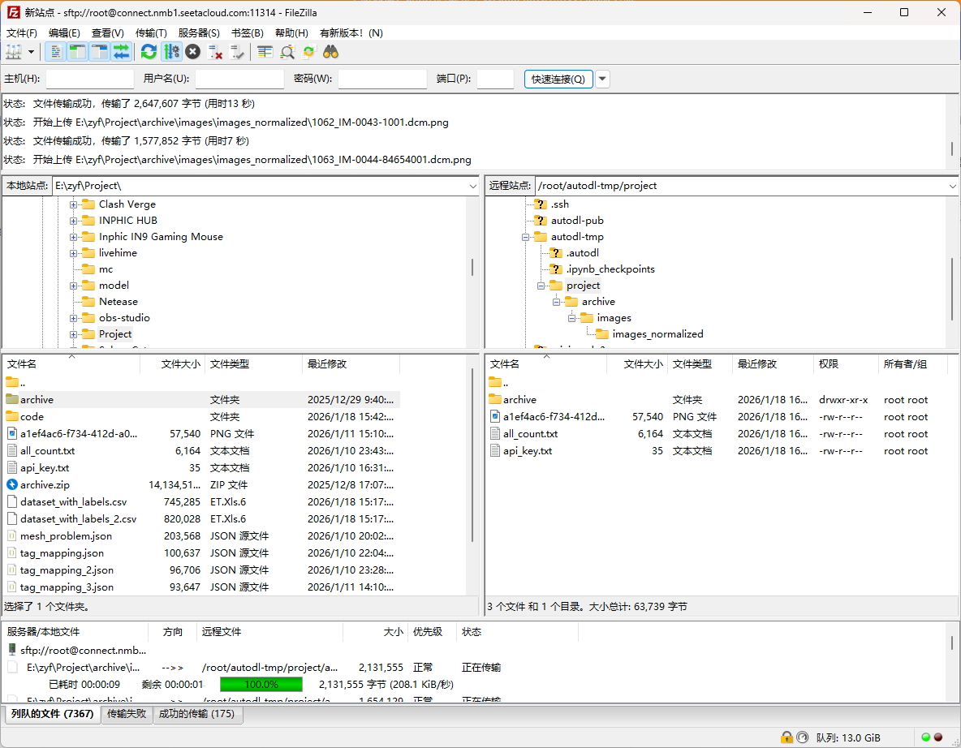

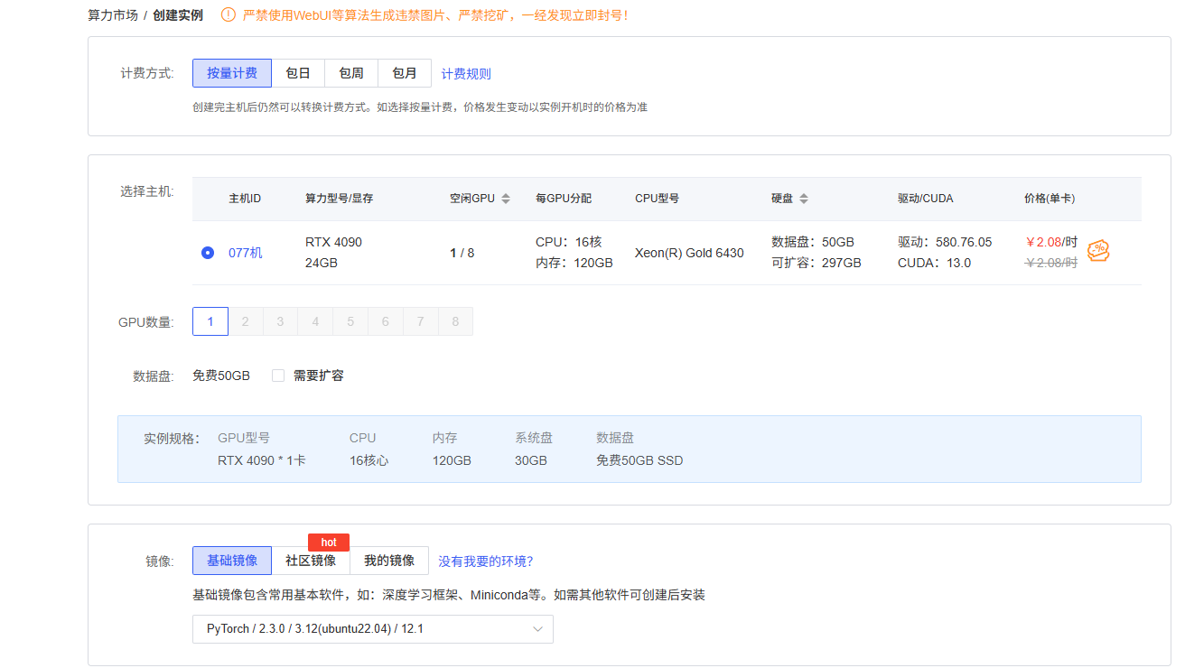

source /etc/network_turbo

人工智能在医学影像学中的应用与实践 | 人工智能
https://github.com/SmileJET/VCLIPSeg
https://github.com/MrGiovanni/R-Super
https://arxiv.org/pdf/2010.11929

https://doi.org/10.48550/arXiv.1904.03323

单具体疾病分类头
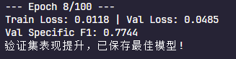


1:2
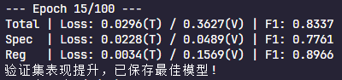
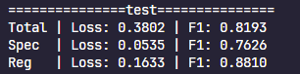

纯vit
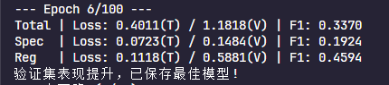


拼接
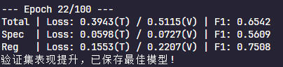


纯文本（mean）
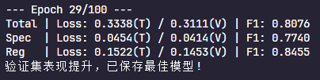
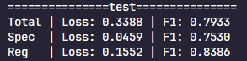

1:1

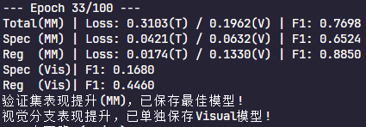



2:1
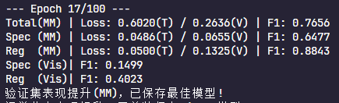
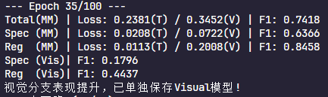

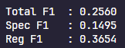
3:1
