**COSC 3P32 Group Assignment Part 2**

By: Yifan Zhu 7345671, Lysa Hannes 6695100, Marylina Beyeh 7056260, Shijie Tong 7081201

**Access Forms Description**

Form1:

public_assign_skill:  
It has 2 elements, character and skill. When you enter the character, the skill section will show which  
skill this character can use.

Form2:  
public_create_weapon:  
This form requires users to input various information about the equipment, in order to  
embed the equipment into the equipment table.

Form3:  
public_modify_gem_armour:  
The main part of this form has 3 elements. These elements include aid, eid and cname. These three elements show which armor piece is equipped to each person. When you click on an armor piece, the sub form, public armor gem, will show what gems are attached. There is a sub form to show armour and gem connection.

Form4:  
public_class_setup:  
This form is for setting up the level up statistics for a class. When you enter the name of the class, it will show its life, description, power, str, def, speed and what skills they can be assigned. There is a sub form that lists all the skills that are assigned to each class.

Form5:  
public_class_can_equip:  
It has 2 elements, name(class name) and subform (public class can equip). When you enter  
the class name, the sub form will show what equipment they can equip. There is a sub form to  
view the class and eid, to know what equipment can equipped for which class.

**Access Reports Description**

Report 1:

• Create a report which will list all the clans, and for each clan it will identify the chief followed by a list of every member of that clan.

We created four reports as requested in the question. Report one is the report concerning the clan. This report shows the number of clans we created. We have two clans. They are “DragonFighters” and “DragonLovers”. The “DragonFighters" clan’s chief is “PuppyLover”. The clan members are “PuppyLover”, “ RustyMike”, “MageMan” and “LoveTrees”. The second clan, “DragonLovers” chief is “WoodsGuy” and clan members are “ImaHealer”, “WoodsGuy”, “RageKing” and “DarknessForever”.

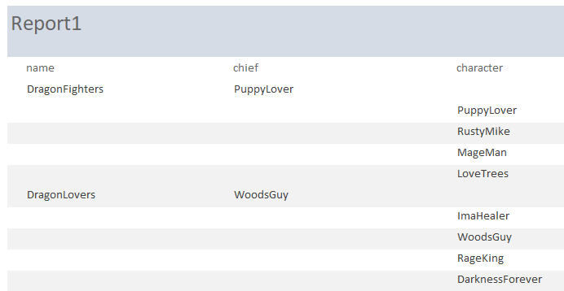

Report2:

• Create a report which will take in a character name, identified as an input parameter, and list all the skills which the character can currently use.

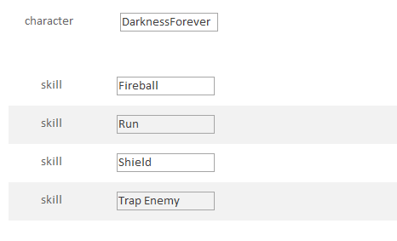

Here we created a report that lists all the skills a character currently has. Before accessing the report, you must input the character name as an input parameter. For example, the character “DarknessForever”, currently has the skills: fireball, run, shield, and trap enemy.

Report3:

• Create a report which will take in a character name, identified as an input parameter, and list all the armor and weapons that character has equipped, along with the gems on the equipment.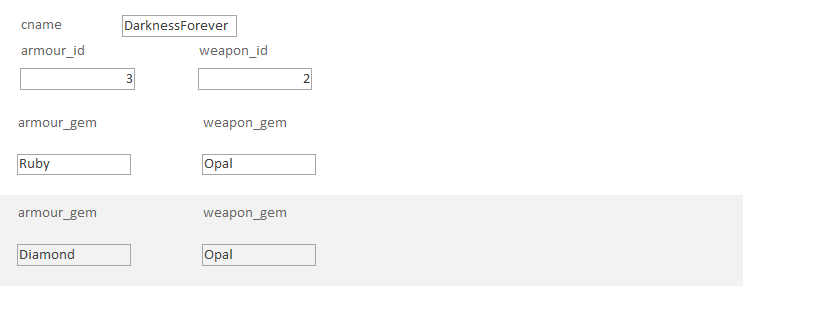

For this report you must first input a character name (e.g DarknessForever) as a parameter input. After, the report lists the character’s armour id, weapon id for the armour and weapon they have equipped. It also displays the gems on the equipment. Here “DarknessForever” has a ruby, and a diamond on their armour and an opal on their weapon.

Report4:

• list their level and calculate the character’s total stats with all equipment and gems taken into consideration (don’t just print the ones out of the character table even if your triggers are working).

For this report we created several views. We have the view named ch_level_stats, which contains the information for character name, level and the statistics related to the level. Similarly, we have ch_weapon_stats, ch_armour_stats, ch_secondary_stats and ch_weapon_gem_stats, ch_secondary_gem_stats, ch_armour_gem_stats. Then we created a view called report4 in which we preformed a left outer join to combine all these statistic tables one by one. We decided to use a left outer join so that any null values will display and not delete the table altogeather. In the report we used the view named report4(the view that preformed the left outer joins). Then to display the character’s total stats we wrote a sum statement for each of the stats in the design view.

**Division of Labour**

• Report on the division of labour within your group. Be sure to spend adequate time on preparing the report as this is the main resource that the marker will have after the presentation to evaluate the finer points of your project.

After the first part of the project. We divided the work by assigning Yifan to finalize the schema and make sure everything is working fine. We also assigned Lysa to check if the ER diagram was setup correctly. We also assigned Marylina and Shijie to come up with an idea of all the triggers we will need for the project. After this we all met to complete and update the list of required triggers. Then we decided to divide the triggers into 4 so we can each do at least 5 triggers. We later discovered we needed more triggers and updated that. We later concluded and divided the triggers so we could perform tests on the triggers to verify if the triggers were working probably. We each divided the triggers according again by 4 and ran different test on the triggers to make sure they all worked properly. We each created a test trigger report for the triggers we tested. We later created the forms and reports and uploaded them on the group form on sandcastle. With the help of the form, we created the final report document which includes a description of the forms and report, division of labour. Attached separately are the test triggers, the queries and the views that were created.