Game Design Document

Fill up the following document

1. Write the title of your project.

Shooting Game

1. What is the goal of the game?

Kill all the villains.

1. Write a brief story of your game.

The player can shoot bullets with the right arrow and the left arrow of the keyboard.

There are four villains in the game which are to be killed with the help of the bullets.

The player animation can move up and down with the help of the cursor.

1. Which are the playing characters of this game?

* Playing characters are the ones who respond to the user based on the input from the user.
* Cars, monkeys, dinos, wizards, etc., are the playing characters in the game.

|  |  |  |
| --- | --- | --- |
| Number | Character Name | What can this character do? |
| 1 | Player | The player is the main character which moves around the game. |
| 2 | Bullet | With the help of the bullet you can kill the villains. |
| 3 |  |  |
| 4 |  |  |
| 5 |  |  |
| 6 |  |  |
| 7 |  |  |
| 8 |  |  |

1. Which are the Non-Playing Characters of this game?

* Non-Playing characters are the ones that don't have an action or behavior when the user interacts with the game.
* Hurdles, stones, bananas, coins, etc., are non-playing characters in the game.

|  |  |  |
| --- | --- | --- |
| Number | Character Name | What can this character do? |
| 1 | Villain1 | They stand in their positions and they disappear on getting hit by the bullet. |
| 2 | Villain2 | They stand in their positions and they disappear on getting hit by the bullet. |
| 3 | Villain3 | They stand in their positions and they disappear on getting hit by the bullet. |
| 4 | Villain4 | They stand in their positions and they disappear on getting hit by the bullet. |
| 5 |  |  |
| 6 |  |  |
| 7 |  |  |
| 8 |  |  |

Draw your imagination of this game. What does this game look like?

* Draw the game either on your computer or on paper.
* Add images of the game scenes to show each of the playing and non-playing characters at least once.

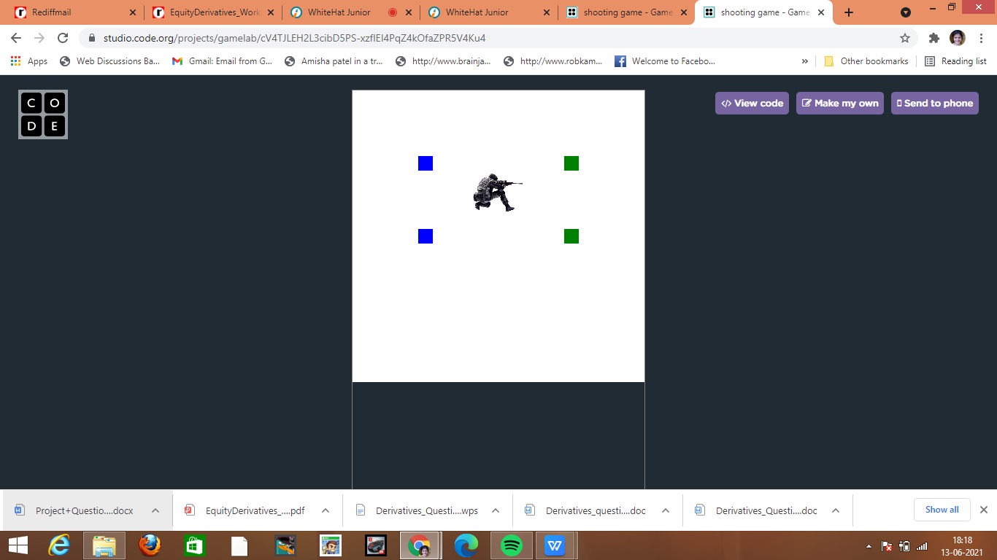

How do you plan to make your game engaging?