Assignment1 Report
71106401夏爱娟
- Assignment Requirements
- Familiar with MS Access
- Establish a university database： university.mdb
- Load data into the database
- Make a group of random tuples for student table and let student has more than 5000 tuples

- Platforms and Tools
  - Windows XP sp2 pro
  - MS Access 2003
  - Visual studio 2008 C#

- Implementation Plan
  - Create a database
After opening MS Access, select the "File" tab, select "New", and then create a "blank database", named the university, which completes the establishment of the database.
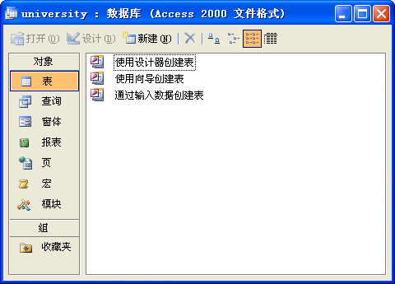
Fig. 1

Other steps are omitted here. Please note that the report needs to include the code written and the results of the run.

- Experimental Feelings
After this experiment, I learned the basic use of access. While exploring the input of 5000 sets of data, I still can't find a programming solution that I don't borrow for additional tools, so I ended up using the familiar vs.net programming. I think we will be able to dig out more access functions in future experiments.

