**mid-term exam paper**

course name database principle examination time 120minutes

student number student name

1. Please briefly answer the following questions: (4+4+4+4+4+4=24)
   1. Explain the difference between Database, DBMS, Database System, and relational DBMS;
   2. Explain the difference between files and Databases;
   3. Explain the difference between Data, Data model and Data Schema;
   4. Explain the difference between Relational Algebra and Relational Calculus;
   5. Explain the three typical forms of Sub-query;
   6. How Database Systems Guarantee that Each Group Returns a Single Value?
2. The following relational modes are given: R = (A, B, C), S = (D, E, F). Let the relations r(R) and s(S) be known. Please give the tuple relational calculus expression equivalent to the following expression: (4+5+6=15)
$\prod_{A}{\left(r\right)}$

$\prod_{A,F}{(σ_{C=D}(r×s))}$

$r*⋈_{C=D}s$

3. Please draw the E-R diagram of the project relationship, the entities including employee, project, supplier, component. The relationship between the entities are as follows: (8)
   1. A project has multiple employees, and one employee can only work in one project;
   2. A project has multiple suppliers, and one supplier can supply multiple projects;
   3. A project requires multiple components, which can come from the same supplier or from different suppliers, and one kind of components can be used by multiple projects.

Note: The entries have been given, please draw the E-R diagram that correctly represents these entities’ relationships.

project

employee

supplier

component

1. In the library management system, there are three tables: student table, book table and borrow table.(7+7+9+9+12=44)

Student(sid, sname, department, gender)

/*Representing the student`s id, name, department and gender(“F”: female, ”M”: male). */

Book(bid, bname) /*Representing the book`s id and name.*/

Borrow(sid, bid, date) /*Representing the student`s id, the book`s id and the date .*/

Using SQL to finish following questions.

* 1. How to find the id of student who borrows book which id is 521 or 520 in 2019;
  2. How to find the girl’s name in CS who borrows book which id is 630;
  3. How to find the name of student who borrows the most books;
  4. How to find the name of book which is borrowed only once and print student`s name who borrows this book;
  5. How to find the name of student who borrows the books including all books that student(sid = 111) borrows.

1. Answer the following questions: (3+6=9)
   1. There is a borrow table and the data schema is as follows:

Borrow(studentID, bookID, date)

Point out the primary key of the borrow table.

* 1. There is a work relationship table and the data schema is as follows:

Work(warehouseID, employeeID, componentID, quantity)

One warehouse has multiple employees, and each employee only works in one warehouse. In each warehouse, one type of components is composed of one employee is responsible, but one employee can be responsible for a variety of components. Analyze all possible candidate keys for this pattern.

1. Please briefly answer the following questions: (4+4+4+4+4+4=24)
   1. Explain the difference between Database, DBMS, Database System, and relational DBMS;
   2. Explain the difference between files and Databases;
   3. Explain the difference between Data, Data model and Data Schema;
   4. Explain the difference between Relational Algebra and Relational Calculus;
   5. Explain the three typical forms of Sub-query;
   6. How Database Systems Guarantee that Each Group Returns a Single Value?
2. The following relational modes are given: R = (A, B, C), S = (D, E, F). Let the relations r(R) and s(S) be known. Please give the tuple relational calculus expression equivalent to the following expression: (4+5+6=15)
$\prod_{A}{\left(r\right)}=\left\{t\left(A\right) | t∈r\right\}$

$\prod_{A,F}{(σ_{C=D}(r×s))}=\{t[AF]|t\left[ABC\right]∈r∧t\left[DEF\right]∈s∧t.C=t.D\}$

$r*⋈_{C=D}s=\{t[ABCDEF]|\left(t\left[ABC\right]∈r∧t\left[DEF\right]∈s∧t.C=t.D\right)∨(t\left[ABC\right]∈r∧¬\left(t.C∈s\left[D\right]\right)∧t.D=NULL∧t.F=NULL∧t.F=NULL)\}$

3. Please draw the E-R diagram of the engineering relationship, the entities including employees, engineering, suppliers, components, the relationship between the entities are as follows: (8)
   1. A project has multiple employees, and one employee can only work in one project;
   2. A project has multiple suppliers, and one supplier can supply multiple projects;
   3. A project requires multiple components, which can come from the same supplier or from different suppliers, and one kind of components can be used by multiple projects.

Note: The entries have been given, please draw the E-R diagram that correctly represents these entities’ relationships.

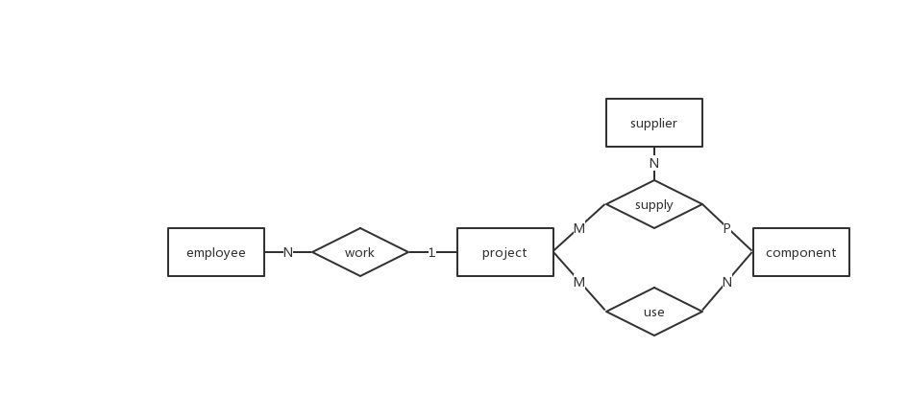

1. In the library management system, there are three tables: student table, book table and borrow table.(7+7+9+9+12=44)

Student(sid, sname, department, gender)

/*Representing the student`s id, name, department and gender(“F”: female, ”M”: male). */

Book(bid, bname) /*Representing the book`s id and name.*/

Borrow(sid, bid, date) /*Representing the student`s id, the book`s id and the date .*/

Using SQL to finish following questions.

* 1. How to find the id of student who borrows book which id is 521 or 520 in 2019;

SELECT SID

FROM BORROW

WHERE (((Year([DATE]))=2019) AND

((BORROW.[BID])=521 OR (BORROW.[BID])=520));

* 1. How to find the girl name in CS who borrows book which id is 630;

SELECT S.SNAME

FROM BORROW AS B, STUDENT AS S

WHERE B.BID=630 AND S.SID=B.SID AND

S.DEPARTMENT ="CS" AND S.SEX="F";

* 1. How to find the name of student who borrows the most books;

SELECT DISTINCT S.SNAME

FROM STUDENT AS S, BORROW AS B

WHERE S.SID=B.SID AND B.SID IN (

SELECT TOP 1 SID

FROM BORROW

GROUP BY SID

ORDER BY COUNT(*) DESC)

* 1. How to find the name of book which is borrowed only once and print student`s name who borrows this book;

SELECT B1.BNAME,S.SNAME

FROM BOOK AS B1,STUDENT AS S,BORROW AS B2

WHERE B1.BID=B2.BID AND S.SID=B2.SID AND B2.BID IN(

SELECT BID

FROM BORROW

GROUP BY BID

HAVING COUNT(*)=1)

* 1. How to find the name of student who borrows the books including all books that student(sid = 111) borrowed.

SELECT sname

FROM Student

WHERE sid IN

(SELECT DISTINCT SID

FROM BORROW AS X

WHERE NOT EXISTS (

SELECT *

FROM BORROW AS Y

WHERE Y.SID=111 AND NOT EXISTS (

SELECT * FROM BORROW AS Z

WHERE Z.SID=X.SID AND Z.BID=Y.BID)

));

1. Answer the following questions: (3+6=9)
   1. There is a borrow table and the data schema is as follows:

Borrow(studentID, bookID, date)

Point out the primary key of the borrow table.

All(reason omit)

* 1. There is a work relationship table and the data schema is as follows:

Work(warehouseID, employeeID, componentID, quantity)

One warehouse has multiple employees, and each employee only works in one warehouse. In each warehouse, one type of components is composed of one employee is responsible, but one employee can be responsible for a variety of components. Analyze all possible candidate keys for this pattern.

1. {employeeID, componentID}
2. {warehouseID, componentID}