NSTP MANAGEMENT SYSTEM
First Walay Modal or Pop Notification na human na ang progress or execution
- Coordinator – Section & Students
- Coordinator – Instructor Management
- Coordinator – Report & Activity
- Coordinator – Activity Calendar
- Coordinator – Generate Report
- Coordinator – OCR Grade
- Instructor – All Section
- ROTC – All Section
COORDINATOR SECTION

SECTIONS & STUDENTS:
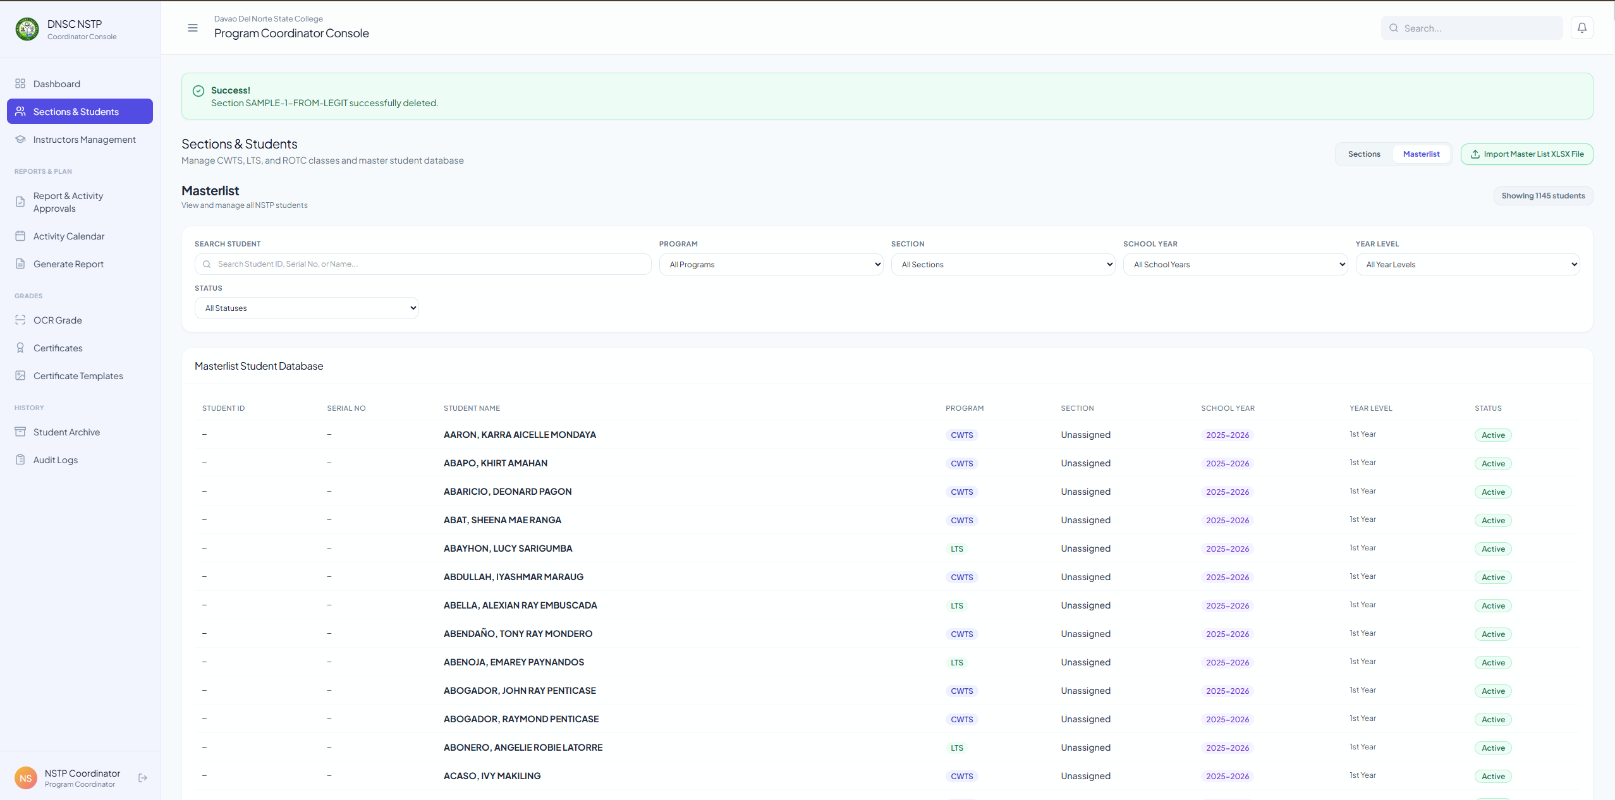
1. Walay Delete Button Para sa Master List
2. Mu dawat Any kinds of Sheet file XLS, XLSX, & etc

REPORT & ACTIVITY:
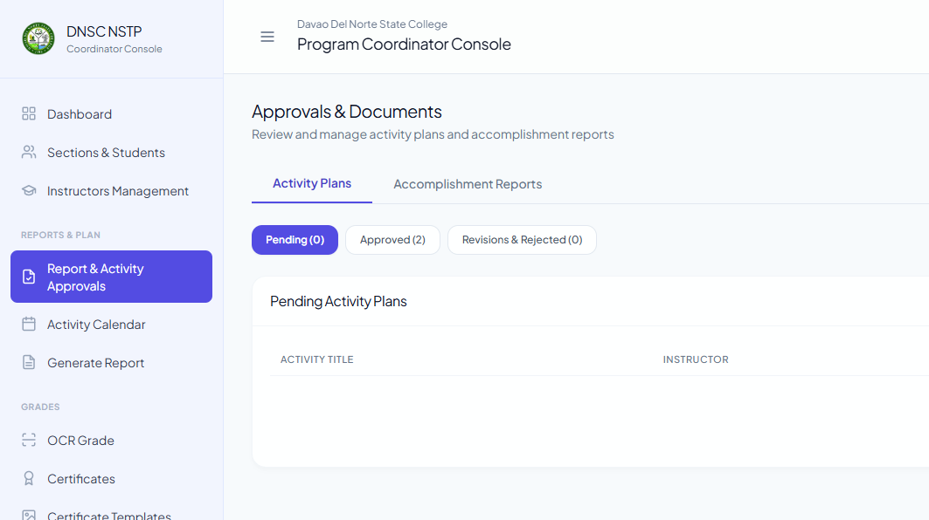
- Dili functional na ang accomplishment reports

ACTIVITY CALENDAR:
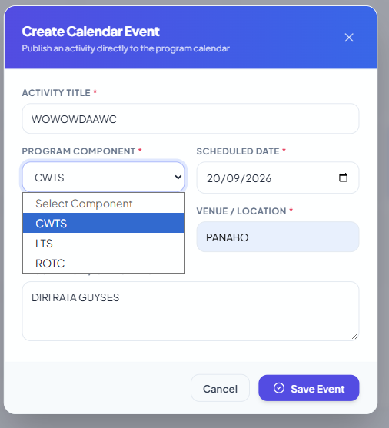
1. Naa dapat sa option na “General“
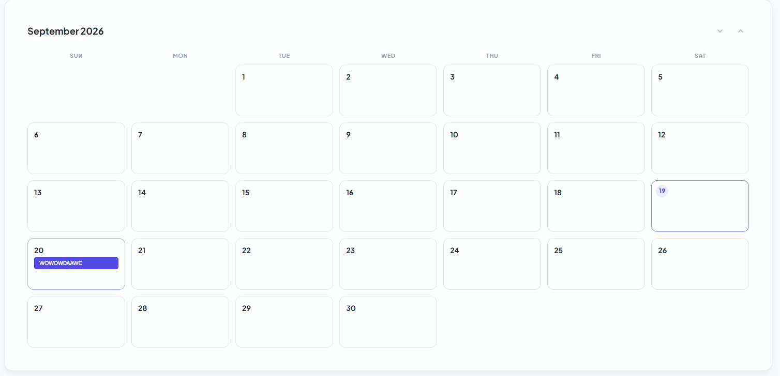
1. Dapat ma kita ang description sa event gi post

GENARATE REPORT:
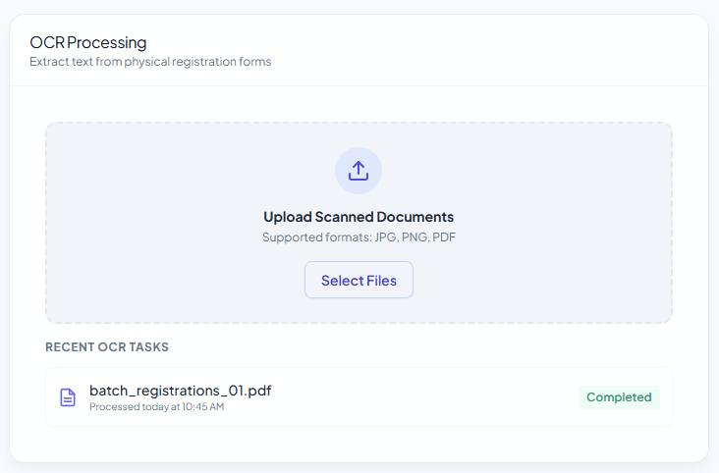
1. Pa remove ko ani boss kay wala ni sa among objective sa system dapita sa Generate Report
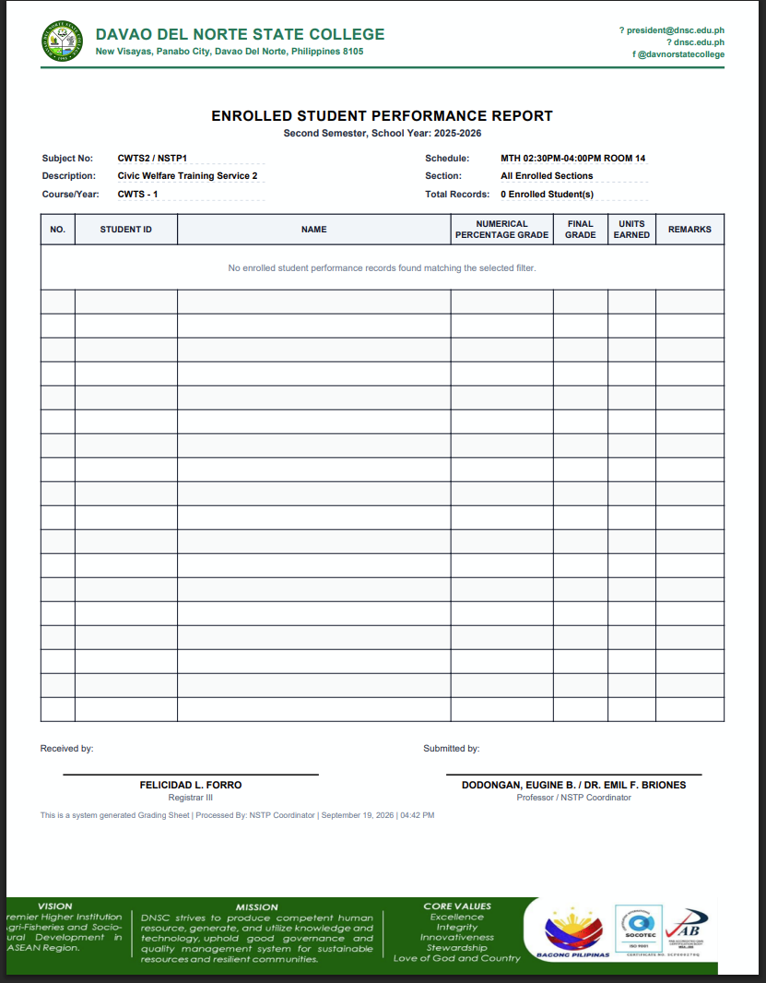
- Asa nako pwede ni ma edit or ma kita dapita sa signiture

OCR GRADE:
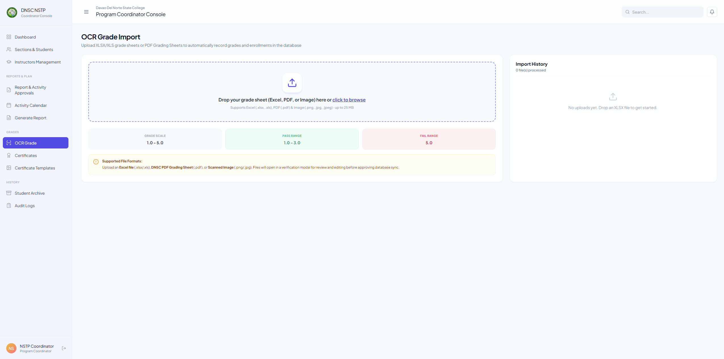
- Dili gihapon functional

STUDENT ARCHIVE:
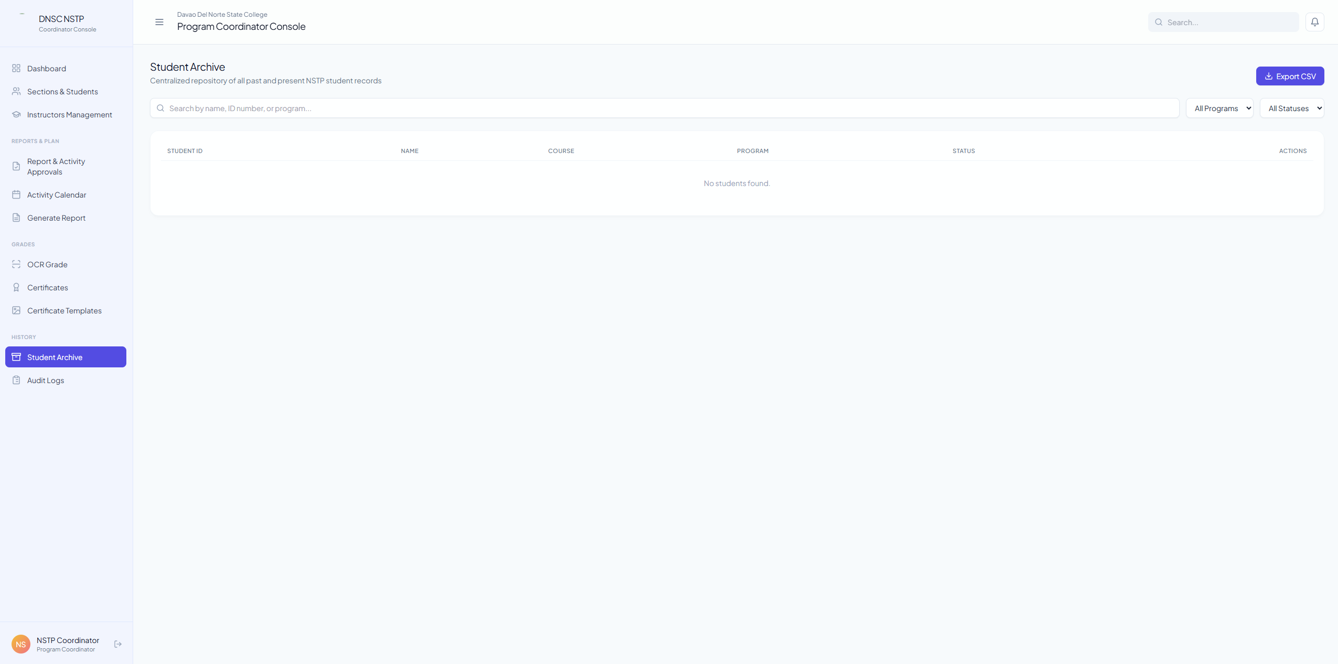
- Dili gihapon nako try kung wala ko naka delete si masterlist

CERTIFICATE TEMPLATES:
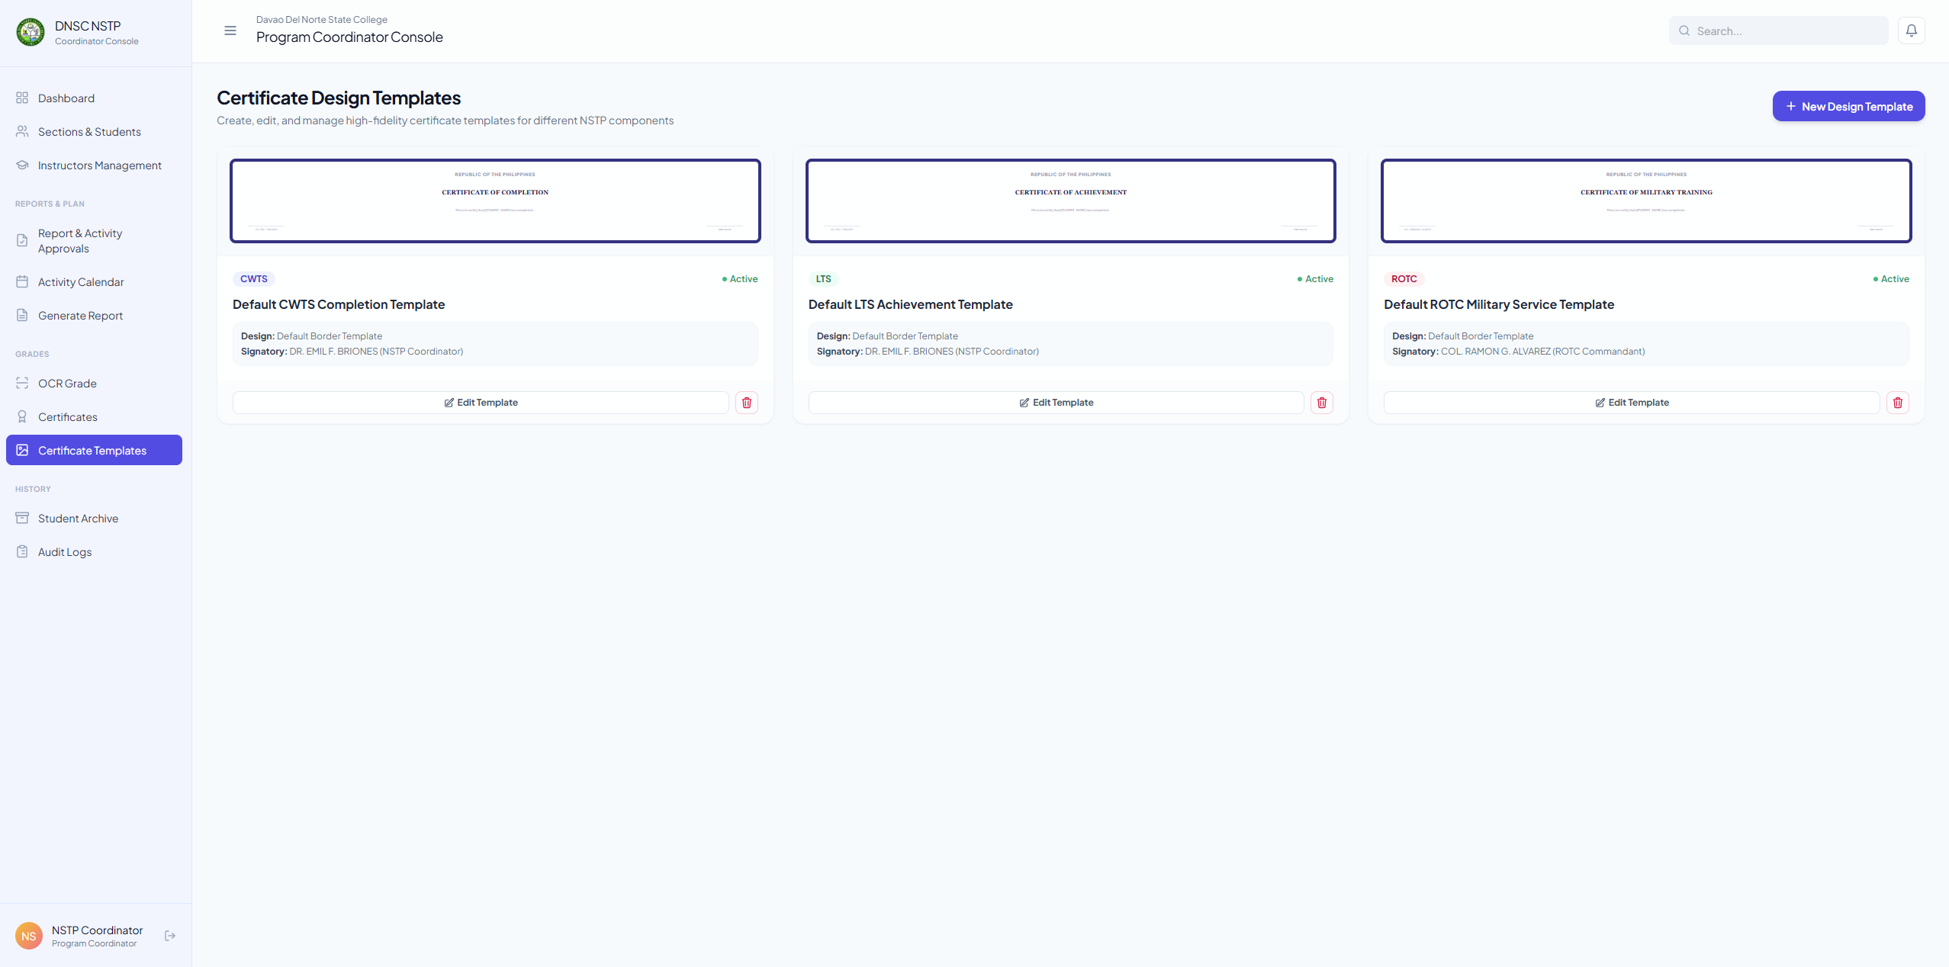
- Dili nako ma try kay dili functional same sa CERTIFICATE.

INSTRUCTOR
ACCOMPLISMENT REPORTS
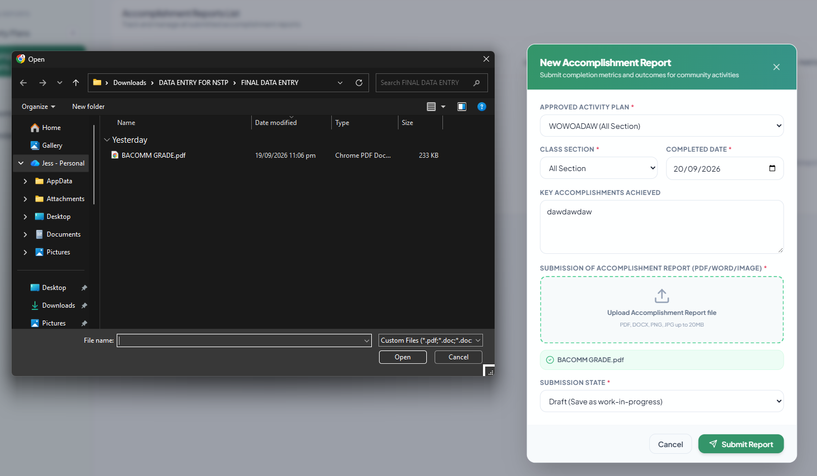
- Maka attach pud unta ug photo
ANNOUNCEMENT:
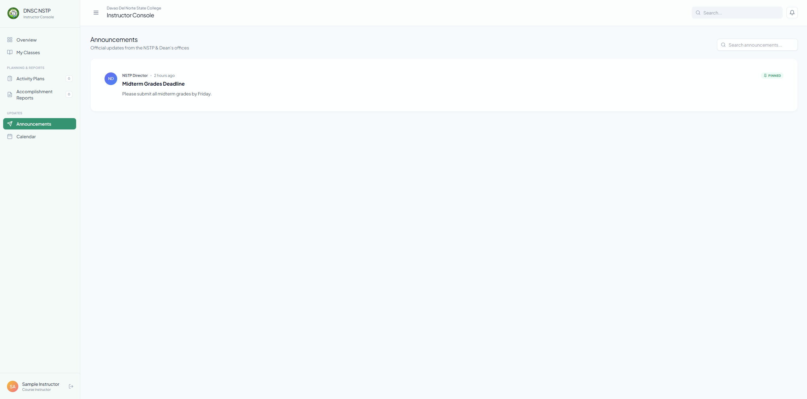
- Asa ma kita ning gi upload mismo sa coordinator boss?
CALENDAR:
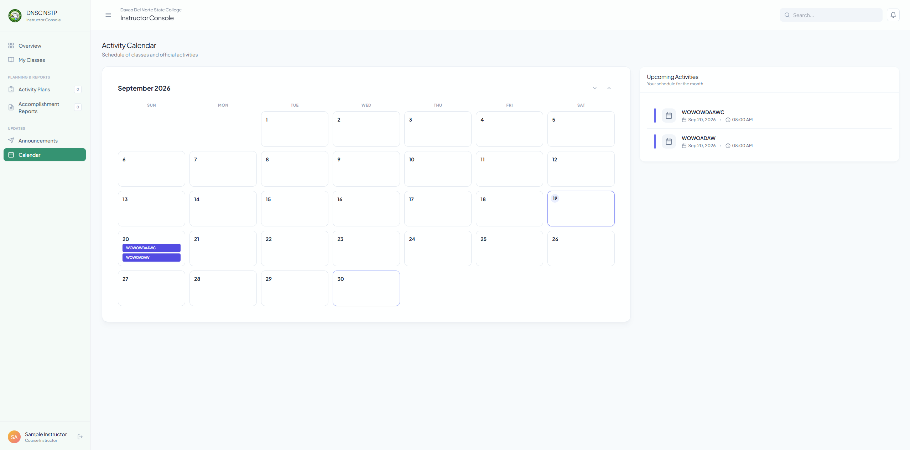
- Dili gihapon nako ma kita ang description after nako I click ang activity

ROTC
OVERVIEW:
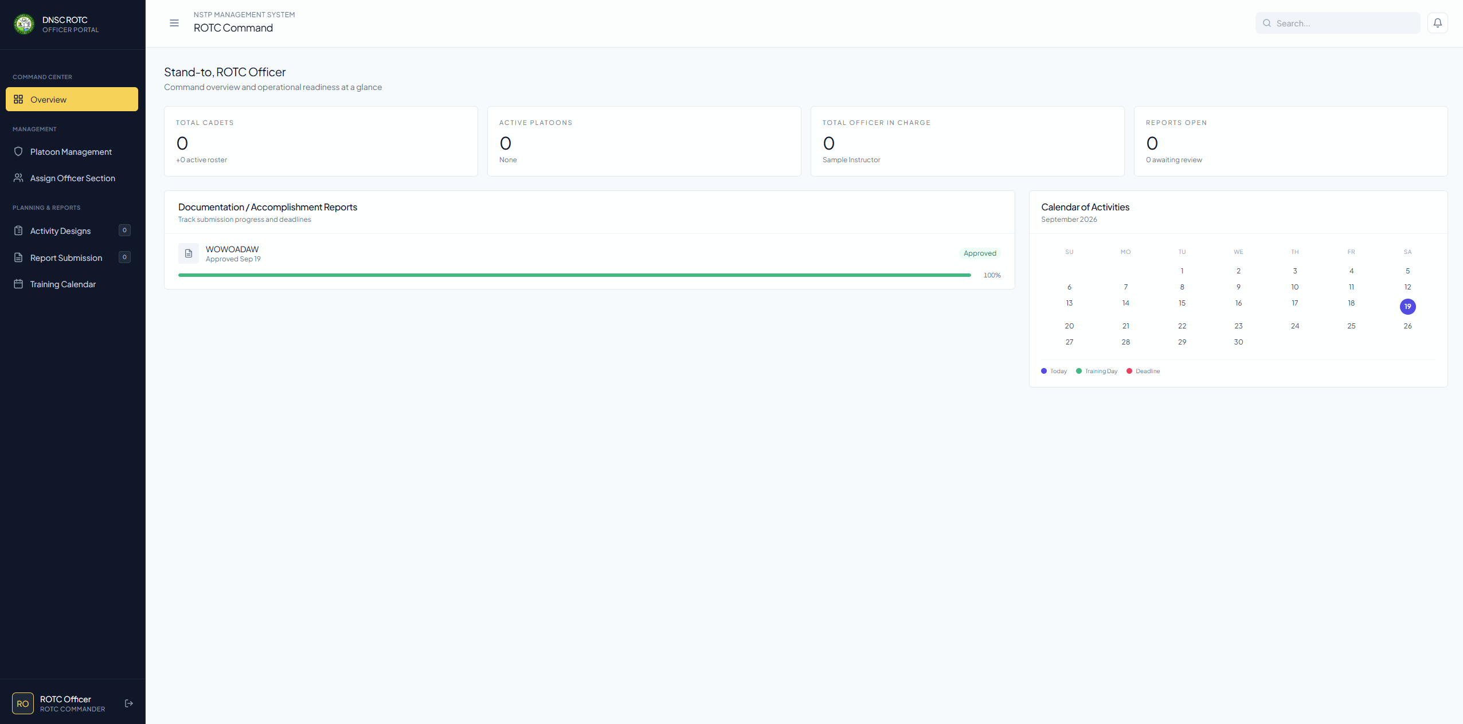
- It is only for CWTS or LTS na kita mismo sa ROTC section

PLATOON MANAGEMENT:
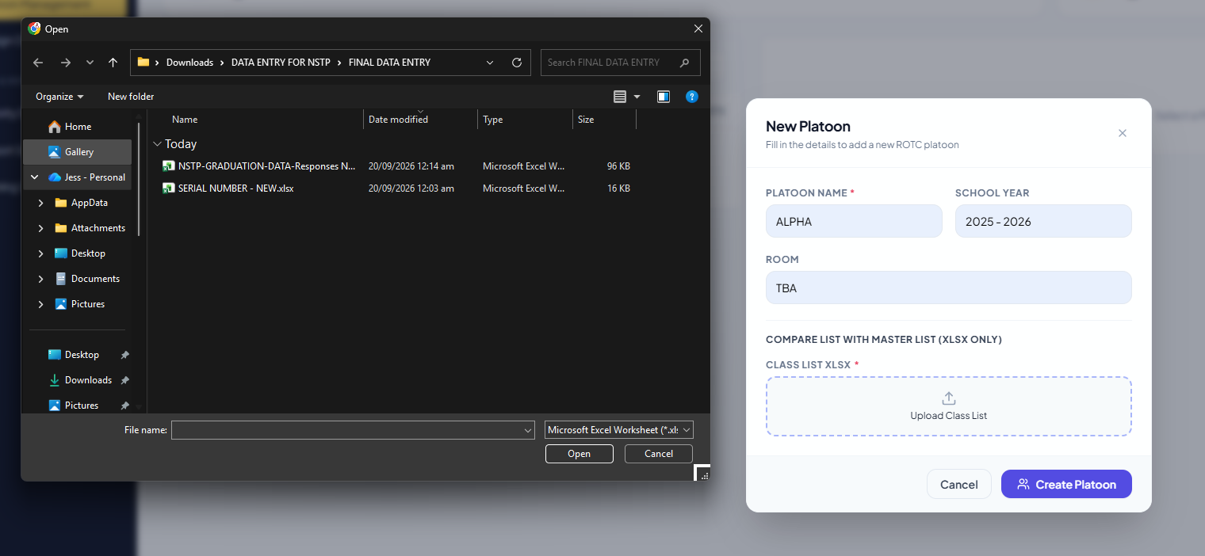
- Still mu dawat unta siya ug XlS or other sheet file and still dili siya functional na same gihapon sa coordinator section tong I compare sa masterlist na excel file
REPORT SUBMISSION:
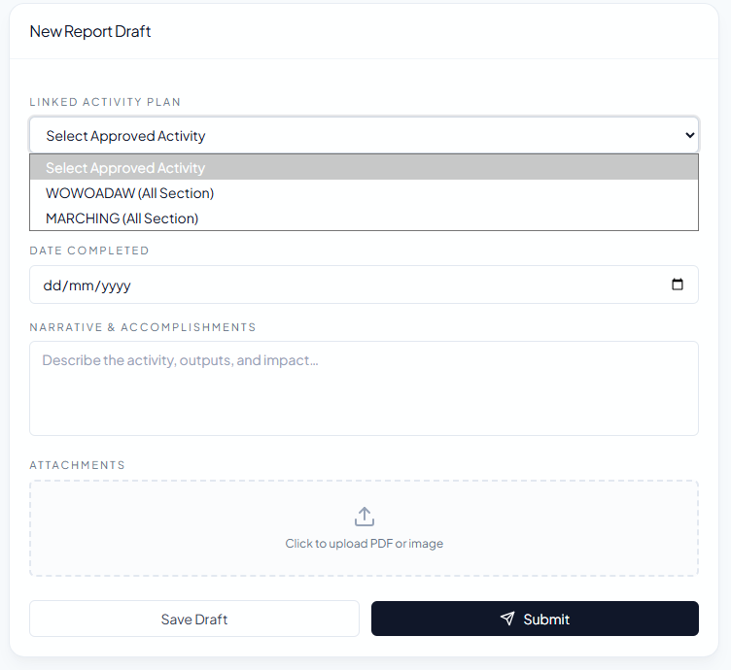
- Dapat dili included ang gikan sa instructor na gi buhat na activity
- And also picture sad like document and picture

TRAINING CALENDAR:
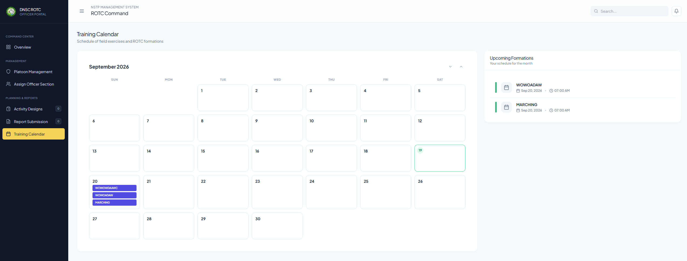
- Dili gihapon nako ma kit an ang description sa activity sa calendar

