**Caution: check the working dictionary should be ../alexAI_GPU-main**

**Check the Nvidia Driver**

**Check the CondaToolkit (Important:11.8)**

**Python version should be 3.9 Or 3.10**

**Install the dependency with specified version (Maybe some package missing, message me then)**

basicsr==1.3.4.9

einops==0.6.1

fastai==2.7.12

fringe==0.0.6

matplotlib==3.7.2

opencv-python==4.8.0.74

scikit-learn==1.3.0

spacy==3.5.4

tensorflow==2.10.1

tensorflow-addons==0.21.0

timm==0.9.2

torch==2.0.1+cu118

torchvision==0.15.2+cu118

tqdm==4.65.0

uvicorn==0.23.1

**Start the ngrok.exe and run for NAT (Register a new one on your desktop maybe):**  
ngrok http https://localhost:8000 --domain=major-ghost-noble.ngrok-free.app

**When all process complete,run python3 main.py. You should see:**  
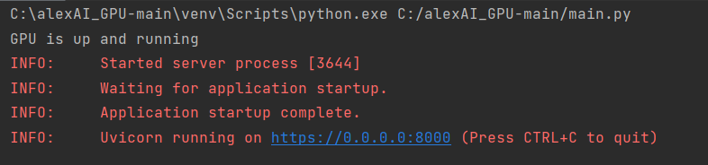

It means the AI server is ready to receive the input from main server

##process.py:

**hat_pipeline.test_pipeline()**:

This is the test_pipeline for HAT model, If you want to use different HAT models. Remember to change the config file. Set the type to "SingleImageDataset". And keep only the "dataroot_lq" , then delete the metrix part of original yml config file.

**calculate_sharpness_and_best_z() need:**

The path to hologram folder

The path to the background image

The path of output folder

**SWINIR part**:

This part is done by simulate the implementation in terminal. Need to be recoded someday