GROUP ASSIGNMENT
Technology Park Malaysia
Web Applications (CT050-3-2-WAPP)

HAND OUT DATE : 7-Nov-2016 Group Members: Abdulaziz Fadhl Ahmed (TP035863)
HAND IN DATE : 3-Feb-2017 Khaled Mahmoud Arbab (TP037287)
WEIGHTAGE : 50% Walid Ramadan Adam (TP037689)
Osamah Saeed Basaad (TP036528)
TOPIC : DigitalTech B2C-digital-devices-Platform Web-App.
INTAKE : UC2F1605IT Lecturer : Sathiapriya
_____________________________________________________________________
INSTRUCTIONS TO CANDIDATES:
- Submit your assignment at the administrative counter.
- Students are advised to underpin their answers with the use of references (cited using the Harvard Name System of Referencing).
- Late submission will be awarded zero (0) unless Extenuating Circumstances (EC) are upheld.
- Cases of plagiarism will be penalized.
- The assignment should be bound in an appropriate style (comb bound or stapled).
- Where the assignment should be submitted in both hardcopy and softcopy, the softcopy of the written assignment and source code (where appropriate) should be on a CD in an envelope / CD cover and attached to the hardcopy.
- You must obtain 50% overall to pass this module.

Catalog-Menu
_______________________________
- Abstract&Introduction ---------- pg. 2
- Project Analysis&Proposal ---------- pg. 3
- Project Description ---------- pg. 4~6
- Requirement Specification ---------- pg. 7~9
- Web-App Logical Design & Modeling ---------- pg.10~21
- Implementation ---------- pg. 22~27
- Conclusion --------- pg. 28
- References --------- pg. 29~30

1. Abstract & Intro.

Digital World is being evolved tremendously, the rapid churning rate of new IT-gadgets and devices made the devices that we are currently using become outdated.
That leads people change their digital devices frequently, so the platform that allow people to purchase the new digital-devices is in high-demand.
DigitalTech is a Malaysia Local digital-device online B2C(Business To Customer) platform which the company DigitalTech buy the original devices from various manufacturer in the wholesale-price, these manufacturer are mainly mobile-devices computer or any modern smart devices or wireless gadgets such as Apple, Samsung, Asus, XiaoMi, Huawei, etc. The DigitalTech online platform then sell these products in second-handed in retail-price to the customer who has registered as member in DigitalTech via this platform.
This online digital-market is designed for people who are seeking for new digital-gadgets in the market, The admin of DigitalTech would constantly upload new devices or products from various manufacturers so as to ensure the customer would get their intended devices as soon as possible.
In this project development, The group of four would produce a fully functional online digital-devices-purchasing-platform with back-end-database connection with working operation and procedure without fatal-failure or error.

- Project Proposal Analysis
Based on a research regarding about “how-often-do-you-buy-a-new-phone?” conducted by Chris-P. in November-2015(Chris,2015), the statistics has shown that more than 70% of people would buy a new phone within 1 to 2 years regardless their old-phone are still intact, this has shown that the fact of fast rate of changing the digital-devices, so this lead to the demand of a platform that could gather all the information about the various kinds of digital devices and gadgets together and let customer to choose their interested one.

In this project, the group of four decided to build up this platform which named DigitalTech that enable people access on it and register as member in order to purchase digital-devices such as smart-phone, computers , camera, etc. Which in turn DigitalTech would gain profits from the items the customer purchase from. The payment approach here is using the PayPal so that the once the customer has picked their interested gadgets into their shopping cart, once they click on the confirm purchase button, the page would direct user to the PayPal payment portal.

The online platform should endure four users log in to the system in parallel which this includes customers who come to purchase, and admin who manage the products, managers who manage the inventory and customers and supplier who supply digital products to DigitalTech.

- Project Description

3.1 Aim and Scope
The main aim of the project Web-Application-DigitalTech is to enable user to access this platform and make purchase on the digital devices that are useful to people.
The Scope of DigitalTech are focus in Few-main digital categories: Mobile, Computer, Camera, etc. The targeted people are mainly stay in Malaysia which the price are all based on Malaysia-Ringgit.

3.2Audience-Description

-Visitors(Non-Registered-Users) Anyone who access the page and view all the digital devices goods but could not make purchase.

-Customers(Registered-Users) could view and purchase specific digital-devices in DigitalTech via DigitalTech PayPal link.

-The Administrator can manage(CRUD[Create,Retieve,Update,Delete]) the information about the digital-devices and all goods.(c# code class administrator.cs)
-The Manager can manage Users in the Digital-Tech-Platform and also manage on the inventory list which later would supplier would view it and supply products based on that inventory list.

-The Supplier can access DigitalTech-Platform view the inventory list and get knowledge about Order from DigitalTech.

3.3 Project Schedule
 | Project Tasks | Days(2Months=2*31=62days) [32blocs(1block=1~2days)]
1 | Project Proposal Analysis
2 | Project Logical Design
3 | Data Analysis
4 | Database Construction, Connection & Maintenance
5 | System Development
6 | System Testing
7 | Project Documentation
8 | Project Overview

(Abdulaziz,2016)

3.4 Porject [DigitalTech] Overview
DigitalTech is an online web-App who simulate the real shopping procedure, it is the B2C-Digital-market that sell the digital-devices such as Samsung Note7, iPhone7, XiaoMi-Note, Asus-Laptop, etc in retail-price, it purchase those digital devices from the direct manufacturer at wholesale price, so DigitalTech gain profit from the difference between the wholesale-price and retail-price. It has 4 main active users to engage with which are customer, administrator, manager, supplier.
The C# & Asp are the programming languages are been chosen to implement the under .NET Environment and Microsoft Sql-Server is the database server it has implemented so as to produce this Web-App,

- Requirement Specification
- Audience-Modeling
The audience-modeling is the process or model that gather and filter the requirements from end-users. Understanding audiences, their needs and behaviours is the heart of this project, because the DigitalTech is a platform that design to be used by people who need to purchase or searching for new-digital-devices such as smartphone, computers, camera, etc.
DigitalTech has 4 active users which interact with DigitalTech Portal actively, so before the development of the website, it has to clarify the requirements from each of them.
-Customer-Requirements: Customers are the largest portion active users of DigitalTech, they are the source of profit that DigitalTech could made from, they come to the site and purchase on the digital items that they are interested with.
- Able to browse through all the digital products by categories
- Able to view their own profile after registration
- Able to make purchase on certain item
- Able to add the item to the shopping-cart and this session remains intact even at the next login.
- Able to make payment via paypal
- Able to recover the password while the forgotten the password of the account
-Admin-Requirements:Administrator is the key one of the key role in site, they manage all the products in the shop, when the new-technology came out or any new digital-gadgets have just released in the market, they have to update the site products-catalog even before the supplier has supplied the goods, because it is the pre-emptive marketing strategy of DigitalTech to attract customers.
- Able to log in to the web site as Administrator to perform any operation as a normal customer such as purchase, add products to shopping-cart, etc.
- Able to add new products for the DigitalTech
- Able to delete outdated products
- .Able to generate Product detail report for current product-catalog
-Manager-Requirements:It is the owner who hire administrator and web-developer, they are in charge of the sales, the marketing, so they have to log in to the system and keep track of the user activities and abstract user information in order to implement their marketing strategies, such as constant voucher-delivery-to-home, constant-newsletter-from-DigitalTech, etc.
- Able to log in to the web site as manager to perform any operation as a normal customer such as purchase, add products to shopping-cart, etc.
- Able to add new users include admin, manager, customer
- Able to edit/change/update anyone’s information
- Able to delete an inactive user
- Able to generate inventory-report and add new-inventory
- Able to communicate with supplier via supplier-inventory module

-Supplier-Requirements:is the original manufacturer who has signed the contract with DigitalTech and supply their digital-goods to digitalTech when DigitalTech request it.
- Able to log in to the website to view the inventory-list
- Check the supplier inventory list with manager so as to supply goods
- Not able to purchase

- Hardware/Software Requirement
Hardware-Requirements:The DigitalTech should be hosted on a online webhosting-provider, and the hardware requirements is the machine should be fast enough to handle the vast amount of purchase query and access. It should be at least 2Ghz-core-processor with RAM 2GB and above.
Software-Requirements:The hardware must have installed Microsoft-Server 2008R2 or Above, it would give the best compatibility and performance for MS-Sql-Server2012, Means The webhosting should has MS-Sql-Server but not MySql-Server or any others, and the system should has ASP.Net framework installed so that the DigitalTech Web-App just could be able to work fine without any extra patch or package needed.

- Major functions

The main function and capability of DigitalTech is enable people purchase the newest Digital Devices such as smartphone, computer, camera, etc. From various locations.
Sub-functions:
-Allow online Paypal-payment with receipt
-Shopping-Cart simulation
-Customer could shop digital devices online
-Admin could manage products
-Manager could manage users and inventory
-Supplier could check the supply list from manager
-...

- Web-App Logical Design &Modeling
  - Database
    - Database ERD[Entity-Relationship-Diagram]
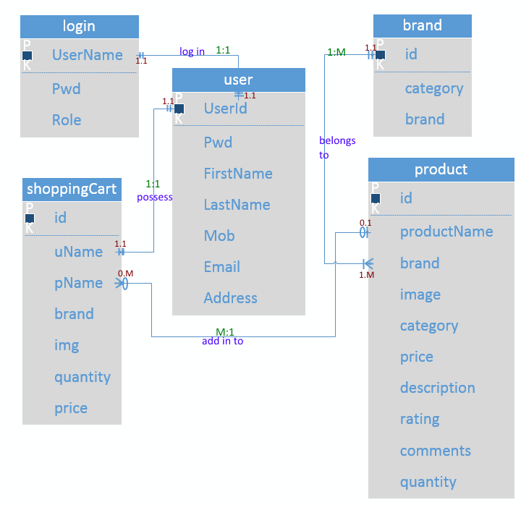
ERD-Crow’sFeet(Abdulaziz,2017)

The picture above is the Entity Relationship Diagram of Crow’s Feet. It has structured and arranged in to such a way that make all the entities to be connected, In this logical design, here has 5 entities all are connected by crow’s feet, in side it contained, 1:1, 1:M, 0:M relationships:
-brand to product one to many relationship: Each brand has many products, this is mandatory on both side.
-product to shoppingCart one to many relationship: Each product could be put in to many shopping cart. Mandatory on product side, Optional on shoppingCart.
-shoppingCart to user one to one relationship: Each user is mandatory to has at least one shopping cart and also maximum one
-login to user one to one relationship:Each account can only sign in as one user exactly one, this is mandatory relationship

    - Use-Case Diagram
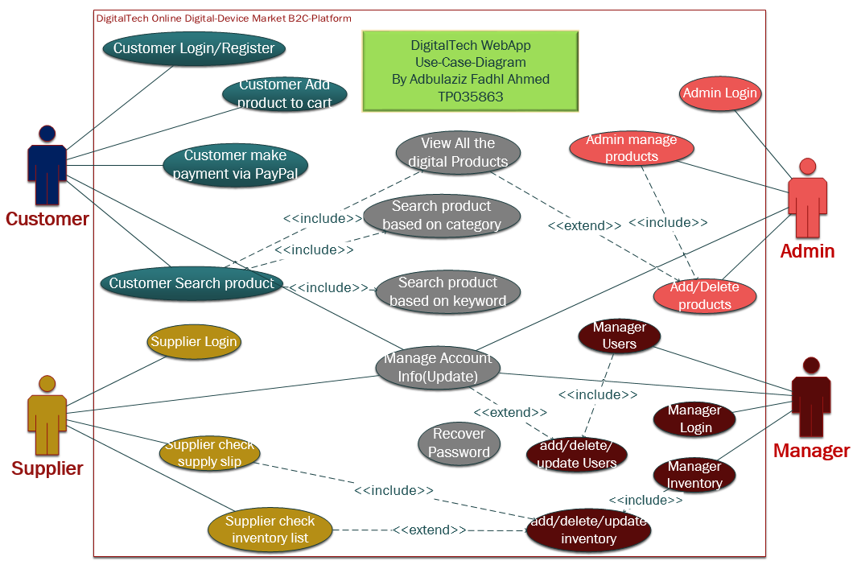
(Abdulaziz,2017)

    - Database-Data-Dictionary

The following tables is the detail description data-dictionary of the database shop.mdf from MS Sql Server for the Web-Application DigitalTech-B2C-Online Digital Market. It has 5 (entities)tables: dbo.userDb, dbo.login, dbo.shoppingCart, dbo.product, dbo.brand.

dbo.userDB
Field Name | Data type | Constraint | Description
UserId | Varchar(50) | NOT NULL | [PK] Unique identifier, user give its own userId.
Pwd | VARCHAR (50) | NOT NULL | The user’s Password
FirstName | VARCHAR (50) | NOT NULL | The User’s first name
LastName | VARCHAR (50) | NOT NULL | The user’s last name
Address | VARCHAR (MAX) | NOT NULL | The address of user
Mob | VARCHAR (50) | NOT NULL | The mobile number or any number of user
Email | VARCHAR (50) | NOT NULL | The Email of user

dbo.login
Field Name | Data type | Constraint | Description
UserName(UserId) | Varchar(50) | NOT NULL | [PK] Unique identifier, Username for log in
Pwd | VARCHAR (50) | NOT NULL | The user’s Password to log in
Role | VARCHAR (50) | NULL | The User’s Role for this website, [user] is the default role and only role for registration, [admin],[manager],[supplier] account cannot be registered.

dbo.shoppingCart
Field Name | Data type | Constraint | Description
id | bigint | NOT NULL | [PK] Unique identifier, auto incremental for product identification
uName | VARCHAR (50) | NOT NULL | Username which the shopping item belongs to
pName | VARCHAR (50) | NOT NULL | The product name of what the product is
brand | VARCHAR (50) | NOT NULL | The brand of the product
img | VARCHAR (MAX) | NOT NULL | The path name of the product where it stores in the web-App folder , it starts with [~/img/]
quantity | int | NOT NULL | The number of items the customer has added into the cart
price | bigint | NOT NULL | The price of the product( is the result of unitprice * quantity)

dbo.product
Field Name | Data type | Constraint | Description
id | bigint | NOT NULL | [PK] Unique identifier, the product identification number, [auto incremental]
productName | VARCHAR (MAX) | NOT NULL | The product name
brand | VARCHAR (MAX) | NOT NULL | The brand of product
image | VARCHAR (MAX) | NOT NULL | The image path of product stores in the web-app file
category | VARCHAR (50) | NOT NULL | The category of product(mobile, computer, etc.)
price | int | NOT NULL | The net price of product(without decimal)
description | VARCHAR (MAX) | NULL | The Details about the product
rating | int | null | The rating number that giving by admin after viewing the comments from people
comments | VARCHAR (MAX) | null | The comments that commented by customers
quantity | int | null | The quantity of product for inventory

dbo.brand
Field Name | Data type | Constraint | Description
id | bigint | NOT NULL | [PK] Unique identifier, auto incremental for brand identification
category | VARCHAR (20) | NOT NULL | The category of this brand
brand | VARCHAR (20) | NOT NULL | The brand name

  - Website Story Board
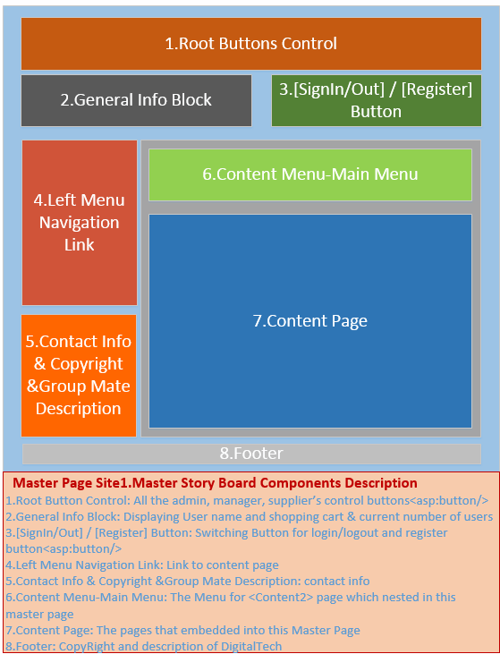
Master-page(Abdulaziz,2017)

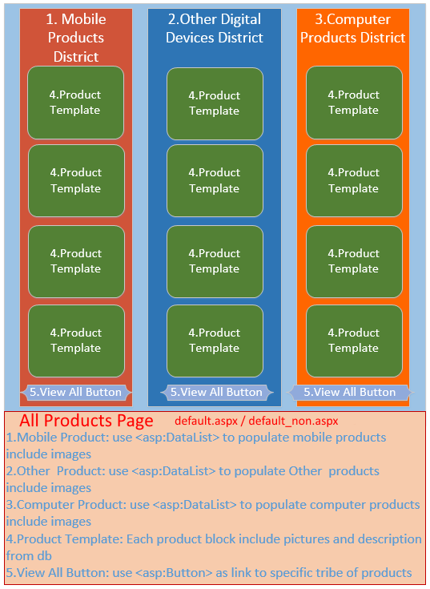
All-Products-page(Abdulaziz,2017)

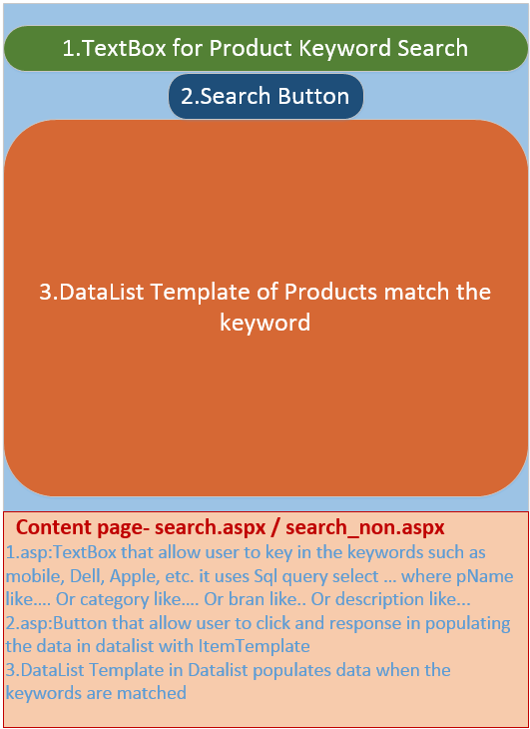
Product-Search-page(Abdulaziz,2017)

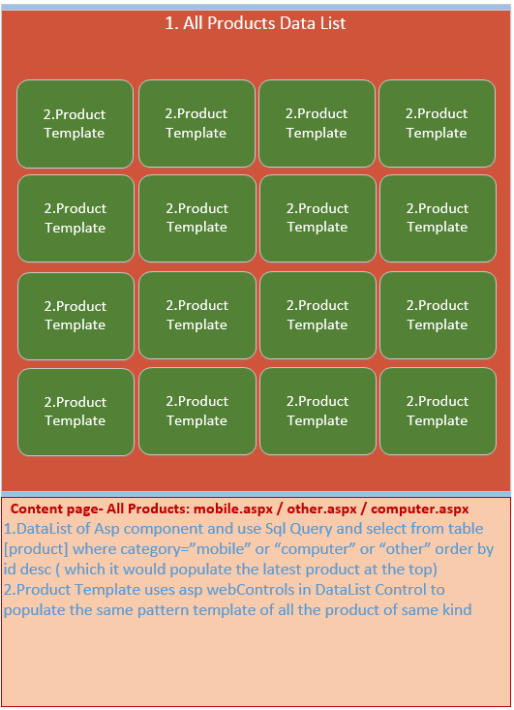 Specific-Category-product district-page(Abdulaziz,2017)
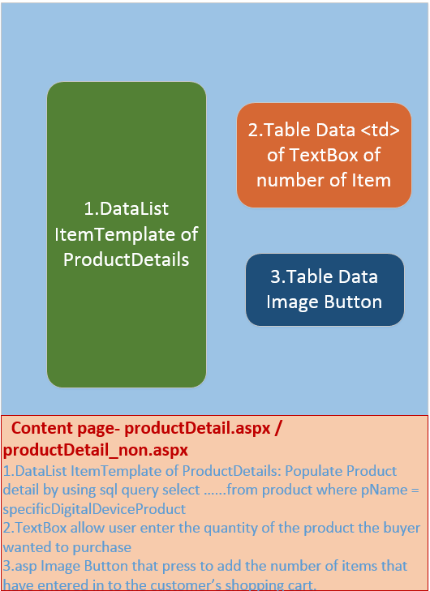
Add to Cart product detail page(Abdulaziz,2017)
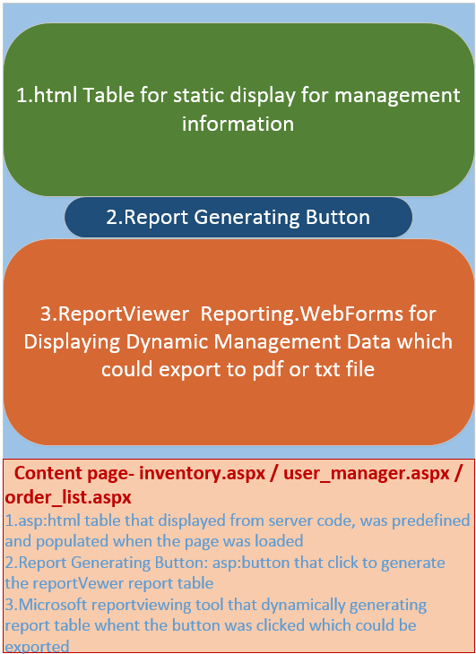
Management Control & Report Page(Abdulaziz,2017)

  - Website Architecture
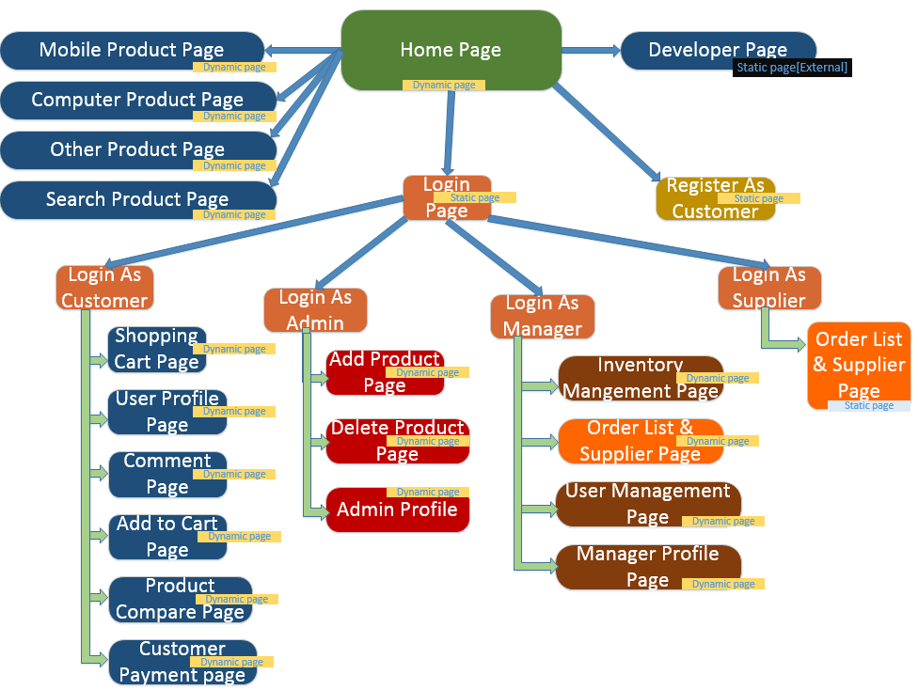
Web-Architecture(Abdulaziz,2017)

- Implementation

5-Code-Snippet-Explanation
a.Use DatList to populate digital products
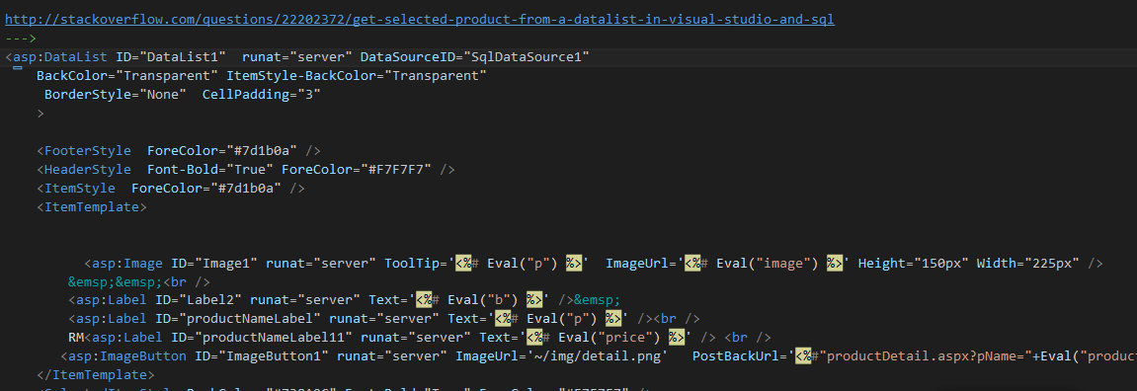
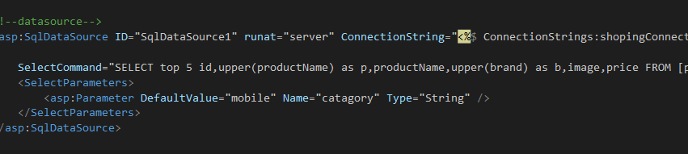 (Abdulaziz,2017)
The code above was captured in the file default.aspx, this is the code that populate the products from database to the website by using the <asp:DataList> , It is suitable to use when the website need to display repeated pattern of different data of same kind, such as shopping list, it uses the ItemTemplate to accomplish it, first it gets data from DataSource, in the DataSource section , it have to perform a sql query which fetches the data from database with some specific Parameters such as <SelectParameters> , it can gets data by use “DefaultValue” which give the field a value so that the Sql could filter the data from database and gets the intended data. It could also set the value by passing the value between pages by using PostBackUrl which another website should get thoses data in PostBackUrl by defining QueryStringField, so that it would filter the sql-requery results to output the data we want.
The Eval which is the C# Server code which belongs to Web.UI namespace, it in charge of displaying data from the query field name, but it only display, where Bind is two way negotiation, it would bind to database and make the changes on the database when the front-end has made changes, so Bind is two-way data-binding, Eval is only one-way displaying.

b.Admin Delete Products by using GridView
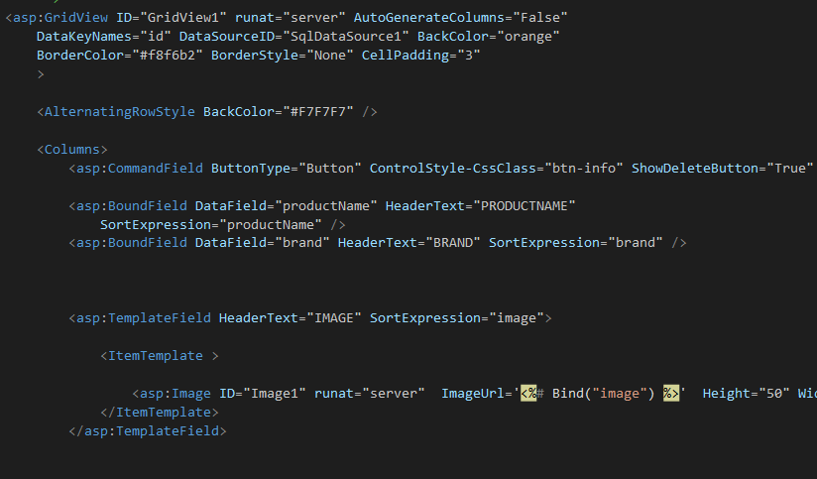
Delete-Product (Abdulaziz,2017)

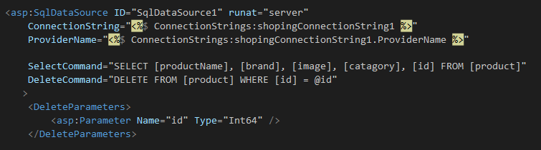
DataSource-Delete-product(Abdulaziz,2017)
The snippet above is the showcase of how we implement the delete product via front end-delete button, Here it uses GridView for displaying data which it would gets data from the DataSource section, the datasource here has an extra DeleteCommand which is reserved to the two-way deletion on the database when we click on the delete button at front page, as long as we make the ShowDeleteButton true, then it would shows up and when admin clicks on specific digital product, it would go through the DataSource to find the DeletCommand and perform deletion. When the admin click on the delete, the specific id of the product is passed in to the delete query so that it could identify which row to delete the product. As the result, the specific product was disappear from the page as same as in the database.

c.Shopping-Cart 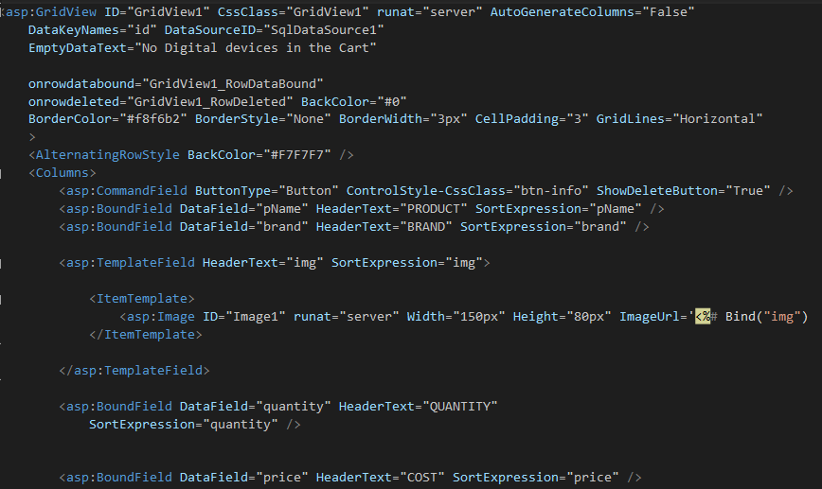
(Abdulaziz,2017)

The asp code above has shown the shopping cart items implementation, it display the button as well so that it is two way databinding situation, which the customer could delete any digital item in its shopping cart, while the customer click on the delete button on specific product, the database side would get affected as well, and that specific product at the front page also disappear which achieve the effect of databinding in both ways. Each BoundField is the header content of the gridview table column header, and the customer could then add and drop product from its own shopping cart easily.

d .populate dropdown-list of customer_name
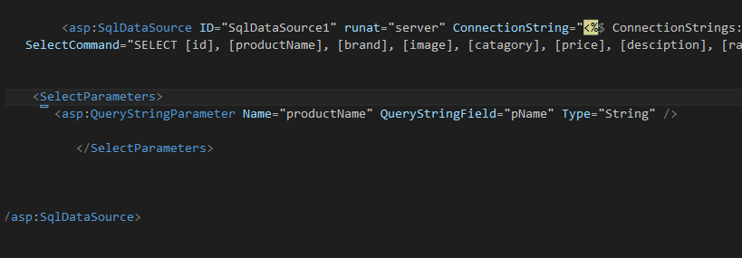
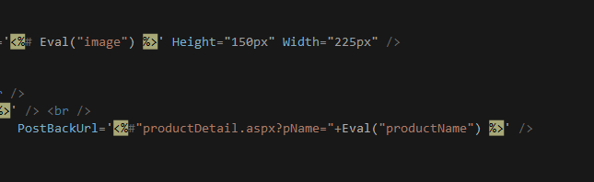
(Abdulaziz,2017)
The snippet above shows how we connect the general product page to a specifc product detail page, here we use the similar strategy, the product detail page is a general page that use datalist which bind to its datasource , inside its datasource ,it has specified Select statement with the QueryStringParameter, this QueryStringParameter is the key for this data passing, on the general product page, we use the PostBackUrl ‘<%#”productDetail.aspx?pName=”+Eval(“productName”)+” ” %>’, so that when it direct to the product detail page, the select sql query where clause would fit this pName value in. as a result, only this product has displayed, because the product Name is unique in DigitalTech.
e.Comments on Products

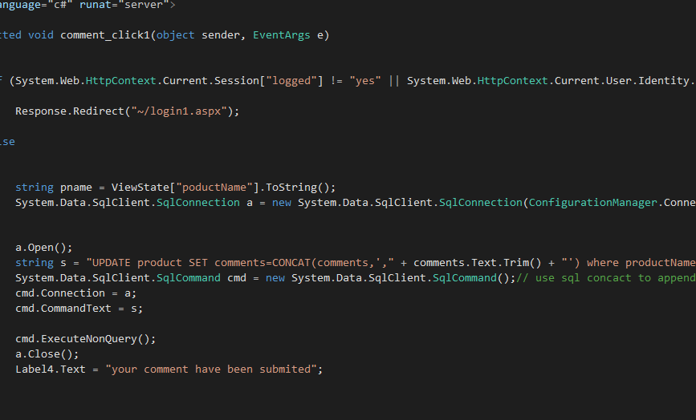
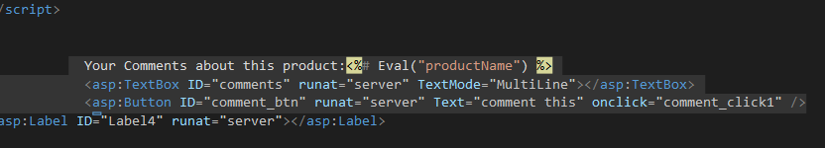
(Abdulaziz,2017)
The comments for products are available for all the registered customer to comment, it uses appends strategy which bind all the comments together and so people could easily see the different comments below the description. We wrote the Sql-query update statement, we set comments to be CONCAT(comments,’,”+comments.Text.Trim()+”’), so it would take the previous comments and append the current comment and concatenate with comma sign. So when user direct to the product detail page, they would see the comments are connected by comma.

- Conclusion
DigitalTech as a B2C online digital market, it has established a platform that gather all the newest release of digital product from various famous manufacturer such as Samsung, Asus, Apple, etc. so that people who need to acquire such digital devices, they would not need to find the original manufacturers one by one, they could directly visit DigitalTech so that they could find all the different brand digital devices all in one location(site).
Asp.net is a server side web language which it backend supported by server code such as c#, basic server side language so as to produce the active dynamic page which actively interact with database data. In Development of DigitlTech, the group of four people has divided work efficiently and completed on time, we have done many research on the data listing and data binding and also updating and populating, we use Datalist which connected with DataSource to populate data on to the ItemTemplates, Datalist is earlier than GridView, but it populate and manipulate data faster than GridView, we have also used GridView to list out, Although We still implemented GridView in some of our pages , because it does have its own advantages such as it has Built-in Paging and Sorting and Built-in supports for Update and Delete operations is provided. But for DataList, you need to write custom code.(Shailendra C,2013)
With the above technology, We have already able to create a complete fully functional online B2C Digital Market platform, But we are not stopping only till here, The modern structure of MVC is more efficient and convenient compare to the current normal ASP.pages and master pages we are using, it divides the pages in to Modal(Database modal), View(Template, structure, frame), Controller(Classes object ,algorithm for controlling and manipulating data between view and modal). The modern websites are all has been implanting this, so this is our next move.
8. References
Chris P. Phone Arena. 2015. How often do you buy a new smartphone?. [ONLINE] Available at: http://www.phonearena.com/news/How-often-do-you-buy-a-new-smartphone_id76028. [Accessed 13 November 2016].
Shailendra Chauhan ,Difference Between Repeater and DataList and GridView. 2013. [ONLINE] Available at: http://www.dotnettricks.com/learn/aspnet/difference-between-repeater-and-datalist-and-gridview. [Accessed 07 January 2017].

CodeProject. 2009. ASP.NET AJAX Control Toolkit ModalPopupExtender Control in Action - CodeProject. [ONLINE] Available at: https://www.codeproject.com/Articles/34996/ASP-NET-AJAX-Control-Toolkit-ModalPopupExtender-Co. [Accessed 07 January 2017].

Scott Mitchell. Microsoft ASP.NET Site. 2017. Displaying Data with the DataList and Repeater Controls (C#) | The ASP.NET Site. [ONLINE] Available at: https://www.asp.net/web-forms/overview/data-access/displaying-data-with-the-datalist-and-repeater/displaying-data-with-the-datalist-and-repeater-controls-cs. [Accessed 07 January 2017].

Microsoft ASP.NET Site. 2017. Displaying Data with the DataList and Repeater Controls (C#) | The ASP.NET Site. [ONLINE] Available at: https://www.asp.net/web-forms/overview/data-access/displaying-data-with-the-datalist-and-repeater/displaying-data-with-the-datalist-and-repeater-controls-cs. [Accessed 07 January 2017].

Mudassar Ahmed Khan. 2011. Difference between Eval and Bind functions in ASP.Net. [ONLINE] Available at: http://www.aspsnippets.com/Articles/Difference-between-Eval-and-Bind-functions-in-ASPNet.aspx. [Accessed 07 January 2017].
DataList Control, asp:DataList Control . 2017. DataList Control, asp:DataList Control . [ONLINE] Available at: http://www.dotnetfunda.com/tutorials/controls/datalist.aspx. [Accessed 09 December 2016].

How to use datalist in asp.net c#? - Stack Overflow. 2017. How to use datalist in asp.net c#? - Stack Overflow. [ONLINE] Available at: http://stackoverflow.com/questions/18306779/how-to-use-datalist-in-asp-net-c. [Accessed 09 December 2016].

How to use DataList control in ASP.NET using C# . 2017. How to use DataList control in ASP.NET using C# . [ONLINE] Available at: http://www.dotnetfox.com/articles/how-to-use-datalist-control-in-Asp-Net-using-C-Sharp-1036.aspx. [Accessed 09 December 2016].

ASP.NET Tutorials | Tutorials, Downloads, & Code Examples. 2017. Displaying Data using ASP.NET 2.0 DataList and C# - ASP.NET Tutorials | Tutorials, Downloads, & Code Examples. [ONLINE] Available at: http://aspnettutorials.com/tutorials/database/db-datalist-aspnet2-csharp/. [Accessed 09 December 2016].

ASP.NET ItemTemplates, EVAL() and embedding dynamic values into controls - Rick Strahl's Web Log . 2017. ASP.NET ItemTemplates, EVAL() and embedding dynamic values into controls - Rick Strahl's Web Log . [ONLINE] Available at: https://weblog.west-wind.com/posts/2006/Apr/27/ASPNET-ItemTemplates-EVAL-and-embedding-dynamic-values-into-controls. [Accessed 09 December 2016].

