GROUP ASSIGNMENT (Technology Park Malaysia)
[-Programming Concepts in C++-]
Programming Concepts in C++ (CT025-3-2-PCPP)

HAND OUT DATE: 7-Nov-2016 Student-Name: Zhang Yu Hao(TP037390)
HAND IN DATE : 23-Feb-2017
WEIGHTAGE : 50%
TOPIC : Felice Home-Stay-Management-System.
INTAKE : UC2F1605IT Lecturer : Dr. Kadhar Batcha Nowshath
_____________________________________________________________________

INSTRUCTIONS TO CANDIDATES:
- Submit your assignment at the administrative counter.
- Students are advised to underpin their answers with the use of references (cited using the Harvard Name System of Referencing).
- Late submission will be awarded zero (0) unless Extenuating Circumstances (EC) are upheld.
- Cases of plagiarism will be penalized.
- The assignment should be bound in an appropriate style (comb bound or stapled).
- Where the assignment should be submitted in both hardcopy and softcopy, the softcopy of the written assignment and source code (where appropriate) should be on a CD in an envelope / CD cover and attached to the hardcopy.
- You must obtain 50% overall to pass this module.

Table of Content
Content Name Page

- Introduction ---------- pg. 2
- Object & Scope ---------- pg. 3
- System-Description ---------- pg. 3~5
- Logic Design ---------- pg. 6~10
- Research & Study on Object-Oriented in C++ ---------- pg. 11~12
- Object-Oriented Implementation in Felice-HMS ---------- pg. 13~23
- Conclusion --------- pg. 24
- Gantt Chart --------- pg. 25
- References --------- pg. 26~27

1. Introduction

As the advent of internet and prevalence of data-revolution, resource sharing become ubiquitous, people could use Application like Grab-Car/Uber to share the empty seats in the car and use Airbnb to share the empty room in normal family.
Malaysia is a tropical tourist-hot-spot, every year, tons-of tourists come to Malaysia to travel and help facilitates Malaysia’s tourism-economic, Penang is one of the well-known target location for holiday for foreigner and also Malaysian people, there has a issue with the staying during the vacation or business-out-station-affair, etc.
Felice-Home-Stay is one of the famous Penang-Local Home-Stay company, recently it wanted to optimize its business operation by creating a Home-Stay-Management System which make the business operation become convenient and efficient.

2. Objective and Scope
The objective of the Felice-Home-Stay-Management system is to allow people who wanted to rent a room/house to find their room with relatively low-price, and for people who wanted to rent out their empty or idle rooms/houses to put their rooms/houses listed on the system, so that customer could visit the system and book on it.

3.System-Description
The System should which develop for Felice need to implement Object Oriented Concept with the language C++ under Visual Studio IDE so as to compatible with Felice other system.

The system has 4 audiences to be interacted with:
- Non-Registered-User:
- view all the available Home for rent and all the home’s details includes prices, facilities, address, etc.
- Register as member(customer) of Felice-Home-Stay company so as to perform booking for their intended-home.
- Registered as member(Client) of Felice-Home-Stay company so as to post and publish their available rooms/houses for rent.

- Customer: It is a role that who book and pay for the available rooms/houses for stay.
- View all the available rooms/houses details as non-registered-users
- Make payment-booking on the stay-period of specific home-stay
- Manage(Update) their profile information such as password, address, contact number, etc.
- Top-up Customer-credit balance(In order to pay for the home-stay[base on period]),
- View all the home-stay that they have been booked and paid by themselves.

- Client: It is a role that who has a long-term-relationship with Felice. They could:
- Publish their homes/rooms to the system
- View/Update their own profile information(Includes Client-Name, Client-Address, Client-Password, etc.).
- Top-up their credit-balance.
- View all other available rooms/houses
- Manage the houses/rooms which posted by themselves only,
- Manage their business[Bookings from customers](check which room/house that was posted was rent-out).

- Staff: It is a role has root(administrator)-privileges, it can do all the CRUD-operation on all objects and items in Felice-Home-Stay-Management-System:
  - Create/Retrieve/Update/Delete Staff Info.
  - Create/Retrieve/Update/Delete Client Info.
  - Create/Retrieve/Update/Delete Customer Info.
  - Create/Retrieve/Update/Delete houses/rooms Info.
  - Create/Retrieve/Update/Delete bookings Info.
4.Logical-Design
4.1Use-Case-Diagram
4.1.1Use-Case-Diagram
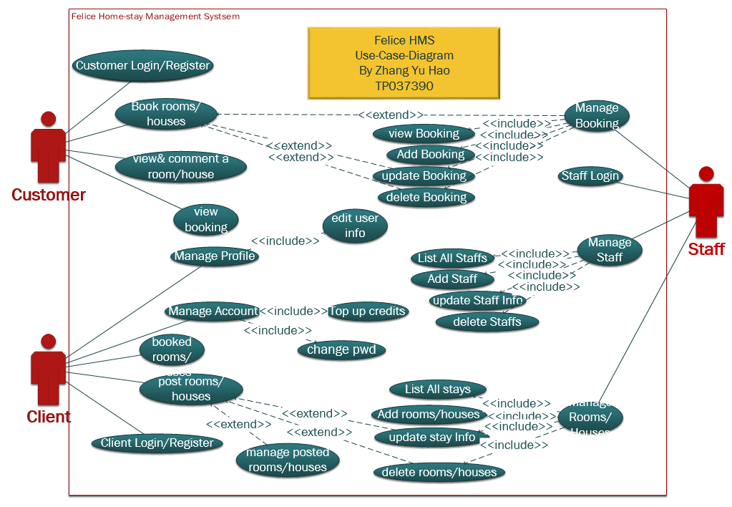
Use-Case-Diagram(Zhang Yu Hao,2017)

4.1.2Use-Case-Description(3 main use cases)
4.1.2.1Use-Case-Description-1-Customer-book-rooms/houses
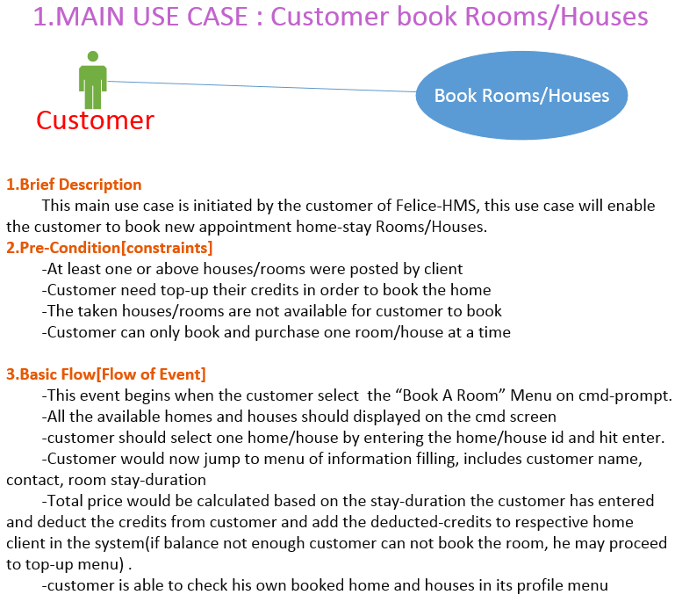
Use-Case-Description-1(Zhang Yu Hao,2017)

4.1.2.1Use-Case-Description-2-Client-post-rooms/houses
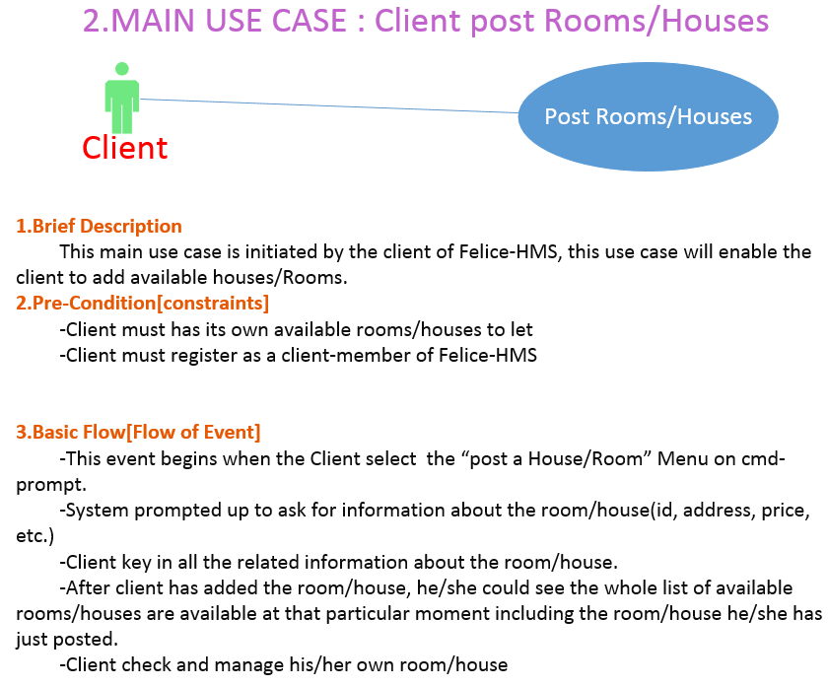 Use-Case-Description-2(Zhang Yu Hao,2017)

4.1.2.1Use-Case-Description-3-admin-manage-rooms/houses
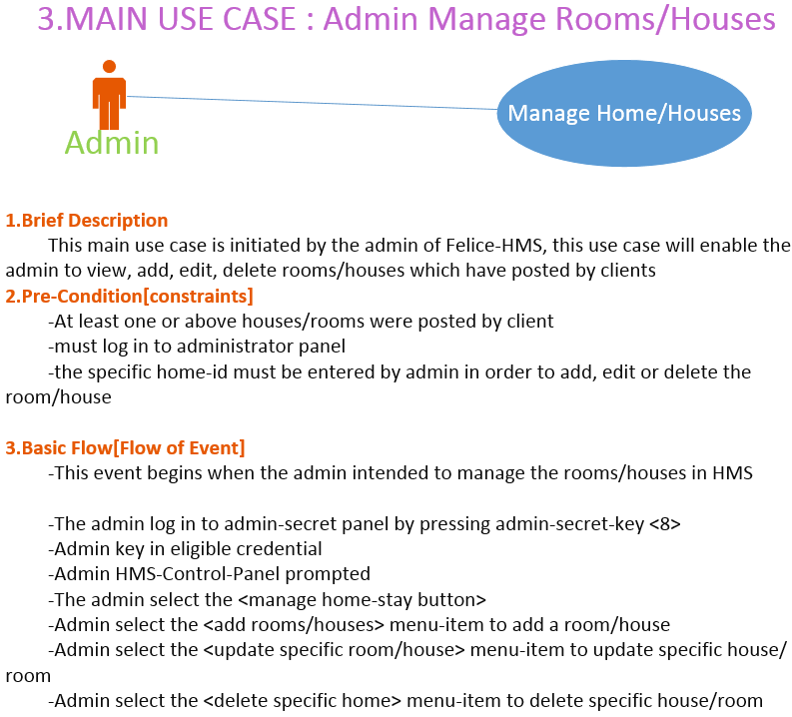
Use-Case-Description-3(Zhang Yu Hao,2017)

4.2Class-Diagram
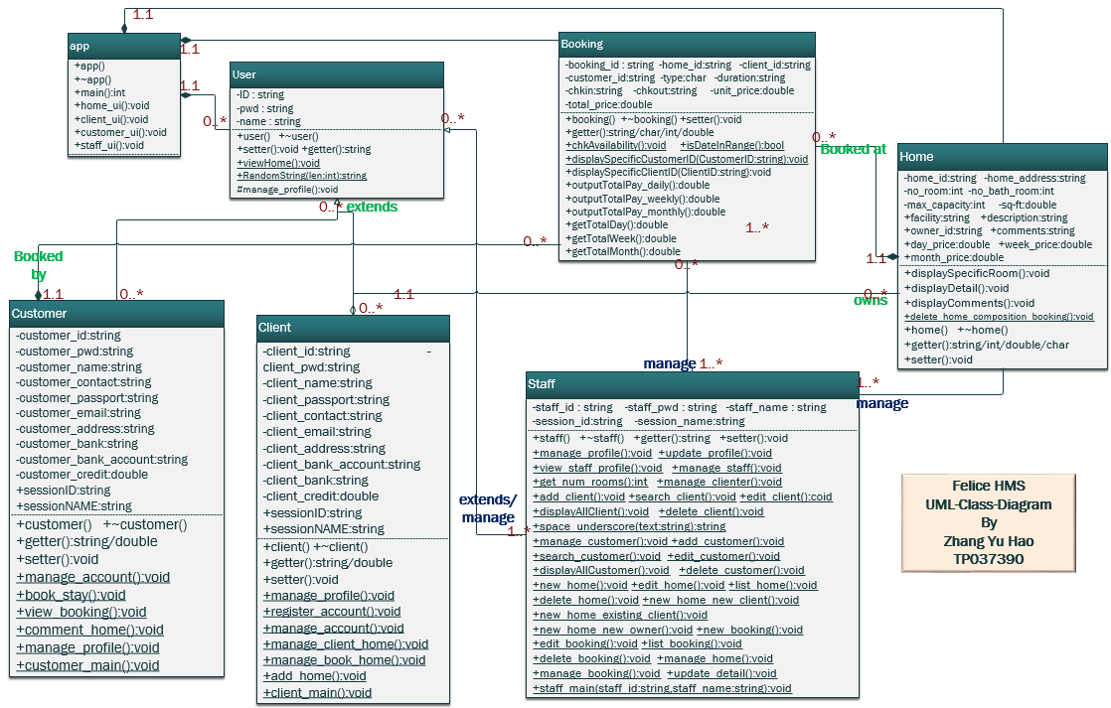
Class-Diagram(Zhang Yu Hao,2017)

5.Object Oriented Programming Study&Research-Overview
i. Object Oriented Programming Concept
According to Angel Margaret Rouse on TechTarget in 2013,Object Oriented Programming which its program structure is based and grouped by object, it is a prominent descendant of Procedure Oriented Programming, Procedure Oriented Programming program backbone structure is based on the procedures and sequence which means the code it executes line by line and follow the sequences, but in OOP , the code is categorized by class and executed by object.
ii. Main Drawback of Procedure Oriented Programming compare to Object Oriented Programming:
In Procedure Oriented Programming, You would be hard to tell which one come at first and which one follow the next when a big project came by, but in Object Oriented Programming, except they can execute of the code which following the sequence, they can also code the program by categorized Class, and the class would have many instantiated object.
For example:
If there has the project called: [Manufacture of the Car], In Procedure Oriented Programming, it has to plan the whole procedures, it has to decide which one come first, it has to know do the engine part first or do the skeleton frame of car first, or make the tyre first:
Step 1 : Make Engine?
Step 2 : Skeleton Framwork?
Step 3 : Make the Tyre?
…
On the above scenario, Procedure Oriented Programming is hard to tell which procedure come at first and which one follow the next, and even if they have decided which one proceed at the first and which one run at next, in the future, if there has any enhancement or any changes, like if the Engine has some issues and it must make the tyre first, so in this case, it has to rearrange the whole procedures which is too tedious and archaic.
But inside OOP, which it break down all the steps into a categorized entity, which called Class:
Class Engine(){ 1….
2….}
Class Skeleton(){ 1….
2….}
Class Tyre(){ 1….
2….}
Inside OOP, All the things are allocated to different class and the attributes, variables, methods, and different procedures are located inside each different classes, so it do not have to tell which step come at first which are next, it just divide the project into different part, and each part called a class, so even in the future if there has any changes or enhancement , it just go to find its specific class and add in the new updates into, no need to rearrange the whole structure of Program inspired from Alex Bobby on Technology Gadgets in 2011.

6.Object Oriented Programming Implementation

6.1Inheritance
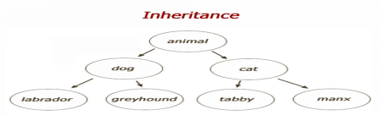
(Neil Verplank,2003)
(1)Inheritance Concept
Inheritance is a very important concept in OOP, it can use all the function and data within the class that has been inherited, and the programmer no need to rewrite the original class and can use all the functions inside the parent class(which is the class that it inherited from), and can expand and extend the functionality of any method inside the parent class. The class which created by Inheritance are called sub class or derived class, and the class which are been inherited are called parent class or super class.( Ailendra Chauhan,013)
(2)Inheritance Limitation
In some of the Object Oriented Programming, one subclass can inherit many parent classes, but generally, one sub class can only has one super class, if it really require the multi-inheritance, it can accomplished by the multi-level-inheritance which means class A inherits class B, and class B inherits class C, so now that the class A has all the information of class C.
(3)Rules of Inheritance
The two classes that inherited from one another should has the relationship of “is a/a type of”, but not “it has”, For example, if we define a class called “Person”, we can instantiate a new object which called Employee, or Manager, because Employee and Manager both are person, “Leg” may not inherited from “Person”, because Leg is not a Person, Leg is inside the Person, but it is not a Person. It could be implemented by using aggregation and composition.
i.Aggregation:is a weak Association,A&B is in aggregation relationship if A has B inside but life cycle of B still exists when A terminated.
ii:Composition:is a strong Association,A&B is in composition relationship if A has B inside and life cycle of B will terminated when A terminated.
(4)Implementation of Inheritance in HMS
i.Staff,Customer,Client inherited from user
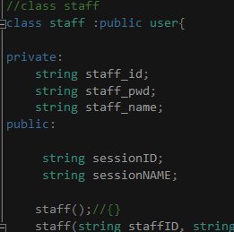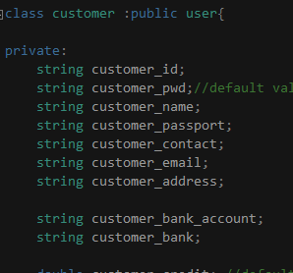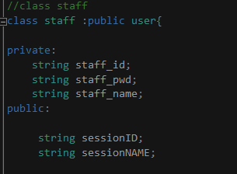
Inheritance-Logic(Zhang Yu Hao,2016)
In Felice-HMS, the user is the parent class of staff, customer and client, which means staff and customer and client are all the users in HMS, and all of them has common characteristics, so that the protected and public attributes&functions could be directly call from child class.
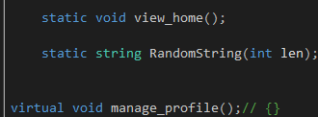
User-functions(Zhang Yu Hao,2016)
The picture above shows 3-functions in user-class: view_home():void, RandomString(int len):string and manage_profile():void, view_home() is a function that display all the available rooms/homes in Felice-HMS, as long as it is a user who open HMS , they could be able to call this function.
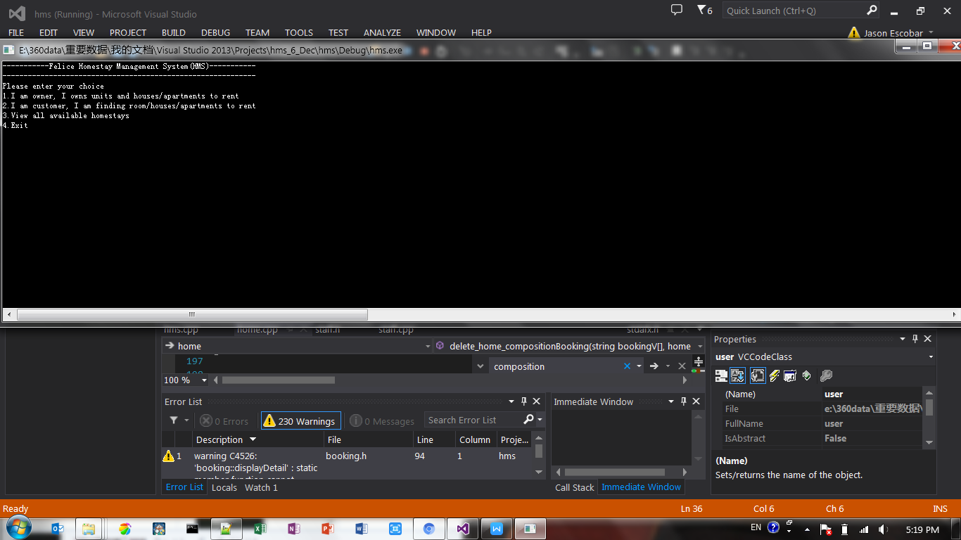
App(Zhang Yu Hao,2016)
As the picture shown above, the number 3 selection is the direct call function to user:view_home():void which list down all the available homes/rooms could be rent and its related information, but in order to rent and post room/home, user need to register/login to the system as either customer or client.
RandomString(int len):string is a function that help customer and client to generate a 6 digit username randomly, so to as to ensure each username is unique in HMS.
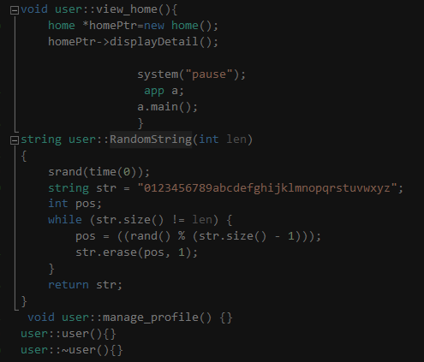
The virtual function manage_profile():void is virtual because it an abstract function which it let its child class staff, customer and client do define its own contents.
these 3 functions are directly call from client, customer and staff class and object, we can notice that the view_home():void & RandomString(int len):string are class-functions whereas manage_profile():void is object-function.

ii. Aggregation & Composition
-Aggregation
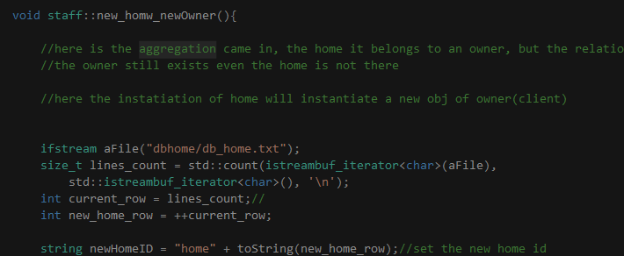
Aggregation(Zhang Yu Hao,2016)
The aggregation relationship between home and owner is manifested here in the function new_homw_newOwner():void, the home in Felice-HMS could be posted by staff and also client, so that even if the home without point to a client, it is still feasible, so the relationship between home and client is a weak association, this function create a new home with a new client, but we can never delete a home with deleting the client at the same time.

-Composition
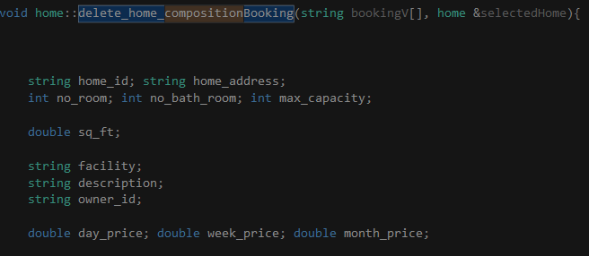
Composition(Zhang Yu Hao,2016)
The composition relationship is manifested in this function in the class home, because the booking is always bond to one home, so the creation of booking must link to one home, and the deletion of the home lead to the booking of that particular home become meaningless, so the related booking should also be deleted, so in this function, it delete a particular home and the booking which link to that particular home is also deleted at the same time.

6.2Encapsulation
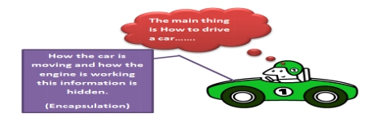
(Hafiz Abdur Rehman,2015)
(1)Encapsulation Capability.
Encapsulation is the one of the main characteristic of Object Oriented Programming , it means it can encapsulate some real and specific thing into a general and abstract class, and the class itself can control the its own data and methods or functions and it can specify who can see its content and who cannot see its contents, or who can use and manipulate its data and functions and who cannot, and it gives the permission to those classes it is reliable and hide its information to those classes that is not reliable.
(2)Encapsulation Concepts and Usability.
Based on Atha Dogi. Encapsulation is a concept that make the program to be highly internal cohesion and external coupling which is the most recommended structure of a program, when programmer define and create programs it takes a lot of time and lots of codes to accomplish a program , but once it is done, programmer does not want the user to see the complicated part of the program, the programmer just want the user use the user interface nicely and easily without any doubts.
(3)Encapsulation Rule.
By implementing the encapsulation, generally it is accomplished by using the codes, like the code “Public”, “Private”, “Protected/Internal”, etc. these code are the attribute that attach to a variable or a class or any function or method that allows it can specify who can access and manipulate it. Adopted from Atefan Steiger on Stack-Overflow in 2014.
Accessibility | Access in same class? | Access in same package? | Can access by sub classes? | Access by all the classes?
Private | Yes
Default | Yes | Yes
Protected | Yes | Yes | Yes
Public | Yes | Yes | Yes | Yes
(4)Implementation of Encapsulation in HMS
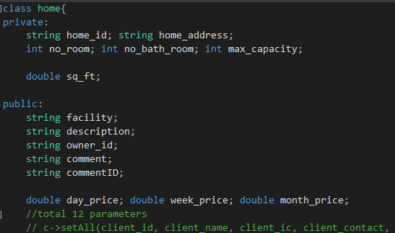
Encapsulation(Zhang Yu Hao,2016)
The picture above shown one of the implementation of encapsulation in Felice-HMS, it is about the attributes in class-home, the home_id, home_address, no_room, no_bath_room, max_capacity are set to be private, because we do not want other object or class to access these information outside the scope of home-class, but they can always use getter():string/double/char to get these data, the setter():void function is also used to access these data and make changes on these data for particular usage
On the other hand, the facility, description, owner_id, comment, commentID, day_price, week_price, month_price are public accessible because Felice-HMS should let anyone who use HMS to view the information of the home/room/house so that people could book on it.

6.3Polymorphism
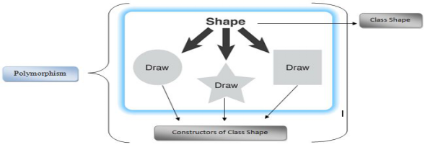
(Naveed Zaman,2013)
(1)Polymorphism Concept
Polymorphism can be counted as the most important concept of OOP, which is means the ability of a class that appear and exists in many forms and states, only when it is executed or run, it just show its current state and form. In another word ,Polymorphism is an ability of class or object or referenced variable to change its behavior and forms depending on what object instance it is generating which based on Raffaele Doti on SlideShare in 2015.
It allows multiple objects of different subclasses to be treated as objects of a single super class, while automatically selecting the proper methods to apply to a particular object according to which subclass it belongs to.
(2)Override
The override characteristic of polymorphism is the main characteristic of Polymorphism, it means the child class that redefine the methods or functions which inside the parent class.
Eg. class Animal{
void eat(){System.out.println("eating...");} }
class Dog extends Animal{
void eat(){System.out.println("eating bread...");} }
(3)Overload
Overload is means it allows subclass to have multi method or functions that has same name as parent class but each method has different contents or parameters.
Eg. class OverloadingExample{
static int add(int a,int b){return a+b;}
static int add(int a,int b,int c){return a+b+c;} }

(4)Implementation of Polymorphism in HMS
-Overload
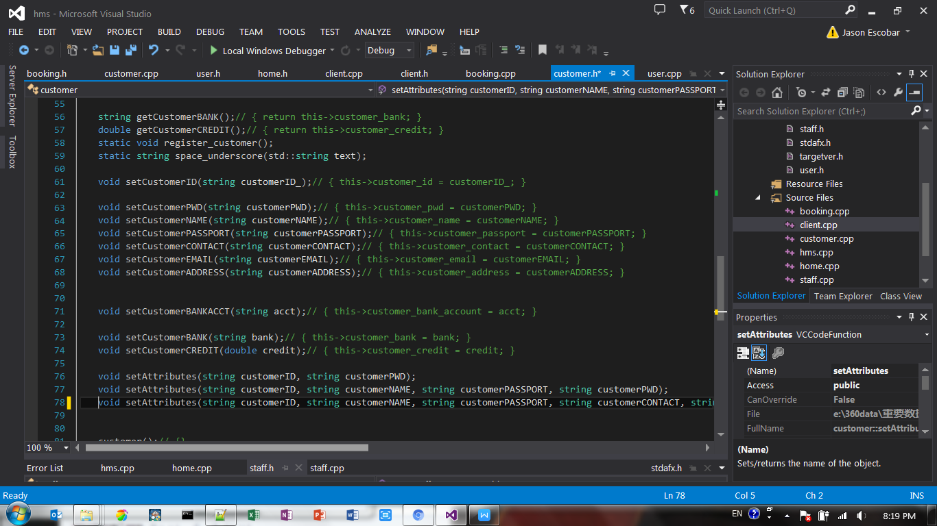
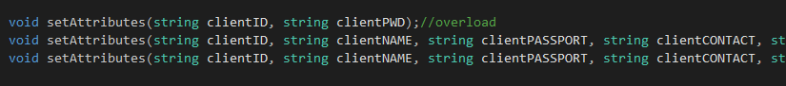
Overload(Zhang Yu Hao,2016)
The pictures above shown the overload implementation in Felice-HMS, it basically use the same function name and append one or more than one arguments into the parameter bracket, in Felice-HMS, it uses a lot of overload, such as above scenario, we could use the same function but leading to different content setting, which the enhance the memory allocation whereas it does not need to pint to another address but overload one or more parameters in to the same address which optimize the system.
-Override
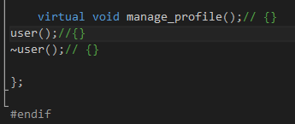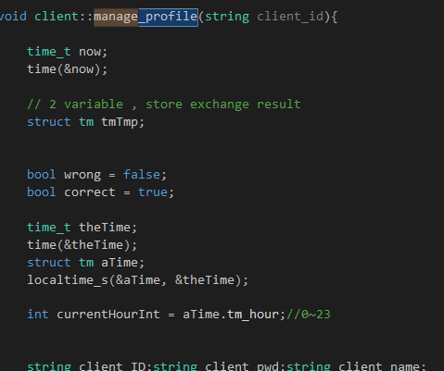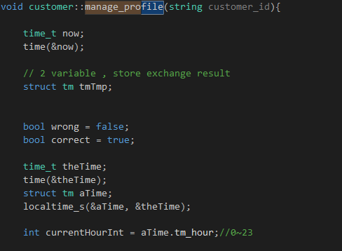
Override(Zhang Yu Hao,2016)

The above pictures has shown how HMS uses override concept in the profile management. First of all, client and customer must inherit from user class, later on , the user class should declare a abstract function manage_profile():void function and make it as virtual which later on, the class client and customer must implement and define the method manage_profile():void, if they fail to define the virtual method manage_profile():void, then the class would become an abstract class.

6.5 Code & Explanation:

7.Conclusion

After we implement Felice-Home-Stay-Management-system, we believe that the procedure and operation of booking and posting become easier and this would definitely increase the efficiency of the Felice-Home-Stay process. It not only has fulfilled the basic operation which is [client post their available rooms/houses] and [customer book the available rooms/houses], it could also enable customer to view comments and communicate with client on the comments and it also enable customer to pay the rental-fees in the Felice-HMS based on daily/weekly/monthly stay-duration and then the balance of customer could be topped up and pay to client, and client could accumulate their balance and exchange it into cash in Felice-Company.

In this Felice-Home-Stay-Management-System development, we have seen how efficient and optimized it is when the system adopt the object-oriented-concept, it groups system in to classes, which it has 7 classes :class-app, class-user, class-client, class-customer, class-staff, class-home, class-booking. So here we have 3 users’classes : customer, client and staff which they inherited from user and booking inherited from home and relationship between home&booking and customer &booking has a tight-dependency relationship: composition which the relationship between client&home has a looser association-relationship:aggregation because the home still exists even without the client. The structure is clear and make sense it facilitate the development cycle and also ease for the future-maintenance and enhancement.

8.Gantt-Chart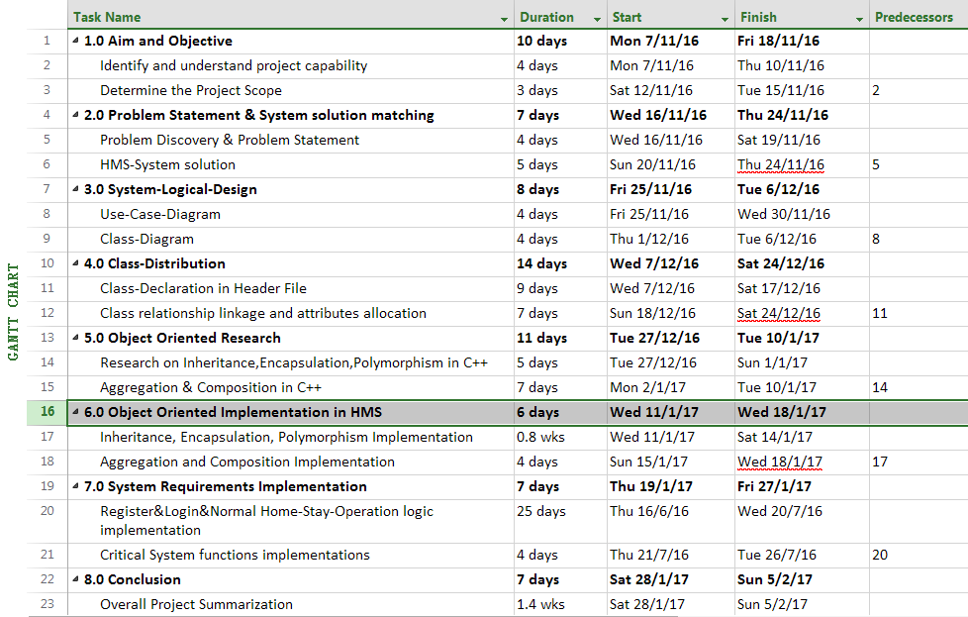
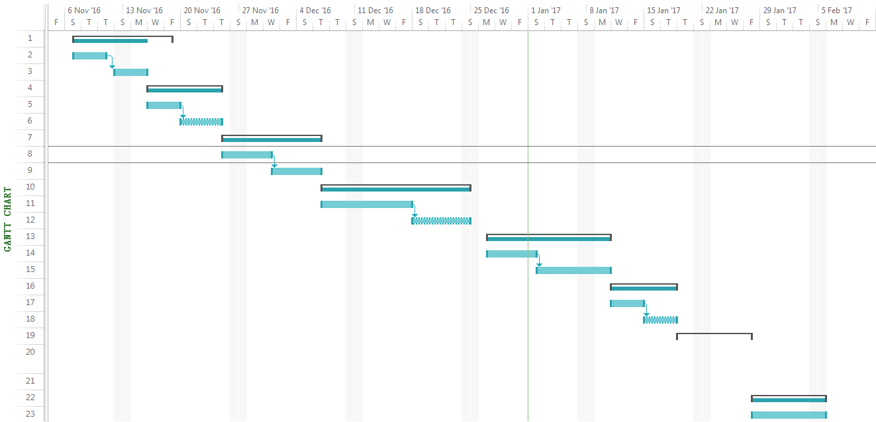
Gantt-Chart(Zhang Yu Hao,2016)

9. References
Alex B. ALL ABOUT TECHNOLOGY,GADGETS,SOFTWARES,HARDWARES,GAMING,COMPUTER SCIENCE and INFORMATION TECHNOLOGY: Procedure Oriented Programming(POP) vs Object Oriented Programming(OOP). 2015. [ONLINE] Available-at: http://hacksnpasses.blogspot.my/2011/05/procedure-oriented-programmingpop-vs.html. [Accessed 22 Dec 2016].

Atha D. OOPS Principle - Encapsulation in C# with an example. 2015. [ONLINE] Available at:http://www.onlinebuff.com/article_oops-principle-encapsulation-in-c-with-an-example_15.html. [Accessed 22 Dec 2016].

Atefan S. c# - What is the difference between Public, Private, Protected, and Nothing? - Stack Overflow. 2014. [ONLINE] Available at:http://stackoverflow.com/questions/614818/what-is-the-difference-between-public-private-protected-and-nothing. [Accessed 23 Dec 2016].

Ailendra C. Understanding Inheritance and Different Types of Inheritance. 2013. [ONLINE] Available at: http://www.dotnet-tricks.com/Tutorial/oops/JaIO211013-Understanding-Inheritance-and-Different-Types-of-Inheritance.html. [Accessed 23 Dec 2016].

Ailendra C. Understanding virtual, override and new keyword in C#. 2013. [ONLINE] Available at: http://www.dotnet-tricks.com/Tutorial/csharp/U33Y020413-Understanding-virtual,-override-and-new-keyword-in-C. [Accessed 23 Dec 2016].

Affaele D. Software Engineer at Engineering Ingegneria Informatica SPA. Polymorphism. 2015. [ONLINE] Available at:http://www.slideshare.net/raffaele.doti/polymorphism. [Accessed 24 Dec 2016].

Benny Michael P. .net - How to connect access database in c# - Stack Overflow. 2013. [ONLINE] Available at: http://stackoverflow.com/questions/17023861/how-to-connect-access-database-in-c-sharp. [Accessed 25 Dec 2016].

HAFIZ A. R. 4 Pillars of OOP Object Oriented Programming. 2016. Android Ustaad [ONLINE] Available at: http://www.androidustaad.com/4-pillars-of-oop-object-oriented-programming/. [Accessed 1 Dec 2016].

NAVEED Z. C# Corner : Error Display . 2016. C# Corner . [ONLINE] Available at: http://www.c-sharpcorner.com/UploadFile/e881fb/learn-object-oriented-programming-using-C-Sharp-part-7/. [Accessed 1 Dec 2016].

NEIL V. Introduction to Design for Electronic Media -- Information Design & Modeling. 2016. [ONLINE] Available at:http://neil.verplank.org/classes/utd/infoD.htm. [Accessed 7 Dec 2016].

ZHANG Y. H. Object Oriented Programming of C# implementing the concept to Salon Management System with Utilization of Class distribution, Access database Connection. 2016. [OFFLINE] Available at: Salon file. [Accessed 12 Dec 2016].

