**Part 1**

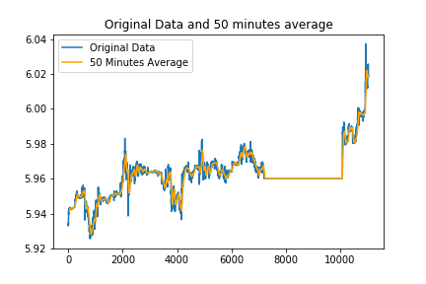

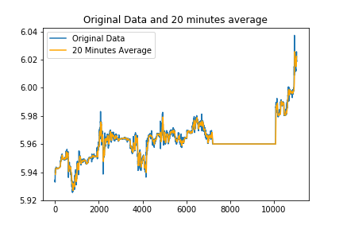

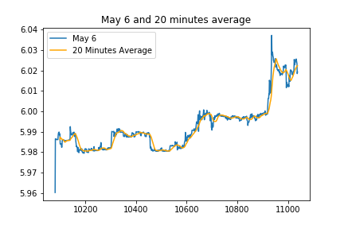

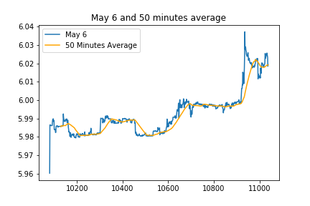

As we can see mean increases so that it is not stationary.

I used 2 methods for predictions. The first one is ordinary least squares and the second one is the ridge regression.

MSE for OLS is 0.0001379714287590362

Estimations for 15.59 and 16.00 are [5.99279731 5.99352189]

MSE for Ridge is 3.5711147945624946e-05

Estimations for 15.59 and 16.00 are [6.00694266 6.00636898]

I repeated the same part with discarding the rows with 0 volume. The results changed a little bit.

MSE for OLS is 0.00013340104564319555

Estimations for 15.59 and 16.00 are [5.9925989 5.99336109]

MSE for Ridge is 3.6008688237281074e-05

Estimations for 15.59 and 16.00 are [6.00654176 6.00601358]

**Part 2**

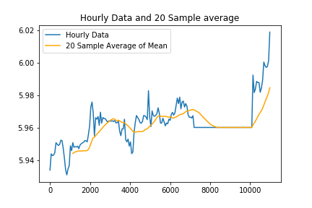

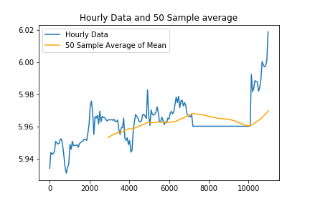

MSE for OLS is 0.00013376886761253367

Estimations for 15.59 and 16.00 are [5.98533831 5.99766034]

MSE for Ridge is 0.00010806865520705216

Estimations for 15.59 and 16.00 are [5.99022165 6.00074111]

**Part 3**

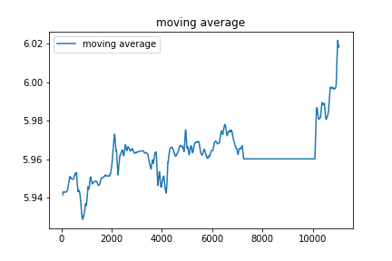

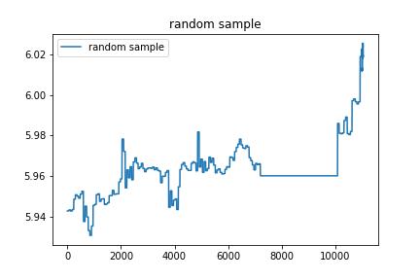

MAData

MSE for OLS is 8.608487867936753e-05

Estimations for 15.59 and 16.00 are [6.00546007 6.00547892]

MSE for Ridge is 1.2209575133841262e-06

Estimations for 15.59 and 16.00 are [6.01762737 6.01763729]

LWMAData

MSE for OLS is 255.19981361896953

Estimations for 15.59 and 16.00 are [-81.15537719 -80.50975272]

MSE for Ridge is 0.012934026923754983

Estimations for 15.59 and 16.00 are [6.02010684 6.02010259]

RSData

MSE for OLS is 0.00012658860312966507

Estimations for 15.59 and 16.00 are [5.9696321 5.9739502]

MSE for Ridge is 1.9189436285304775e-06

Estimations for 15.59 and 16.00 are [6.01644092 6.01513976]