Summary

The Remote Coding Test (Calculator) is completed approximately 7 hours.

The solution provided consists of 3 projects:

1. a demo console application project which implement the method double Calculate(string sum)
2. a class library project which solves the mathematical expression given
3. a test project that tests the class library

# Console Application Project

Console Application project is a demo to show how the implementation can be made to consume the API of CalculatorService Library.

# Class Library Project CalculatorService

The class library solves the problem in recursive manner. Please see the following.

Mathematical Expression

Calculator Service

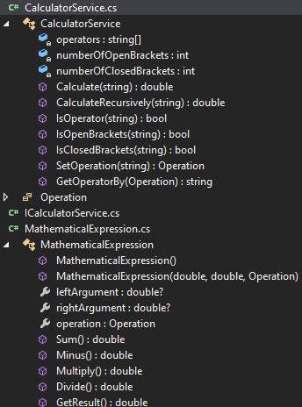

Mathematical Expression (***expression***) class is an object that represents the basic expression.

For example, [leftArgument Operator rightArgument], where leftArgument and rightArgument are numbers while Operators are Add, Minus, Multiply and Divide (+, -, *, /).

When an ***expression*** has the information, [leftArgument Operator rightArgument], an expression can easily return the result of the ***expression***.

On the other hand, Calculator Service act as the reader to read the given complex expression and put them into ***expression*** object to get the result. This process happened recursively to calculate the final result from left to the right of the given complex expression. Besides, it also will decide which expression to calculate (left argument or right argument) based on the Operators and brackets “(“, “)”.

Using the expression below as example, when an opening bracket “(“ is detected, Expression 1 will calculate the right argument first which consist of Expression 2.

***1 – ( 2 + 3 )***

Expression 2

Left argument = 2

Right argument = 3

Operator = Add

Expression 1

Left argument = 1

Right argument = Expression 2

Operator = Minus

# Test Project

I have provided test cases in the solution. However, I do not have any experience in writing test cases during my work.

# Conclusion

If there are any comment or suggestion for improvements, I would like to listen and I appreciate very much.

Thank you.