KPR INSTITUTE OF ENGINEERING AND TECHNOLOGY
(Autonomous), Coimbatore – 641 407 · Department of CSE
U21CSP12 – JavaScript Frameworks
ASSIGNMENT – II
Detail
Name | Sathya R V
Roll Number | 24CS192
Year / Semester | III / V – B.E. CSE
Academic Year | 2026 – 2027
Issue / Submission Date | 15-10-2026 / 31-10-2026
GitHub Repository | https://github.com/______________________

Questions Answered
Q.No | Task | Application | Stack | CO | Marks
Q1 | Student Management System using MERN Stack | EduRoster | MERN | CO3 | 8
Q2 (Task 1) | Online bookstore application | PageTurn Books | MERN | CO5 | 16
Q3 (Task 1) | Course registration application for college students | EnrollEase | MEAN | CO4 | 16

Technologies
MongoDB + Mongoose (database), Express.js + Node.js (REST API), React 18 with Vite (MERN – Q1, Q2), Angular 20 with Reactive Forms (MEAN – Q3). Each app follows Browser → React/Angular → REST/JSON → Express → Mongoose → MongoDB. Complete source code and run steps are in the GitHub repository / zip.
Signature of the Student Signature of the Course In-charge

Q1 – EduRoster – Student Management System
Task: Develop a Student Management System using MERN Stack: React form to enter student details, REST APIs with Express.js and Node.js, student records stored in MongoDB, add / view / update / delete operations.
Stack: React 18 (Vite) · Node.js + Express.js · MongoDB (sathya_eduroster)

Requirements and Implementation
Requirement | Implementation
React form to enter student details | StudentForm.jsx – controlled inputs for roll no, name, email, phone, department, year, CGPA with validation
REST APIs using Express.js and Node.js | routes/studentRoutes.js + controllers/studentController.js – GET, POST, PUT, DELETE on /api/students
Store student records in MongoDB | models/Student.js – Mongoose schema with validation, unique roll number, timestamps
Add, view, update and delete operations | Add & Update through the form, View in a searchable table, Delete with confirmation

Database
Collection fields: rollNo (String), name (String), email (String), phone (String), department (String), year (Number), cgpa (Number), createdAt / updatedAt (Date).

REST API
Method | Endpoint | Purpose
GET | /api/students | List students (query: search, department, year, sort)
GET | /api/students/:id | Get one student
POST | /api/students | Add a student (409 if roll number exists)
PUT | /api/students/:id | Update a student
DELETE | /api/students/:id | Delete a student
GET | /api/students/meta/departments | Department list for the form

Output
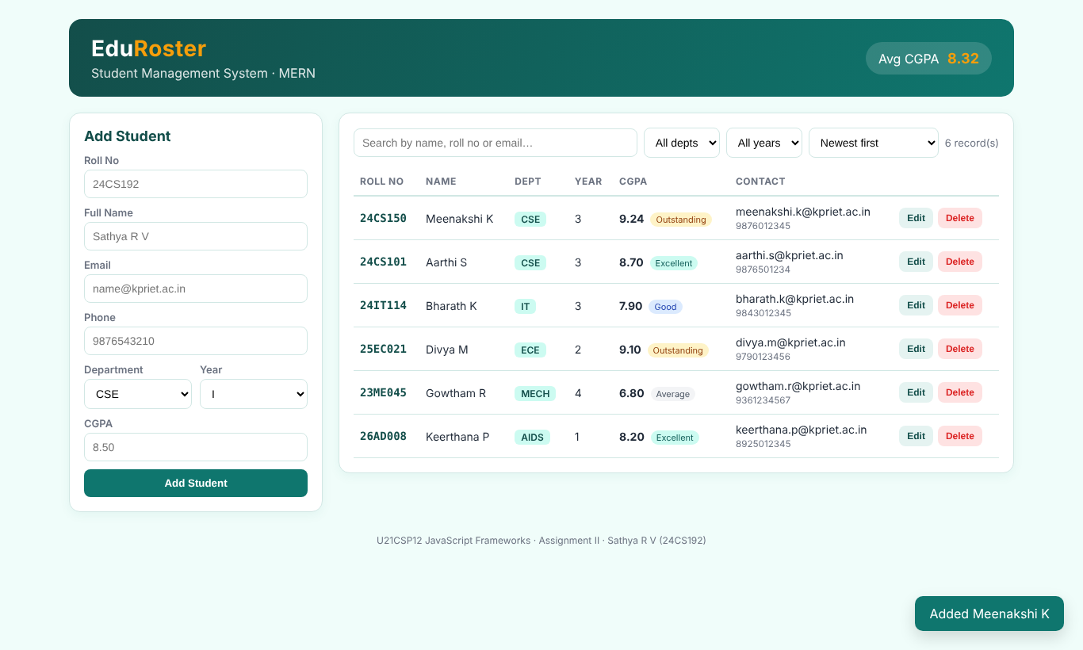  Fig. 1: CREATE – new student added | 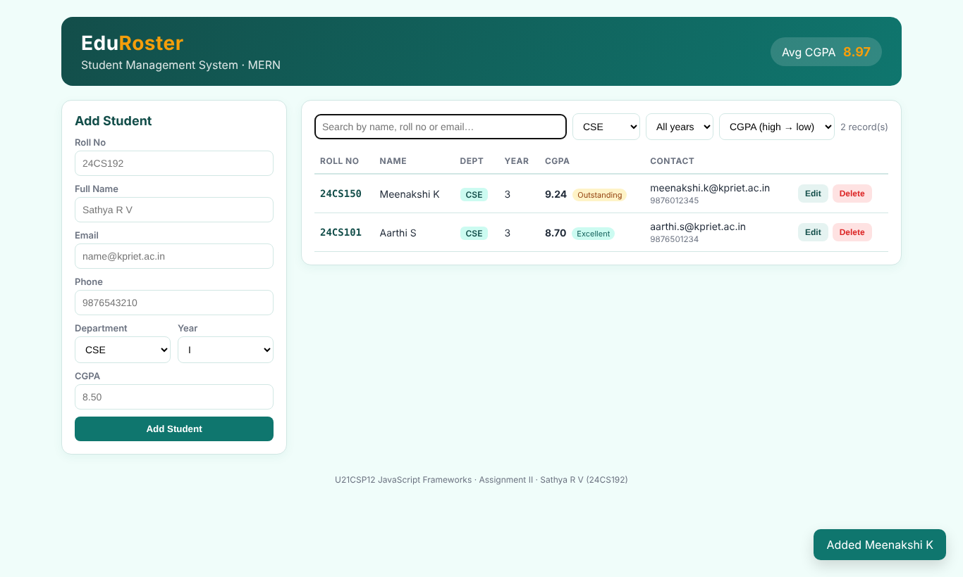  Fig. 2: VIEW – filter by department and sort by CGPA
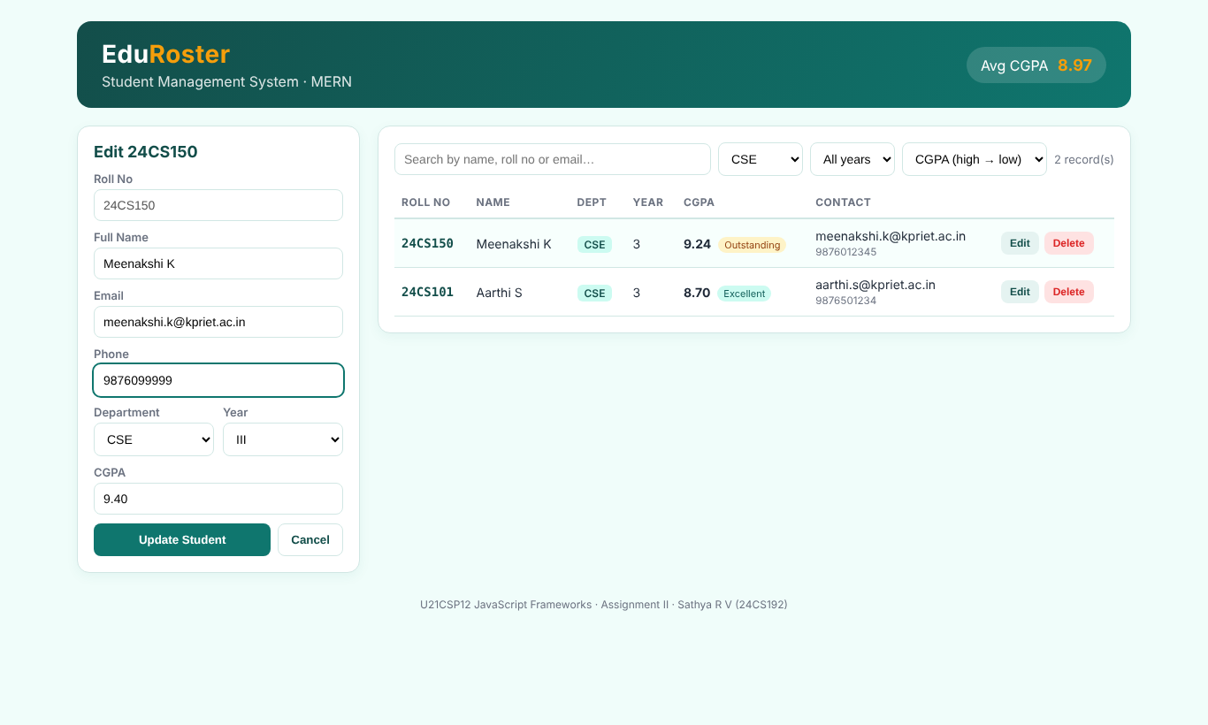  Fig. 3: UPDATE – form in edit mode | 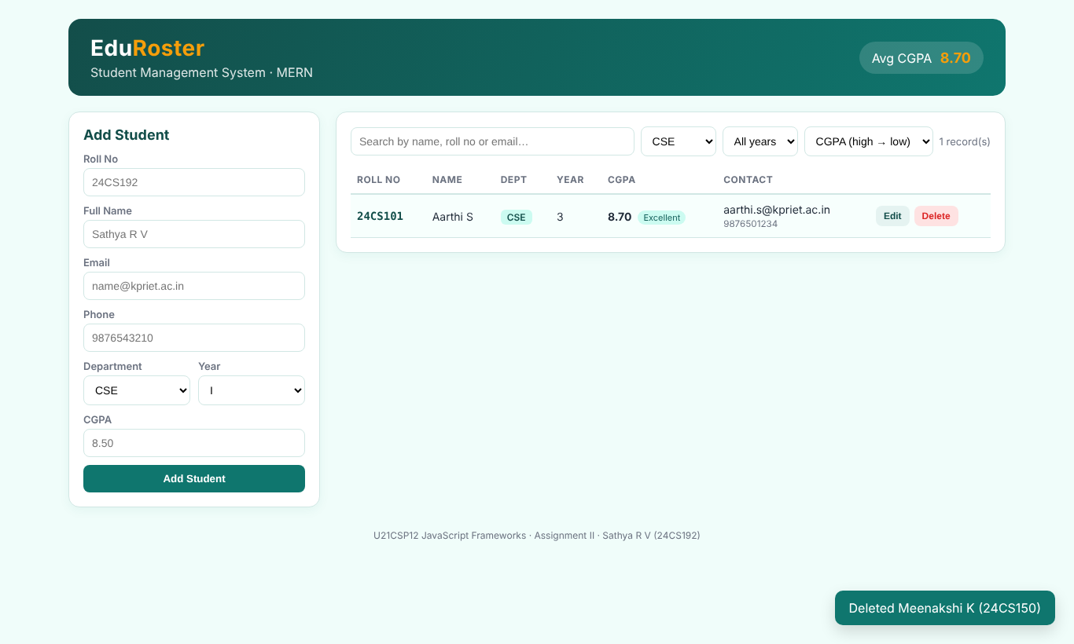  Fig. 4: DELETE – record removed
Result: The application was implemented and all required operations were tested successfully.

Q2 (Task 1) – PageTurn Books – Online Bookstore
Task: Design an online bookstore application: display books using React components, store book title, author, price and availability in MongoDB, create APIs to retrieve and manage books, implement search by book title or author.
Stack: React 18 (Vite) · Node.js + Express.js · MongoDB (sathya_pageturn)

Requirements and Implementation
Requirement | Implementation
Display books using React components | BookList → BookCard components render each book as a card with a drawn cover
Store title, author, price and availability in MongoDB | models/Book.js – title, author, price, available (+ stock, genre, year)
Create APIs to retrieve and manage books | GET / POST / PUT / PATCH / DELETE on /api/books + summary endpoint
Search by book title or author | GET /api/books?q=..&searchBy=title|author|all – case-insensitive regex in MongoDB; switch in SearchBar.jsx

Database
Collection fields: title (String), author (String), price (Number), available (Boolean), stock (Number), genre (String), publishedYear (Number), coverColor (String).

REST API
Method | Endpoint | Purpose
GET | /api/books | List / search books (query: q, searchBy=title|author|all, genre, available, sort)
GET | /api/books/:id | Get one book
POST | /api/books | Add a book
PUT | /api/books/:id | Edit a book
PATCH | /api/books/:id/availability | Toggle In stock / Out of stock
DELETE | /api/books/:id | Delete a book
GET | /api/books/meta/summary | Totals for the header + genre list

Output
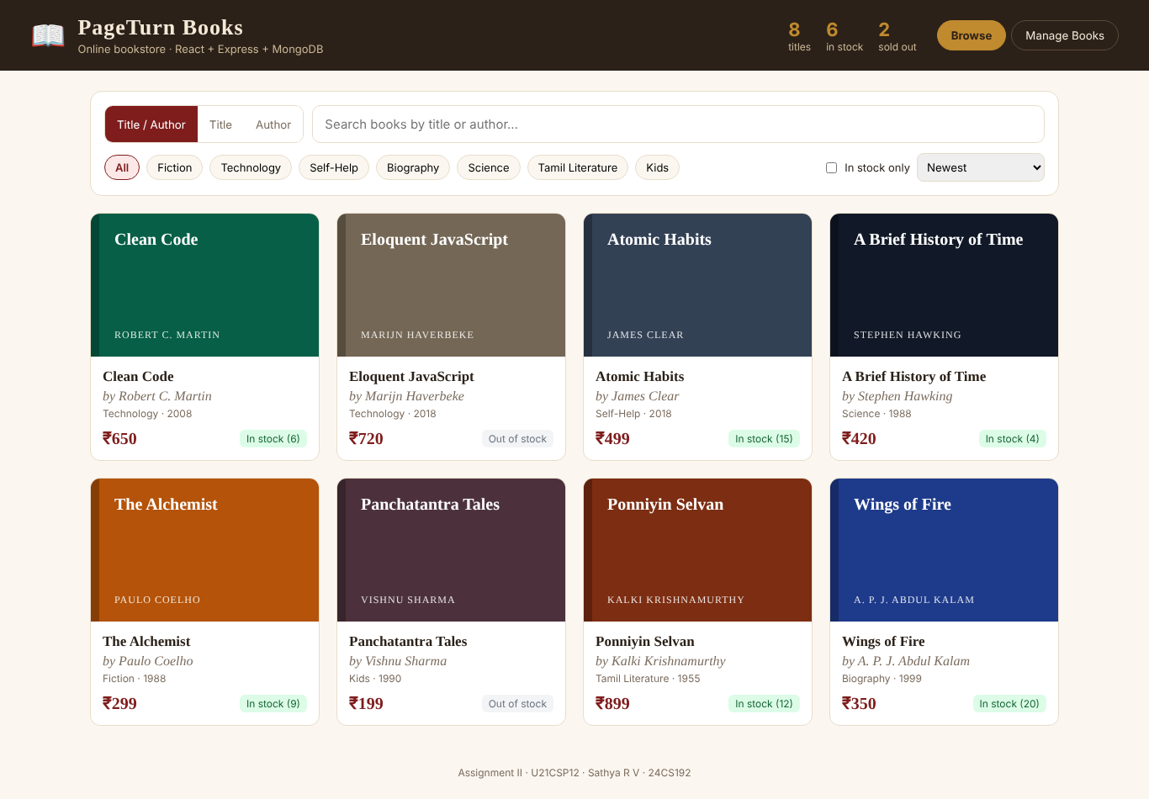  Fig. 5: Bookstore home – books displayed with React components | 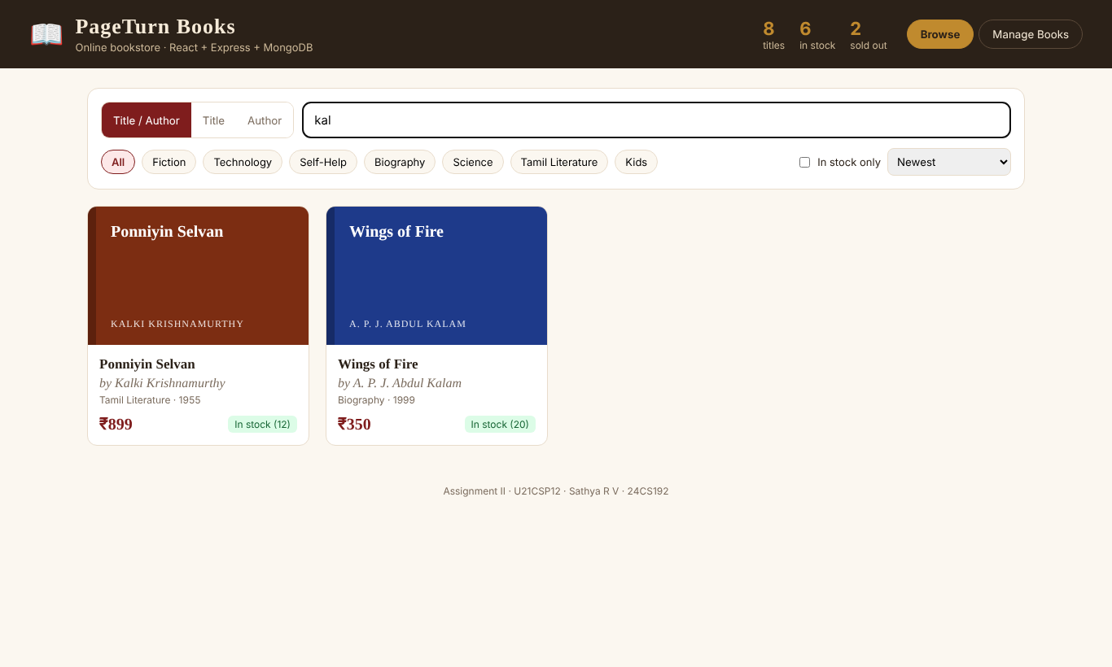  Fig. 6: Search by AUTHOR ("kal" → Kalam, Kalki)
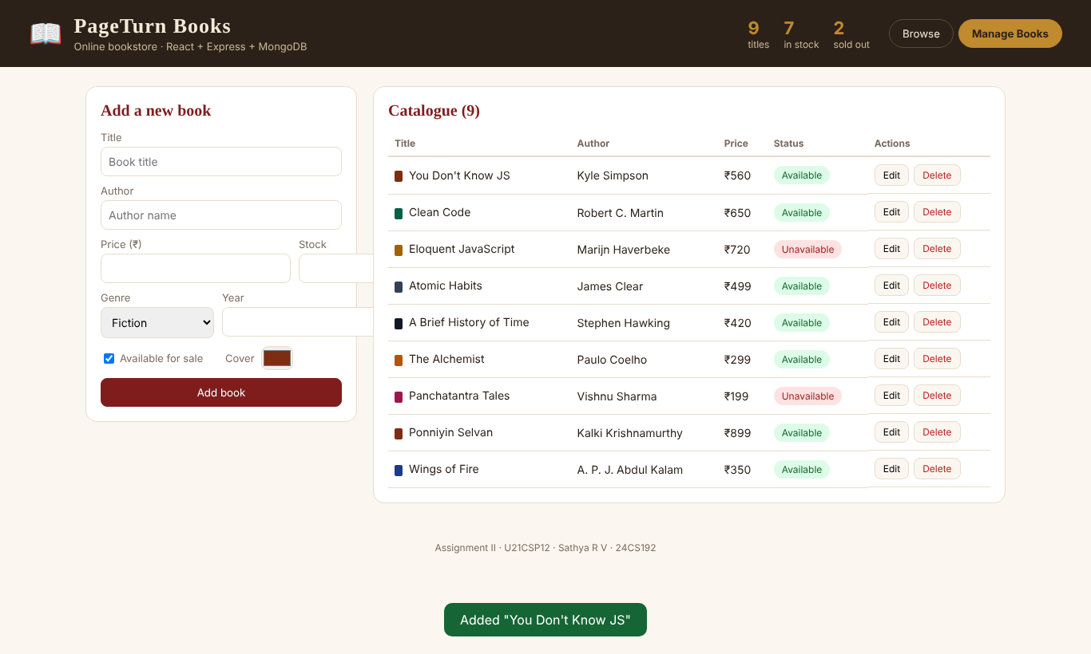  Fig. 7: New book stored in MongoDB and listed | 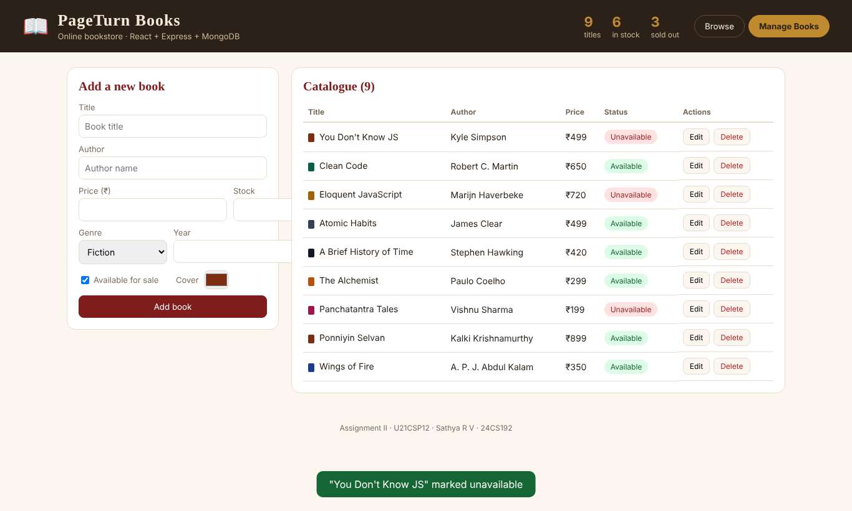  Fig. 8: Availability toggled to Unavailable
Result: The application was implemented and all required operations were tested successfully.

Q3 (Task 1) – EnrollEase – Course Registration (MEAN)
Task: Create a course registration application for college students: display available courses using Angular, implement course registration and cancellation, store course and student details in MongoDB, validate user inputs using Angular forms.
Stack: Angular 20 (standalone components, Reactive Forms, signals) · Node.js + Express.js · MongoDB (sathya_enrollease)

Requirements and Implementation
Requirement | Implementation
Display available courses using Angular | CourseList component shows course cards with seats left, category filter and search
Course registration and cancellation | POST /api/registrations (seat, duplicate and credit checks) and PATCH /api/registrations/:id/cancel
Store course and student details in MongoDB | Course, Student and Registration collections linked with ObjectId references
Validate user inputs using Angular forms | Reactive Forms – custom roll-number validator, required, minLength, pattern, email, requiredTrue

Database
Course: code, title, instructor, credits, category, schedule, capacity | Student: rollNo (unique), name, email, department, year | Registration: student (ref), course (ref), status Registered / Cancelled, cancelledAt

REST API
Method | Endpoint | Purpose
GET | /api/courses | Courses with enrolled count and seats left
POST | /api/courses | Add a course (admin)
DELETE | /api/courses/:id | Delete a course (only if nobody registered)
POST | /api/registrations | Register a student for selected courses
GET | /api/registrations/student/:rollNo | A student's registrations + total credits
PATCH | /api/registrations/:id/cancel | Cancel a registration
GET | /api/registrations | All registrations (admin)

Output
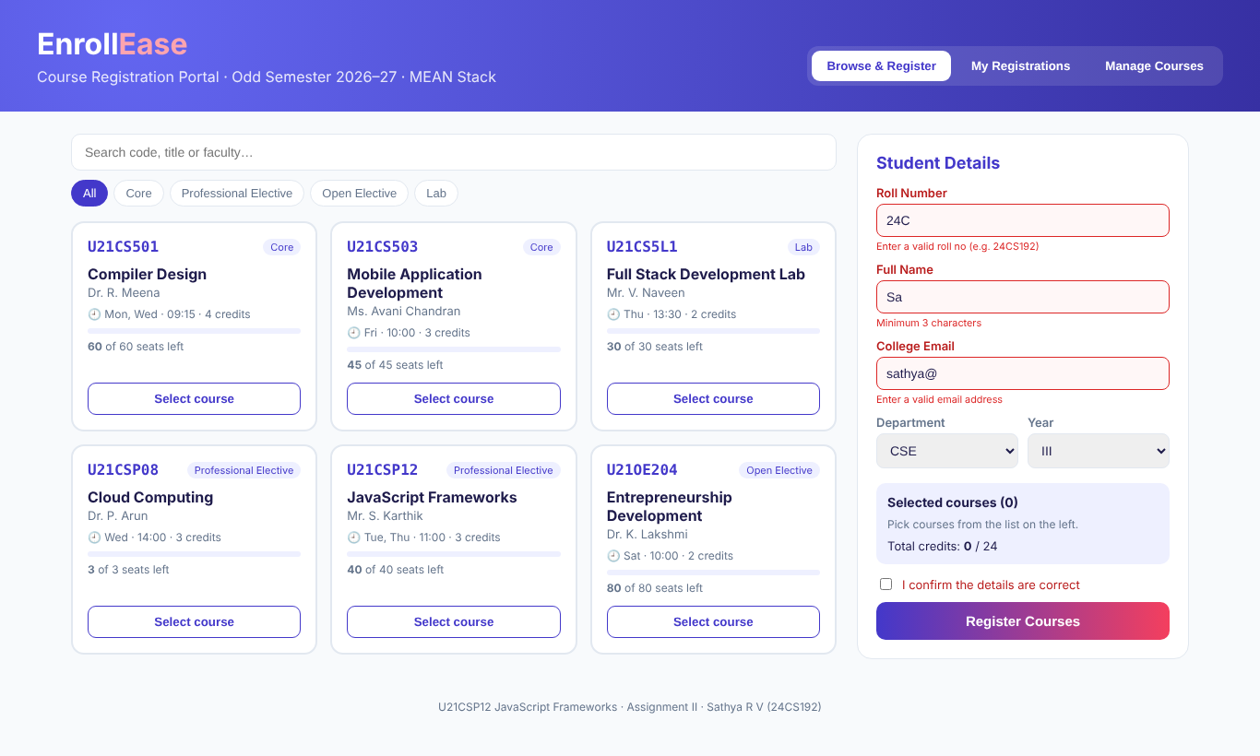  Fig. 9: Angular Reactive Form validation messages | 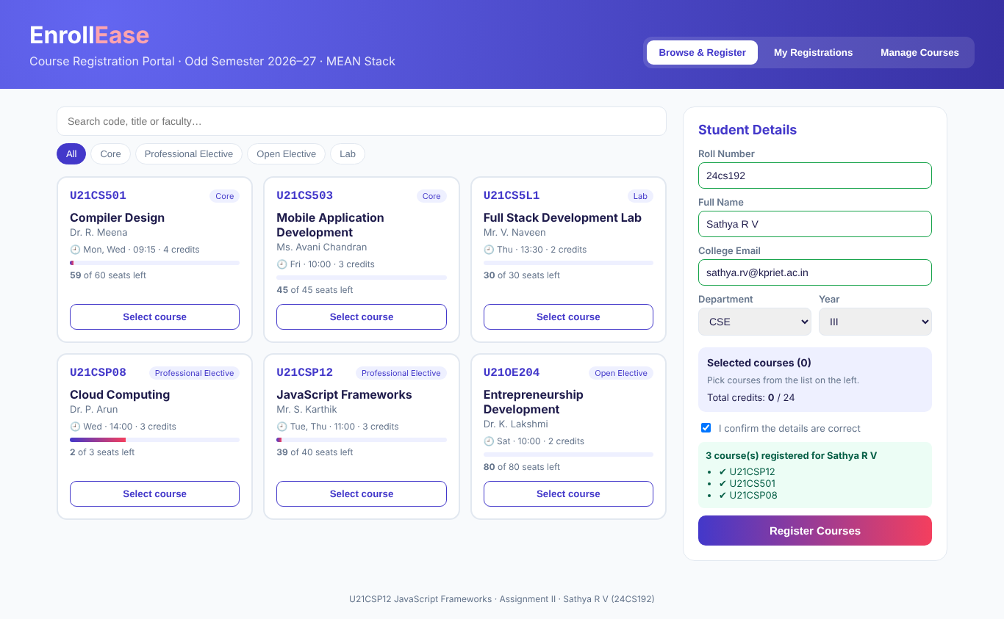  Fig. 10: REGISTRATION – 3 courses registered
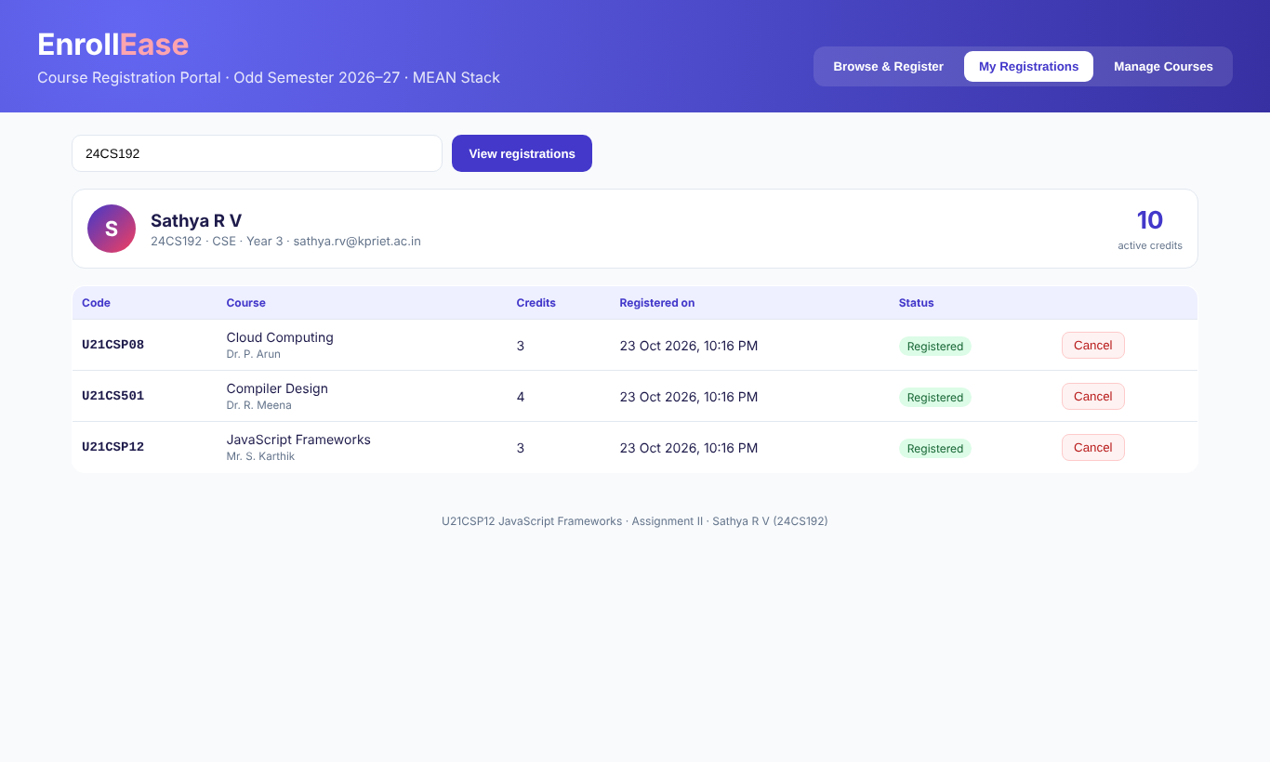  Fig. 11: Student's registrations with total credits | 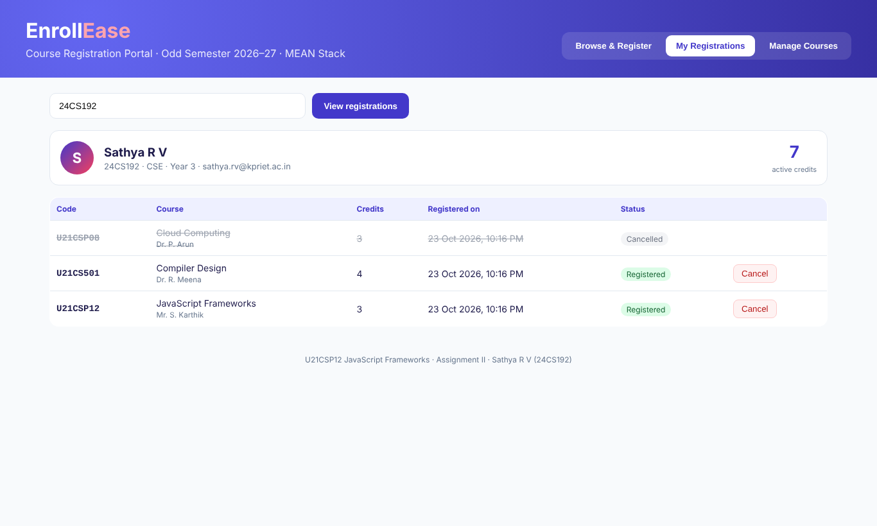  Fig. 12: CANCELLATION – Cloud Computing cancelled
Result: The application was implemented and all required operations were tested successfully.
Conclusion: All three questions were implemented as working MERN/MEAN applications using React Hooks, Angular forms and services, Express REST APIs and MongoDB.

