Name: Zeyuan Li

Andrew ID: zeyuanl

Email: [zeyuanl@cs.cmu.edu](mailto:zeyuanl@cs.cmu.edu)

Task 1

1. Domain diagram for IntelligentInformationSystem

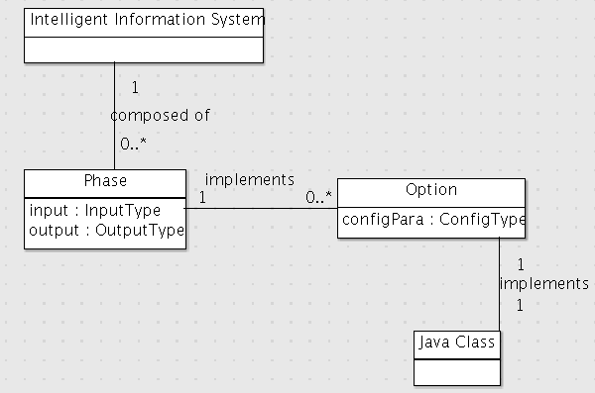

1. Domain diagram for AnalysisEngine

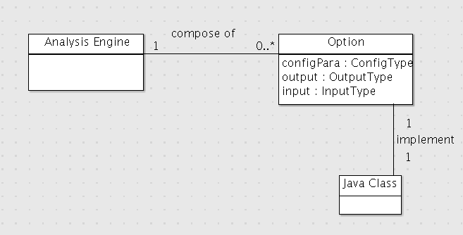

1. Sequence Diagram

