ZPU – Zylin Soft CPU
Presentation agenda

V1.0

April 11. 2005
Copyright © 2005, Zylin AS
oyvind.harboe@zylin.com

Abstract

The ZPU demonstration will give a good overview of the ZPU architecture and its capabilities.

This document gives an impression of what will be covered in the presentation.

Demonstration of ZPU implementation
A few programs will be uploaded and run on a board using with a Xilinx XC3S400 part.

As the tools are currently in an alpha version, the entire cycle from compiling the program to creating net-lists will be explained, but not demonstrated.

- Drystone 2.1. Runs infamous Drystone test and prints out the report.
- eCos hello world application

ZPU architecture introduction
The ZPU is a 0 operand or stack based architecture.

Although less common than e.g. a traditional RISC register LOAD/STORE architecture, the 0 operand or stack based architecture has been extensively studied and exists in numerous implementations: the Transputer, x86 FPU, MMIX, CLR, Java, etc.

The ZPU implements the 0 operand type architecture in a way that provides excellent code size characteristics and performance for small CPU's. Architecturally, it scales well for the range of CPU's that are reasonable to implement in an FPGA.

Opcodes
The opcodes have a fixed width of 8 bits.

Example:

IM 5 ; push 5 onto the stack
LOADSP 20 ; push value at memory location SP+20
ADD ; pop 2 values on the stack and push the result

As can be seen, a lot of information is packed into the 8 bits, e.g. the IM instruction pushes a 7 bit signed integer onto the stack.

The choice of opcodes is intimately tied to the GCC toolchain capabilities.

GCC compiler backend
The GCC compiler is most known for its support of register based architectures. However the ZPU backend(and others, e.g x86 FPU, the Transputer, CLR, MMIX) proves that it can work for stack based architectures as well.

In particular, the ZPU GCC backend has optimisations that specifically target the stack nature of the architecture. Consider the C code fragment below and its disassembly output:

/* simple program showing some interesting qualities of the ZPU toolchain */
void bar(int);
int j;
void foo(int a, int b, int c)
{
a++;
b+=a;
j=c;
bar(b);
}

foo:
loadsp 4 ; a is at memory location SP+4
im 1
add
loadsp 12 ; b is now at memory location SP+12
add
loadsp 16 ; c is now at memory location SP+16
im 24 ; «j» is at absolute memory location 24.
; Notice how the ZPU toolchain is using link-time relaxation
; to squeeze the address into a single no-op
store
im 22 ; the fn bar is at address 22
call
im 12
return ; 12 bytes of arguments + return from fn

Compiler completeness
A compiler must not only generate fast code, but also correct code. Additionally it is not sufficient to generate code for algorithms written from scratch that only read/write memory, it is also necessary to support numerous features required by standard software and embedded operating systems. The ZPU GCC toolchain, as of writing, passes the major GCC testsuites(execute.exp & compile.exp) and it compiles e.g. eCos(embedded operating system), though work remains for the more obscure features(profiling, various debug information cases, etc.).

ZPU alpha version HDL implementation

The ZPU alpha version has a simple, and small, implementation. It uses a 32 Kbytes dual-port RAM for both the data (stack) and the program. All stack operations are 32-bit wide.
The data width of the external interface can be configured from 8 to 32 bits depending on peripheral modules.

Our current ZPU evaluation board is connected to some peripheral modules as shown in the figure below.

ZPU minimal hello world
An Eclipse CDT ZPU plugin for debugging has been developed.
Eclipse CDT is a popular IDE choice that needs little introduction. Some companies that are already deploying it are: Altera for NIOS, STmicro, TI, etc.

Compile
Quick tour of how to write and compile a newlib/libgloss hello world application in Eclipse.
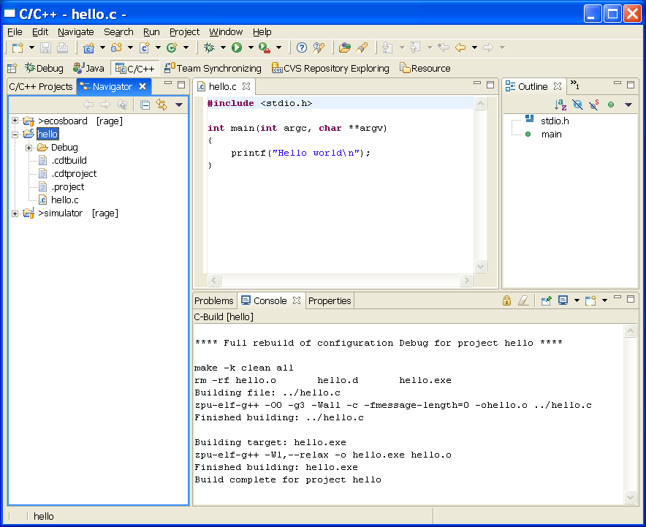

Debugging
The prototype does not have a JTAG interface as of writing, however the ZPU simulator has a GDB TCP/IP remote protocol interface:
