梦熊联盟CSP-J模拟赛（2024-06-16）

A. 孤独的数列 (lonely)
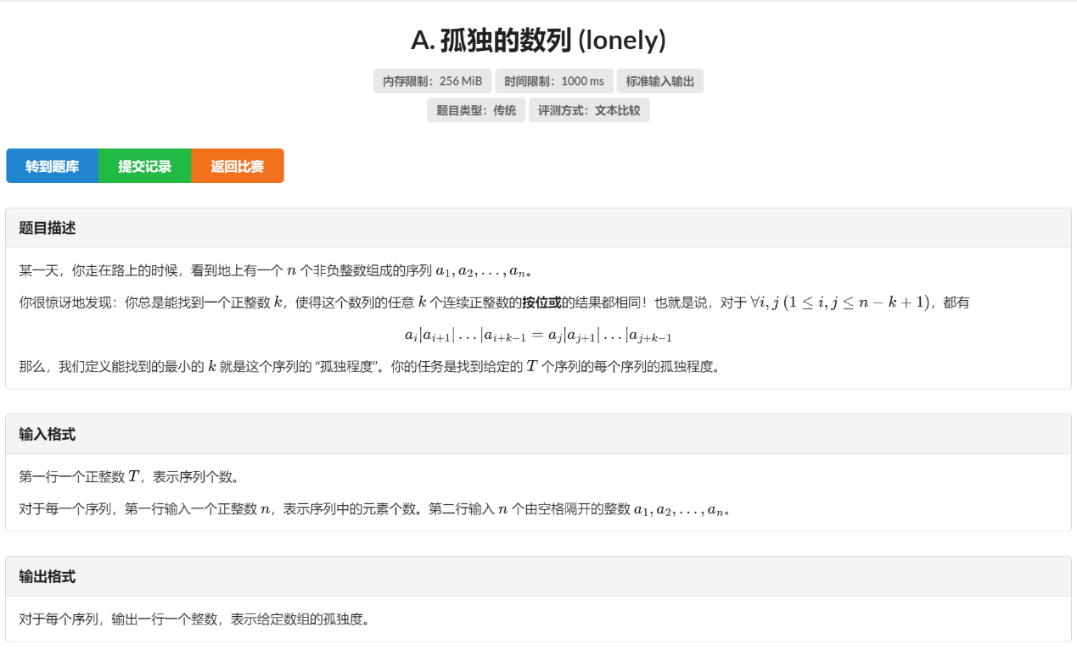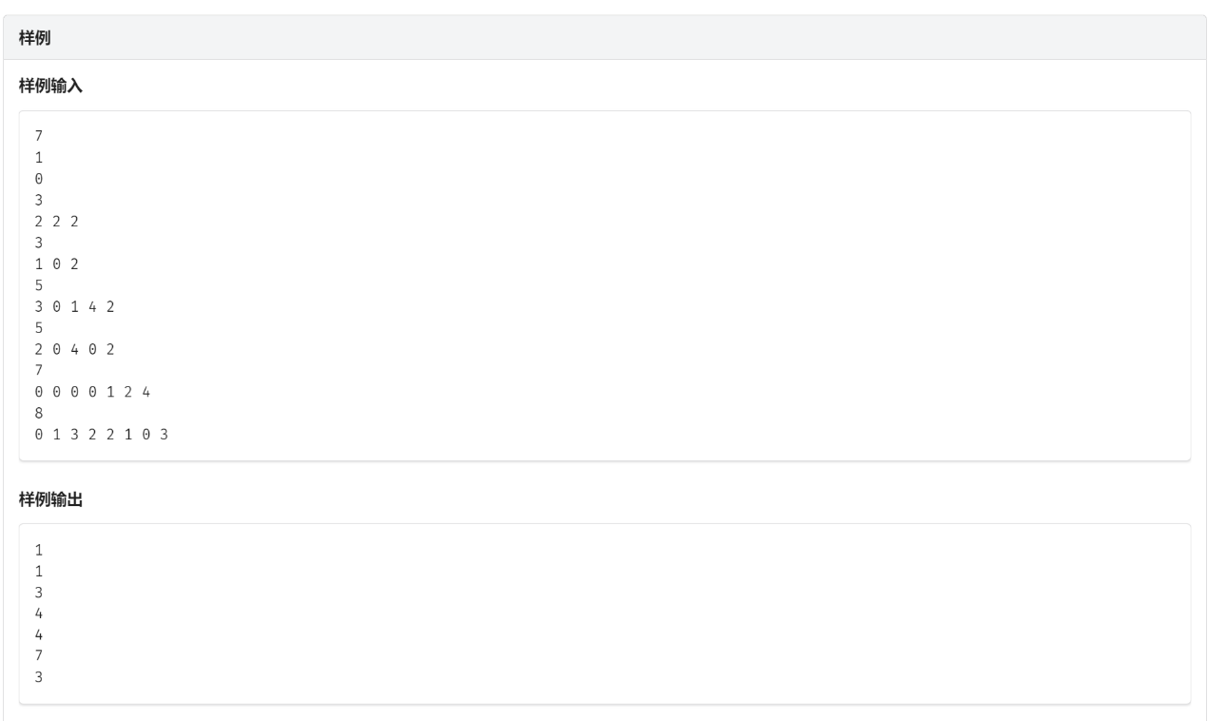
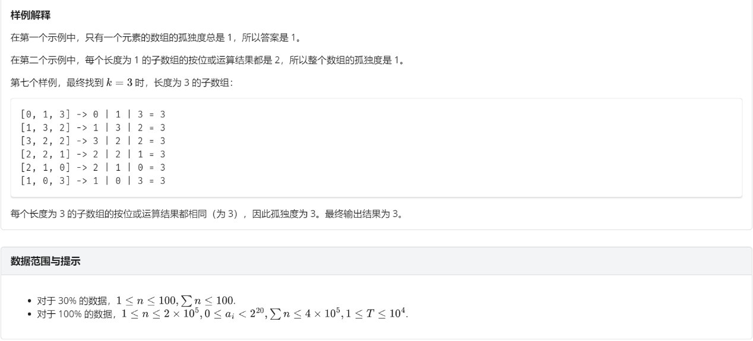
刘锦晨的代码：（80分）
#include <iostream>
#include <cstring>
using namespace std;

int a[200005];
int sda[200005][25];
bool num[25];
int n;
bool check(int mid){
for (int i = 1; i <= 21; i++)
num[i] = sda[mid][i];
for (int i = 1; i <= n - mid; i++)
for (int j = 1; j <= 21; j++)
if (num[j] != bool(sda[mid+i][j] - sda[i][j]))
return false;
return true;
}
void set_sda(int x){
int cur = 0;
for (int i = 1; i <= 21; i++)
sda[x][i] = sda[x-1][i];
while (a[x] > 0){
cur++;
sda[x][cur] += a[x] % 2;
a[x] /= 2;
}
}
int main(){
int t;
cin >> t;
for (int _ = 1; _ <= t; _++){
cin >> n;
for (int i = 1; i <= n; i++)
cin >> a[i];
memset(sda, 0, sizeof(sda));
for (int i = 1; i <= n; i++)
set_sda(i);
int l = 1, r = n;
while (l < r){
int mid = (l + r) / 2;
if (check(mid)) r = mid;
else l = mid + 1;
}
cout << l << endl;
}
return 0;
}

B. 五颜六色 (color)
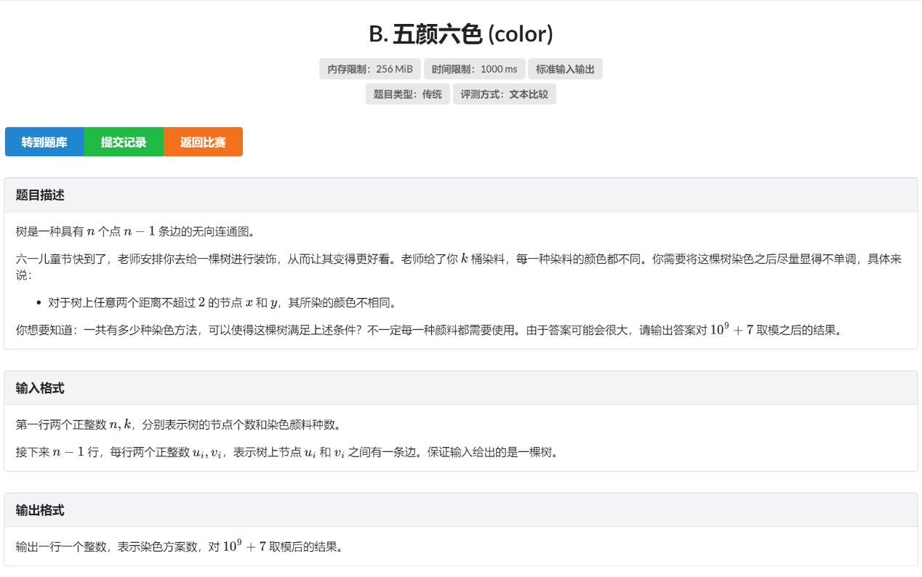
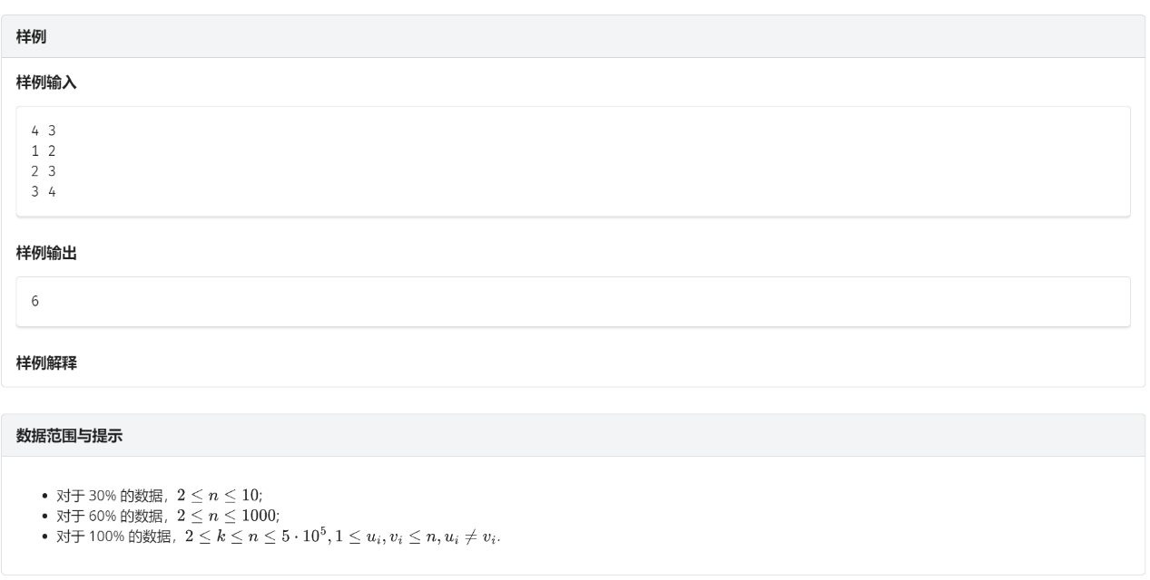
刘锦晨的代码：（0分）
#include <iostream>
#include <vector>
using namespace std;

const int mod = 1e9 + 7;
int f[500005], child[500005], depth[500005];
int n, k;
vector<int> v[500005];
void dfs(int x, int fa, int numch){
f[x] = k;
if (depth[x] > 2) f[x] -= 2;
else if (depth[x] > 1) f[x]--;
if (fa != 0) f[x] -= numch;
if (fa != 0) child[x] = v[x].size() - 1;
else child[x] = v[x].size();
int cur = 0;
for (int i = 0; i < v[x].size(); i++)
if (v[x][i] == fa) continue;
else{
depth[v[x][i]] = depth[x] + 1;
dfs(v[x][i], x, cur++);
}
}
int main(){
cin >> n >> k;
for (int i = 1; i < n; i++){
int a, b;
cin >> a >> b;
v[a].push_back(b);
v[b].push_back(a);
}
depth[1] = 1;
dfs(1, 0, 0);
long long ans = 1;
for (int i = 1; i <= n; i++){
cout << f[i] << endl;
if (f[i] <= 0){
cout << 0 << endl;
return 0;
}
ans *= f[i];
ans %= mod;
}
cout << ans << endl;
return 0;
}

C. 获取字符串 (obtain)
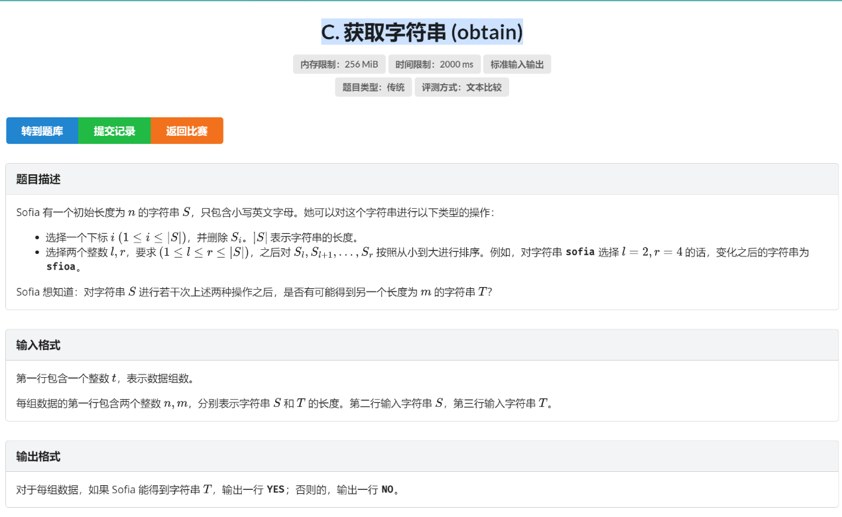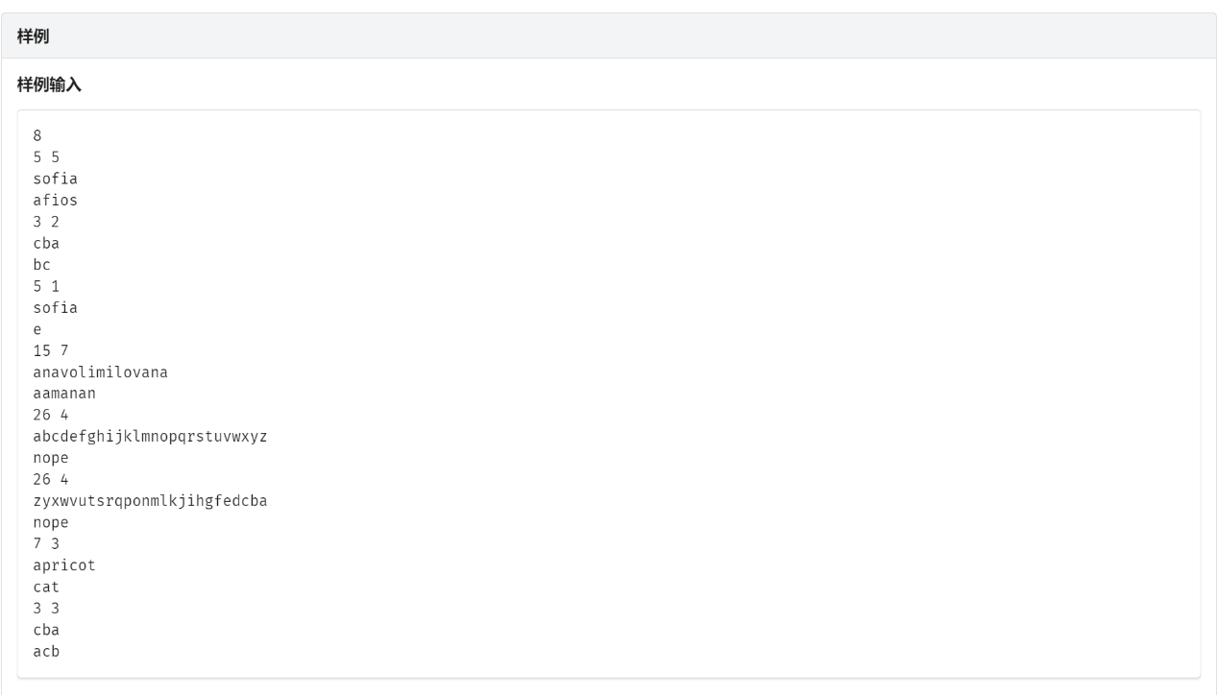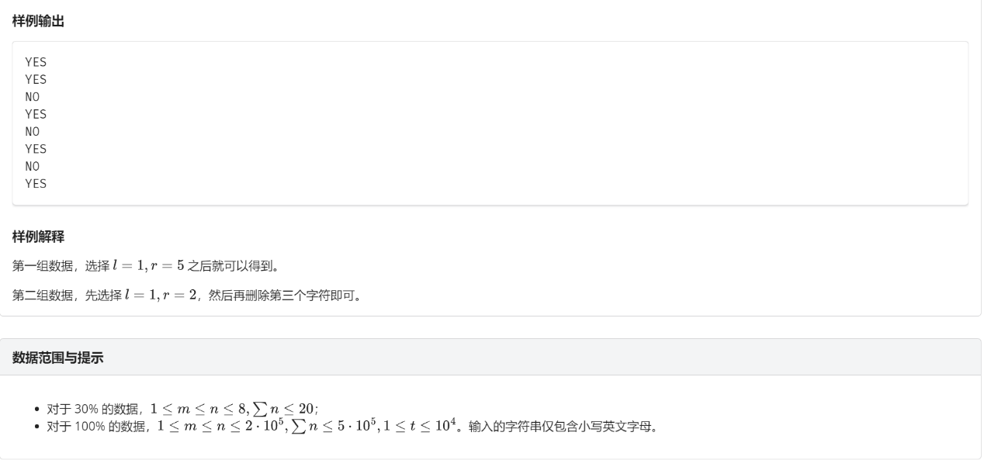
刘锦晨的代码：（0分）
#include <iostream>
#include <cstring>
using namespace std;

int n, m;
bool ans;
bool flag[155];
char a[200005];
string s1, s2, s3;
void dfs(int x, int last){
if (ans) return;
if (x >= m){
for (int i = 0; i < m; i++){
if (a[i] > s2[i]){
ans = true;
return;
} else if (a[i] < s2[i]) return;
if (i == m - 1){
ans = true;
return;
}
}
}
for (int i = last; i < s3.size(); i++){
a[x] = s3[i];
dfs(x+1, i+1);
}
}
int main(){
int t;
cin >> t;
while (t--){
memset(flag, false, sizeof(flag));
ans = false;
cin >> n >> m >> s1 >> s2;
for (int i = 0; i < m; i++)
flag[s2[i]] = true;
for (int i = 0; i < n; i++)
if (flag[s1[i]]) s3 += s1[i];
if (s3.size() < s2.size()){
cout << "No" << endl;
continue;
}
dfs(0, 0);
if (ans) cout << "Yes" << endl;
else cout << "No" << endl;
}
return 0;
}

D. 仙人掌方块 (cactus)
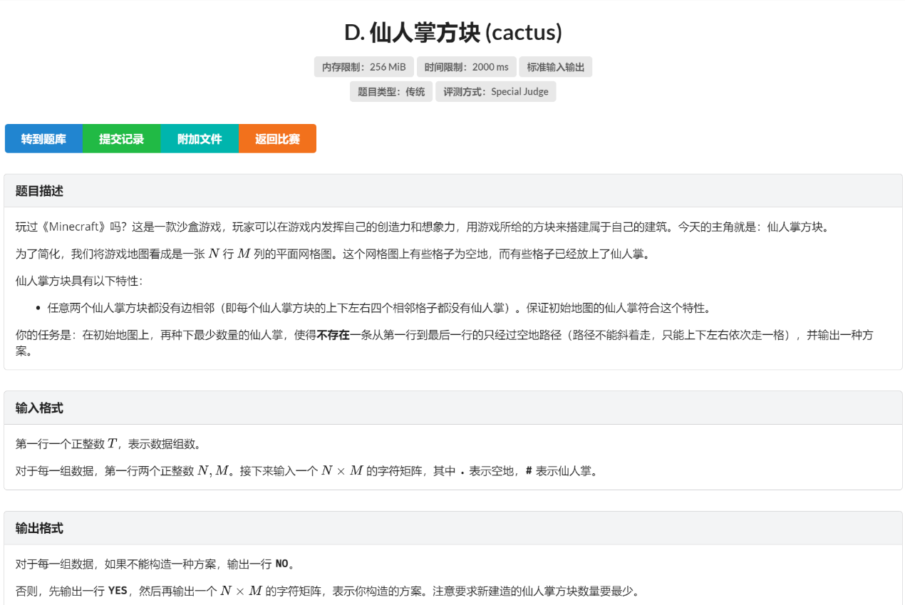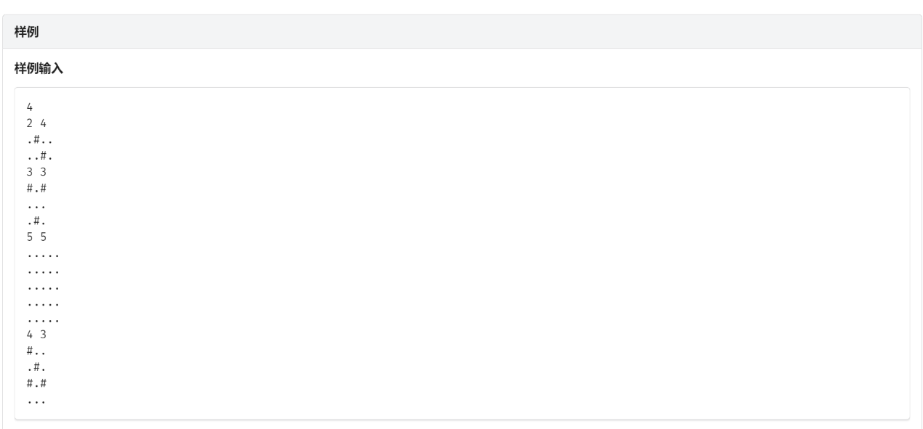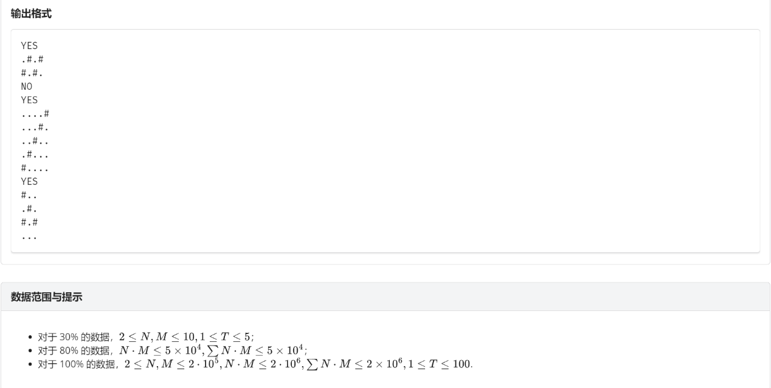
刘锦晨的代码：（0分）
#include <iostream>
#include <vector>
using namespace std;

int n, m;
vector<char> mp[200005], ans[200005];
int mina = 1e9;
vector<bool> vis[200005];
int dx[4] = {1, 1, -1, -1};
int dy[4] = {1, -1, 1, -1};
bool in(int x, int y){
return 0 <= x && x < n && 0 <= y && y < m;
}
void dfs(int x, int y, int num){
// cout << x << ' ' << y << ' ' << num << endl;
// for (int i = 0; i < n; i++){
// for (int j = 0; j < m; j++)
// cout << mp[i][j];
// cout << endl;
// }
if (x > 0)
if (mp[x-1][y] == '#') return;
if (x < n-1)
if (mp[x+1][y] == '#') return;
if (y > 0)
if (mp[x][y-1] == '#') return;
if (y < m-1)
if (mp[x][y+1] == '#') return;
bool flag = false;
vis[x][y] = true;
if (mp[x][y] == '.'){
mp[x][y] = '#';
flag = true;
num++;
}
if (y == m-1){
if (num < mina){
for (int i = 0; i < n; i++)
for (int j = 0; j < m; j++)
ans[i][j] = mp[i][j];
mina = num;
}
return;
}
for (int i = 0; i < 4; i++){
int nx = x + dx[i];
int ny = y + dy[i];
if (!in(nx, ny)) continue;
if (vis[nx][ny]) continue;
dfs(nx, ny, num);
}
if (flag) mp[x][y] = '.';
}
int main(){
int t;
cin >> t;
while (t--){
cin >> n >> m;
for (int i = 0; i < n; i++){
for (int j = 0; j < m; j++){
char c;
cin >> c;
mp[i].push_back(c);
}
ans[i].resize(m);
vis[i].resize(m);
}
for (int i = 0; i < n; i++)
if (!vis[i][0])
dfs(i, 0, 0);
if (mina != 1e9){
cout << "Yes" << endl;
for (int i = 0; i < n; i++){
for (int j = 0; j < m; j++)
cout << ans[i][j];
cout << endl;
mp[i].resize(0);
vis[i].resize(0);
ans[i].resize(0);
}
} else {
cout << "No" << endl;
for (int i = 0; i < n; i++){
mp[i].resize(0);
vis[i].resize(0);
ans[i].resize(0);
}
}
mina = 1e9;
}
return 0;
}

