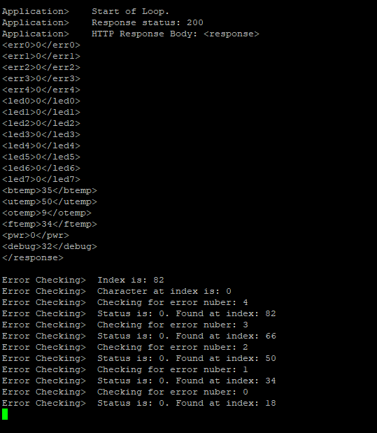

Logged Server response – no errors

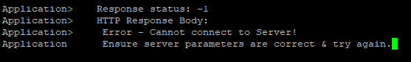

Logged Server response – No server

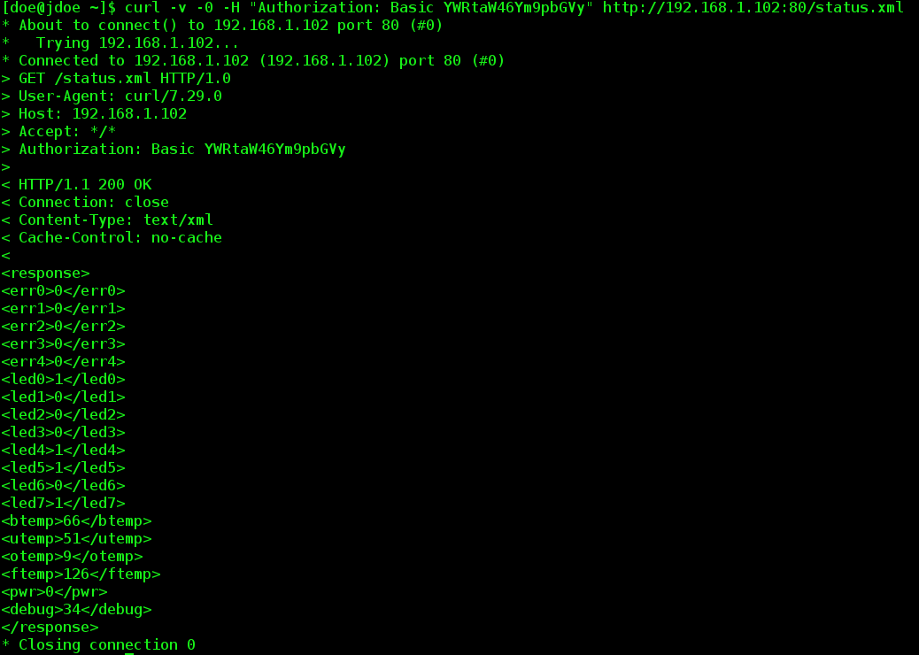

Server response for http/1.0 request with http/1.1 response

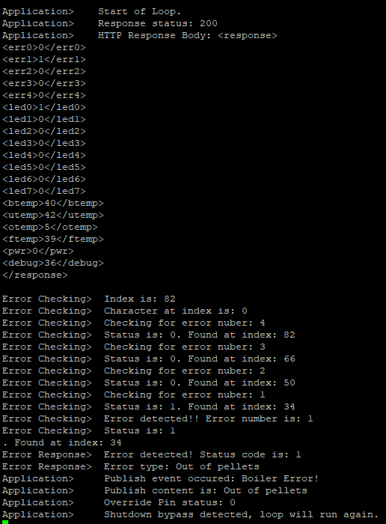

Full code with real error, and deep_sleep bypass enabled

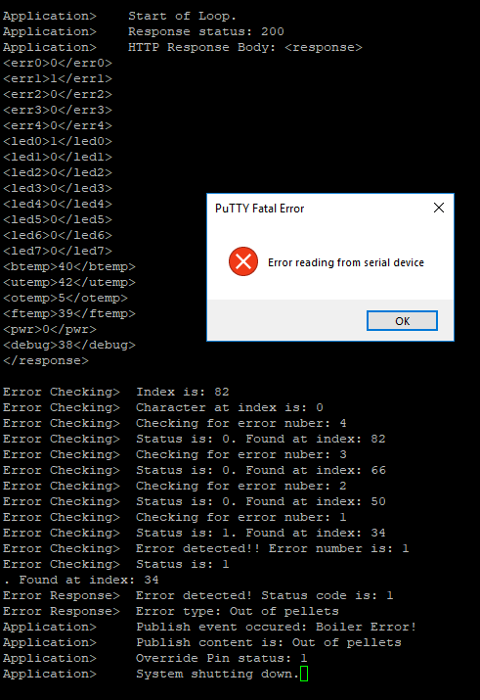

Full code with real error, and deep_sleep enabled

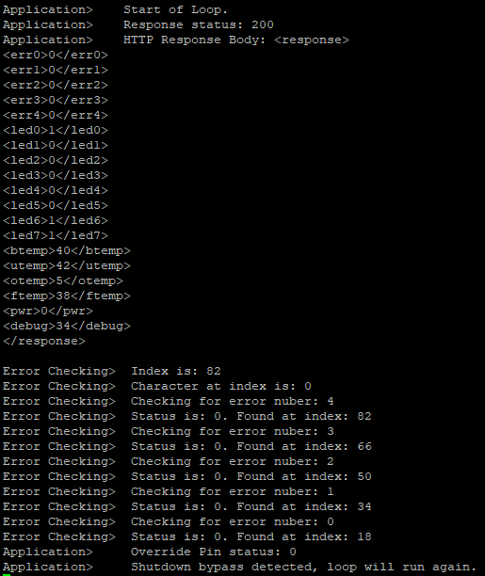

Full code real implementation – no errors.