

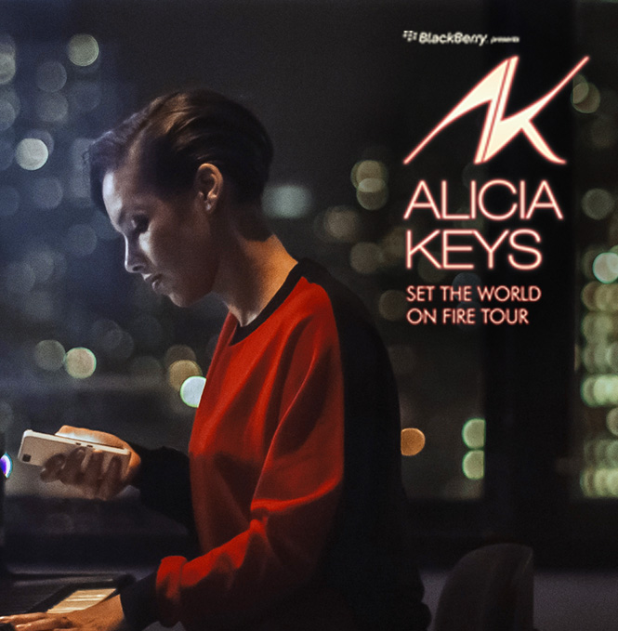

**BlackBerry Presents Alicia Keys**

**‘Set the World on Fire Tour’**

**Event Report**

**$city$**

**$date$**

**QUICK STATS**

**OVERALL EVENT INFORMATION**

**Manager:** $managerName$

|  |  |
| --- | --- |
| **City:** | $city$ |
| **Venue:** | $venue$ |
|  |  |
| **Doors Open:** | $doorsOpen$ |
| **Show time:** | $showtime$ |
| **Overall Attendance:** | $overallAttendance$ |
| **Will Call Location:** | $willCallLoc$ |
|  |  |
| **Tickets Allocated:** | $ticketsAllocated$ |
| **RSVP Total:** | $rsvpNo$ |
| **Tickets Used:** | $ticketsUsed$ |
| **Avg. Arrival Time:** | $avgArrivalTime$ |
|  |  |
| **Weather:** | $weather$ |

|  |  |
| --- | --- |
| **Guest Comment:** | $guest-comment$ |

|  |  |
| --- | --- |
| **Manager Comment:** | $manager-comment$ |

**DIRECT ENGAGEMENT NUMBERS**

|  |  |
| --- | --- |
| **Number of Hubs:** | $deHubNo$ |
| **Location:** | $deLocation$ |
|  |  |
| **# Brand Ambassadors:** | $debaNo$ |
| **# of Demos:** | $deDemoNo$ |
| **Est. Dwell Time:** | $deDwellTime$ |
| **# of Photos Emailed:** | $dePhotos$ |
| **Giveaways:** | $deGiveaways$ |
| **Promotional Material:** | $dePromoMat$ |
| **Activity Feedback:** | $deFeedback$ |

|  |  |
| --- | --- |
| **Most Asked Questions:** | $faq$ |

|  |  |
| --- | --- |
| **Feedback:** | $feedback$ |

**HOSPITALITY**

|  |  |
| --- | --- |
| **Location:** | $hospLoc$ |
| **Type:** | $hospType$ |
|  |  |
| **# of Guests RSVP:** | $rsvpGuestNo$ |
| **# of Guests Attended:** | $guestsAttended$ |
| **Guest Type:** | $guestType$ |
| **# of Ambassadors:** | $ambassNo$ |
| **Décor Used:** | $decor$ |
| **Menu:** | $menu$ |
| **Gift Bags:** | $giftBags$ |

**BRAND AMBASSADORS**

|  |  |
| --- | --- |
| **On Duty Manager:** | $onDutyManager$ |
| **# Brand Ambassadors:** | $ambassNo$ |

**RADIO**

|  |  |
| --- | --- |
| **Station Name:** | $stationName$ |
| **Giveaway:** | $giveaway$ |
| **Audio URL:** | $radioAudio$ |
| **Notes:** | $radioNotes$ |

  

**BRANDING**

**External Venue:**

|  |  |
| --- | --- |
| **Details:** | $extBrandDetails$ |

  

**Internal Venue:**

|  |  |
| --- | --- |
| **Details:** | $intBrandDetails$ |

  

**Concourse:**

|  |  |
| --- | --- |
| **Details:** | $concourseDetails$ |

  

**Jumbotron:**

|  |  |
| --- | --- |
| **Details:** | $jumboDetails$ |

  

**Stage Screens:**

|  |  |
| --- | --- |
| **Details:** | $stageDetails$ |

  

**Additional Branding:**

|  |  |
| --- | --- |
| **Details:** | $addtlBrandDetails$ |

  

**Competitor Branding:**

|  |  |
| --- | --- |
| **Details:** | $competeDetails$ |

  