

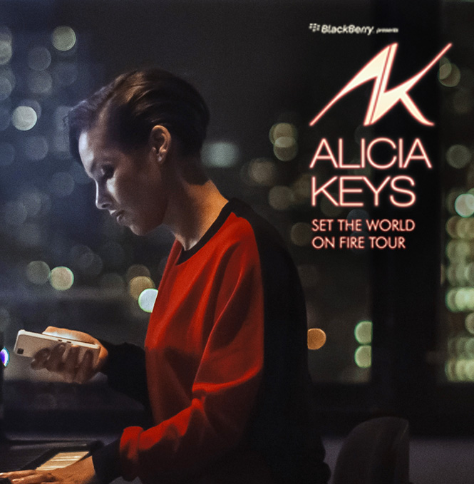

**BlackBerry Presents Alicia Keys**

**‘Set the World on Fire Tour’**

**Event Report**

**Miami**

**March 23rd, 2013**

**QUICK STATS**

**OVERALL EVENT INFORMATION**

**Manager:** Molly Williams

|  |  |
| --- | --- |
| **City:** | Miami |
| **Venue:** | American Airlines Arena |
|  |  |
| **Doors Open:** | 7:00pm |
| **Show time:** |  |
| **Overall Attendance:** | 9000 approx |
| **Will Call Location:** | TBD |
|  |  |
| **Tickets Allocated:** |  |
| **RSVP Total:** |  |
| **Tickets Used:** | 193 |
| **Avg. Arrival Time:** | 7:30 pm |
|  |  |
| **Weather:** | Hot and muggy. 81 high. |

|  |  |
| --- | --- |
| **Guest Comment:** |  |

|  |  |
| --- | --- |
| **Manager Comment:** |  |

**DIRECT ENGAGEMENT NUMBERS**

|  |  |
| --- | --- |
| **Number of Hubs:** | 2 |
| **Location:** | Main Concourse |
|  |  |
| **# Brand Ambassadors:** | 21 |
| **# of Demos:** | 1030 |
| **Est. Dwell Time:** | 2 Mins |
| **# of Photos Emailed:** | 35 |
| **Giveaways:** | 0 |
| **Promotional Material:** | 0 |
| **Activity Feedback:** |  |

|  |  |
| --- | --- |
| **Most Asked Questions:** |  |

|  |  |
| --- | --- |
| **Feedback:** |  |

**HOSPITALITY**

|  |  |
| --- | --- |
| **Location:** | Backstage - Grey Goose Lounge |
| **Type:** | Lounge event. 7P - 915P |
|  |  |
| **# of Guests RSVP:** | 60 |
| **# of Guests Attended:** | 38 |
| **Guest Type:** | TSM x 6 and AT&T x 50 |
| **# of Ambassadors:** | 21 |
| **Décor Used:** | Atomic wall, 4 planters, 8 plants, 16 light cubes. Used venue\\\\\\\\\\\\\\\\\\\\\\\\\\\\\\\\\\\\\\\\\\\\\\\\\\\\\\\\\\\\\\\'s ottomans. |
| **Menu:** | Menu: All Beef Mini Slider topped with Mushrooms and Swiss Ã�ï¿½Ã¯Â¿Â½Ã�ï¿½Ã�Â¢Ã�ï¿½Ã�Â¯Ã�ï¿½Ã�Â¿Ã�ï¿½Ã�Â½Ã�ï¿½Ã�Â¯Ã�ï¿½Ã�Â¿Ã�ï¿½Ã�Â½ZLTÃ�ï¿½Ã¯Â¿Â½Ã�ï¿½Ã�Â¢Ã�ï¿½Ã�Â¯Ã�ï¿½Ã�Â¿Ã�ï¿½Ã�Â½Ã�ï¿½Ã�Â¯Ã�ï¿½Ã�Â¿Ã�ï¿½Ã�Â½ flatbread sandwich grilled zucchini, vine ripe tomatoes, jalapeno jack cheese and romaine served on chargrilled flatbread brushed with sundried tomato pesto Coconut curry chicken satay with mango chutney Ahi Tuna Crostini- Sesame seared Ahi Tuna with Wasabi Crema on a Wonton Skin Vegetable Crudite Skewers with Garlic Hummus Imported and Domestic Beer Wines by the Glass Assorted Pepsi Sodas Bottled Water Assorted Juices |
| **Gift Bags:** | NO |

**BRAND AMBASSADORS**

|  |  |
| --- | --- |
| **On Duty Manager:** | Thekla Roth |
| **# Brand Ambassadors:** | 21 |

**RADIO**

|  |  |
| --- | --- |
| **Station Name:** | WHQT - Hot 105 |
| **Giveaway:** | (5) Pairs of Tickets |
| **Audio URL:** |  |
| **Notes:** | :30 promos and live mentions teased on-air giveaways on 3/20 & 3/21, encouraging listeners to call-in. Hot 105 also posted contest mentions on their Facebook page each day. |

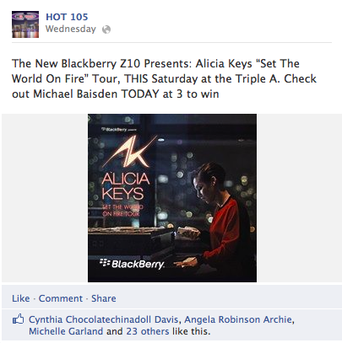 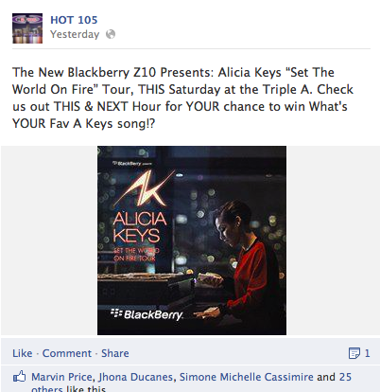 

**BRANDING**

**External Venue:**

|  |  |
| --- | --- |
| **Details:** |  |

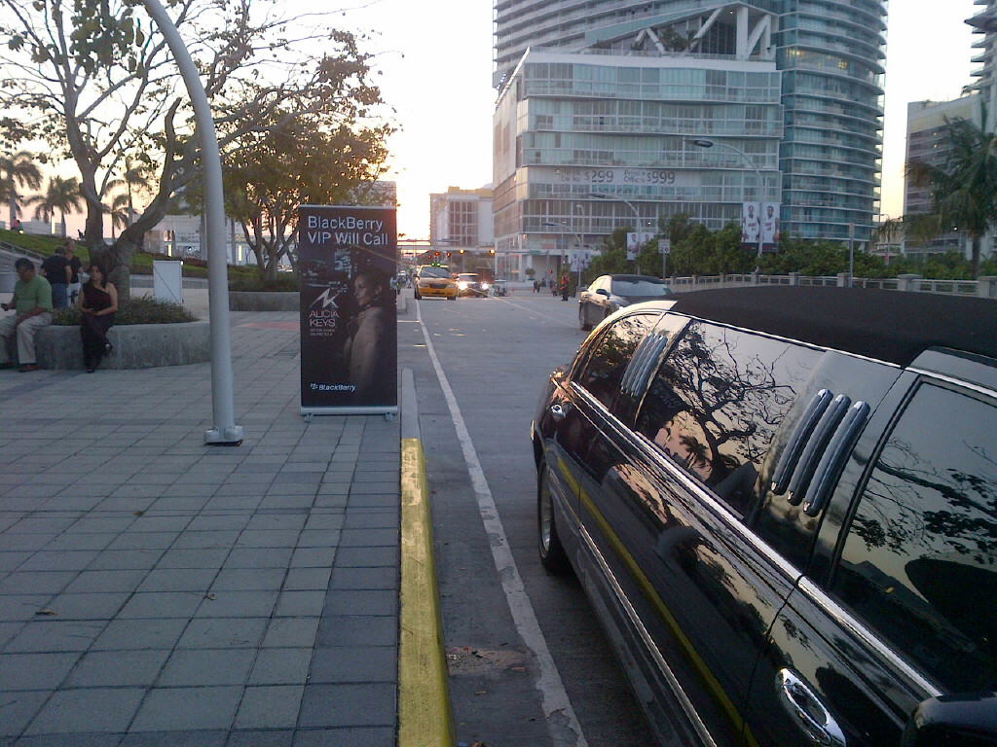 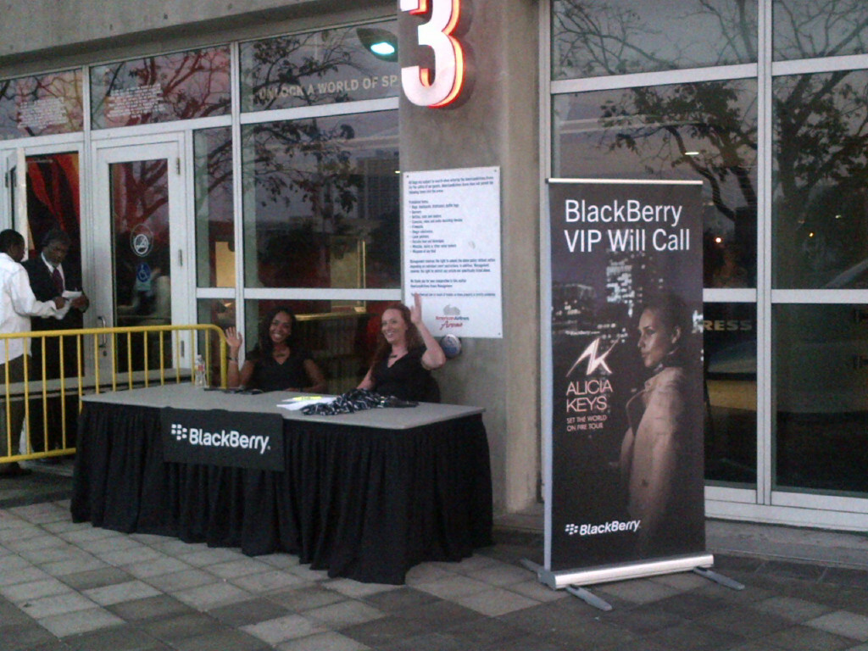 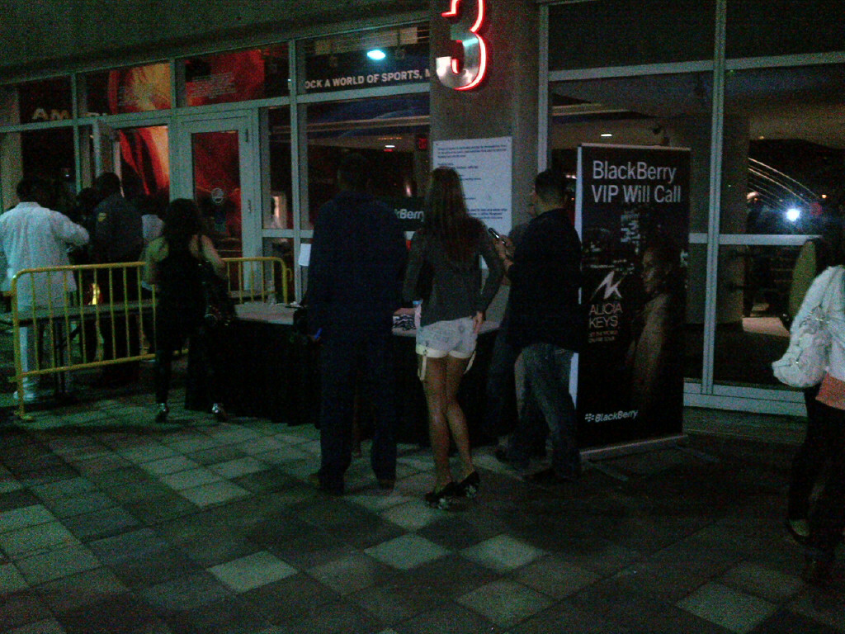

**Internal Venue:**

|  |  |
| --- | --- |
| **Details:** |  |

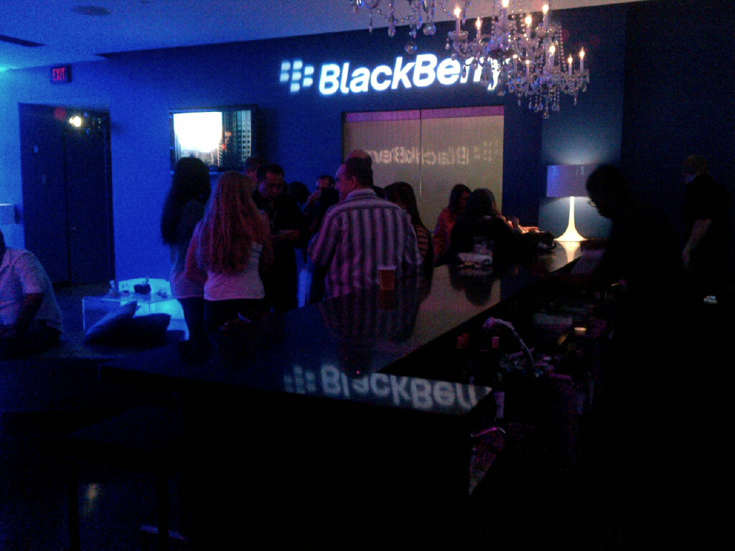 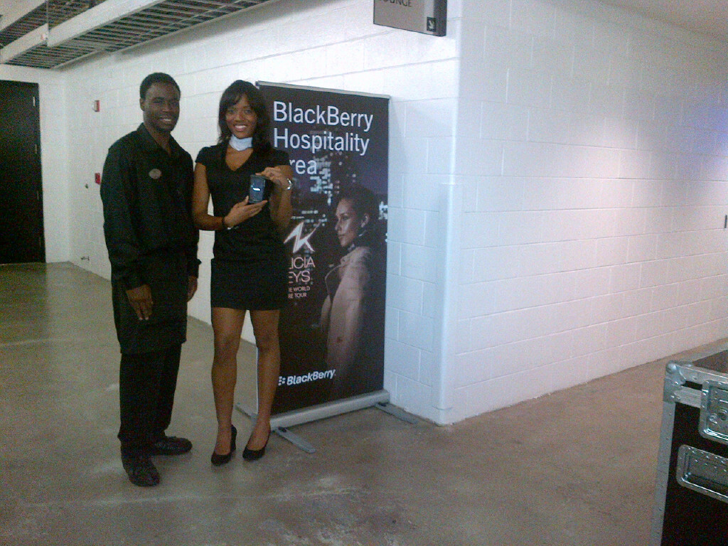 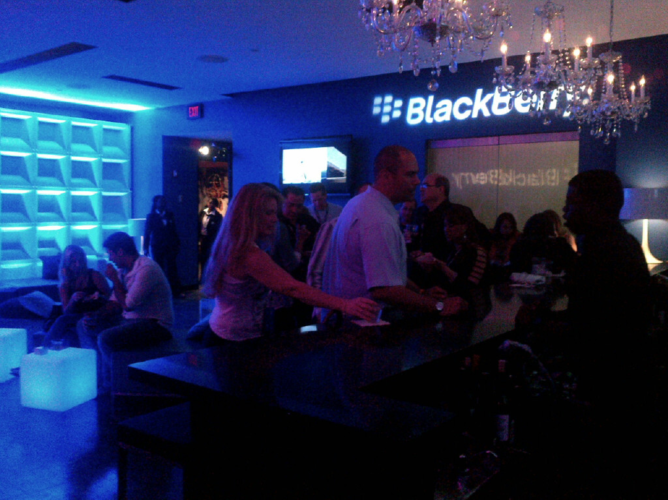

**Concourse:**

|  |  |
| --- | --- |
| **Details:** | 3 hubs = 1 large and 2 small, located directly inside one of the main entrances. Saw lots of foot traffic and interest in the Z10. |

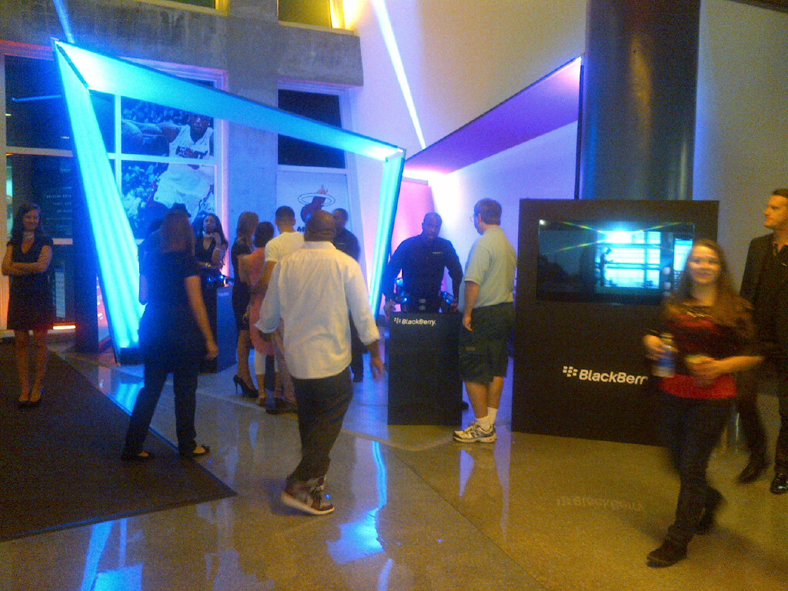 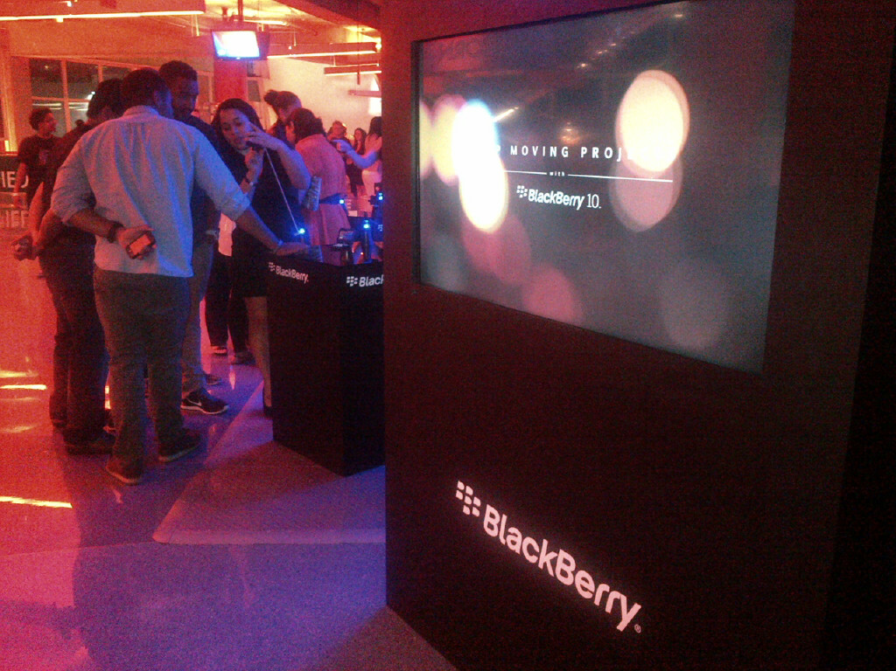 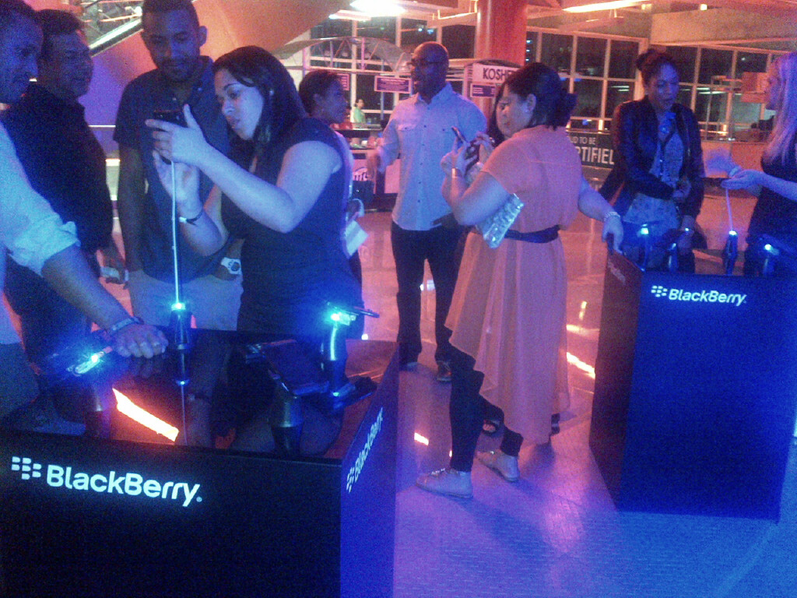

**Jumbotron:**

|  |  |
| --- | --- |
| **Details:** |  |

  

**Stage Screens:**

|  |  |
| --- | --- |
| **Details:** |  |

  

**Additional Branding:**

|  |  |
| --- | --- |
| **Details:** |  |

  

**Competitor Branding:**

|  |  |
| --- | --- |
| **Details:** |  |

  