

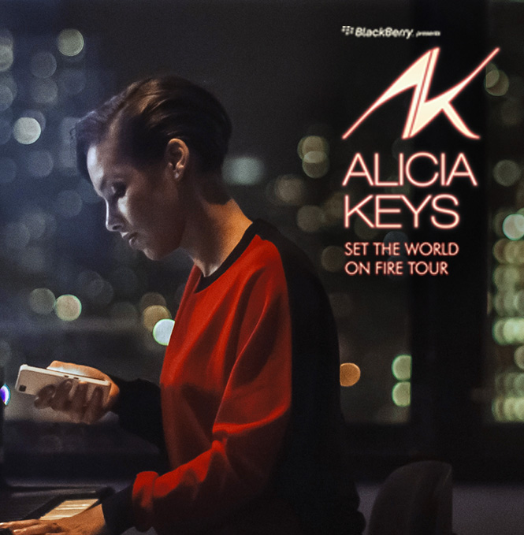

**BlackBerry Presents Alicia Keys**

**‘Set the World on Fire Tour’**

**Event Report**

**Tampa**

**March 24th, 2013**

**QUICK STATS**

**OVERALL EVENT INFORMATION**

**Manager:** Molly Williams

|  |  |
| --- | --- |
| **City:** | Tampa |
| **Venue:** | Tampa Bay Times Forum |
|  |  |
| **Doors Open:** | 6:30 P |
| **Show time:** |  |
| **Overall Attendance:** | 5500 |
| **Will Call Location:** | Main Box Office Will Call - Farthest window on Right |
|  |  |
| **Tickets Allocated:** | 103 |
| **RSVP Total:** | 54 |
| **Tickets Used:** | 0 |
| **Avg. Arrival Time:** | 7:30 Pm |
|  |  |
| **Weather:** | and degrees |

|  |  |
| --- | --- |
| **Guest Comment:** |  |

|  |  |
| --- | --- |
| **Manager Comment:** |  |

**DIRECT ENGAGEMENT NUMBERS**

|  |  |
| --- | --- |
| **Number of Hubs:** | 2 |
| **Location:** | Main Concourse |
|  |  |
| **# Brand Ambassadors:** | 18 |
| **# of Demos:** | 860 |
| **Est. Dwell Time:** | 3 mins |
| **# of Photos Emailed:** | 128 |
| **Giveaways:** | 0 |
| **Promotional Material:** | 0 |
| **Activity Feedback:** |  |

|  |  |
| --- | --- |
| **Most Asked Questions:** |  |

|  |  |
| --- | --- |
| **Feedback:** |  |

**HOSPITALITY**

|  |  |
| --- | --- |
| **Location:** | TBD |
| **Type:** |  |
|  |  |
| **# of Guests RSVP:** | 54 |
| **# of Guests Attended:** | 0 |
| **Guest Type:** |  |
| **# of Ambassadors:** | 18 |
| **Décor Used:** |  |
| **Menu:** |  |
| **Gift Bags:** |  |

**BRAND AMBASSADORS**

|  |  |
| --- | --- |
| **On Duty Manager:** | Thekla Roth |
| **# Brand Ambassadors:** | 18 |

**RADIO**

|  |  |
| --- | --- |
| **Station Name:** | WBTP - 95.7 The Beat |
| **Giveaway:** | (5) Pairs of Tickets |
| **Audio URL:** |  |
| **Notes:** | WBTP conducted on-air giveaways 3/18 - 3/21 (M-Thu) during PMD, giving listeners the chance to win a pairs of AK tickets, (1) pair per day. WPTB also posted an online contest page 3/18 - 3/21, giving listeners an additional chance to win (1) pair of tickets. |

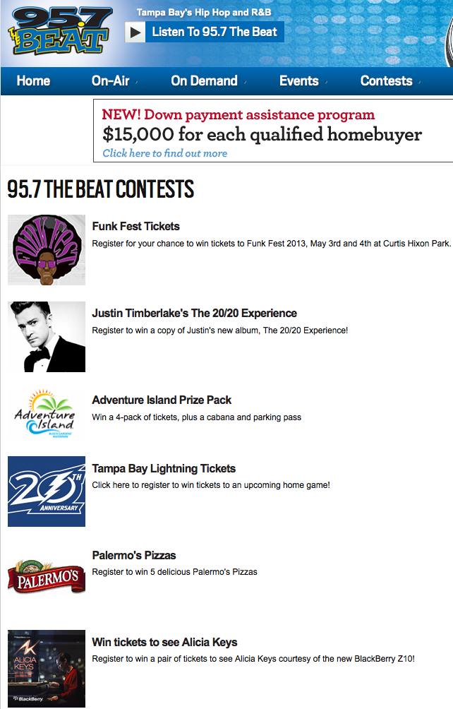 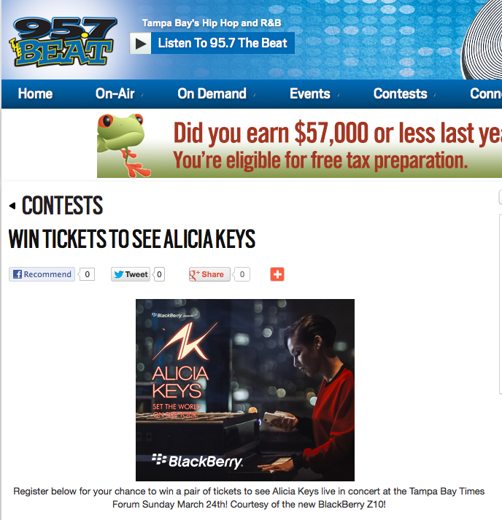 

**BRANDING**

**External Venue:**

|  |  |
| --- | --- |
| **Details:** | Prominent Gobos highlighted both Main Entrances. VIP Will Call was at the Premium Entrance of the Box Office. |

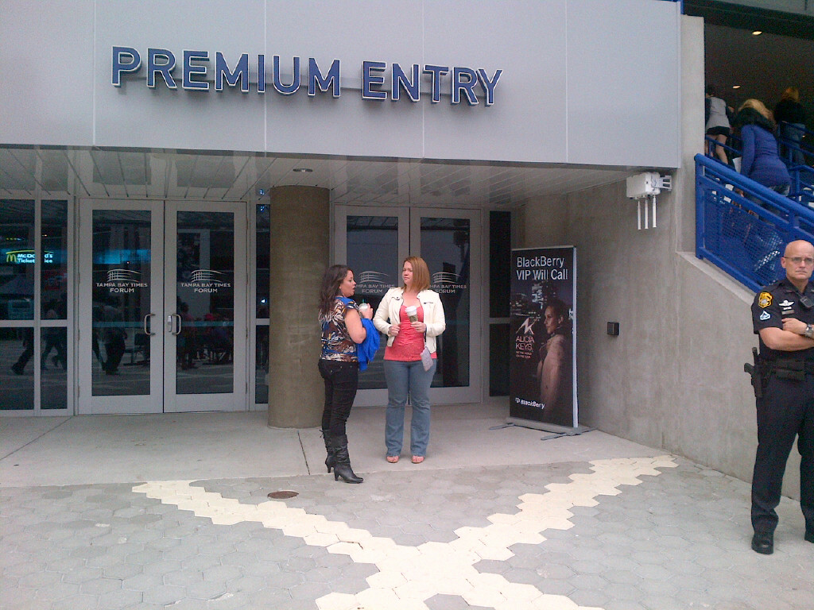 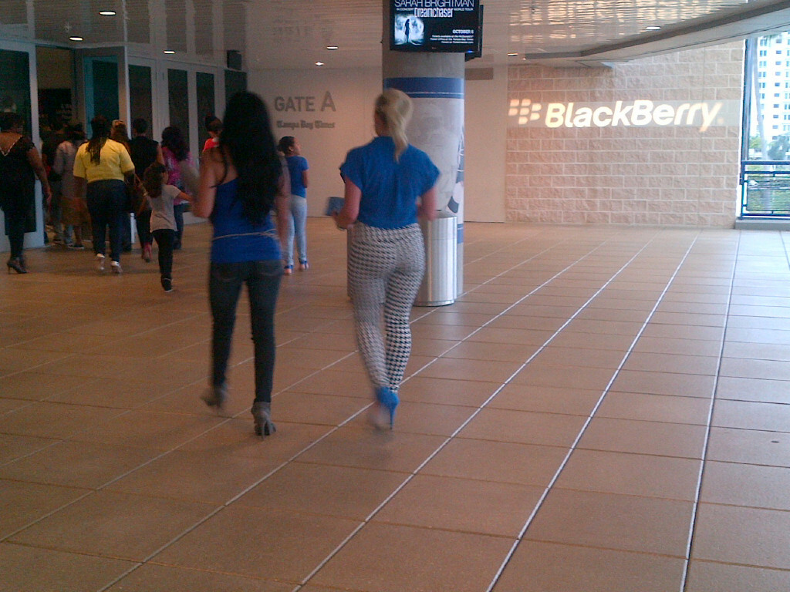 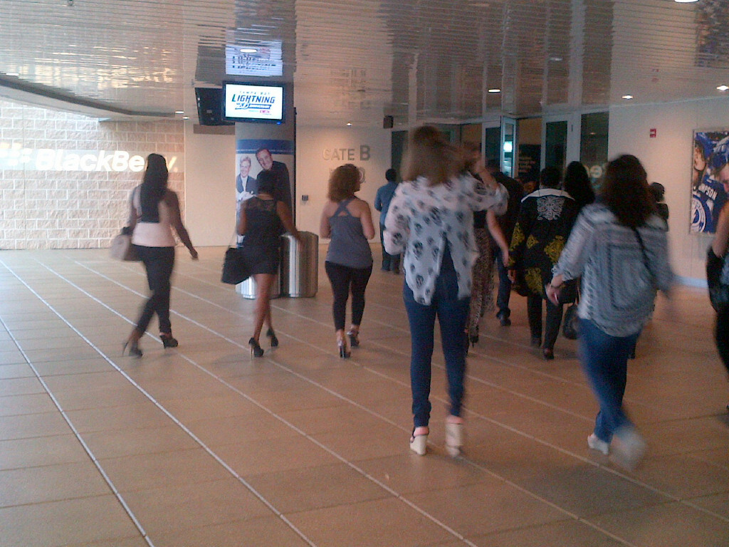

**Internal Venue:**

|  |  |
| --- | --- |
| **Details:** | Monitors and Signage throughout |

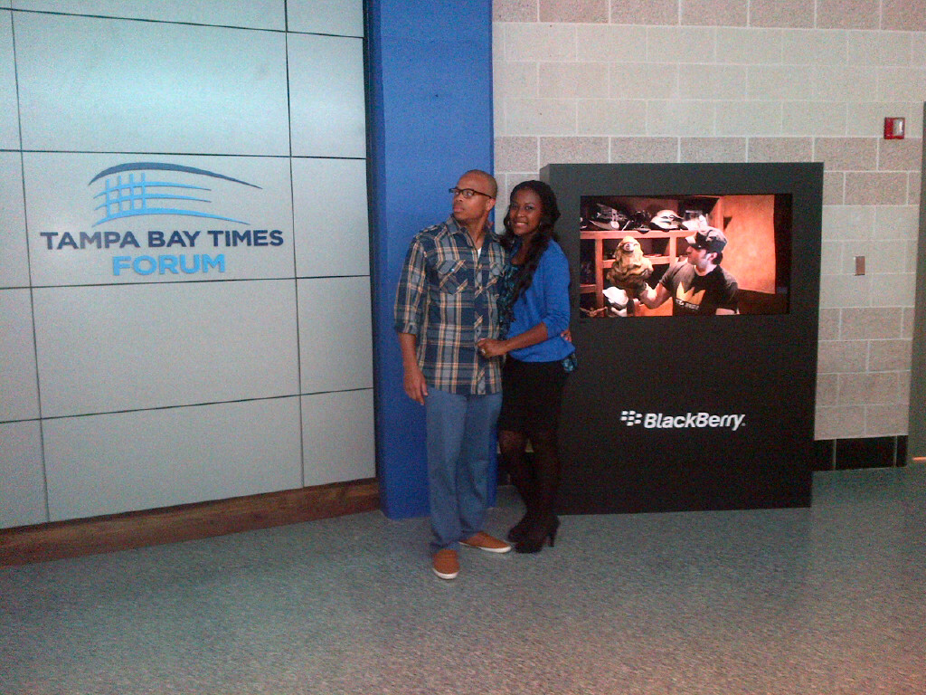 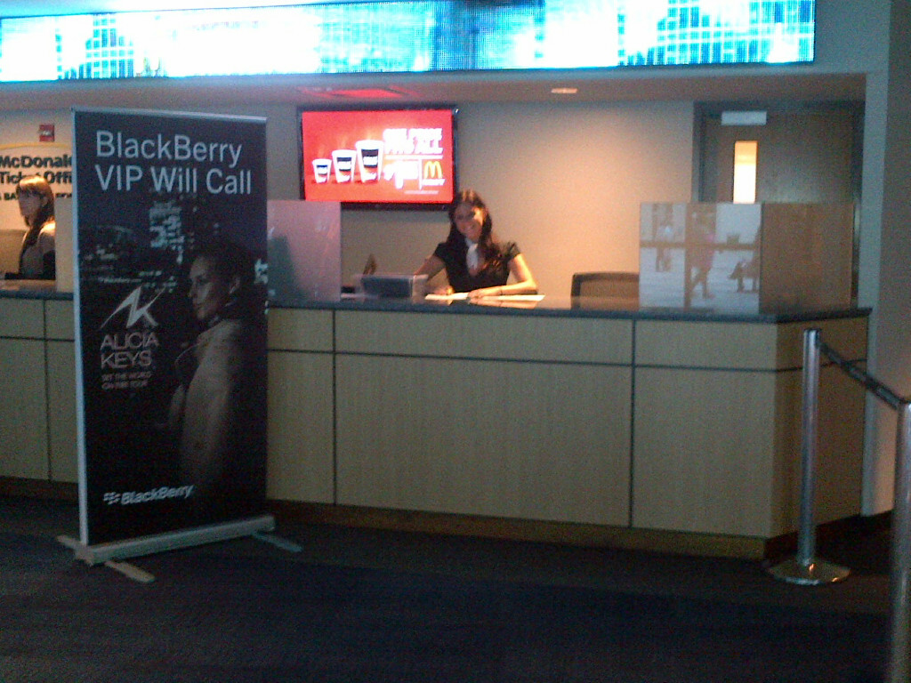 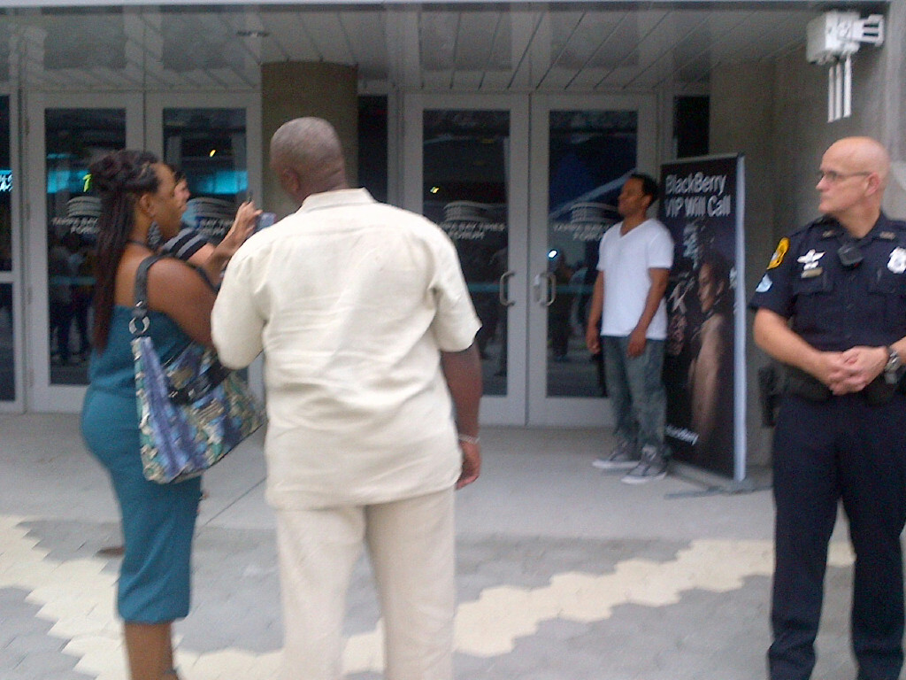

**Concourse:**

|  |  |
| --- | --- |
| **Details:** | 2 hubs: 1 large one in the main intersection of the concourse, 1 smaller one next to Guest Services. |

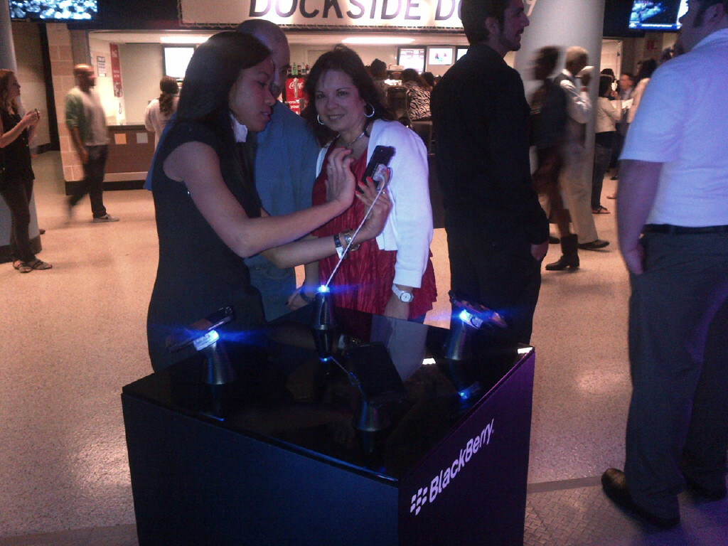 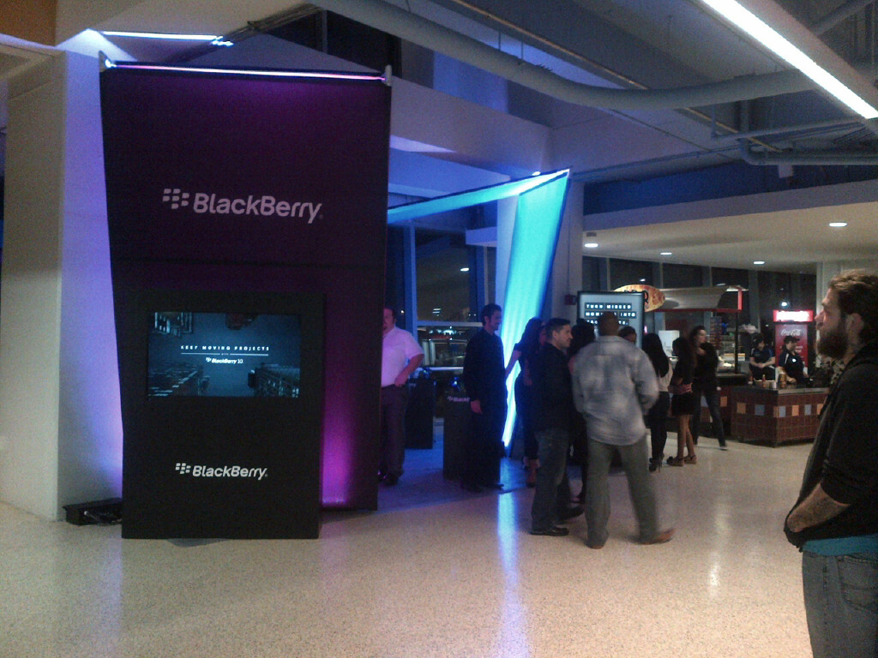 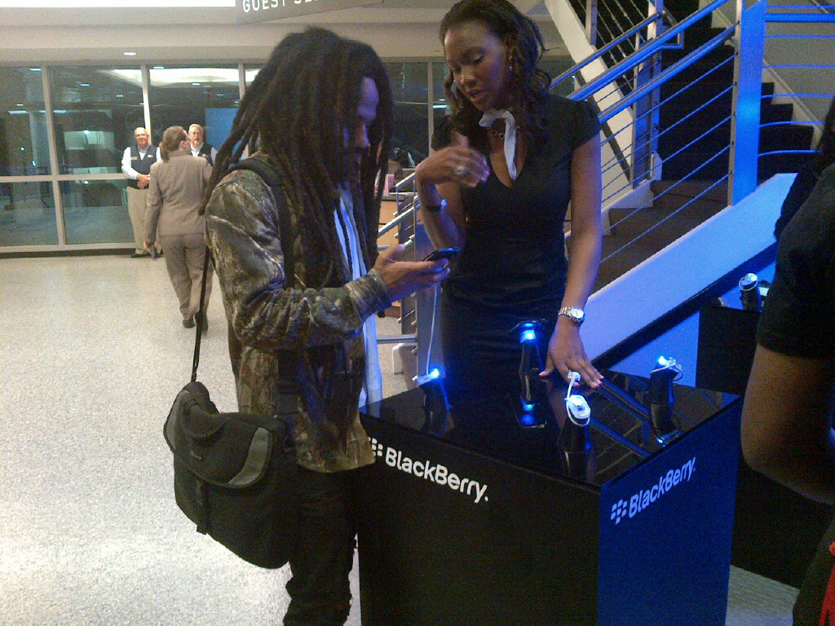

**Jumbotron:**

|  |  |
| --- | --- |
| **Details:** | The Keep Moving video plays near the end of the AK show. As well as the video playing pre-show. |

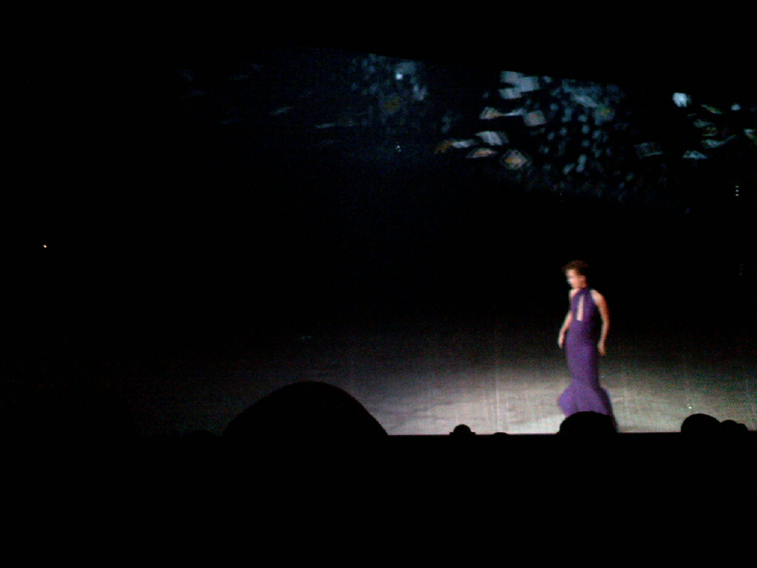 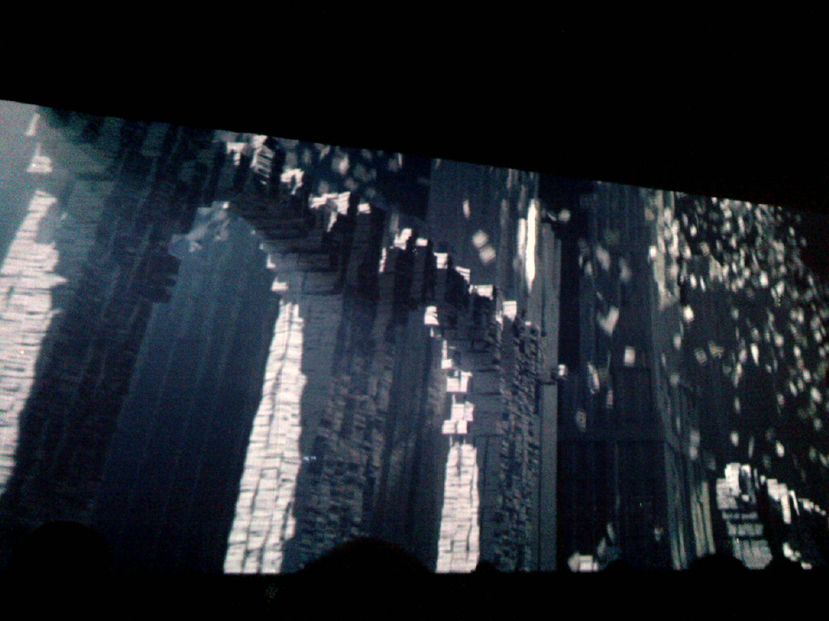 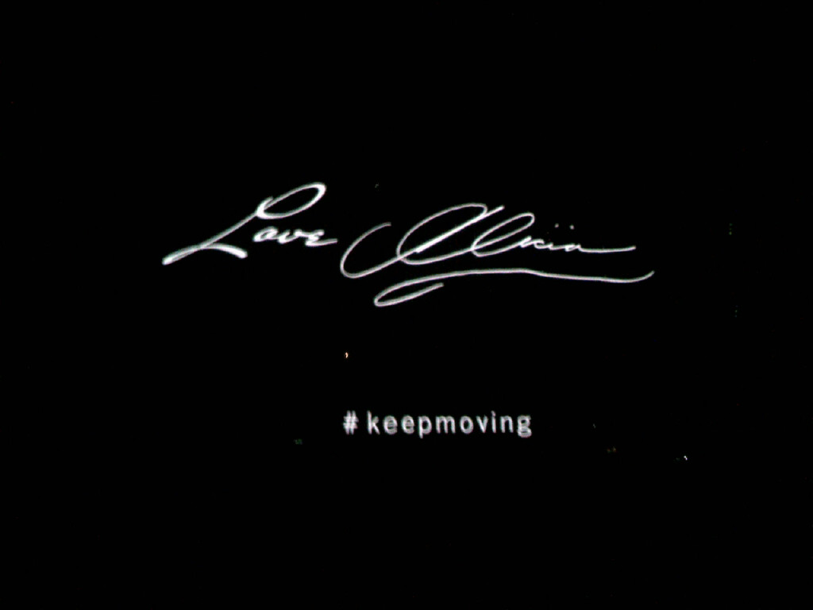

**Stage Screens:**

|  |  |
| --- | --- |
| **Details:** |  |

  

**Additional Branding:**

|  |  |
| --- | --- |
| **Details:** |  |

  

**Competitor Branding:**

|  |  |
| --- | --- |
| **Details:** |  |

  