

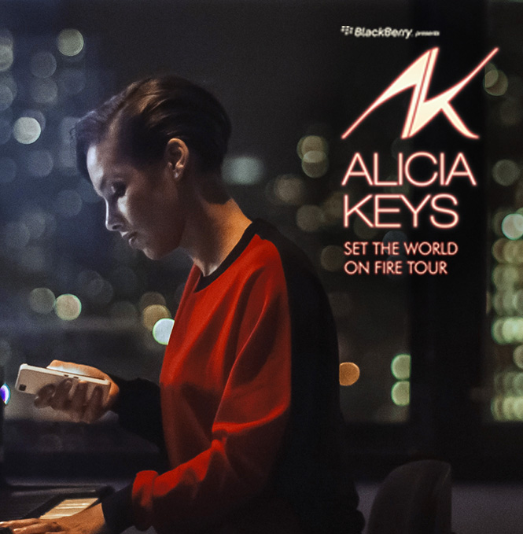

**BlackBerry Presents Alicia Keys**

**‘Set the World on Fire Tour’**

**Event Report**

**Atlanta**

**March 29th, 2013**

**QUICK STATS**

**OVERALL EVENT INFORMATION**

**Manager:** Molly Williams

|  |  |
| --- | --- |
| **City:** | Atlanta |
| **Venue:** | Philips Arena |
|  |  |
| **Doors Open:** | 6:00pm |
| **Show time:** |  |
| **Overall Attendance:** | 8785 |
| **Will Call Location:** | Techwood VIP Entrance next to Main Box Office |
|  |  |
| **Tickets Allocated:** | 168 |
| **RSVP Total:** | 84 |
| **Tickets Used:** | 0 |
| **Avg. Arrival Time:** | 6:45 pm |
|  |  |
| **Weather:** | Clear & 59 degrees |

|  |  |
| --- | --- |
| **Guest Comment:** |  |

|  |  |
| --- | --- |
| **Manager Comment:** |  |

**DIRECT ENGAGEMENT NUMBERS**

|  |  |
| --- | --- |
| **Number of Hubs:** | 2 |
| **Location:** | Main Concourse |
|  |  |
| **# Brand Ambassadors:** | 26 |
| **# of Demos:** | 1100 |
| **Est. Dwell Time:** | 2 mins |
| **# of Photos Emailed:** | 113 |
| **Giveaways:** | 0 |
| **Promotional Material:** | 0 |
| **Activity Feedback:** |  |

|  |  |
| --- | --- |
| **Most Asked Questions:** |  |

|  |  |
| --- | --- |
| **Feedback:** |  |

**HOSPITALITY**

|  |  |
| --- | --- |
| **Location:** | Backstage - loading dock |
| **Type:** | AT&T Carrie Lepage. Pre show hospitality. |
|  |  |
| **# of Guests RSVP:** | 88 |
| **# of Guests Attended:** | 77 plus |
| **Guest Type:** | AT&T |
| **# of Ambassadors:** | 26 |
| **Décor Used:** | 16 light cubes, 2 peekaboo tables, atomic wall, new atomic wall BlackBerry panels, 5 ottomans, 1 blue sofa, 2 light bars, 2 chandeliers |
| **Menu:** | Mini beef wellingtons with boursin cream Pimiento cheese pretzel crostini Beef satay with red eye gravy Southern shrimp roll Ã¢ï¿½ï¿½ blackened shrimp remoulade, scallion, roasted red pepper, benne Prosciutto wrapped melon Local Georgia cheese Ã¢ï¿½ï¿½ Thomasville Tomme, Asher Blue, Heat, Green Hill Mini caprese panini Ã¢ï¿½ï¿½ buffalo mozzarella, basil, tomato Mini quiches Chocolate mousse sweet shots Red velvet sweet shots Imported and domestic beer Wines by the glass Soft drinks Bottled water |
| **Gift Bags:** | N/A |

**BRAND AMBASSADORS**

|  |  |
| --- | --- |
| **On Duty Manager:** | Thekla Roth |
| **# Brand Ambassadors:** | 26 |

**RADIO**

|  |  |
| --- | --- |
| **Station Name:** | WSTR - Star 94 |
| **Giveaway:** | (5) Pairs of Tickets |
| **Audio URL:** |  |
| **Notes:** | Star gave away tickets through an on-air trivia contest during PMD from 3/25 - 3/27 (2 pairs on 3/25 & 3/26, 1 pair on 3/27) |

  

**BRANDING**

**External Venue:**

|  |  |
| --- | --- |
| **Details:** | BlackBerry VIP Will Call signage outside Techwood VIP Entrance. |

  

**Internal Venue:**

|  |  |
| --- | --- |
| **Details:** | Roaming BAs on the Concourse captured several captive consumers, taking their photos and demoing Time Shift. |

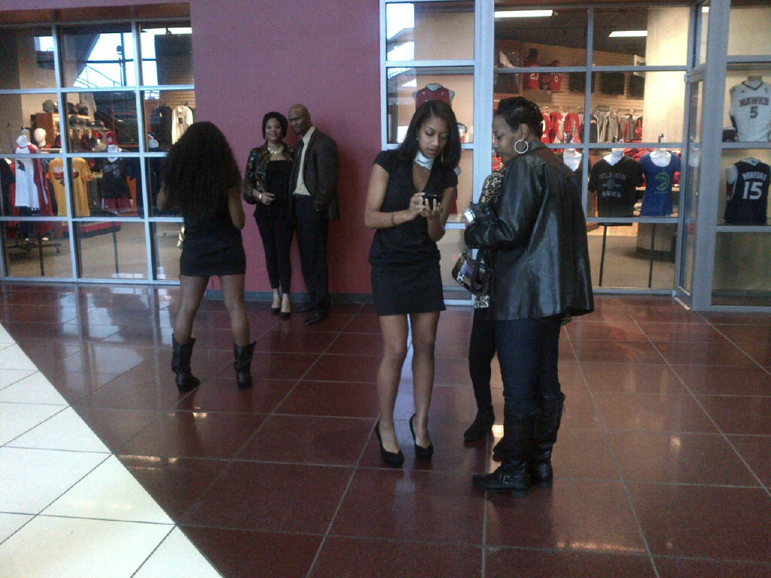  

**Concourse:**

|  |  |
| --- | --- |
| **Details:** | 2 full size hubs in high-traffic areas on the concourse. 1 near the main entrance, and 1 where all patrons have to go to Floor seats. |

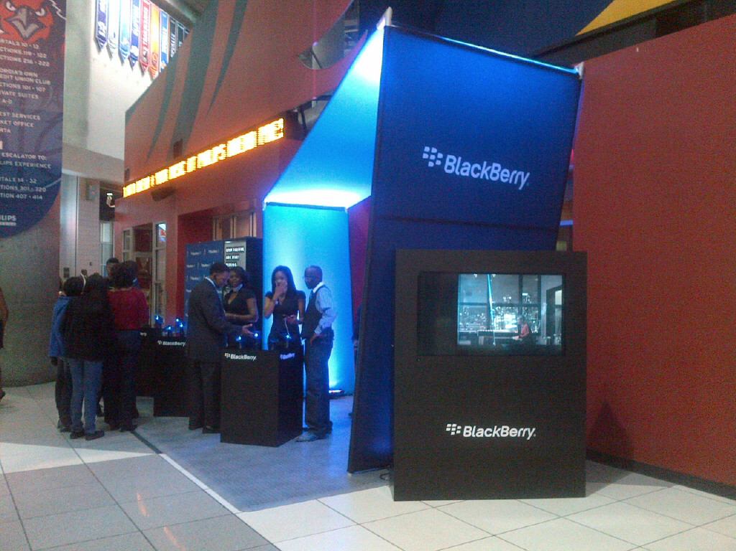 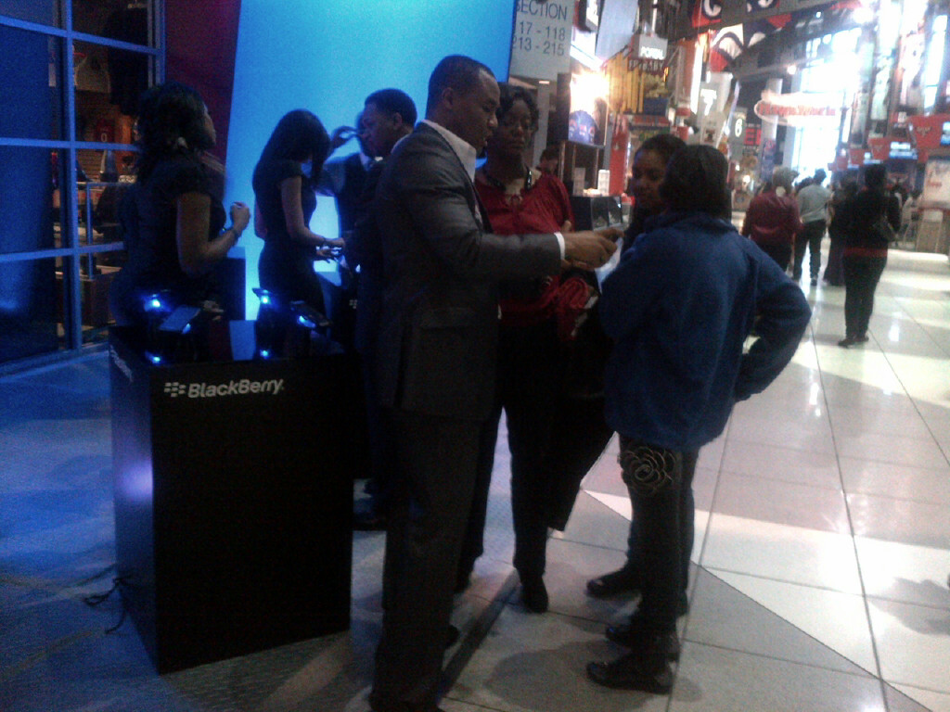 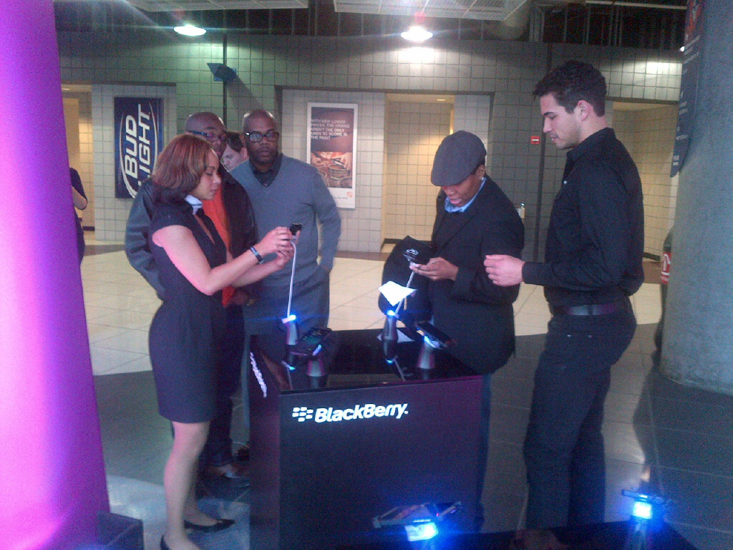

**Jumbotron:**

|  |  |
| --- | --- |
| **Details:** |  |

  

**Stage Screens:**

|  |  |
| --- | --- |
| **Details:** |  |

  

**Additional Branding:**

|  |  |
| --- | --- |
| **Details:** | AT&T Backstage Hospitality Party, directly behind stage. |

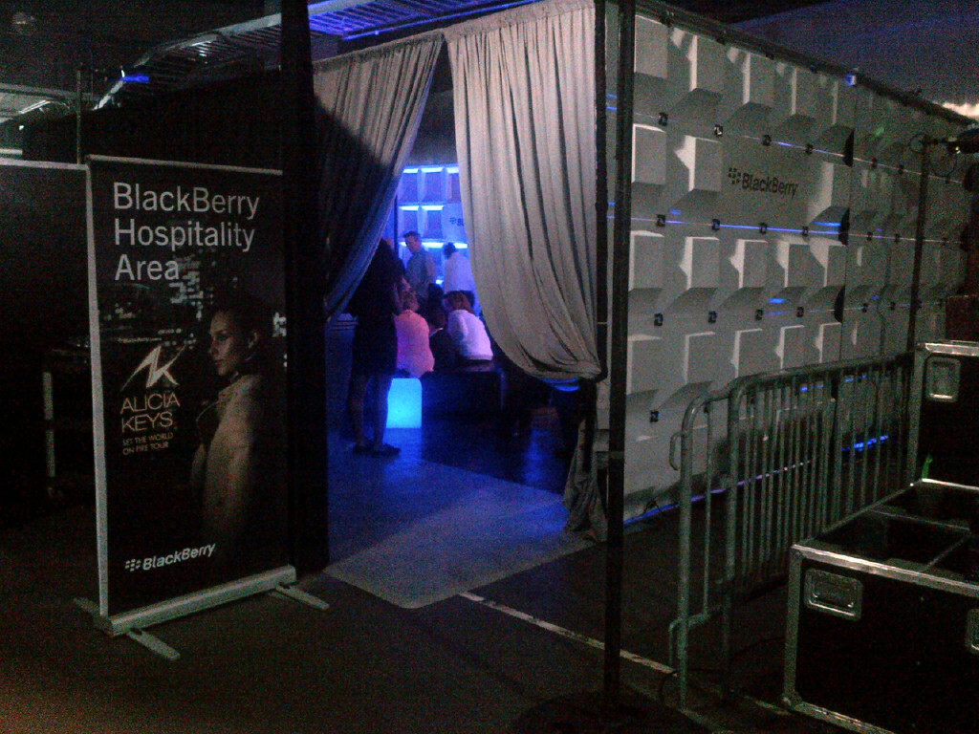 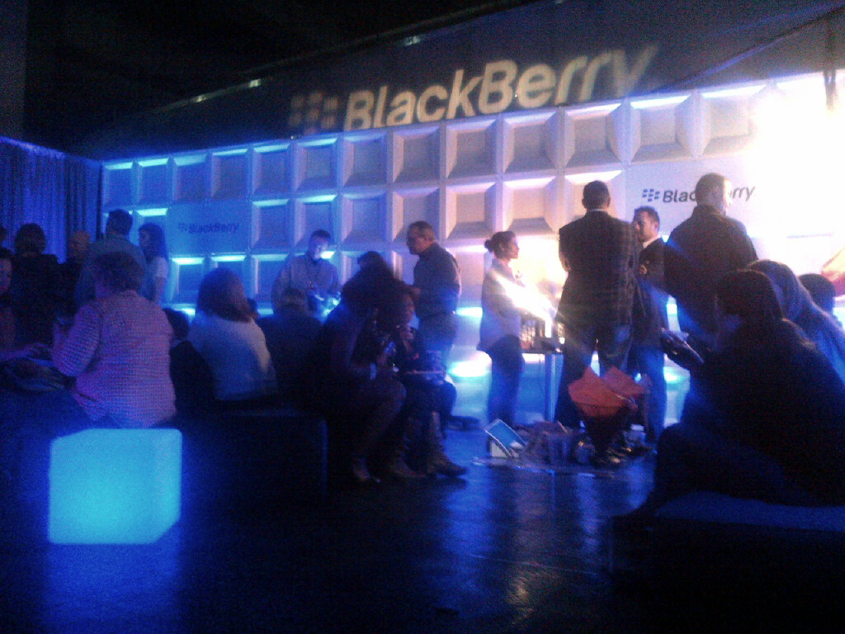 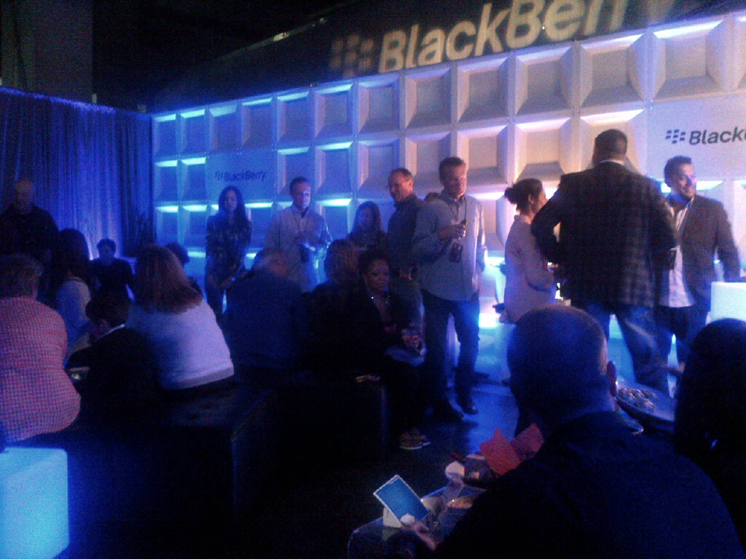

**Competitor Branding:**

|  |  |
| --- | --- |
| **Details:** |  |

  