截图

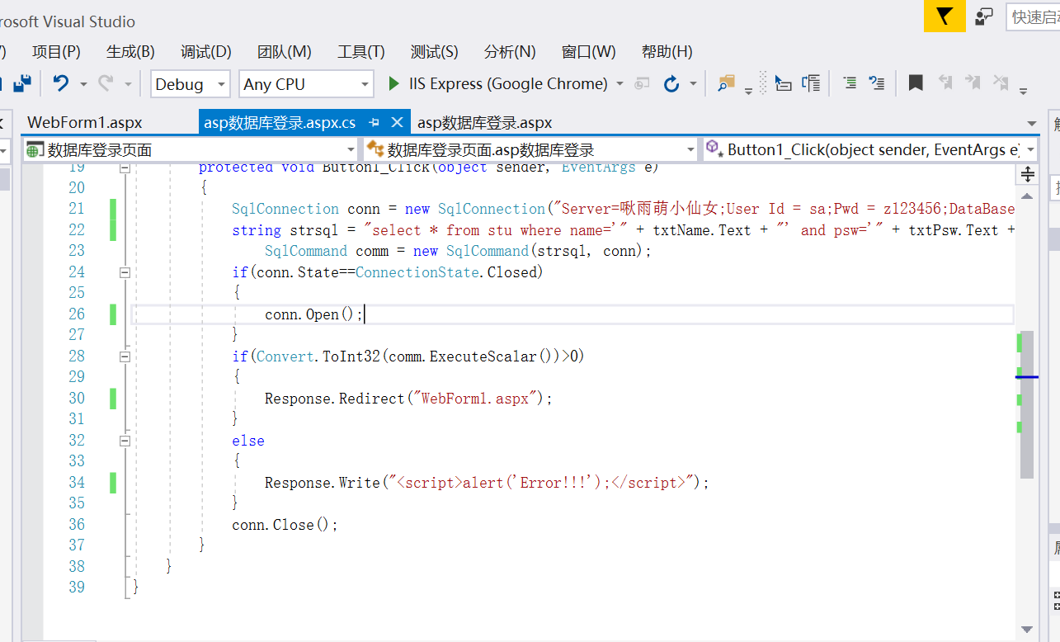

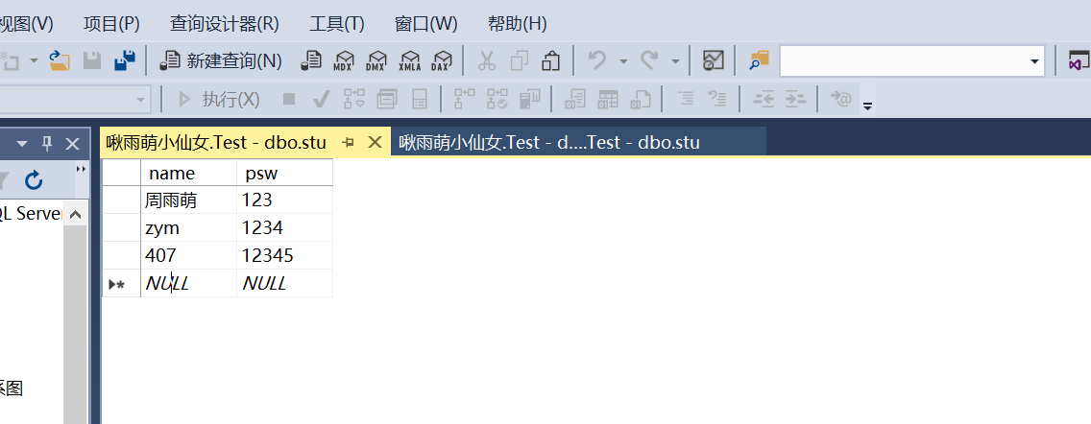

结果

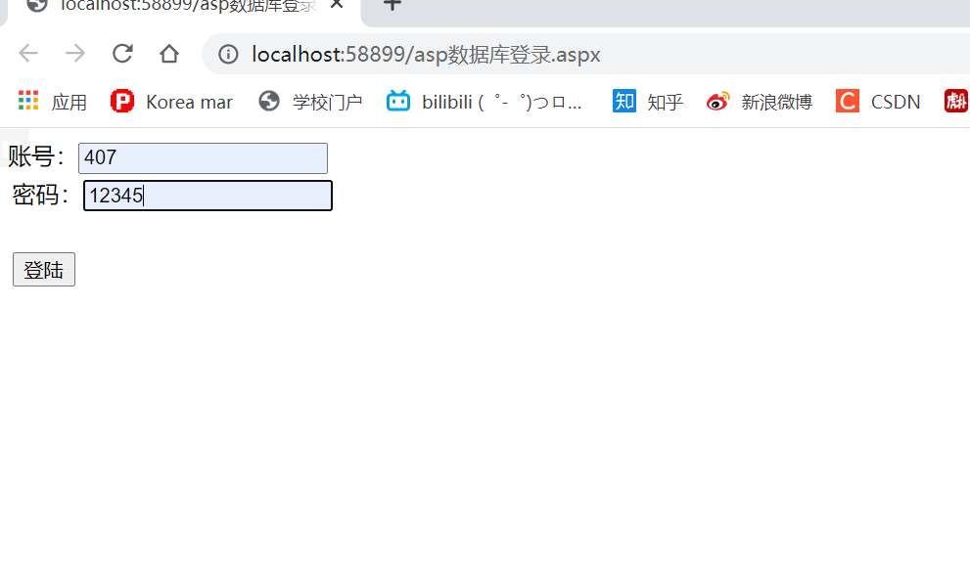

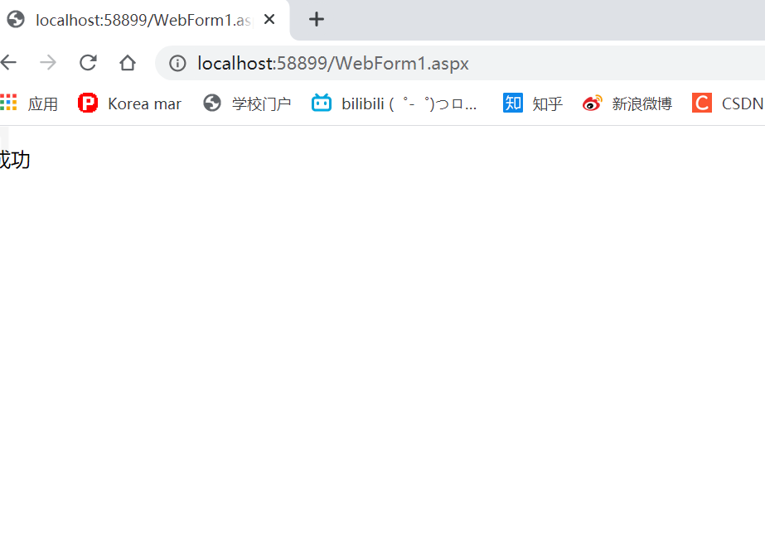

后代码

using System;

using System.Collections.Generic;

using System.Linq;

using System.Web;

using System.Web.UI;

using System.Web.UI.WebControls;

using System.Data;

using System.Data.SqlClient;

namespace 数据库登录页面

{

public partial class asp数据库登录 : System.Web.UI.Page

{

protected void Page_Load(object sender, EventArgs e)

{

}

protected void Button1_Click(object sender, EventArgs e)

{

SqlConnection conn = new SqlConnection("Server=啾雨萌小仙女;User Id = sa;Pwd = z123456;DataBase=Test");

string strsql = "select * from stu where name='" + txtName.Text + "' and psw='" + txtPsw.Text + "'";

SqlCommand comm = new SqlCommand(strsql, conn);

if(conn.State==ConnectionState.Closed)

{

conn.Open();

}

if(Convert.ToInt32(comm.ExecuteScalar())>0)

{

Response.Redirect("WebForm1.aspx");

}

else

{

Response.Write("<script>alert('Error!!!');</script>");

}

conn.Close();

}

}

}