前四种磁盘调度算法
操作系统实验报告

题目: ___实验五前四种磁盘调度算法______
学号:__ _ __ 10518407 ________
姓名:_ ____ 周雨萌 ___ ______
教师:__ _ _ __ _ 王老师 ___

东南大学成贤学院计算机系
2021年1月10日

一、实验简介
1)FCFS算法实现思路：将vector内随机产生的数依次读出，相当于对于队列数据结构中的出队操作。

2)SSTF算法实现思路：在时间复杂度和空间复杂度上的综合考虑，我首先将vector内的数据进行排序，然后确定当前磁道号在有序数据中的位置，然后在该位置的左右找到离它最近的数，并将当前位置进行刷新。

3)SCAN算法实现思路：首先将vector内的数据进行排序，然后同样地确定当前磁道号在有序数据中的位置，然后在向内的方向上依次访问，访问完了之后，再输出初始位置向外的服务序列。

4)CSCAN算法实现思路：开始和前面的算法一样，也是先进行排序，定位，然后在向内的方向上依次访问，访问完了之后，再从最外层向内扫。
二、实验环境
Vs2017
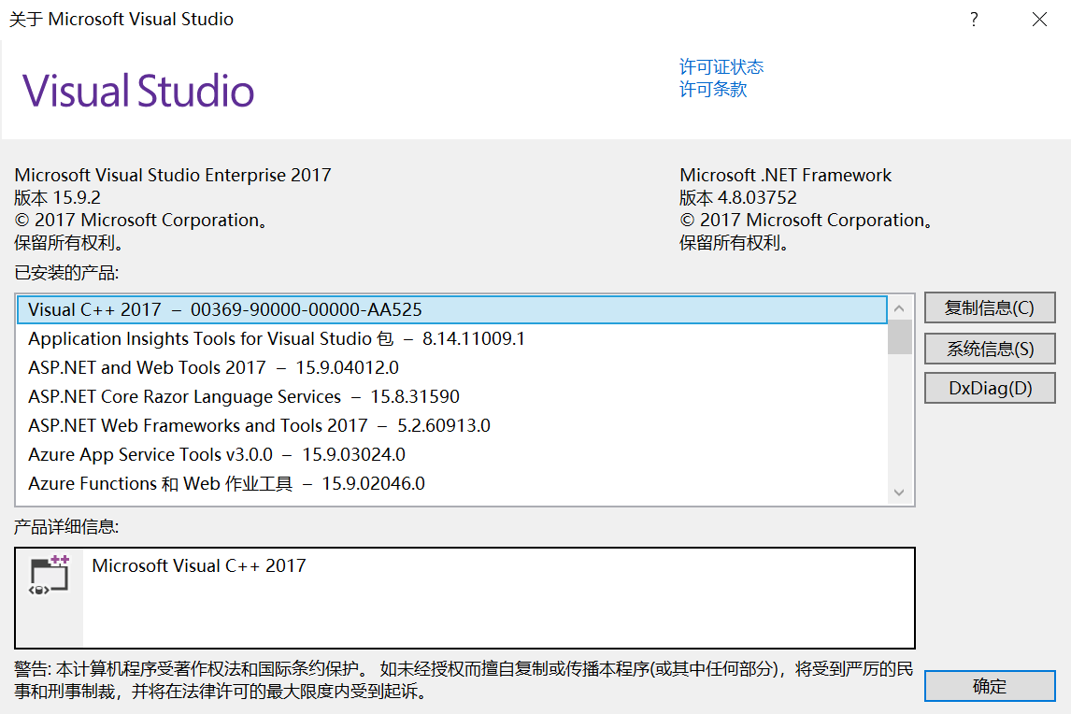
三、实验截图
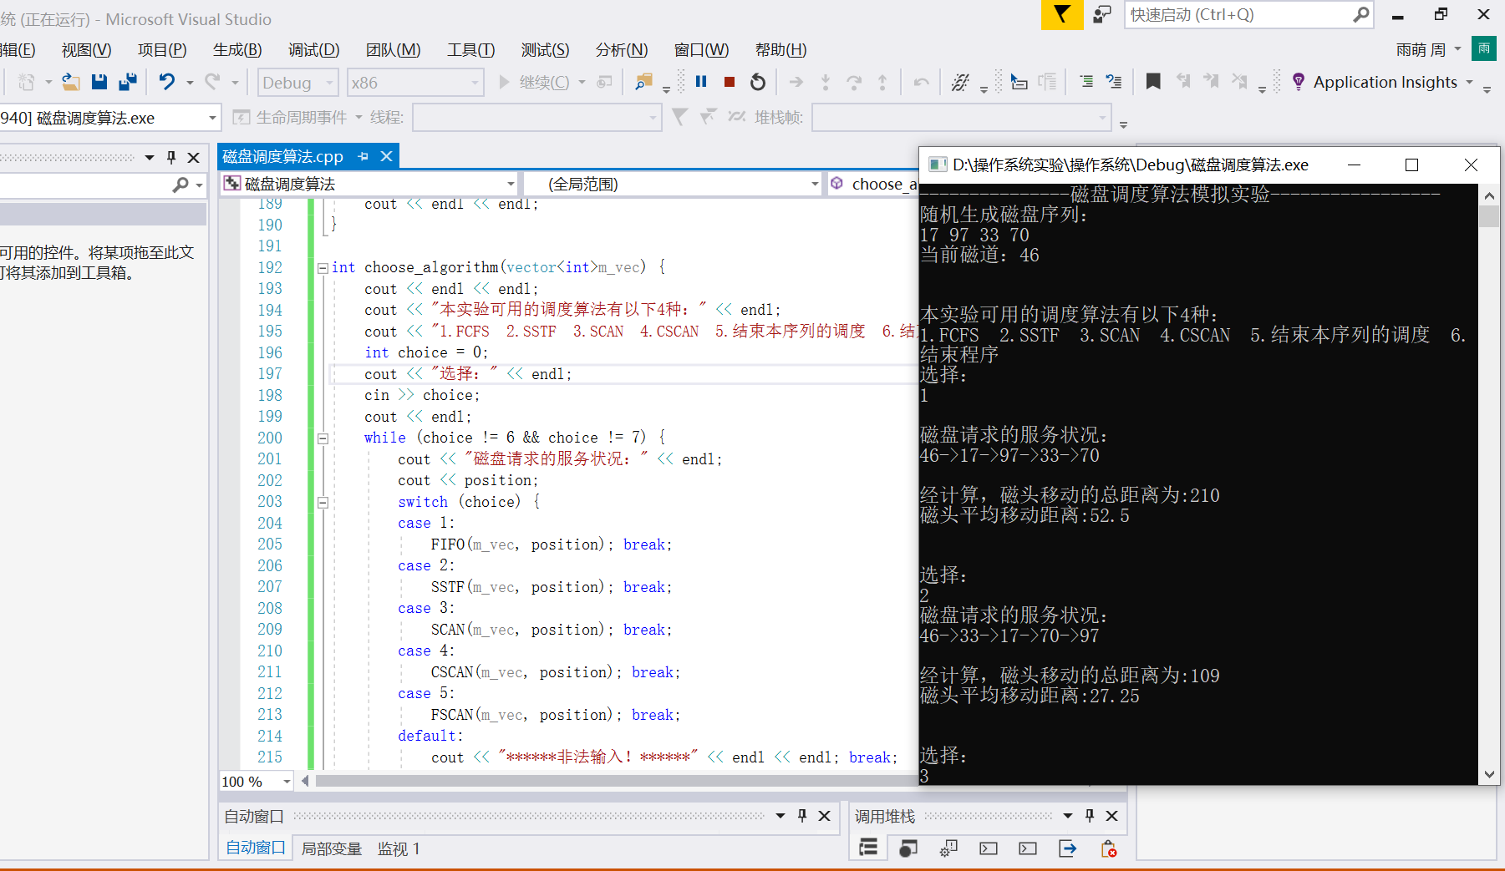

四种算法的运行:
(1) FCFS
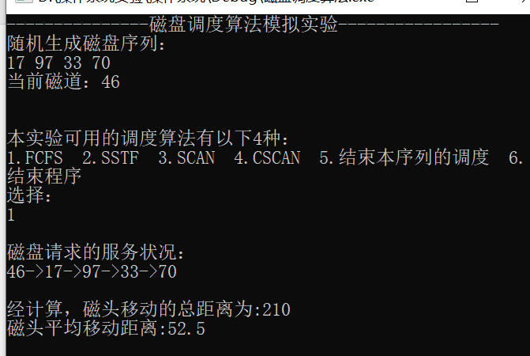

(2) SSTF
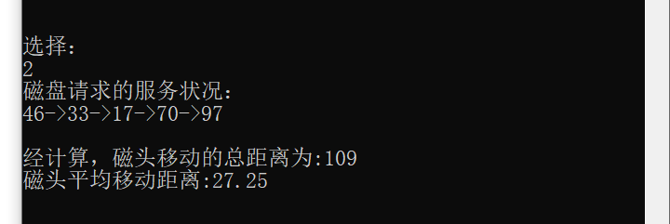

(3)SCAN
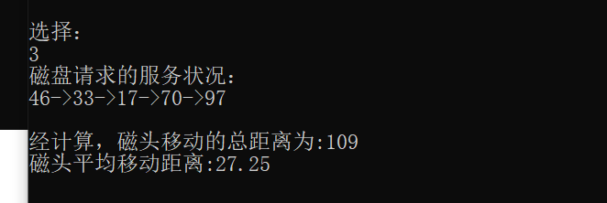

(4)CSCAN

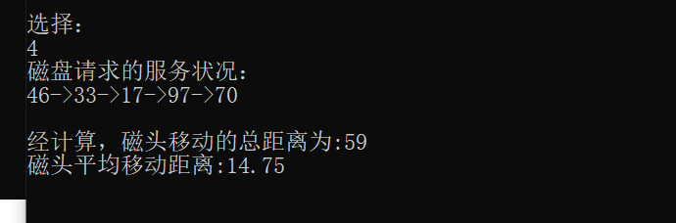

四、实验源代码

#include <iostream>
#include <time.h>
#include <vector>
#include <math.h>
#include <stdlib.h>
#include <algorithm>
#include <cstring>
#include <windows.h>
#include <fstream>
using namespace std;

int position = 0; //当前磁道位置
int dis = 0;
double average_distance = 0;

void request(vector<int>&m_vec, ofstream &outfile) {
cout << "随机生成磁盘序列：" << endl;
int n = 0;
srand(time(NULL)); //添加随机数种子
n = rand() % 20 + 1;
int temp = 0;
for (int i = 0; i < n; i++) {
temp = rand() % 100;
m_vec.push_back(temp);
cout << temp << " ";
outfile << temp << endl;
}
cout << endl;
position = rand() % 100;
cout << "当前磁道：" << position << endl;
}

void compute_dis(vector<int>m_vec, int &dis, double &average_distance) {
average_distance = (double)dis / (double)m_vec.size();
}

void FIFO(vector<int>m_vec, int position) { //先来先服务算法
dis = 0;
average_distance = 0;
for (vector<int>::iterator it = m_vec.begin(); it != m_vec.end(); it++) {
dis += abs(position - *it);
Sleep(500);
cout << "->" << *it;
position = *it;
}
compute_dis(m_vec, dis, average_distance);
}

void SSTF(vector<int>m_vec, int position) { //最短寻道时间算法
dis = 0;
average_distance = 0;
sort(m_vec.begin(), m_vec.end()); //从小到大排序
int i = 0;
for (vector<int>::iterator it = m_vec.begin(); it != m_vec.end(); it++) {
if (position >= *it)
i++;
}
int count = 0;
int left = i - 1;
int right = i;
while (count < m_vec.size()) {
if ((left >= 0 && abs(m_vec[right] - position) > abs(m_vec[left] - position)) || right >= m_vec.size()) {
dis += abs(m_vec[left] - position);
Sleep(500);
cout << "->" << m_vec[left];
position = m_vec[left];
left--;
}
else {
dis += abs(m_vec[right] - position);
Sleep(500);
cout << "->" << m_vec[right];
position = m_vec[right];
right++;
}
count++;
}
compute_dis(m_vec, dis, average_distance);
}

void SCAN(vector<int>m_vec, int position) { //电梯调度算法
dis = 0;
average_distance = 0;
sort(m_vec.begin(), m_vec.end()); //从小到大排序
int i = 0;
for (vector<int>::iterator it = m_vec.begin(); it != m_vec.end(); it++) {
if (position >= *it)
i++; //找到position所在的磁道
}
int left = i - 1; //先从外到内扫描
int right = i;
while (left >= 0) {
dis += abs(position - m_vec[left]);
Sleep(500);
cout << "->" << m_vec[left];
position = m_vec[left];
left--;
}
while (right < m_vec.size()) {
dis += abs(position - m_vec[right]);
Sleep(500);
cout << "->" << m_vec[right];
position = m_vec[right];
right++;
}
compute_dis(m_vec, dis, average_distance);
}

void CSCAN(vector<int>m_vec, int position) { //循环扫描算法
dis = 0;
average_distance = 0;
sort(m_vec.begin(), m_vec.end()); //从小到大排序
int i = 0;
for (vector<int>::iterator it = m_vec.begin(); it != m_vec.end(); it++) {
if (position >= *it)
i++; //找到position所在的磁道
}
int left = i - 1; //先从外到内扫描
int right = i;
while (left >= 0) {
dis += abs(position - m_vec[left]);
Sleep(500);
cout << "->" << m_vec[left];
position = m_vec[left];
left--;
}
position = 100; //立即到最外侧的磁道
int len = m_vec.size() - 1;
while (len >= right) {
dis += abs(position - m_vec[len]);
Sleep(500);
cout << "->" << m_vec[len];
position = m_vec[len];
len--;
}
compute_dis(m_vec, dis, average_distance);
}

void FSCAN(vector<int>m_vec, int position) { //分步电梯调度算法，。分两个队列
dis = 0;
average_distance = 0;
//SCAN(m_vec,position);
sort(m_vec.begin(), m_vec.end()); //从小到大排序
int i = 0;
for (vector<int>::iterator it = m_vec.begin(); it != m_vec.end(); it++) {
if (position >= *it)
i++; //找到position所在的磁道
}
int left = i - 1; //先从外到内扫描
int right = i;
while (left >= 0) {
dis += abs(position - m_vec[left]);
Sleep(500);
cout << "->" << m_vec[left];
position = m_vec[left];
left--;
}
while (right < m_vec.size()) {
dis += abs(position - m_vec[right]);
Sleep(500);
cout << "->" << m_vec[right];
position = m_vec[right];
right++;
}
cout << endl;
cout << "在扫描的过程中新产生的服务序列：" << endl;
vector<int>ve;
while (!ve.empty())
ve.pop_back();
int n = 0;
n = rand() % 20 + 1;
int temp = 0;
for (i = 0; i < n; i++) {
temp = rand() % 100;
cout << temp << " ";
ve.push_back(temp);
}
cout << endl;
cout << position;
SCAN(ve, position);
average_distance = (double)dis / (double)(m_vec.size() + ve.size());
}

void print() {
cout << endl << endl;
cout << "经计算，磁头移动的总距离为:" << dis << endl;
cout << "磁头平均移动距离:" << average_distance << endl;
cout << endl << endl;
}

int choose_algorithm(vector<int>m_vec) {
cout << endl << endl;
cout << "本实验可用的调度算法有以下4种：" << endl;
cout << "1.FCFS 2.SSTF 3.SCAN 4.CSCAN 5.结束本序列的调度 6.结束程序" << endl;
int choice = 0;
cout << "选择：" << endl;
cin >> choice;
cout << endl;
while (choice != 6 && choice != 7) {
cout << "磁盘请求的服务状况：" << endl;
cout << position;
switch (choice) {
case 1:
FIFO(m_vec, position); break;
case 2:
SSTF(m_vec, position); break;
case 3:
SCAN(m_vec, position); break;
case 4:
CSCAN(m_vec, position); break;
case 5:
FSCAN(m_vec, position); break;
default:
cout << "******非法输入！******" << endl << endl; break;
}
if (choice <= 7 && choice >= 1)
print();
cout << "选择：" << endl;
cin >> choice;
}
if (choice == 7)
return 0;
else
cout << endl << endl;
return 1;
}

int main() {
cout << "---------------磁盘调度算法模拟实验-----------------" << endl;
ofstream outfile;
outfile.open("data.txt");
while (1) {
vector<int> vec;
while (!vec.empty())
vec.pop_back();
request(vec, outfile); //请求服务序列
int flag = choose_algorithm(vec);
if (flag == 0)
break;
}
outfile.close();
return 0;
}五、实验心得总结
本次实验，我通过将书本上的四种磁盘调度算法实际操作到实验中，觉得对知识的理解更深刻了，巩固了算法的理解和意义，希望可以再接再厉。

