同步互斥模拟实验
操作系统实验报告

题目: ___实验一同步互斥模拟实验______
学号:__ _ __ 10518407 ________
姓名:_ ____ 周雨萌 ___ ______
教师:__ _ _ __ _ 王老师 ___

东南大学成贤学院计算机系
2021年1月10日

一、实验简介
1）利用互斥的思想完成模拟购票
2）利用同步的思想完成抢三十小游戏
二、实验环境
Vs2017

三、实验截图
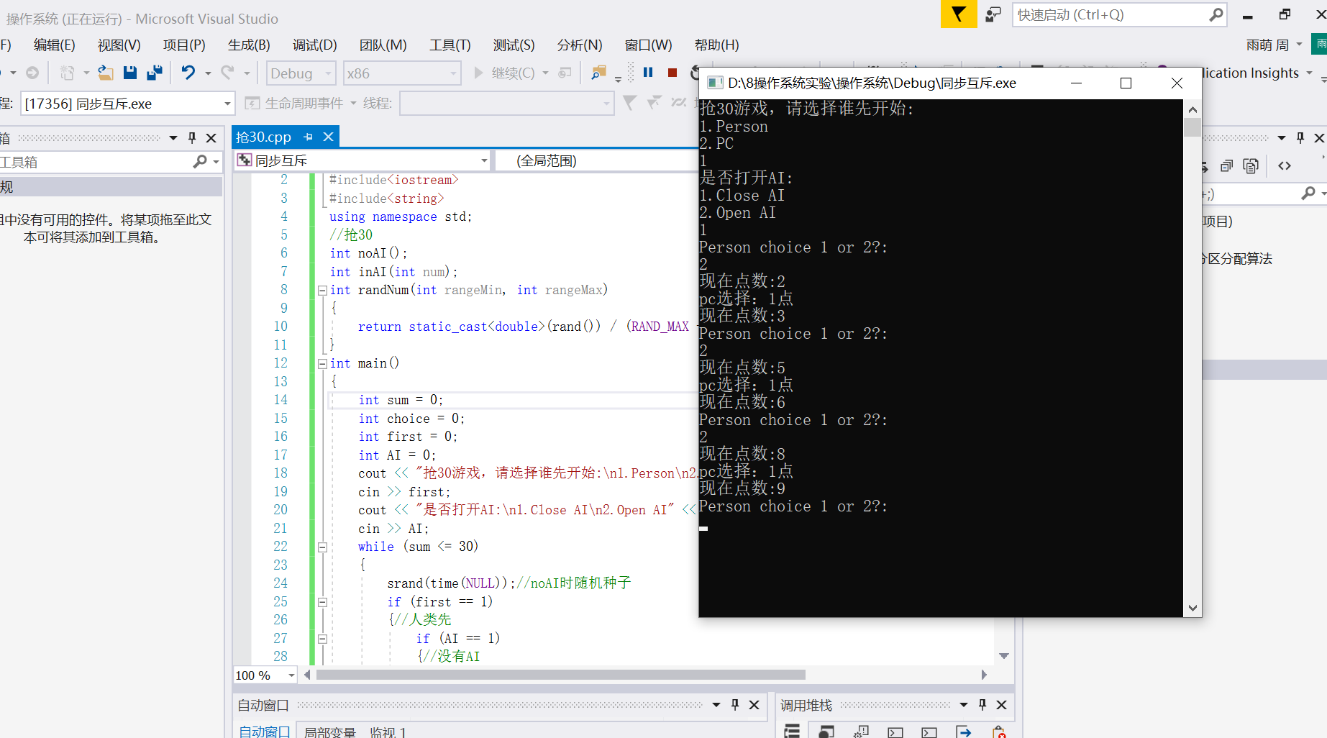
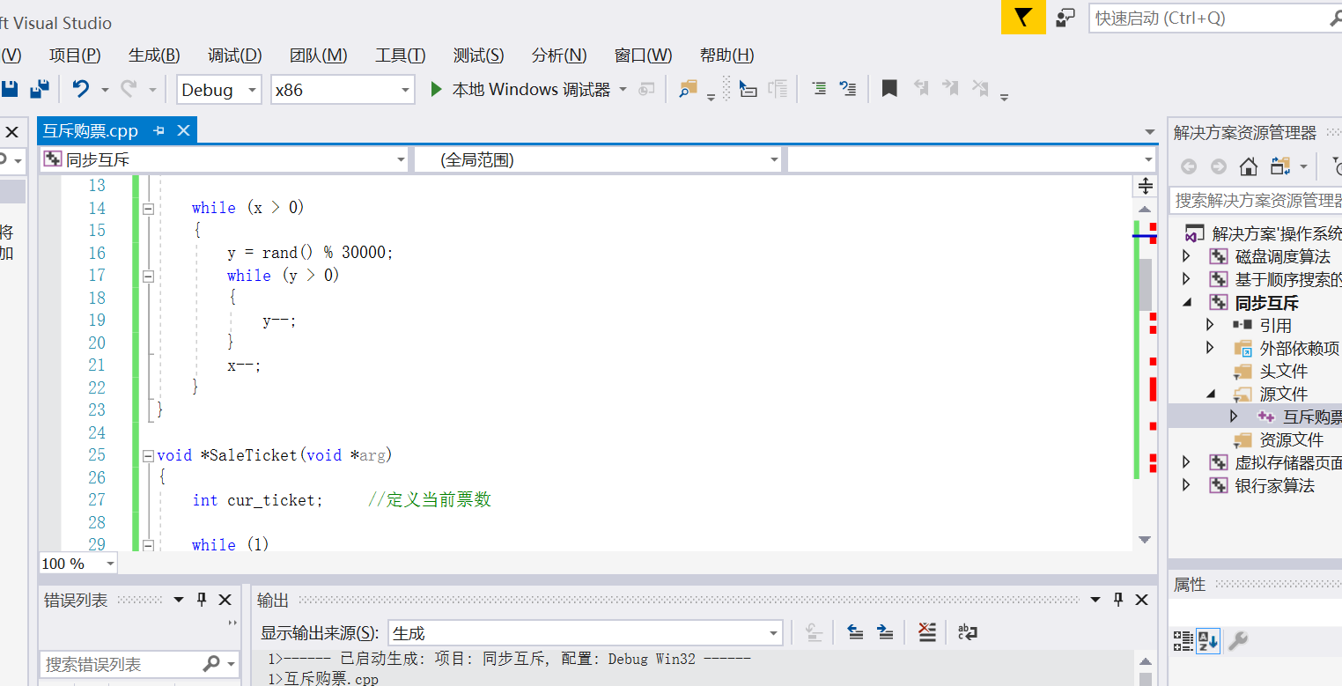

四、运行结果

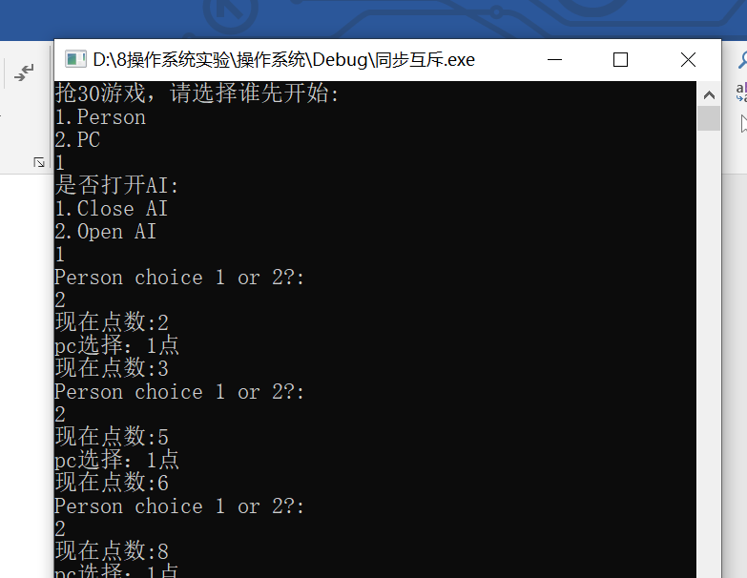
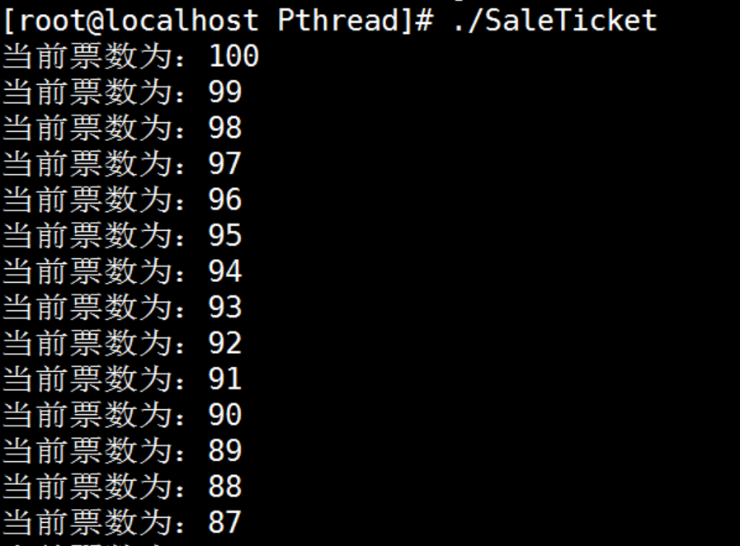

四、实验源代码

#include<time.h>
#include<iostream>
#include<string>
using namespace std;
//抢30
int noAI();
int inAI(int num);
int randNum(int rangeMin, int rangeMax)
{
return static_cast<double>(rand()) / (RAND_MAX + 1)*(rangeMax - rangeMin + 1) + rangeMin;
}
int main()
{
int sum = 0;
int choice = 0;
int first = 0;
int AI = 0;
cout << "抢30游戏，请选择谁先开始:\n1.Person\n2.PC" << endl;
cin >> first;
cout << "是否打开AI:\n1.Close AI\n2.Open AI" << endl;
cin >> AI;
while (sum <= 30)
{
srand(time(NULL));//noAI时随机种子
if (first == 1)
{//人类先
if (AI == 1)
{//没有AI
cout << "Person choice 1 or 2?:" << endl;
cin >> choice;
if (choice > 2)
{
cout << "耍阴招,Person lose!";
break;
}
sum += choice;
if (sum == 30)
{
cout << "Person win!" << endl;
break;
}
cout << "现在点数:" << sum << endl;
int pc = noAI();
cout << "pc选择：" << pc << "点" << endl;
sum += pc;
if (sum >= 30)
{
cout << "AI win!" << endl;
break;
}
}
else
{//有AI
cout << "Person choice 1 or 2?:" << endl;
cin >> choice;
if (choice > 2)
{
cout << "耍阴招,Person lose!";
break;
}
sum += choice;
if (sum == 30)
{
cout << "Person win!" << endl;
break;
}
cout << "现在点数:" << sum << endl;
int pc = inAI(sum);
cout << "pc选择：" << pc << "点" << endl;
sum += pc;
if (sum >= 30)
{
cout << "AI win!" << endl;
break;
}
}
}
else
{//人类后
if (AI == 1)
{//没有AI
int pc = noAI();
sum += pc;
if (sum >= 30)
{
cout << "AI win!" << endl;
break;
}
cout << "PC选择：" << pc << "点" << endl;
cout << "现在点数:" << sum << endl;
cout << "Person choice 1 or 2?:" << endl;
cin >> choice;
if (choice > 2)
{
cout << "耍阴招,Person lose!";
break;
}
sum += choice;
if (sum == 30)
{
cout << "Person win!" << endl;
break;
}
}
else
{//有AI
int pc = inAI(sum);
sum += pc;
if (sum >= 30)
{
cout << "AI win!" << endl;
break;
}
cout << "PC选择：" << pc << "点" << endl;
cout << "现在点数:" << sum << endl;
cout << "Person choice 1 or 2?:" << endl;
cin >> choice;
if (choice > 2)
{
cout << "耍阴招,Person lose!";
break;
}
sum += choice;
if (sum == 30)
{
cout << "Person win!" << endl;
break;
}
}
}
cout << "现在点数:" << sum << endl;
}
return 0;
}
int noAI()
{
return randNum(1, 2);
}
int inAI(int num)
{
int choice = 0;
if (num == 0)
return noAI();
if (num % 3 == 0)
{
return noAI();
}
else
{
while (num % 3 != 0)
{
num++;
choice++;
}
return choice;
}
}

#include <stdio.h>
#include <stdlib.h>
#include <pthread.h>

int Tickets = 100; //定义票数为全局变量，所以线程都可访问

pthread_mutex_t mutex; //定义互斥锁

void delay() //自定义延迟函数，不可使用sleep
{
int x = rand() % 30000;
int y;

while (x > 0)
{
y = rand() % 30000;
while (y > 0)
{
y--;
}
x--;
}
}

void *SaleTicket(void *arg)
{
int cur_ticket; //定义当前票数

while (1)
{
pthread_mutex_lock(&mutex); //加锁
cur_ticket = Tickets;
if (cur_ticket <= 0)
{
pthread_mutex_unlock(&mutex);
break;
}
printf("当前票数为：%d\n", cur_ticket);

delay(); //随机延迟

cur_ticket--;

Tickets = cur_ticket; //把当前票数返回给全局变量，让所有线程都知道
pthread_mutex_unlock(&mutex); //解锁
}
}

int main()
{
pthread_t tid[5] = { 0 }; //定义5个线程ID
int ret, i;

srand(time(NULL)); //初始化随机函数

ret = pthread_mutex_init(&mutex, NULL); //初始化互斥锁
if (0 != ret) //初始化失败返回0
{
perror("pthread_mutex_init");
exit(1);
}

for (i = 0; i < 5; i++) //模拟5个线程同时运行
{
ret = pthread_create(&tid[i], NULL, SaleTicket, NULL); //创建线程
if (0 != ret) //创建失败
{
perror("pthread_create");
exit(1);
}
}

for (i = 0; i < 5; i++)
{
pthread_join(tid[i], NULL); //线程等待
}

pthread_mutex_destroy(&mutex); //最后销毁互斥锁
return 0;
}
}

五、实验心得总结
本次实验，我通过将书本上的同步和互斥的概念实际操作到实验中，觉得对知识的理解更深刻了，巩固了算法的理解和意义，希望可以再接再厉。

