18F-0358 Mehdi Raza *COAL*

Assignment# 2

Question#1

Code:-

include irvine32.inc

.data

a db 01H, 02H, 03H, 04H

b DB 05H, 06H, 07H, 08H

cnt DB 04H

RES db ?

.code

St :

mov ax,data

mov ds,ax

mov cl,cnt

LEA si,a

LEA di,b

L1 :

mov al, [si]

mov bl, [di]

SUB al, bl

PUSH ax

INC si

INC di

LOOP L1

CALL st

St PROC

POP ax

LEA si, RES

SUB SI, 04H

MOV CL, 04H

L2 :

POP ax

MOV[si], AL

DEC si

LOOP L2

INT 3H

RET

main ENDP

end main

Question#2

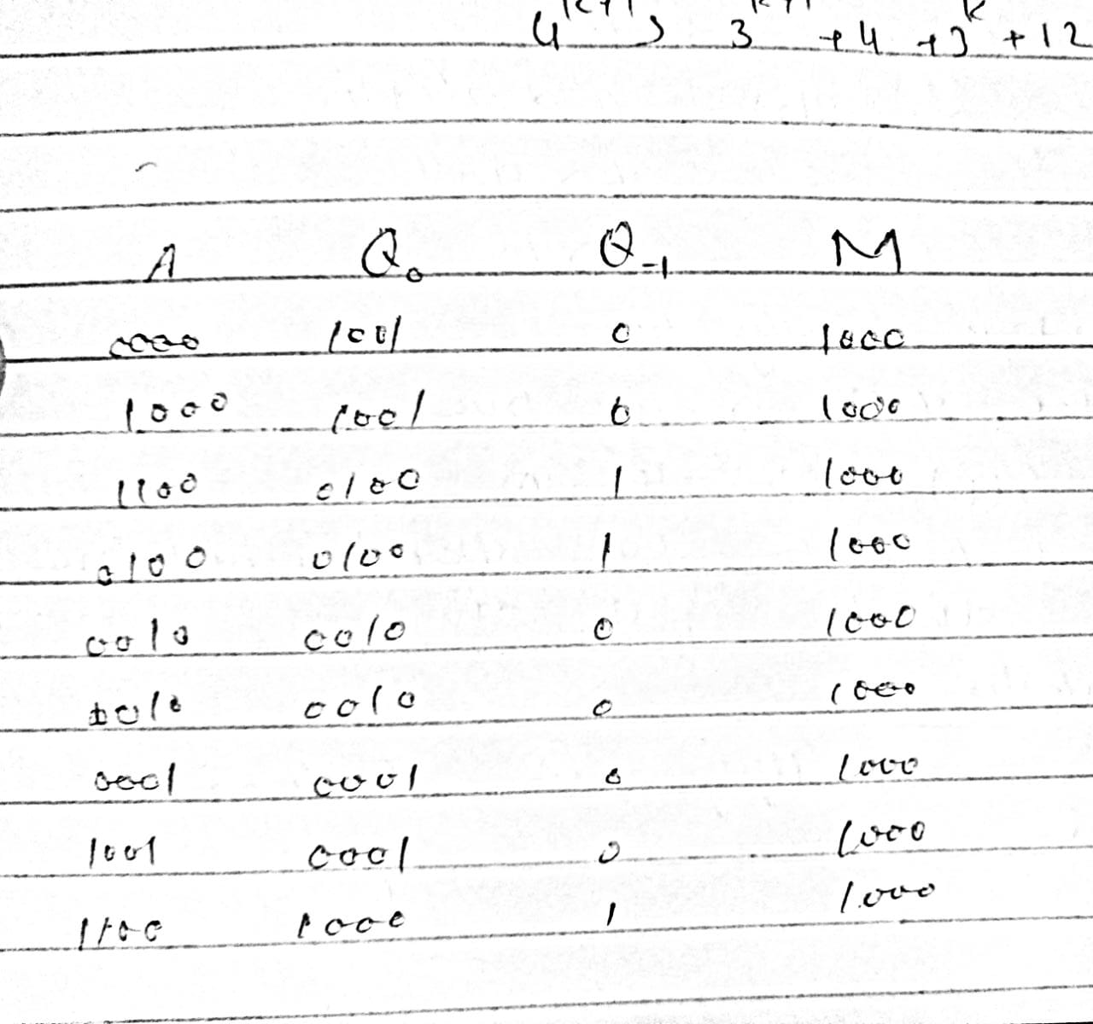

Question#3

Include Irvine32.inc

.data

welcome BYTE "Number b/t 1 and 10. "

BYTE "You must Guess.", 0dh, 0ah, 0

prompt BYTE "Guess Number? ",0

report1 BYTE "You guessed:", 0

report2 BYTE 13, 10, "The secret number was: ", 0

report3 BYTE 13, 10, "Thank You ", 13, 10, 0

secret DWORD ? ;

.code

main PROC

mov edx, OFFSET welcome

call WriteString

call Randomize

mov eax, 10

call RandomRange

inc eax

mov secret, eax

mov edx, OFFSET prompt

call WriteString

call readInt

display the user guess

mov edx, OFFSET report1

call WriteString

call WriteInt

mov edx, OFFSET report2

call WriteString

mov eax, secret

call WriteInt

mov edx, OFFSET report3

call WriteString

exit

main ENDP

END main

Question#4

Include Irvine32.inc

.data

P1 DB "Enter Time in Seconds",0

P2 DB "Time Format hh:mm:ss",0

time DB "\ :\ :"

.code

main PROC

mov ax,data

mov ds, ax

LEA dx, P1

mov ah, 9

INT 21h

call INDEC

push ax

LEA dx, P2

mov ah, 9

INT 21h

pop ax

xor dx,dx

mov cx,3600

div cx

cmp ax,10

jge hours

call OUTDEC

mov ax,dx

push ax

LEA dx, time

mov ah, 9

INT 21h

pop ax

xor dx,dx

mov cx,60

div cx

cmp ax,10

jge minutes

push ax

mov ax,0

call OUTDEC

pop ax

minutes:

call OUTDEC

mov bx,dx

LEA dx, time

mov ah, 9

INT 21h

mov ax,bx

cmp ax,10

jge seconds

push ax

mov ax, 0

call OUTDEC

pop ax

seconds:

call OUTDEC

mov ah, 4ch

INT 21h

exit

main ENDP

END main