Problem 1

PART-1

Real Address Mode:

In this mode the processor uses 16 bit internal registers to execute 16 bit instructions.

Protected Address Mode:

In this mode the processor uses 32 bit registers to access the memory.

Each program that is running has its own assigned memory locations.

PART-2

A byte 10

B sbyte -19

C sbyte ?

.code

Mov al, A

Neg b

Sub al,b

Mov c,al

C= 1D

PART-3

Mov eax, 0001h

Jmp eax

Part-4

mov AL,0EH

add AL,72H

*Part-5*

include Irvine32.inc

.data

arr DB 8 DUP(?)

RolNo DB "18F0195", 0dh, 0ah

L2D DB 95

DB "Last two Digits: 95", 0

output DB "Array: ", 0

bracket1 DB "[",0

bracket2 DB "]",0

.code

main PROC

mov ecx, 8

xor eax, eax

mov edx, offset RolNo

call WriteString

call crlf

mov al, L2D

mov esi, 0

L1:

shl al, 1

JC Store

JNC ZeroValue

Store :

mov arr[esi], 1

JMP Next

ZeroValue :

mov arr[esi], 0

Next :

add esi, type arr

loop L1

mov edx, offset output

call Writestring

mov ecx, 8

mov esi, offset arr

Print :

mov edx, offset bracket1

call WriteString

mov al, [esi]

call Writedec

mov edx, offset bracket2

call WriteString

add esi, type arr

loop Print

call Readchar

exit

main endp

end main

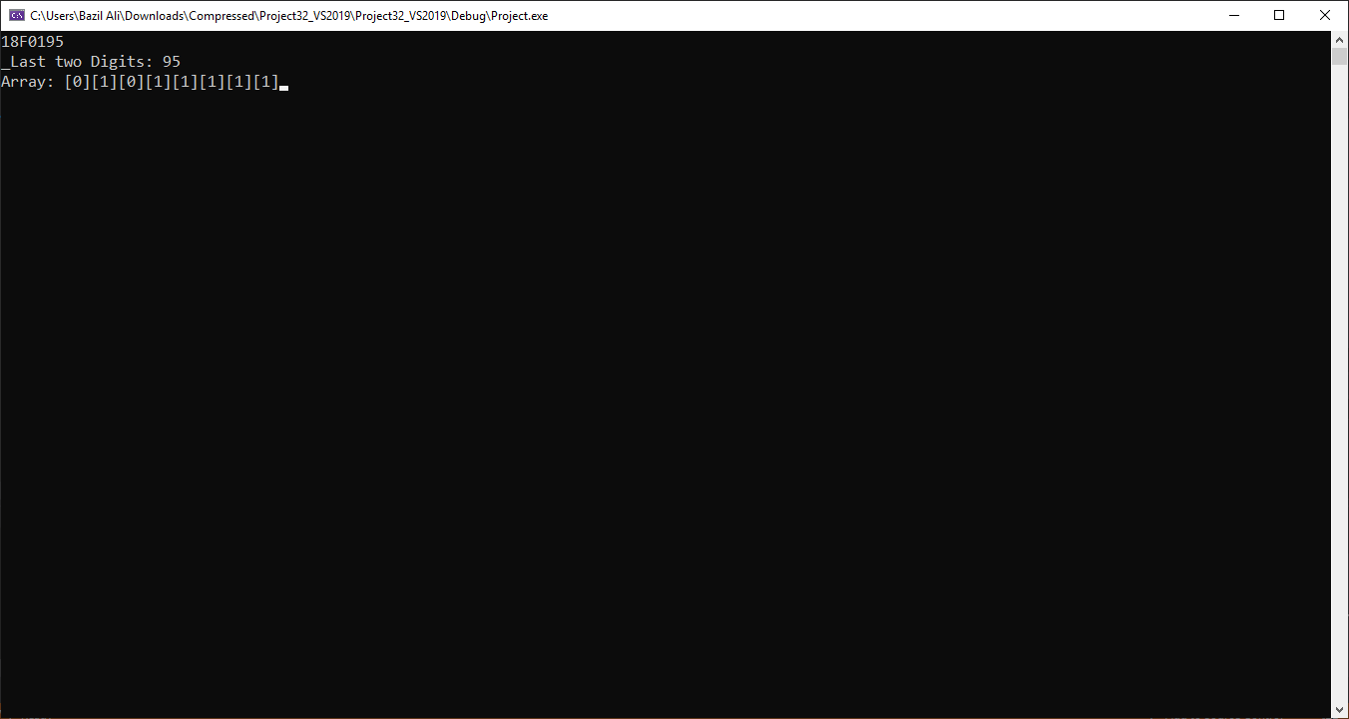

Part-6

The assembler will proceed at label l3 because of the greater value.

Problem 2

Part-B

include Irvine32.inc

.data

array DD 26 DUP(? )

str1 BYTE 26 DUP(? )

var DD ?

spacemsg DB " ", 0

msg1 DB "FREQUENCY TABLE: ", 0

msg2 DB "ENTER STRING : ", 0

str2 DB "ABCDEFGHIJKLMNOPQRSTUVWXYZ", 0

.code

str_in PROC

mov edx, offset msg2

call WriteString

mov ecx, 26

mov edx, offset str1

call ReadString

call crlf

ret

str_in endp

Get_Frequencies PROC

cld

mov edi, offset array

mov ecx, 26

mov ebp, offset str2

L1 :

mov var, ecx

mov ecx, 26

mov al, [ebp]

mov edx, 0

mov ebp, offset str1

L2 :

cmp al, [ebp]

JNZ next

inc dl

next :

inc ebp

loop L2

push eax

mov eax, 0

mov al, dl

stosd

pop eax

inc ebp

mov ecx, var

loop L1

ret

Get_Frequencies endp

main PROC

xor eax, eax

xor ebx, ebx

xor ecx, ecx

xor edx, edx

call str_in

call Get_Frequencies

mov esi, offset array

mov ecx, 26

mov edx, offset msg1

call WriteString

mov edx, offset spacemsg

Print :

mov eax, [esi]

call Writedec

call Writestring

loop Print

call Readchar

exit

main endp

end main

*Output:*

