2021

DANISH AHMAD (19F-0170)

MUHAMMAD ZAIN (19F-0288)

DATABASE LAB PROJECT

(PART 1)

**“PHARMACY MANAGEMENT SYSTEM”**



1. *SPLASH SCREEN*

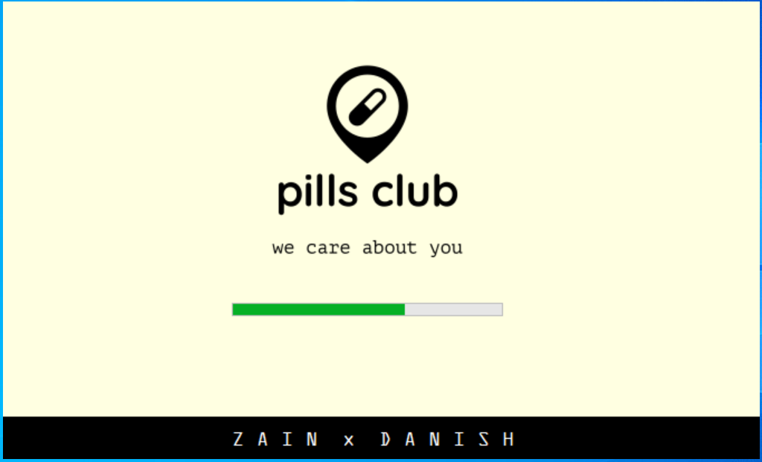

“AFTER THE LOADING COMPLETES, THEN IT WILL SHOW’S THE LOGIN WINDOW.”

1. *LOGIN WINDOW*

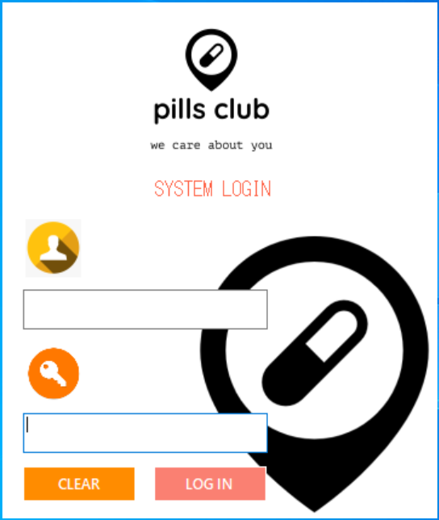

“USERNAME AND PASSWORD ISN’T ADDED YET BECAUSE IT’S A PROTO TYPE YET. SO JUST BY CLICKING ON ‘LOG IN’ BUTTON YOU CAN MAKE TO THE MAIN MENU.”

1. *MAIN MENU*

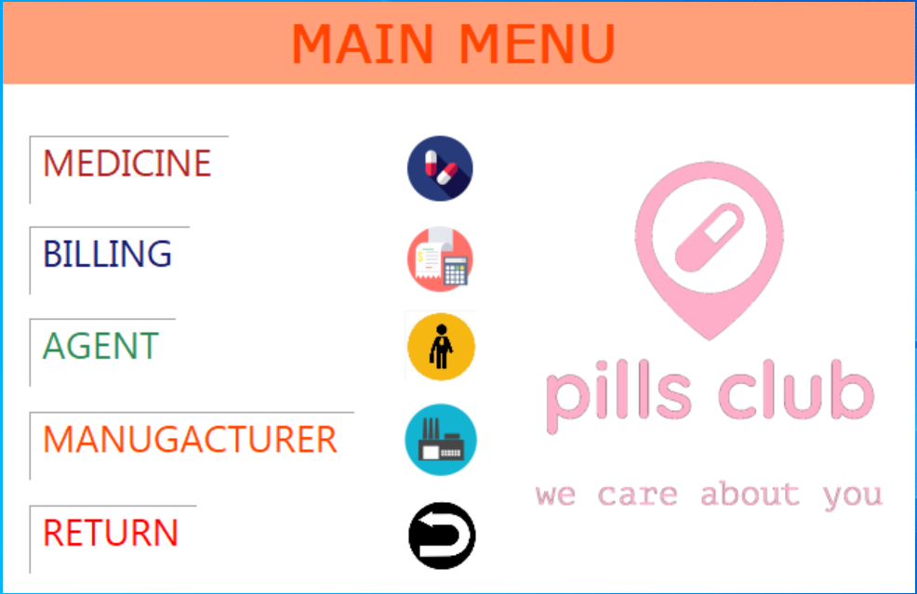

“THE MAIN MENU CONTAINS ALL THE OPTIONS THAT ARE PRESENT IN OUR PHARMACY MANAGEMENT SYSTEM.”

(THE END 😊)