**National University of Computer and Emerging Sciences**



**Assignment # 03**

**Programming Fundamentals  
Section B&D  
Due Date: 17-NOV-19 (11:55pm)**

**Department of Computer Science**

|  |  |
| --- | --- |
| Instructor | Zain Iqbal |
| Semester | Fall 2019 |

# Task1:

Explain each of the following 12 in 2 to 3 lines.

1. User Defined Function
2. void function

(also write a function in which function body is printing “I am a SNAKE :---“.

1. reference parameters
2. value parameter's
3. static variable(write a program by yourself, so that after reading your program I will know the concept of this).
4. local variable(write a program by yourself, so that after reading your program I will know the concept of this).
5. global variable(write a program by yourself, so that after reading your program I will know the concept of this).
6. function calling other function's
7. Default arguments
8. Function overloading
9. Exit Function
10. Menu Driven Program

# 

# Task2:

Write a program that has a function that takes 3 alphabet characters and find their preceding alphabets. For example if user entered a, m, y it will show b, n, z. Take input in main, pass values to function and show the output in main.

# TASK3:

An integer is said to be a perfect number if the sum of its divisors, including 1 (but not the number itself), is equal to the number. For example, 6 is a perfect number, because 6=1+2+ 3. Write a function **IsPerfect** that determines whether parameter number is a perfect number. Use this function in a program that determines and prints all the perfect numbers between 1and 1000. Print the divisors of each perfect number to confirm that the number is indeed perfect.

# TASK4:

Write a function **Power** that takes coefficient and components as arguments and return the power of coefficient. (**Note: Do not use in-built pow() function)**

# TASK5:

Write a function **Zero** that will take a number as a parameter and return the number of zeroes and the number of remaining digits in the number. Print the returned value in the main i.e. Num=7050800, Zeroes= 4, Other Digits=3.

# TASK6:

Write a single function **ConvertToUpper** that can take two or three or four characters as arguments from main. This function will convert them to uppercase if they are lower-case letters. Also restrict the function to maximum three calls. When the function is called after third time, it should display message that it has been already called thrice.

# TASK7:

Write two functions having same name **Add** and takes two arguments. When called from main, they will print “I have been called n times” where n is the number of calls, they have received from main, and will return the sum of arguments passed.

# TASK8:

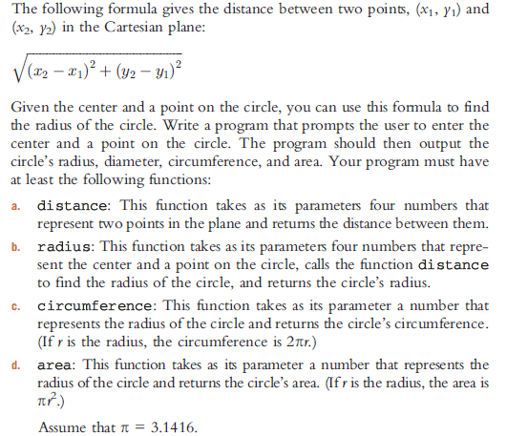

# TASK9:

Write a program to convert the time from 24-hour notation to 12-hour notation and vice versa. Your program must be menu driven, giving the user the choice of converting the time between the two notations.

Furthermore, your program must contain at least the following function: a function to convert the time from 24-hour notation to 12-hour notation, a function to convert the time from 12-hour notation to 24-hour notation, a function to display the choices, function(s) to get the input, and function(s) to display the results. (For 12-hour time notation, your program must display AM or PM.)

# TASK10:

# The cost to become a member of a fitness centre is as follows:

# (a) Senior citizens discount is 30%

# (b) If membership is bought and paid for 12 or more months, the discount is 15%

# (c) If more than five personal training sessions are bought and paid for, the discount on each session is 20%.

# Write a menu-driven program that determines the cost of a new membership.

Your program must contain a function that displays the general information about the fitness centre and its charges; a function to get all of the necessary information to determine the membership cost; and a function to determine the membership cost. Use appropriate parameters to pass information in and out of a function

# TASK11:

The use of computers in education is referred to as *computer- assisted instruction* (*CAI*). Write a program that will help an elementary school student learnmultiplication. Use the rand function to produce two positive one-digit integers. The programshould then prompt the user with a question, such as if integers are 6 and 7 then program will ask:

“How much is 6 times 7?”

The student then inputs the answer. Next, the program checks the student’s answer. If it’s correct, display the message "Very good!" and ask another multiplication question. If the answer is wrong, display the message "No. Please try again." and let the student try the same question repeatedly until the student finally gets it right. A separate function should be used to generate each new question.

This function should be called once when the application begins execution and each time the user answers the question correctly.

# TASK12:

Write a function that takes an integer value and returns the number with its digits reversed. For example, given the number7631, the function should return 1367.

# TASK13:

An integer is said to be prime if it’s divisible by only 1 and itself. For example, 2, 3, 5 and 7 are prime, but 4, 6, 8 and 9 are not.

a) Write a function that determines whether a number is prime.

b) Use this function in a program that determines and prints all the prime numbers between 2 and 10,000. How many of these numbers do you really have to test before being sure that you’ve found all the primes?

c) Initially, you might think that n/2 is the upper limit for which you must test to see whether a number is prime, but you need only go as high as the square root of n. Why?

# TASK14:

Write a complete C++ program with the two alternate functions specified below, each of which simply triples the variable count defined in main. Then compare and contrast the two approaches. These two functions are

a) function tripleByValue that passes a copy of count by value, triples the copy and returns the new value and

a) function tripleByReference that passes count by reference via a reference parameter and triples the original value of count through its alias (i.e., the reference parameter).

**Instructions:**

* Make a word file and put all your codes with proper screenshots in it.
* Word file format should be ‘**section_rollNo_assignmentNo’** for example C_17F8087_03
* The Questions should be in order, otherwise -5.

**Guidelines**

· A single violation of guideline will lead to Zero mark in your assignment.

· You will have maximum marks if you have done all of the tasks.

· Only ".doc" file should be uploaded on slate, Assignment would not be accepted via email, Facebook or USB flash drive etc.

· Do not zip your assignment it should be uploaded as individual file in following format. "RollNo_Assignment_No.doc"

· Paste all the required outputs, codes etc. in the single .doc file.

· Deadlines should be kept in mind no extension in assignment dates

· This is an individual assignment. PLAGARISM IS NOT ACCEPTABLE!

* **Use given cover page format**

· Follow the instructions as it is, otherwise your assignment would not be accepted at all.

HAPPY CODING ☺

 

