

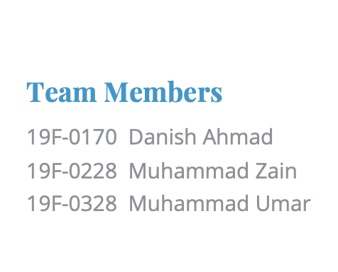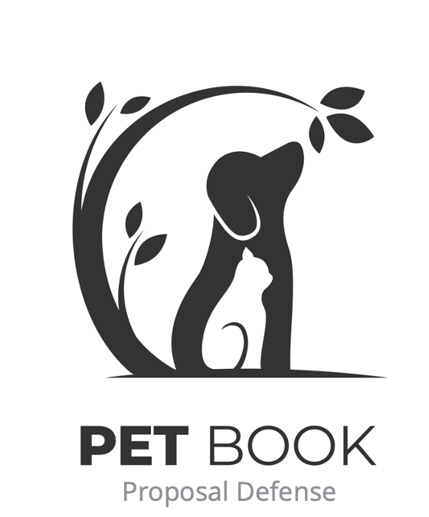

Table of Contents

1. Problem Statement 2

2. Motivation 2

3. Expected Outcome 2

4. Impact 2

5. Type of Project 2

6. Use 2

7. Project Scope 3

8. Modules/Features 3

8.1. Accounts 3

8.2. Newsfeed 3

8.3. Ad Posting 3

8.4. Blogs 3

8.5. Food and habitat 3

8.6. Vaccination 4

8.7. Animal Photography 4

8.8. Communication with experts 4

8.9. Pet Trainers 4

9. Architecture Diagram 4

10. Tools/Technologies 5

## Problem Statement

Taking care of pets is not easy at all. They require the same amount of love and care as human beings. Many pet owners do not have enough knowledge about how to take care of their pets. There are numerous health issues that arise in animals due to a lack of awareness and education among pet owners.

## Motivation

To provide the best option in the animal marketplace for pet enthusiasts and other animal-related business entities. A mobile app that possesses flexibility and reliability to educate people about pets and provide an amazing experience for pet lovers.

## Expected Outcome

A mobile application that provides a reliable marketplace for buying and selling animals.

Friendly support from a community filled with animal lovers.

Allows communication with experts to solve daily life queries related to animal diet, health, and vaccination.

Provides a business opportunity for wholesalers and retailers to sell animal accessories.

Develop an interest in people about animals through daily blogs.

## Impact

The best animal community to entertain animal lovers and business entities. A solution to educate people about animals and help them to make some profit out of that too.

## Type of Project

It is a development project.

## Use

An online community for people to buy and sell animals, ask queries, post ads, make announcements, conduct pet shows, share their valuable experiences, upload, and download animal photographs, and make some money also.

## Project Scope

A Community of pet lovers where we provide information in newsfeed, blogs, and alerts. Integration of nearby pet shops so the people will get petfood and accessories. Creating a marketplace for buying and selling of pets in an online community, peer to peer jobs for trainers, photographers.

## Modules/Features

## Accounts

This module includes user authentication and login signup.

* + 1. User authentication
    2. Email Integration
    3. Login
    4. Signup

## Newsfeed

Feed includes status updates, photos, videos, links, app activity and likes from people, pages, and groups that you follow on social media sites.

## Ad Posting

This module includes user authentication and login signup.

* + 1. Buying
    2. Selling
    3. Missing Pets
    4. Disease Alerts

## Blogs

This feature shall be used to enhance interest in audience via blogs, articles, and expert opinions.

## Food and habitat

This feature allows user to get better knowledge about food and habitat for the projects.

## Vaccination

This feature ensures the vaccination of pets before buying selling and provide the information related to vaccination.

## Animal Photography

This module allows users to upload and download the royalty free photos of animals and allows to hire a professional photographer for pet photography.

## Communication with experts

This module allows pet lovers to get pet for their functions, shoots, and events.

## Pet Trainers

This is a paid module in which you can book an appointment with trainers to get their pet trained.

## Architecture Diagram

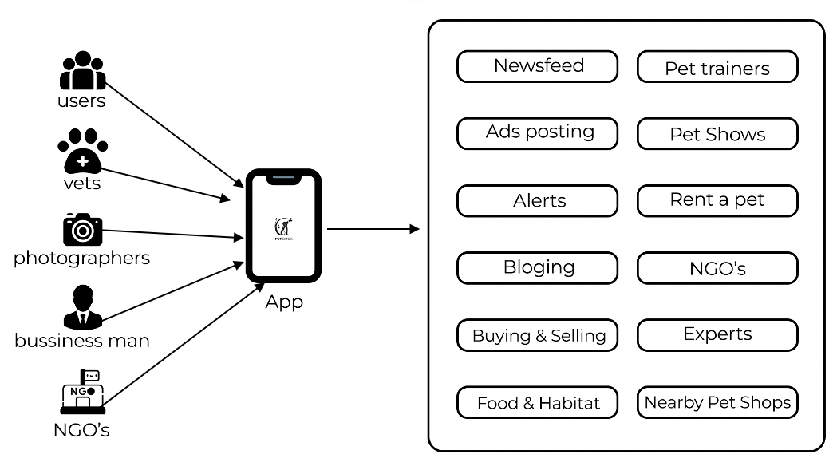

## Tools/Technologies

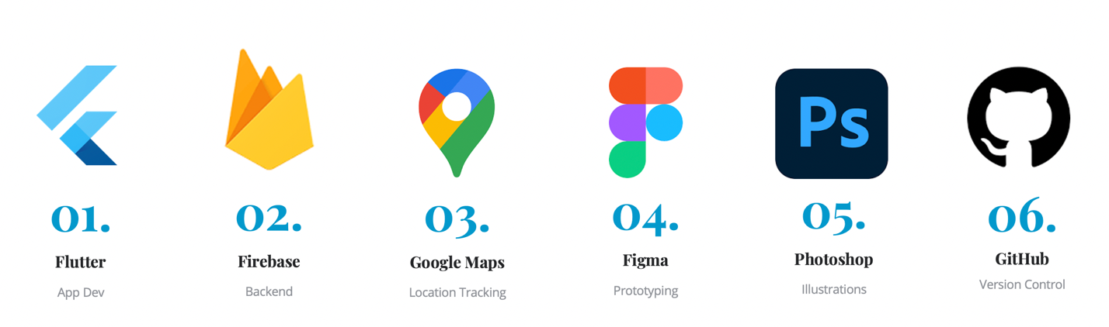

## Related Projects

Some existing applications to animal pet care are as following:

* Adopt Pets
* Pet Geeks

## Summary

This is app development project in which we provide the pet enthusiastic to get together.