# Step 1:

Importin both SRTM and Pakistan shape file:

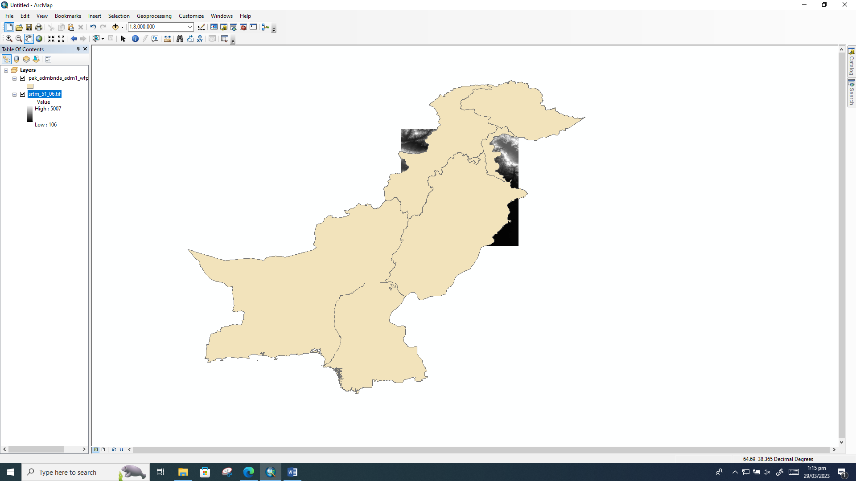

# Step 2:

Select City from Attributes

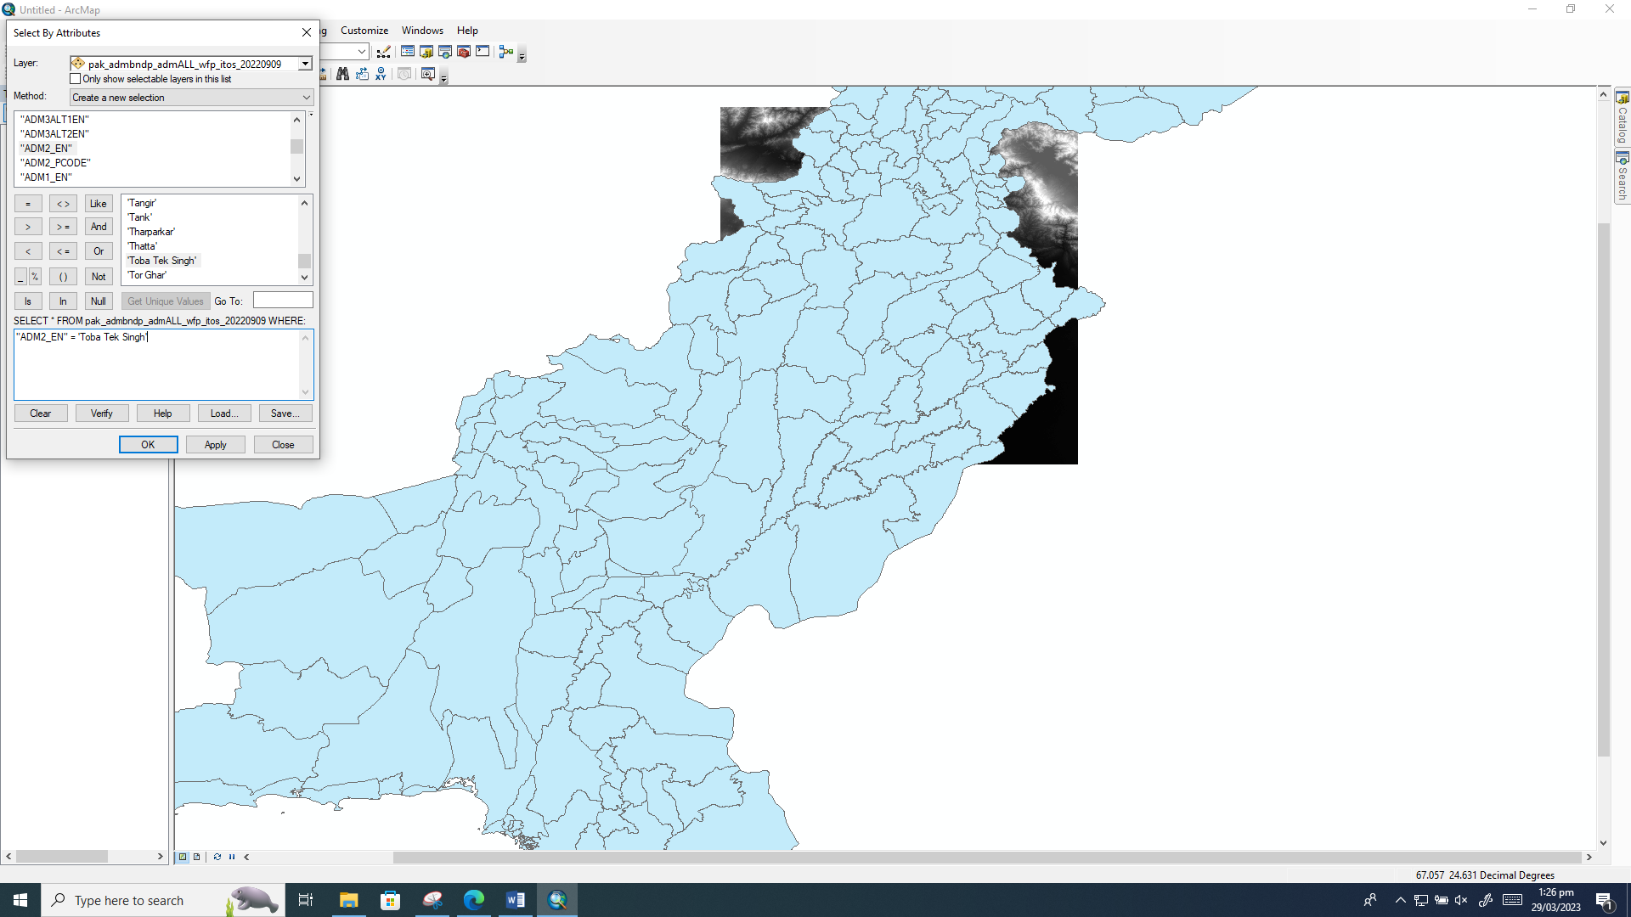

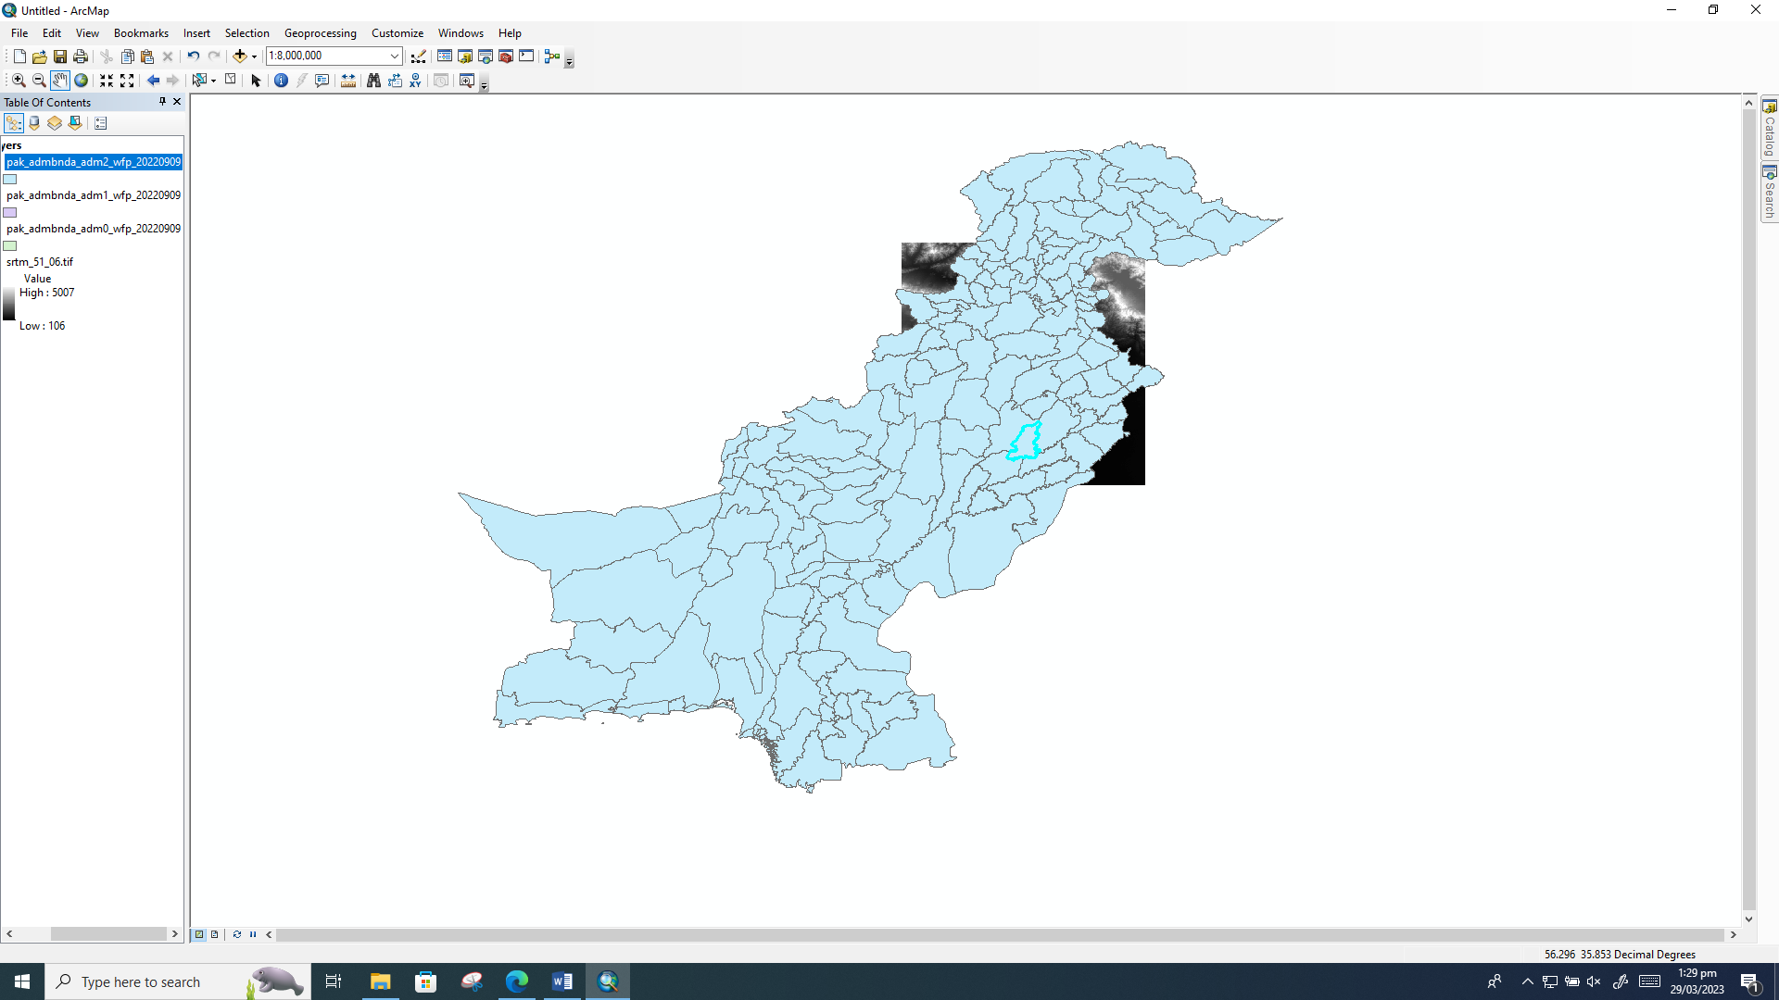

# Step 3:

Exporting Shape file of Toba Tek Singh

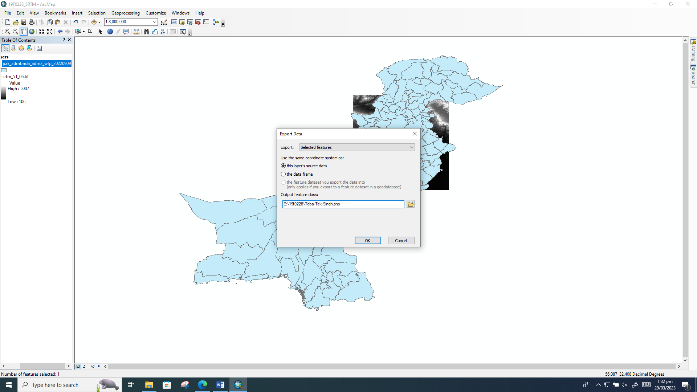

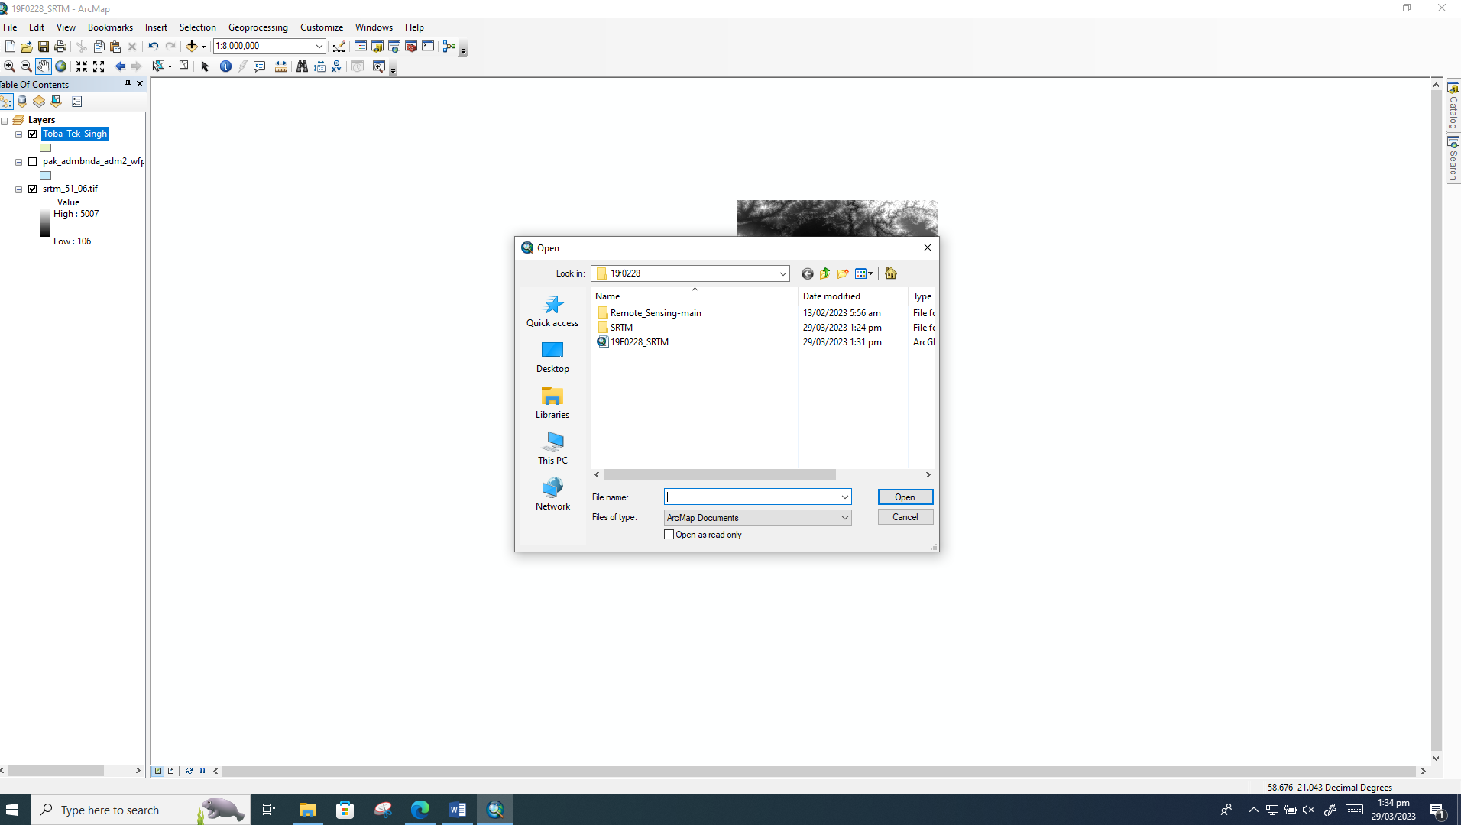

# Step 4:

Search Extract by mask

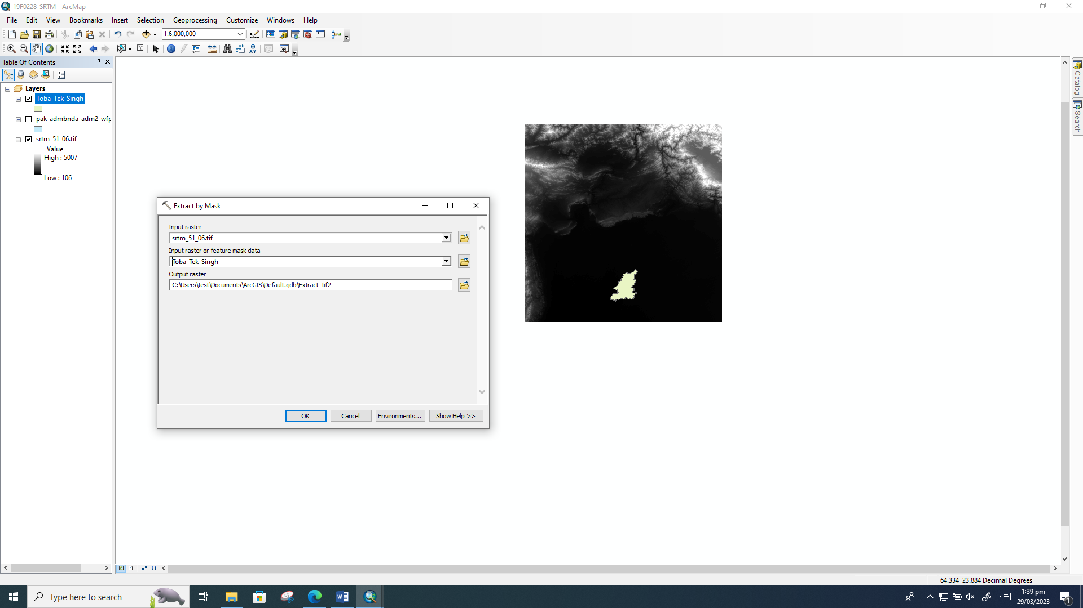

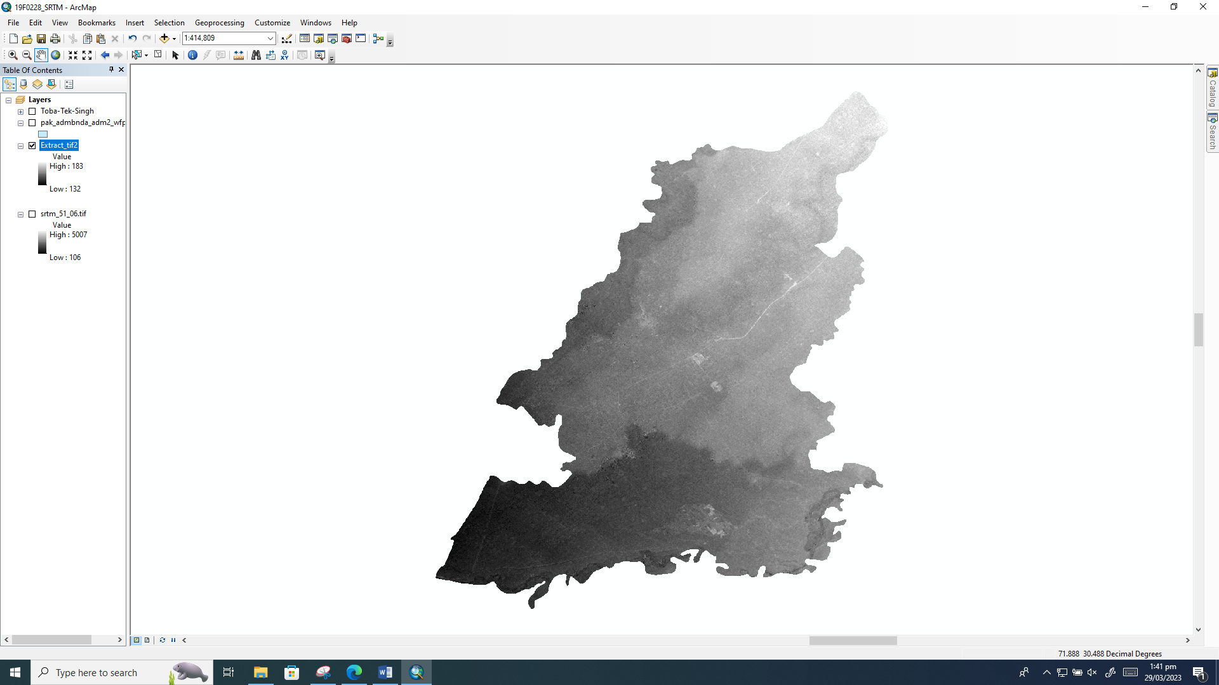

# Step 5:

Catalog->ToolBox->SystemToolBoxes-> Spatial Analyist Toolbox -> Hydrology -> Fill

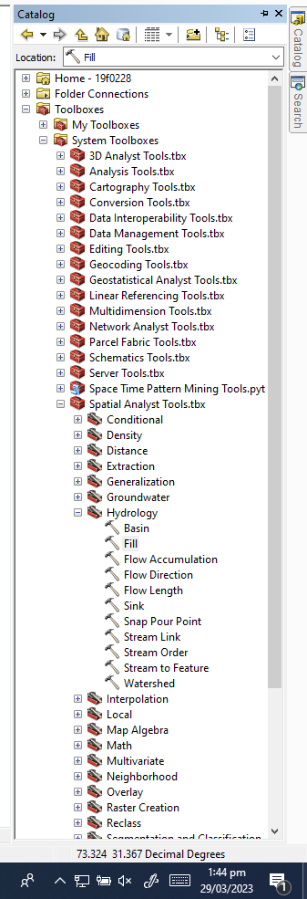

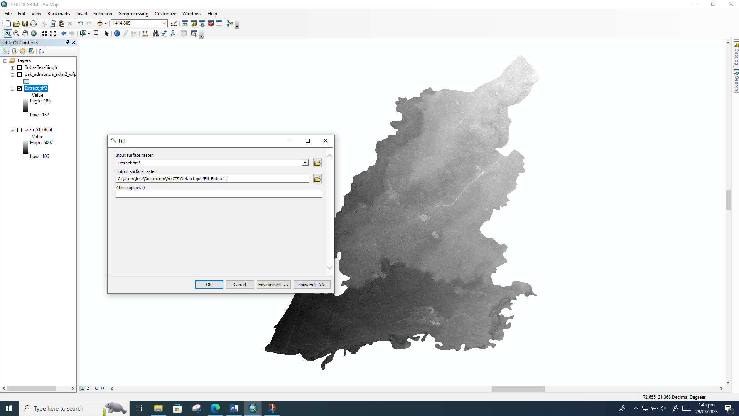

# Step 6:

## Catalog->ToolBox->SystemToolBoxes-> Spatial Analyist Toolbox -> Hydrology🡪 FLOW DIRECTION

# 

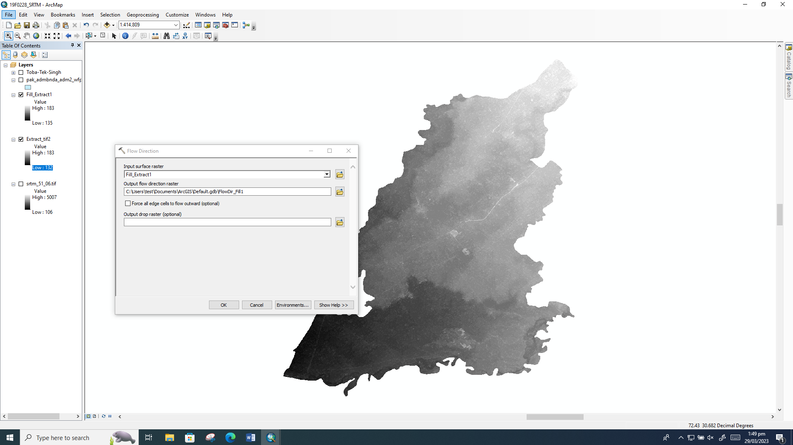

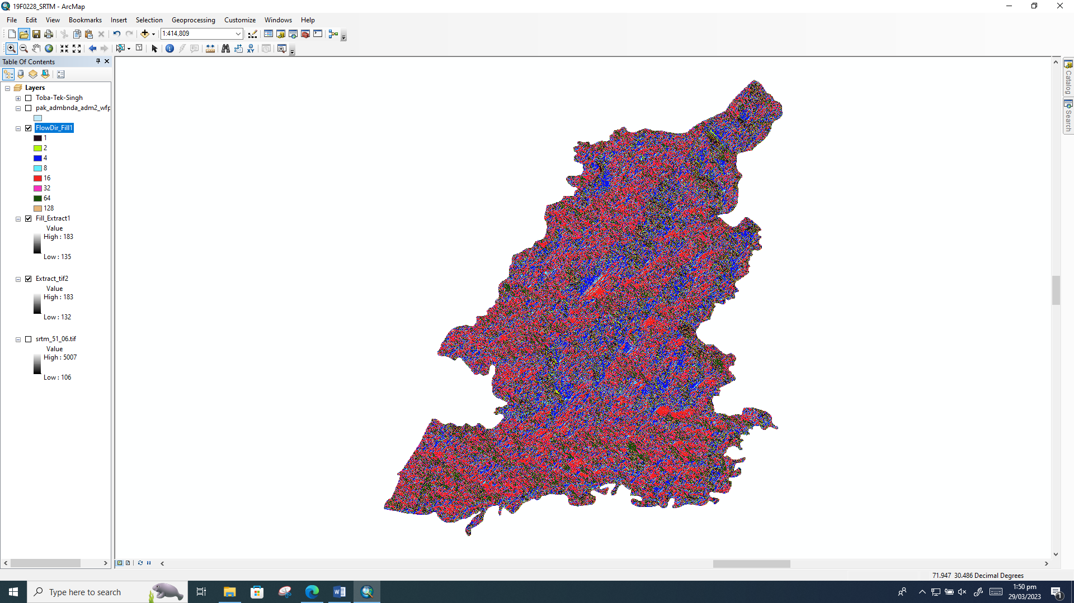

# Step 7:

## Catalog->ToolBox->SystemToolBoxes-> Spatial Analyist Toolbox -> Hydrology🡪 FLOW Accumulation

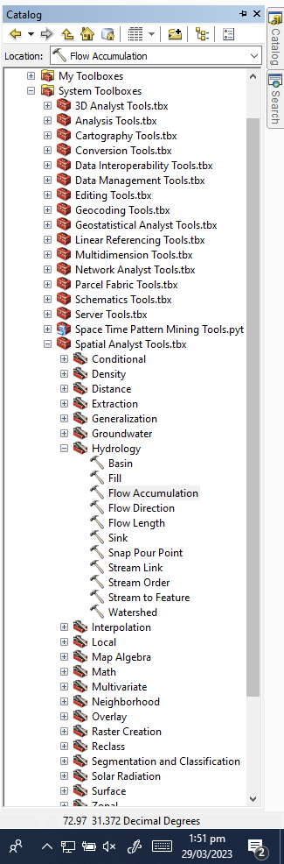

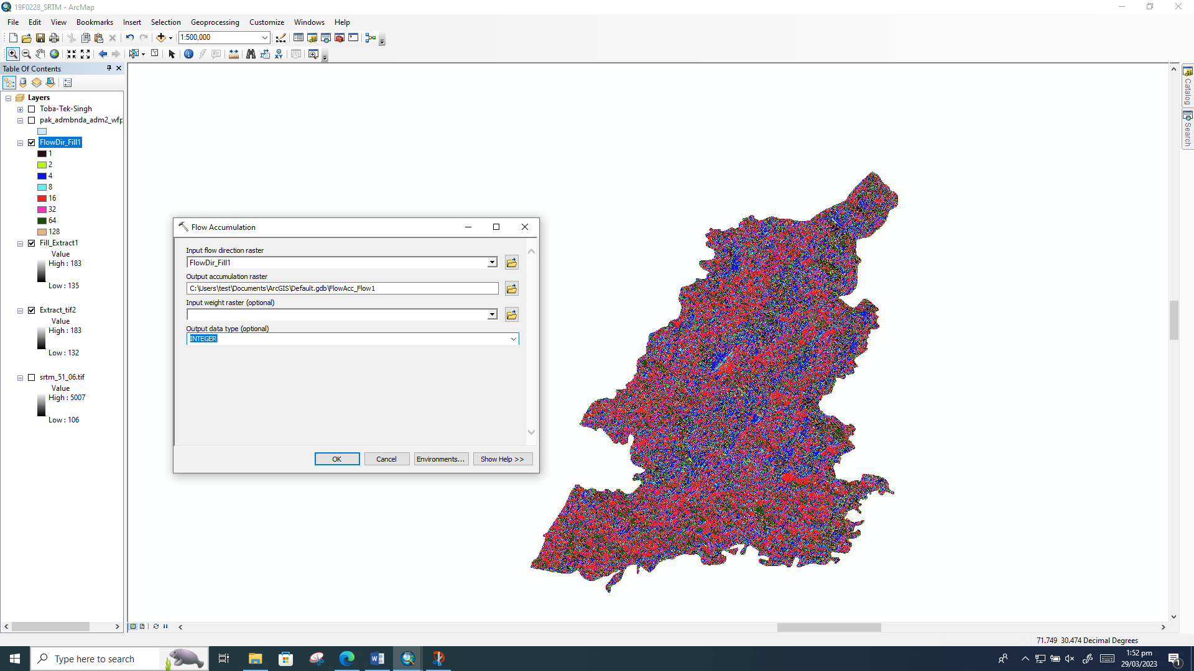

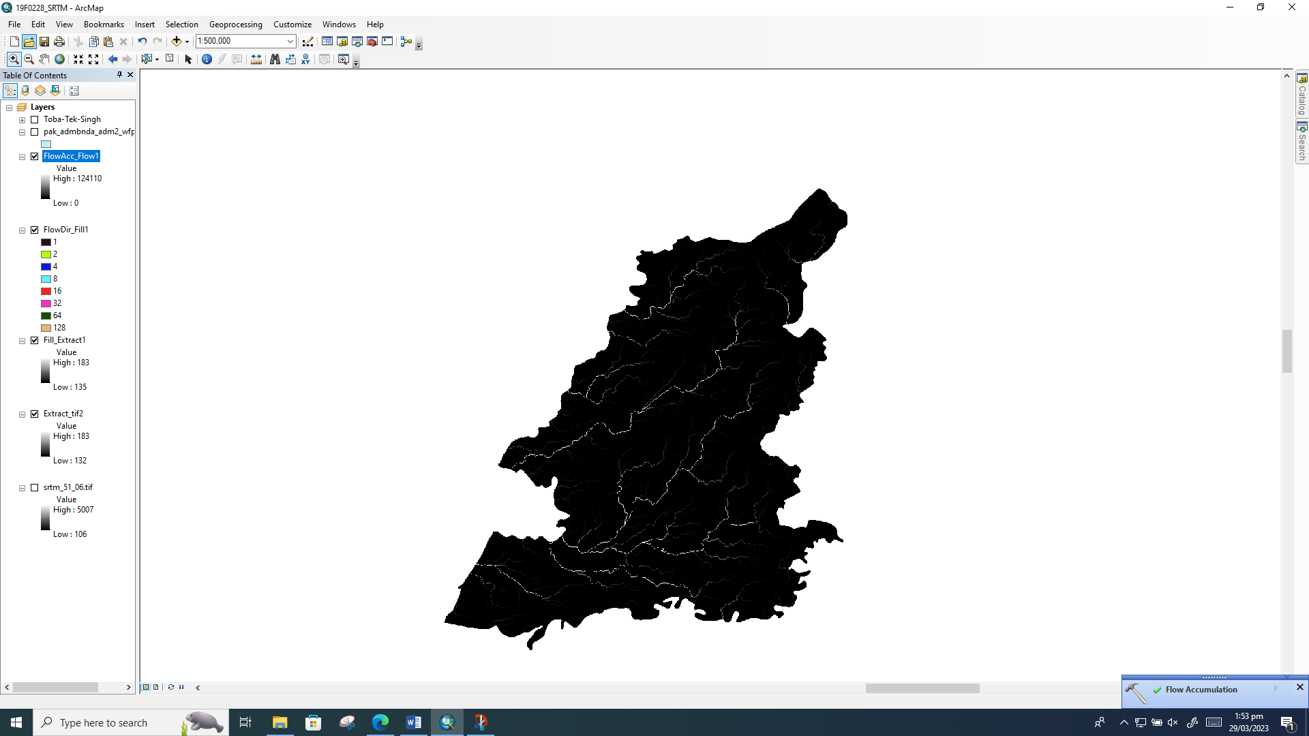

# Step 8:

Conditional

Checking flow

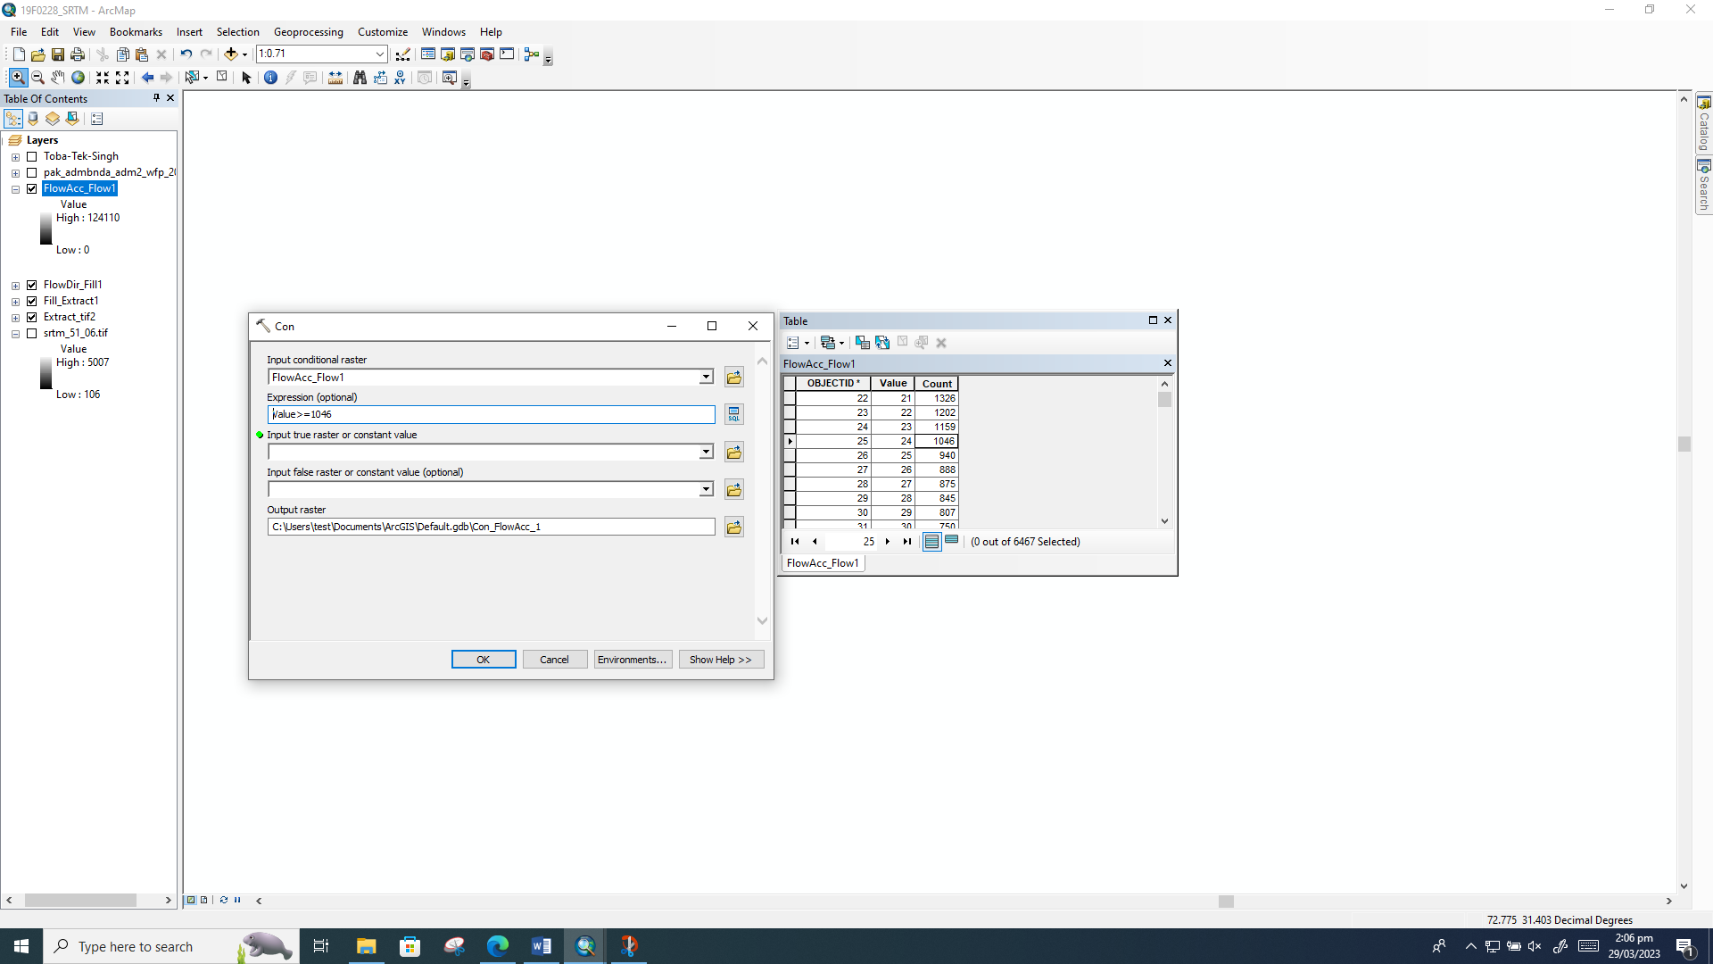

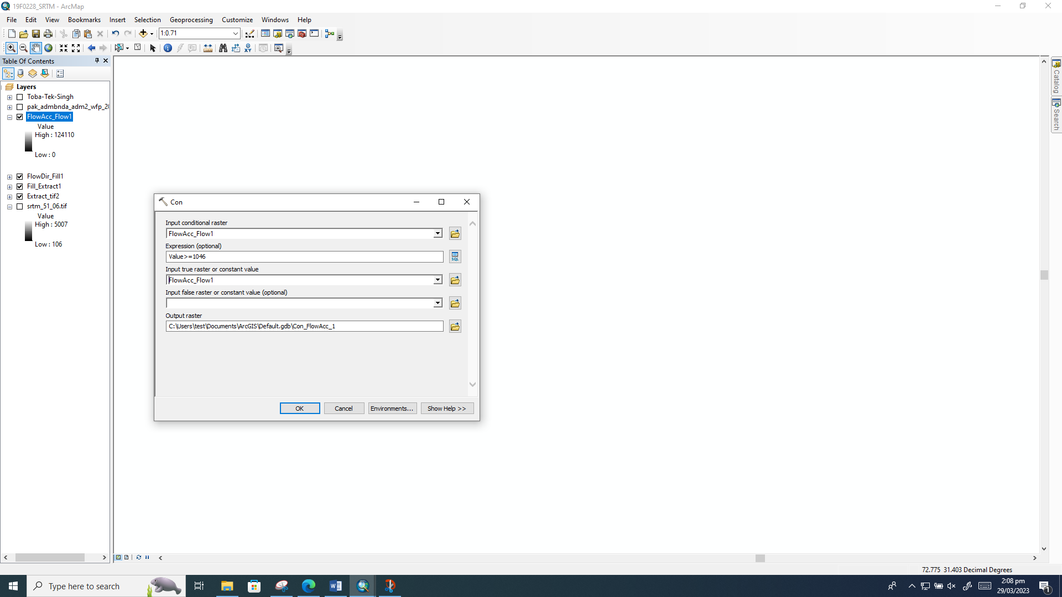

In these area flow is high

