ZyndPay
Payments for the agent economy
Technical research and system design
1st draft

The problem

There are six protocols trying to solve agent payments right now. None of them cover the full path from identity to settlement. x402 does micropayments but has no fiat, no sessions, no spending limits. MPP does session batching but has no identity or discovery. ACP is merchant checkout, not agent to agent. OWS is just a wallet. UCP is pre-launch and retail focused.

So if you build a LangChain agent on Ethereum, you're stuck with x402. If you're an n8n workflow, you can't use MPP session keys. If your enterprise customer needs fiat, none of these work at all.

We already have most of the hard infrastructure, The missing piece is a payment orchestration layer that wires all of it together and picks the right settlement rail for each transaction.

What exists today
Protocol | Owner | What it does | What it doesn't do | Volume
x402 | Coinbase / Cloudflare | Per-request HTTP 402 stablecoin micropayments on Base, Polygon, Solana | No fiat, no sessions, no spending controls, no reputation | ~$28K daily
MPP | Stripe / Tempo | Session batched settlement, session keys, Tempo L1 (100K+ TPS) | No identity, no discovery, no trust, heavy onboarding | Private beta
ACP | OpenAI / Stripe | Agent-to-merchant checkout with Stripe | B2C only, no agent-to-agent path | Not disclosed
OWS | MoonPay | AES-256-GCM encrypted wallet keys, policy gated signing | Wallet only, no routing or settlement | Wallet-level
UCP / AP2 | Google | Commerce discovery + payment authorization mandates | Retail focused, early stage, no A2A | Pre-launch

What ZyndPay actually is

It's a routing layer. It sits between the agent app (any framework) and the settlement rails (any chain or fiat processor). The developer calls agent.call(target, message) and ZyndPay figures out which protocol to use, runs spending checks, signs the transaction, settles it, takes a fee, and updates reputation scores. The developer doesn't think about any of that.

To be clear about what it is not: it is not a new blockchain, not a new wallet, not a checkout flow, not a token. It uses everything that already exists and adds the orchestration logic on top.

System architecture

This is the full flow from Agent A (the caller) through ZyndPay to Agent B (the provider). The red dashed path is the escrow route for agents with low trust scores. The teal path is the normal return flow.

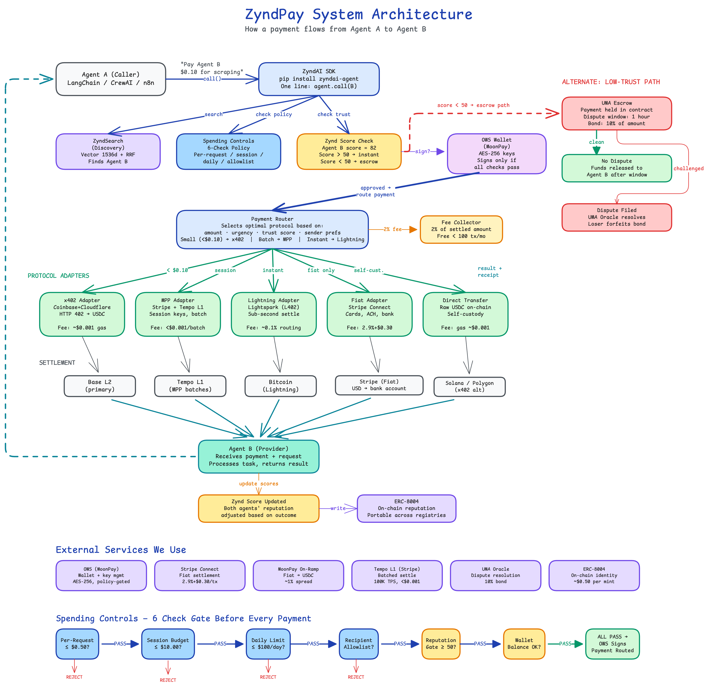

Figure 1: ZyndPay system architecture

The six modules

ZyndPay breaks into six pieces. They're independent: you can use discovery without payments, or bring your own identity layer and just use the payment router. Here's what each one does and where we currently stand with it.

ZyndID (identity)

Every agent gets a DID in the format did:zynd:<pubkey-hash> when it registers. That DID goes into the registry and the agent's local .agent/config.json. If the agent wants portable identity that survives registry changes, it can mint an ERC-8004 NFT on Ethereum. The DID supports Ed25519 and secp256k1 key pairs, and we generate W3C Verifiable Credentials for capability proofs. For A2A protocol compatibility, agents also get an agent card at .well-known/agent-card.json.

There's a serious bug here that needs fixing before anything else: the SDK doesn't verify DID signatures on incoming webhook messages. The sender_did field is trusted as is, which means any agent can impersonate any other agent. We need to add Ed25519 signature verification on every inbound message before payment logic even starts.

ZyndSearch (discovery)

The registry stores 1536-dim OpenAI text-embedding-3-small vectors for every agent. Search runs a hybrid query combining vector similarity with keyword matching through Reciprocal Rank Fusion (RRF). On top of that, AgentDNS does federated gossip discovery across peer registries, using bloom filters (FNV-64a) for fast relevance pre-screening and hop counted announcements capped at 5 hops.

What's new for ZyndPay: price becomes a first class ranking signal. Results get sorted by a composite score that factors in semantic relevance, EigenTrust reputation, the agent's listed price, and whether it's actually responding to health checks. A cheap agent with good reputation ranks above an expensive one that nobody has used. Dead agents (3 consecutive failed health pings over 15 minutes) get pulled from results entirely.

ZyndTrust (reputation)

This is the part none of the competing protocols have. Trust affects payment routing directly. An agent with a good score gets instant settlement. An agent with a bad score gets routed through escrow automatically. Nobody else does this.

The trust metric is called Zynd Score, it's a 0 to 100 composite:

zynd_score = (0.30 * eigentrust + 0.20 * tx_success_rate + 0.15 * uptime + 0.15 * caller_satisfaction + 0.10 * bond_amount_normalized + 0.10 * age_factor) * 100

Agents above 50 get instant settlement. Below 50, payments route through UMA escrow with a dispute window. The score shows up on every search result and is portable across registries through ERC-8004.

Agents can also stake USDC as a reputation bond. Staking 10 USDC gets a 15% search ranking boost. The bond gets slashed if the agent loses a dispute or keeps failing deliveries. The idea is to create a feedback loop: reliable agents earn more, stake more, rank higher, earn more.

ZyndPay router (the actual payment engine)

This is the core of the system. It's a routing engine with pluggable protocol adapters. Each adapter implements a common interface: create_payment(), verify_payment(), settle(), refund(). The router scores every available protocol for a given transaction and picks the best one.

Routing rules:
Condition | Protocol | Why
Amount < $0.10 | x402 or Lightning | Lowest cost per transaction
Amount $0.10 to $10 | MPP (batched) | Aggregates settlement, good cost/speed balance
Amount > $10 | UMA Escrow | Buyer protection with dispute window
Fiat only sender | Stripe Connect | No crypto required
Needs instant finality | x402 or Lightning | Sub-second settlement
Session (many calls) | MPP sessions | One settlement at session close
Low trust recipient (<50) | UMA Escrow | Funds held until window closes

The selection formula: final_score = 0.30 * cost_score + 0.25 * speed_score + 0.25 * reliability + 0.20 * preference. Router picks argmax from the intersection of protocols both sender and receiver support.

The five adapters:
Adapter | Backend | Settlement | Fee | Chains
x402 | Coinbase / Cloudflare | HTTP 402, USDC | ~$0.001 gas | Base, Polygon, Solana
MPP | Stripe / Tempo | Session keys, batched | <$0.001/batch | Tempo L1
Lightning | LN (L402) | Sub-second | ~$0.15 routing | Bitcoin (Lightning)
Fiat | Stripe Connect | Cards, ACH, bank | 2.9% + $0.30 | Stripe (Fiat)
Direct Transfer | Raw on-chain | USDC self custody | gas + $0.001 | Base, Solana, Polygon

OWS wallet (key management)

Right now the SDK exposes EthAccountSigner directly to agent code. That means any code running in the agent process can sign arbitrary transactions with no limits. This is bad.

ZyndPay wraps this with MoonPay's Open Wallet Standard. Private keys get encrypted at rest with AES-256-GCM and never leave protected memory. Before any transaction gets signed, a policy engine checks spending limits. The migration is non-breaking: we wrap the existing signer with the OWS policy middleware, so the SDK surface stays identical. Developers don't change their code.

Fee collector

ZyndPay takes 2% of every settled transaction. The fee gets deducted at settlement time before funds reach the provider. Discovery and identity are free. The fee collector contract sits on Base L2 and aggregates across all protocol adapters.

Spending controls

Every payment goes through six checks before the wallet signs anything. Any single failure kills the transaction immediately.
# | Gate | What it checks | Default
1 | Per-request limit | Single payment exceeds max_per_request? | $0.50
2 | Session budget | Cumulative session spend exceeds max_per_session? | $10.00
3 | Daily limit | 24-hour rolling spend exceeds max_per_day? | $100.00
4 | Recipient allowlist | Is the recipient DID on the approved list? | Any (open)
5 | Reputation gate | Is recipient Zynd Score below min_reputation? | Score >= 30
6 | Wallet balance | Enough balance for payment + gas? | Balance check

These six checks run atomically. The policy lives in .agent/config.json and the OWS wallet middleware enforces it before any transaction gets signed. Developers set it up in the SDK constructor and can update at runtime through the PaymentPolicy API.

Policy configuration example

payment_policy = PaymentPolicy(

max_per_request = 0.50,

max_per_session = 10.00,

max_per_day = 100.00,

allowed_recipients = ["did:zynd:0x..."],

require_escrow_above = 5.00,

min_reputation = 30

)

Escrow and disputes

When the router sees a low trust situation (recipient Zynd Score below 50, or the payment is above require_escrow_above), funds go to a UMA Escrow contract on Base instead of directly to the recipient. The contract holds USDC for a configurable dispute window, default 1 hour.

If nobody disputes during the window, anyone can call settleAssertion() and the funds release to the provider. If the caller files a dispute, they post a 10% bond and UMA's optimistic oracle resolves it. Loser forfeits their bond. Caller wins: funds return. Provider wins: they get the full escrow plus the caller's bond.

For disputes under $5 we skip UMA entirely and auto-resolve based on which agent has the higher Zynd Score. The oracle overhead isn't worth it for tiny amounts.

Fiat and crypto

We don't build a fiat processor or a crypto exchange. We plug into what exists.

If the agent already holds USDC on Base, payments settle on-chain through x402. That's the cheapest path for micropayments and the default for crypto native agents.

If the agent is making a bunch of small calls in one session, MPP session keys authorize batched settlement on Tempo L1. Individual calls within the session budget are free. Settlement happens once when the session closes. This is the right path for orchestrator agents calling dozens of sub-agents per task.

If the sender can't or won't touch crypto, the fiat adapter goes through Stripe Connect for card/ACH/bank settlement. MoonPay handles the on-ramp for agents converting fiat deposits to USDC. The developer never deals with payment processing compliance.

The router picks the path automatically based on what the sender and receiver support. Developers can force a specific protocol with preferred_protocol in the policy object if they want.

What happens when Agent A calls Agent B

Say Agent A needs a web scraper. Here's the actual sequence:

Agent A calls agent.search("web scraper", max_price=0.10). ZyndSearch runs the hybrid vector + keyword query, applies the RRF ranking with reputation and price dimensions, filters out dead agents, returns ranked results.

Agent A picks one and calls agent.call(target=B, message="Scrape example.com"). The SDK hands this to ZyndPay middleware.

The 6-check policy gate runs. If anything fails (payment too large, recipient not on allowlist, Zynd Score too low, wallet empty), the call is rejected. No funds move.

OWS Wallet gets the payment intent. The policy engine re-validates, then signs the transaction with the AES-256-GCM encrypted key in protected memory.

The router scores available protocols. For a $0.05 payment to a trusted agent, it picks x402. For $15 to a new agent, it picks UMA escrow.

The adapter settles the payment on the appropriate chain. Fee collector takes 2%. Provider gets the net amount.

Agent B processes the request and returns the result via webhook. The SDK gets the response along with a payment receipt (the on-chain tx hash).

Both agents' Zynd Scores update based on the outcome. Good delivery improves both scores. Failed delivery or dispute lowers the responsible party. Updates go to the ERC-8004 on-chain reputation registry.

External services

ZyndPay is a routing and orchestration layer. We use other people's infrastructure for everything that isn't routing and orchestration:
Service | We use it for | Alternative | Why this one
OWS (MoonPay) | Wallet key management, policy gated signing | Coinbase AgentKit | Policy engine, AES-256-GCM, open standard
Stripe Connect | Fiat settlement (cards, ACH, bank) | Adyen, PayPal | API quality, coverage, MPP compatible
MoonPay On-Ramp | Fiat to USDC conversion | Ramp, Transak | OWS integration, clean API
Tempo L1 (Stripe) | MPP batched settlement | Base, Polygon | 100K+ TPS, sub-second finality, MPP native
UMA Oracle | Dispute resolution for escrow | Chainlink, Kleros | Bond based, already in our escrow agent
ERC-8004 | On-chain agent identity + reputation | Custom contract | MetaMask/Coinbase backed, portable
Base L2 | Primary chain for x402 + direct transfers | Polygon, Solana | Coinbase ecosystem, x402 native, low gas
OpenAI Embeddings | 1536-dim vectors for search | Local model fallback | Quality, already integrated (SPOF risk)

What we have vs what we need to build

A lot of the infrastructure already exists. Here's the gap:
Component | Already built | Still needed
Identity (ZyndID) | DID generation, registry storage, agent registration | ERC-8004 bridge, VC issuance, signature verification
Discovery (ZyndSearch) | Vector + keyword hybrid search, AgentDNS gossip, EigenTrust | Cost aware RRF ranking, health check cron, local embedding fallback
Trust (ZyndTrust) | EigenTrust in AgentDNS, UMA escrow contract | Zynd Score composite, reputation bonds, fraud detection
Payment Router | x402 processor, basic webhook flow | Multi-protocol adapters, routing engine, fee collector
Wallet (OWS) | Basic wallet generation, USDC on Base Sepolia | OWS integration, multi-chain, fiat ramps, policy engine
Dashboard | ~45% done (Next.js 15), basic agent listing | Wallet page, tx history, revenue charts, withdrawal flow
CLI | Nothing | zyndai init, run, search, call, withdraw

API surface

Three groups of endpoints. All JSON, all require DID auth headers, all return standardized errors.

Payment router

POST /v1/payments/create -- payment intent (amount, currency, recipient DID)

POST /v1/payments/execute -- execute (router picks protocol, runs checks)

GET /v1/payments/:id -- status + settlement receipt

POST /v1/payments/:id/refund -- request refund (escrow or reversal)

POST /v1/sessions/create -- spending session with budget + session key

DELETE /v1/sessions/:id -- close session, settle remaining balance

Wallet

GET /v1/wallet/balance -- multi-chain balances (Base, ETH, Solana, Polygon)

POST /v1/wallet/withdraw -- withdraw to external address (min $5, rate limited)

POST /v1/wallet/topup -- fund via fiat on-ramp or crypto deposit

PATCH /v1/wallet/policy -- update spending policy at runtime

Trust

GET /v1/trust/:agent_id/score -- Zynd Score + component breakdown

POST /v1/trust/bond -- stake reputation bond (USDC)

POST /v1/trust/dispute -- file dispute against a transaction

Developer experience

From the developer's side, payments are invisible. You configure a policy and call agents. Everything else happens behind the scenes:

from zyndai import ZyndAIAgent, PaymentPolicy

agent = ZyndAIAgent(

name="my-research-agent",

capabilities=["research", "summarization"],

price=0.05,

payment_policy=PaymentPolicy(max_per_request=0.50, max_per_day=100.00)

)

results = agent.search("web scraper", max_price=0.10, min_reputation=0.7)

response = agent.call(target=results[0], message="Scrape example.com")

# payment already happened:

print(response.payment.amount) # $0.05

print(response.payment.protocol) # "x402"

print(response.payment.receipt) # on-chain tx hash

Why we made certain calls

Why not just use x402 for everything?

x402 works great for one-off micropayments. But if an agent makes 100 calls in a task, that's 100 on-chain transactions (expensive gas, slow). There's no session concept. There's no reputation, so a brand new agent and a proven one get treated identically. There's no fiat path, which locks out enterprise customers. And there are no spending controls, so a malicious provider can drain an agent's wallet by billing repeatedly. x402 is one adapter in ZyndPay, not the whole system.

Why OWS instead of raw signers?

The current EthAccountSigner approach means any code in the agent process can sign any transaction with no guardrails. OWS gives us encrypted keys at rest (AES-256-GCM), policy gated signing where the limits are checked before the key ever touches a transaction, and keys that never leave protected memory. The migration wraps the existing signer, so nothing breaks on the SDK surface.

Why ERC-8004 for identity?

Agent identity as an on-chain NFT means it's portable across registries, compatible with the Ethereum ecosystem (MetaMask, Coinbase, Foundation are all behind it), and comes with a built-in reputation registry. We don't have to build a custom identity contract.

Why not build a new chain?

Tempo L1 already does 100K+ TPS with sub-second finality. Base has wide adoption and low gas. A new chain would take 12+ months, have zero adoption at launch, and pull focus from the actual product. We deploy contracts on Base (primary) and Tempo (for MPP settlement) and call it done.

Open questions

Mainnet or testnet for launch? Leaning mainnet on Base from day one. Real money, real transactions. Keep a testnet flag for developers testing integrations, but the default should be production.

Build or buy the fiat ramp? Buy. MoonPay already integrates with OWS. Stripe Connect is proven. Building our own is 200+ hours of work and regulatory paperwork we don't need.

Token or no token? No token at launch. Revenue is 2% transaction fees. A governance token only makes sense after there's real volume to govern.

Disputes under $5? Auto-resolve based on Zynd Score. The higher-score agent wins. UMA oracle overhead isn't justified for amounts that small.

OpenAI embedding dependency? It's a single point of failure right now. Registration blocks on the API call. We need an async embedding pipeline with a local model fallback (sentence-transformers or similar) for when the API is down.

