*1 mark တန် 10 ပုဒ် (unseen)
5 marks (4ပုဒ် ဖြေရမယ်)
- Dyad, Lean medium and Rich medium
Dyad: a group of two people
Lean medium: a medium that conveys little detailed information beyond the main message
Rich medium: a medium that conveys a range of verbal and nonverbal information, including colour, auditory and visual elements
- Formal meetings’ Strengths
Information channel | Strengths
Formal meetings | ■ Personal  ■ Easy to observe nonverbal behaviour  ■ Conversational pacing/interchange cues clear  ■ Formal record kept (minutes)  ■ Easy for observers, media to monitor

- What idea did Mehrabiam develop?
He developed the idea that only about 7 per cent of meaning in communication could be extracted from the actual words spoken, while tone of voice accounted for about 38 per cent and body language about 55 per cent of conveyed meaning.
- How do recent biological ……?
Some recent biological theories suggest that the body is not merely the medium used to convey meaning, but in fact may have itself been shaped by deeper forces, and that therefore much nonverbal communication can best be understood as the expression of basic biological drives.

- Explain the differences between direct gaze and averted gaze in some culture?
Eye contact, or direct gaze, means different things to different people. Euro-American, Saudi Arabian, Korean and Thai people tend to regard a direct gaze as a desirable characteristic indicating openness and honesty. Conversely, an averted gaze can be construed as suggesting dishonesty or shiftiness.

- How can we be become ….. according to the learning and manipulation problem?
The more successful we become in identifying subtle aspects of human communication (emotional intelligence, nonverbal communication, negotiation skills, listening skills and so on), the more likely we are to become better communicators; the same knowledge, however, can also be used for unethical and manipulative ends.

- Passive notation
  - He that cannot ask, cannot live. (English proverb)
  - Turn the other cheek too often and you get a razor through it. (Johnny Rotten (John Lydon))
  - Hatred is the coward’s revenge for being intimidated. (George Bernard Shaw)
  - Strong men can always afford to be gentle. Only the weak are intent on giving as good as they get. (Elbert Hubbard)

 | Task roles
Role | Verbal behaviour | Nonnverbal behaviour
Implementer | ■ Can do.  ■ Sure!  ■ Okay!  ■ There are ways and means. ■ Leave it to me. | ■ Alert  ■Makes notations  ■ Looks at watch  ■Writes in diary  ■ Uses calculator/laptop computer

Stage | Characteristics
Decision-making defects | 1. Incomplete survey of alternatives.  2. Incomplete survey of objectives.  3. Poor information search.  4. Selective bias in processing information.  5. Failure to reappraise alternatives.

10 marks ( 2ပုဒ်ဖြေရမယ်)
- တိုက်ရိုက်တစ်မျိုးမေးမယ် / သွယ်ဝိုက်တစ်မျိုးမေးမယ်
Stage | Characteristics
Concurrence seeking | Group members openly agree with the perceived group position even if a group member privately disagrees — there is a need to be seen to ‘be a team player’, or not to ‘rock the boat’ or cause disruption.
Poor decision outcomes | Groupthink occurs.  Almost certainly, a bad decision will be made when all previous factors are present. Sometimes groups in the grip of groupthink will still make a decision, especially when a leader advocates a good decision, but this is infrequent.
Figure. Stages in the groupthink process
- What are the task role of implementer? / နောက်တစ်မျိုးကြိုက်တာရေးလို့မေးမယ်
Analysis of roles played in groups
 |  | Task roles
Role | Verbal behaviour | Nonverbal behaviour | Analysis
implementer | ■ Can do.  ■ Sure!  ■ Okay!  ■ I’ll have a draft back to this group in a week. ■ There are ways and means.  ■ Leave it to me. | ■ Alert  ■ Shuffles, arranges papers  ■Makes notations  ■ Looks at watch ■Writes in diary  ■ Uses calculator/laptop computer | ■ A master of details  ■ A fixer  ■ Can become impatient, however, and might force team to premature closure

- Self-talk
Self-talk: internal conversations we have with ourselves; a form of intrapersonal communication
The idea of self-talk, or the conversations we have with ourselves, has been used in speech therapy, sports training and motivation (e.g. cricket, badminton, endurance), and self-motivation through affirmations (Miles and Neil 2013; Hidayat and Budiman 2014; Blanchfield et al. 2014, Depape et al. 2006; Gammage, Hardy & Craig 2001; Hay 2004; Manders 2014; Flaxington 2013).
Ostrow (2003) suggests that when we send negative and destructive messages to ourselves, we are addressing ourselves in a manner we simply would not tolerate from others.
Brinthaupt, Hein and Kramer (2009) suggest that there are four types of self-talk or conversations that we have with ourselves.
1. Self-criticism. For example, ‘I should have done something differently — I’m really upset with myself’.
2. Self-reinforcement. For example, ‘Something good has happened to me; I’m proud of something I’ve done’.
3. Self-management. For example, ‘I need to figure out what to do or say and I’m giving myself instructions or directions about what I should do or say’.
4. Social assessment. For example, ‘I try to anticipate what someone will say and how I’ll respond to him or her’.

- Environment
The physical environment in which we find ourselves can itself be a powerful mode of communication. As Winston Churchill said, ‘We shape our buildings; thereafter they shape us’. A North American football coach understood the value of manipulating the environment to maximise his team’s performance: at half-time players would rest in blue-painted rooms, but the coach would give his last-minute pep-talks in a smaller room painted in bright colours. The British Labour politician Aneurin Bevan observed that party conferences held in cheerful, bright-coloured rooms were significantly more successful than those held in dingy, depressing rooms. Building architecture, room size and shape, furniture, interior decoration and climate can all communicate strong messages to those who use or visit them.
15 marks (2 ပုဒ်ဖြေရမယ်)
- Time and cultural context
Time and cultural context can also help us to understand nonverbal communication. The study of time use as a form of communication is called chronemics (Ballard & Seibold 2006; Turner & Reinsch 2007). Anthropologist Edward T Hall has made a useful distinction between ‘high context’ and ‘low context’ cultures. The high-context/low-context model incorporates variables such as chronemics (or the study of time use behaviour), the degree of sensory involvement in a situation, the nature of messages sent and how they are sent or concealed in a given situation, and the extent to which identity is formed by affinity with individuals or groups. The context model thus has implications for intercultural communication and intra- and inter-group communication. The chief differences are shown in table 8.2.
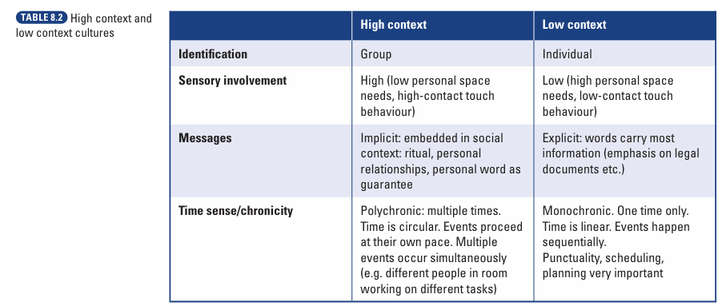

- Communication and ethics
- Should I embellish my résumé or curriculum vitae with ‘half-truths’ in order to get a job?
- Should I ‘lie with statistics’ when using graphs or charts in documents or presentations to make my arguments more persuasive?
- Should I pass on, and perhaps embellish, rumours on the organisational grapevine?
- Should I plagiarise material to pad out documents I am writing?
- Should I use dubious tactics (attack the person, divide and conquer) when negotiating with others?
- Should I censor or filter or block information getting to others?
- Should I censor myself or remain silent when the group I am in is making important decisions?
- Should I contribute to a ‘shoot-the-messenger’ culture by coercing those who bring bad news or those who are ‘whistleblowers’ or want to speak out about organisational malpractice?
- Should I create ‘spin’ or deceptive impressions when communicating with the public?
- Should I use knowledge about human behaviour (body language, emotional intelligence, neurolinguistic programming) to more effectively manipulate others?
- Should I deliberately distort the situation analysed in a report I am writing in order to create further work opportunities for myself?
Should I manipulate meetings so that a hidden agenda, rather than the written agenda, is followed?
- Stages of group development
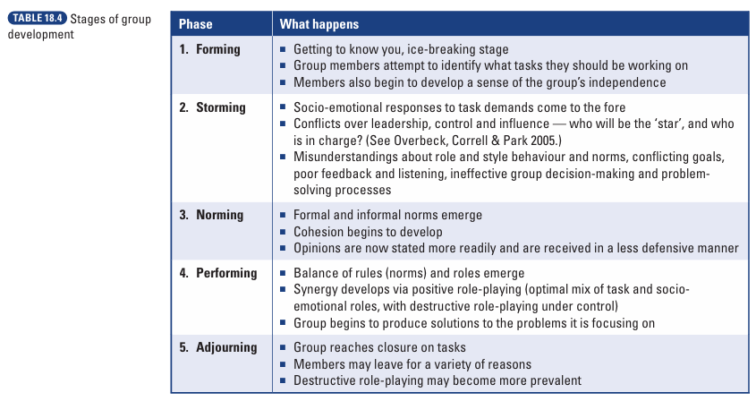
20 marks writing (1 ပုဒ်ဖြေရမယ်) (at least 250 words)
- Team and individual strengths and weakness
- School life/ daily life/ work life ဒီအကြောင်းအရာကိုအခြေခံပြီးရေး

