Setting up VMConnect

Installing the Server Component
This is a normal Joomla! component. Log into the Administrator section of your Joomla! installation and choose Installers -> Components from the menu at the top.

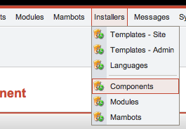

Then choose the Browse from the Upload Package File section, select the component, and choose Upload File & Install

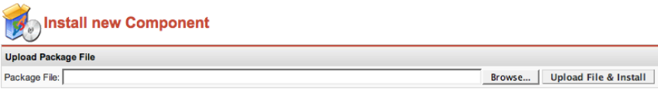

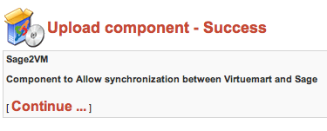

Configuring the Server Component
To go to the Sage to Virtuemart component, choose Components -> VM Connect from the menu at the top.

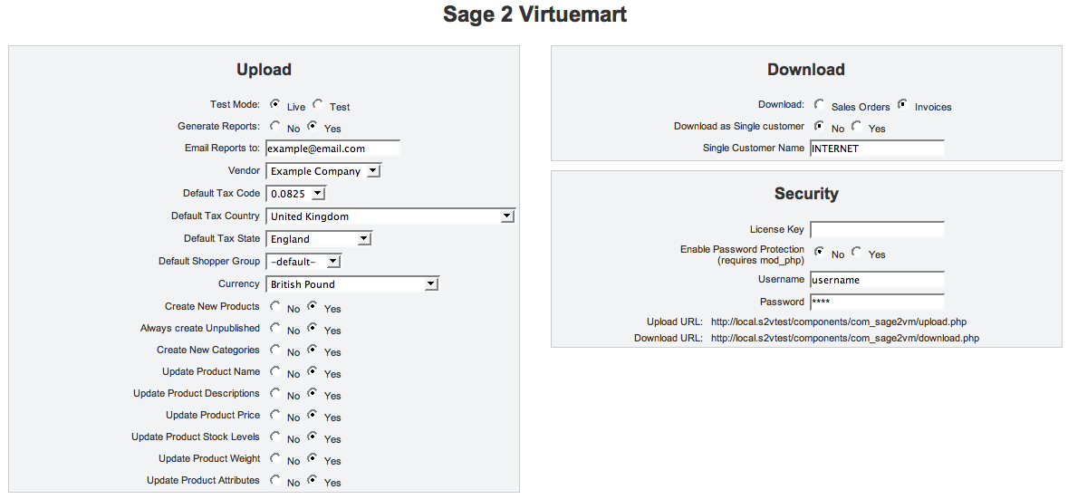
UPLOAD:
Testmode – if set to Test then changes that would occur are recorded in the Report instead, the changes will actually happen if running in ‘Live’ mode.
Generate Reports – You will probably want to generate reports for your first few synchronisations but will then want to turn this option off. Reports can be viewed by clicking on the Reports button at the top.
Vendor, Default Tax Code, Default Tax Country, Default Tax State, Default Shopper Group, Currency – These are used when creating new products since these values have no equivalents in Sage.
The remaining options affect behaviour when creating new products and updating existing ones.

DOWNLOAD:
Download - This controls whether Sage receives the orders from Virtuemart as Sales Orders or as Invoices.
Download as Single customer – By default VMConnect will create a new customer in Sage for every new customer in Virtuemart. If you would prefer all orders to be grouped under a single customer, select this option and choose the customer name to group orders under.
NB: Orders will still contain individual customer payment and delivery details

SECURITY:
You will need to enter the License Key you were provided with in the first box, if you received this by email then it best to copy and paste the license key to avoid typing errors.

If your webserver is using mod_php, you can enable password protection to limit access to the VMConnect scripts.
It is recommended that you protect access, either by this option or by other means, since the scripts allow access your products, orders & customers. If using another method you will need to password protect the components/com_vmconnect folder within your web space.

This section also shows the URLs you will need to enter into the Connect program running on you desktop computer.

Installing the Client Component
Run the connectsetup.exe installer (available from http://www.ibexinternet.co.uk/connectsetup.exe), and follow through the installation.
This will place an icon on your desktop to launch Connect. The first time you run Connect, it will ask you for a product key, either enter the one we have provided or choose to run Connect in trial mode.
NB: If you have a firewall preventing outgoing connections you will need to adjust it to allow Connect to contact both the licensing server and your own webserver.

Configuring the Client Component
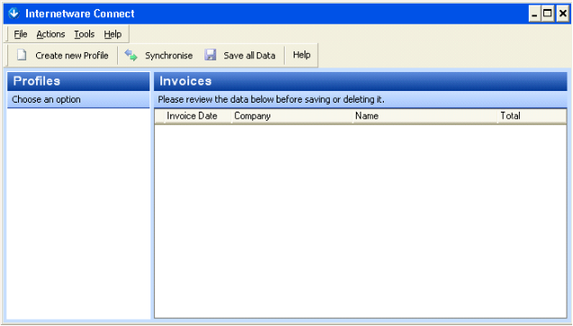

You will need to create a new Profile with details of how to connect to your webserver. Click the Create new Profile button.

Enter a name for the Profile and click Next. Then select the Company in Sage to use from the drop down list, and enter the username and password to connect to sage with. Then click Next.
NB: If these are the same as the Username and Password you normally log into Sage with then you will need to close Sage prior to running the Connect program.

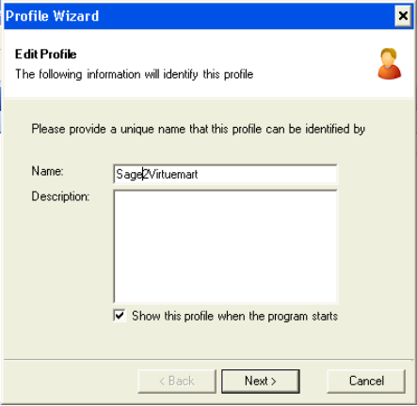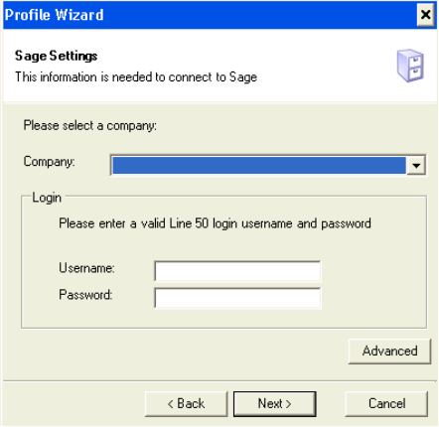

You will then be asked for the URLs (web addresses) to upload new products to, and to download new orders from. These are the URLs shown in the Security panel in the Sage2Virtuemart screen in Joomla! You will also need to tick the Connect using Network Credentials option, and enter the Username and Password required to access the connector.

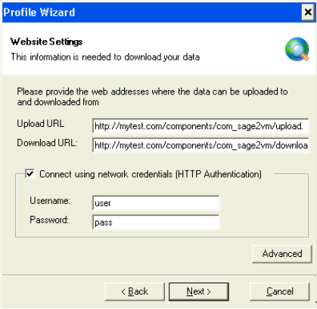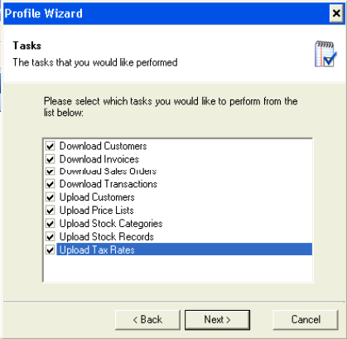

You can then Select the tasks you would like Connect to perform.

Finally you get the option to schedule connect to run on a regular basis. It is best to run Connect manually at first. You can edit the Profile settings later on by right clicking on the profile and choosing Edit Profile.

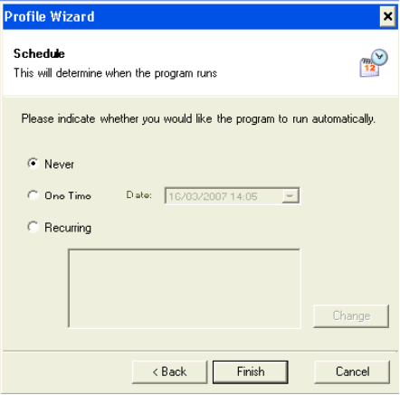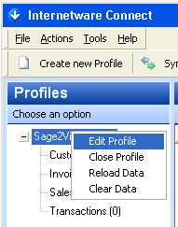

Running the Client Component
To run a Synchronisation click the button. This will send up new or changed Products and pull down new Customers and Orders. The downloaded Customers and Orders are shown, and double clicking on Invoices, Sales Orders, or Customers will show you the details Connect has retrieved from the webserver. These are then transferred to Sage when you click the button. At this point they are marked as downloaded from the webserver to prevent them from being downloaded again in the future.

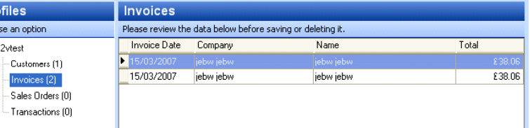

FAQs

1. Downloads work fine, Uploaded products went up on the first Testmode run but now aren’t going up in Live mode.
A. By default only new or changed Products are uploaded, if you run the server component in test mode, then subsequently run it in Live mode. The products will not have changed so will not be uploaded during the ‘Live’ run. This can be solved by editing the profile, and on the second screen (Sage Settings) clicking Advanced, and choosing the Data tab. Select all the categories of information you want to fully upload. Click OK, and continue through the wizard till you choose Finish.

