## Integrated supply chain design for commodity chemicals production via woody biomass fast pyrolysis and upgrading

**Yanan Zhanga, Guiping Hu\*b, c and Robert C Browna, b**

a Department of Mechanical Engineering, Iowa State University, Ames, IA 50011

b Bioeconomy Institute, Iowa State University, Ames, IA 50011

c Industrial and Manufacturing Systems Engineering, Iowa State University, Ames, IA 50011

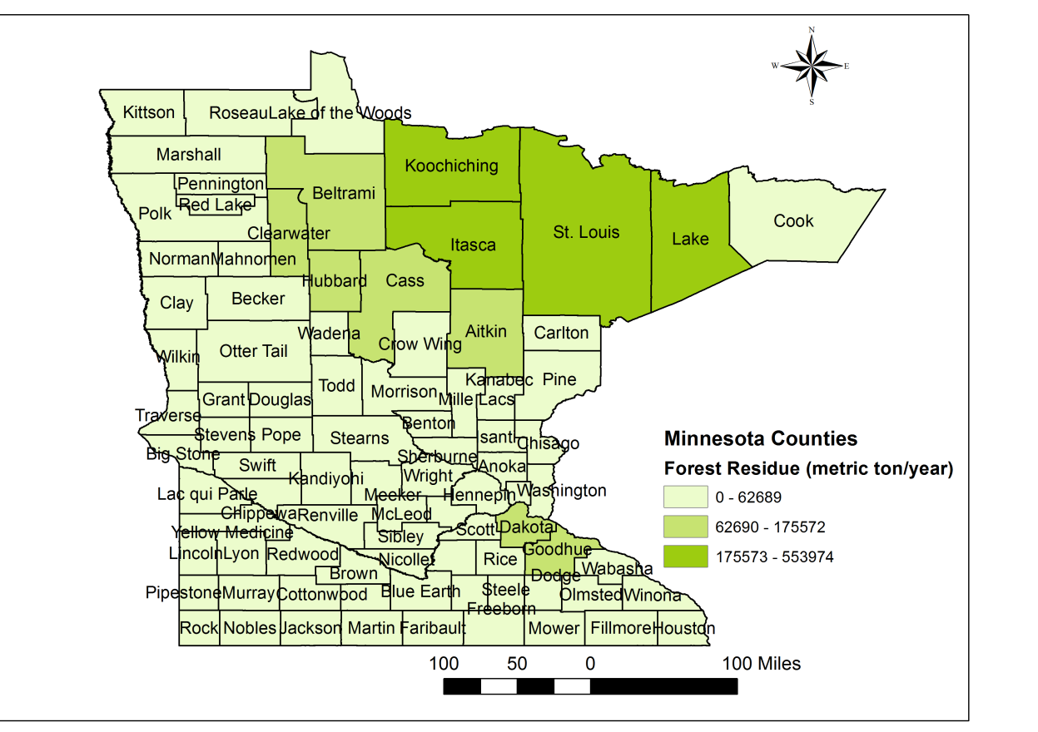

(a)

E:\phd\supply_chain\BioresouceTechnology\newdata\Minnesota_forest_residue_1104.tif

(b)

Figure S1. Forest residue availability and optimal facility locations for Minnesota State.