Advanced Software Engineering

Homework 2

Yanan Zhang (yz3054)

Ziyi Mu (zm2263)

**1.    Description**

We build a toy webapp with Python Django web framework and SQLite database. The website is running on Django server on Ubuntu localhost, and it will render simple HTML views for users.

There is a polls app built in this website, which could record the simple poll results from users. This app is mostly a follow up of the Django framework tutorial, which demonstrates the basic webapp building process within that framework.

We have committed it to our git repository, which may needs change of settings to run locally.

**Github Repository:**

https://github.com/zyntop2014/ASE_HW2.git

To use this, follow the steps:

1.      git clone https://github.com/zyntop2014/ASE_HW2.git

2.      locate the path to ASE_HW2/mysite3/

3.      Execute the command: $python3 manage.py runserver

4.      Users can use shell to manage. Execute the command: $ python3 manage.py shell

**2.    Code checking**

After we build the code, we use the code smell detector of pyflakes detector to check the code. After several round revisions, now we have the code PASSED by the pyflakes detector.

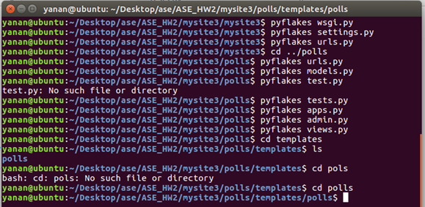

**3.    Simple tests**

For the tasks, we build 2 tests for the web development and both of them are OK. The two tests are related to the question posting date. The two tests results screens are presented below:

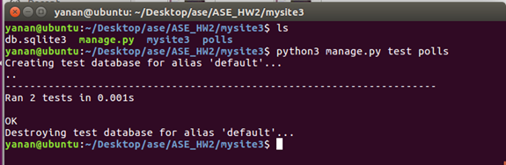

**4.    Experiences**

The process is essentially a follow up of the Django webapp building tutorial. We did the pair programming and together made the website successfully run.

At first, we wanted to install python 2 with Django and found it needs additional work when installing Django on python 2. In addition, it always reports errors. So we found it easier to use python 3 environment along with Django and we switched to python 3 eventually.

It needs to build the url linking for the project as well as the polls. At first, we only built the urls linking in the project and forget to link the app urls to the project. The results show that we could not implement the app function at all. After debugging, we fixed the problems and run the application successfully.

For Django, migration is very important, we run into problems such as missing migration which caused the Django not linking the database models and web views correctly.

Due to time constraint, the layout is very simple. For next step, we need to improve the look of the app and also need to add more testing cases.

**5.    Appendix**

There are 4 views for the application which are admin, index, details and results. The admin is used for managing the voting system where the super user could login to edit, add, or delete the questions with their voting choices.

**Admin view**

The admin view consisted of several linked pages. The main url is:  127.0.0.1/admin

1.      When the super user login, he/she need to type the username and password. The Username is admin and Password is zyntop0138682812.

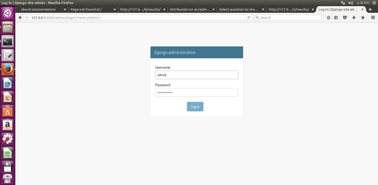

2.      After the user login, then he/she could edit, add or delete the questions.

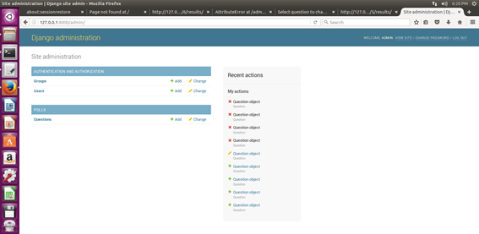

3.      There is a list of questions, the user could click on them and edit.

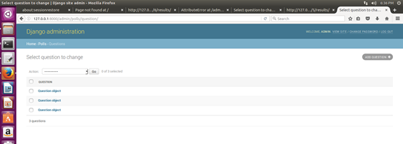

4.       This is one of the sample questions in this system.

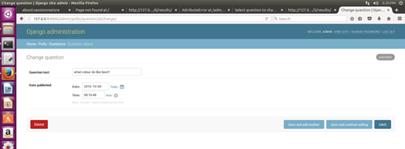

5.      The user could also add new questions.

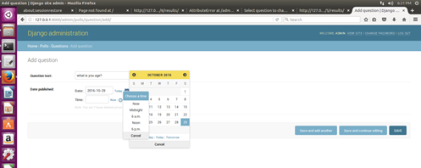

**Polls Views**

There are index views, details view and results view associated with polls app. The url for polls index is 127.0.0.1/polls, which is different from the admin url.

1.      Index view.

In this index view, the web shows the total questions. Click on each link will direct the clients to the details view.

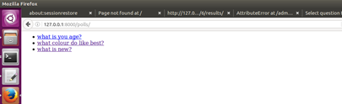

2.      details view

When the clients click on one of the questions, the web will be directed to the details view for the question. Here is the one example. It shows the question and the voting choices. The clients could vote by clicking on the radio buttons.  The voting data will be saved to the database automatically.

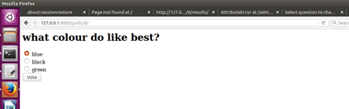

3.      results view

After the clients voted, it will direct to the web page for the voting results.

