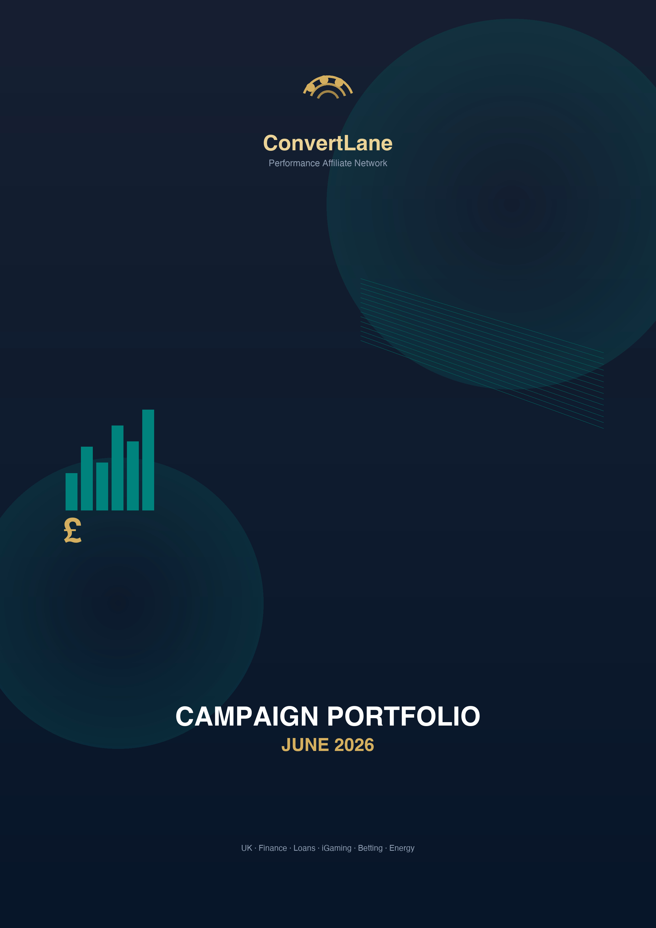

Campaign | Commission | Reward | Market | Preview
Finance
Experian — Credit score | Per new verified signup | CPA | UK | Landing Page
ClearScore — Credit score | Up to ~£50 per referral | CPL | UK | Landing Page
Credit Karma UK — Credit score | TBC | CPL | UK | Landing Page
Checkmyfile — Credit report | TBC | CPL | UK | Landing Page
TotallyMoney — Credit report | TBC | CPL | UK | Landing Page
Loqbox — Credit builder | TBC | CPA | UK | Landing Page
Credit Ladder — Credit builder | TBC | CPA | UK | Landing Page
Zilch — BNPL / cards | £2.60 SOI (benchmark) | SOI | UK | Landing Page
Vanquis — Credit cards | TBC | CPA | UK | Landing Page
Capital One UK — Credit cards | TBC | CPA | UK | Landing Page
Aqua / Marbles — Credit cards | TBC | CPA | UK | Landing Page
IVA / debt management lead gen — Debt help | TBC | CPL | UK | Landing Page
Debt consolidation brokers — Debt consolidation | TBC | CPL | UK | Landing Page
Car finance claims | TBC | CPL | UK | Landing Page
AutoDosh — Car finance | Tiered | RevShare | UK | Landing Page
Total Car Finance — Car finance | Tiered | RevShare | UK | Landing Page
Credit Knowlege — Credit knowledge | TBC | CPL | UK | Landing Page

Campaign | Commission | Reward | Market | Preview
Loans
Multa (TWIBLI Ltd) — Loan broker | CPL on application | RevShare | UK | Landing Page
Leadtree Global — Loan broker | Competitive UK rates | RevShare | UK | Landing Page
Viva Payday Loans UK — Payday CPL | TBC | CPL | UK | Landing Page
Loan Diamond UK — Payday CPL | £8 CPA (benchmark) | CPL | UK | Landing Page
IWantLoan UK — RevShare broker | RevShare on matched leads | RevShare | UK | Landing Page
ZippyLoan UK — RevShare broker | RevShare | RevShare | UK | Landing Page
118 118 Money — Personal loans | TBC | CPS | UK | Landing Page
Ocean Finance — Secured loans | TBC | CPL | UK | Landing Page
Everyday Loans — Subprime | TBC | CPA | UK | Landing Page
Likely Loans — Subprime | TBC | CPA | UK | Landing Page
Aro (Freedom Finance) — Comparison | Tiered | RevShare | UK | Landing Page
Fundably — Business loans | Up to ~30% broker commission; £200–£10k+ | CPS | UK | Landing Page
Capital Business Partners — Business loans | ~50% on funded deal | CPS | UK | Landing Page
PDQ Funding — Business loans | Paid on funded deal | CPS | UK | Landing Page
SupaLoans — Loan broker | Competitive commission | RevShare | UK | Landing Page
SupaFinance — Loan broker | £5 CPL benchmark | RevShare | UK | Landing Page
Just Loans — Loan broker | 80% revshare (Monetise) | RevShare | UK | Landing Page
Tangerine Loans — Loan broker | Tiered | RevShare | UK | Landing Page
Loans 247 — Loan broker | Tiered | RevShare | UK | Landing Page
SupaCompare — Comparison | Tiered | RevShare | UK | Landing Page
The Loan Tree — Loan broker | Tiered | RevShare | UK | Landing Page
Your Loan Today — Loan broker | Tiered | RevShare | UK | Landing Page
MediaBlanket lender panel — Lender panel | Via broker commissions | RevShare | UK | Landing Page

Campaign | Commission | Reward | Market | Preview
iGaming
bet365 Partners — Sports + casino | 30% RevShare; CPA on request | RevShare | UK | Landing Page
William Hill Affiliates — Multi-product | 30% sports/casino; 15% bingo/poker | RevShare | UK | Landing Page
Betway Partners — Sports + casino | Up to 40% RevShare; up to 75% (tiered) | RevShare | UK | Landing Page
888 Affiliates — Multi-product | Up to 40% RevShare | RevShare | UK | Landing Page
LeoVegas Affiliates — Casino + sports | Competitive RevShare | RevShare | UK | Landing Page
Coral / Ladbrokes (Entain) — Multi-brand | 25–35% RevShare | RevShare | UK | Landing Page
PlayOJO Affiliates — Casino | Tiered | RevShare | UK | Landing Page
Grosvenor Casinos Affiliates — Casino | Tiered | RevShare | UK | Landing Page
Mecca Bingo Affiliates — Bingo | Tiered | RevShare | UK | Landing Page
Tombola Affiliates — Bingo | Tiered | RevShare | UK | Landing Page
Sky Vegas / Gaming Affiliates — Casino | Tiered | RevShare | UK | Landing Page
Virgin Games Affiliates — Casino + bingo | Tiered | RevShare | UK | Landing Page
Jackpotjoy Affiliates — Bingo + slots | Tiered | RevShare | UK | Landing Page
PokerStars Partners — Poker + casino | Tiered | RevShare | UK | Landing Page
NetBet Affiliates — Casino + sports | Tiered | RevShare | UK | Landing Page
UKGC-licensed operators — Network load | £15–£600 CPA FTD (market) | RevShare | UK | Landing Page

Campaign | Commission | Reward | Market | Preview
Betting
bet365 Sports — Sportsbook | 30% RevShare; £250–£600 CPA (market) | RevShare | UK | Landing Page
William Hill Sports — Sportsbook | 30–35% RevShare | RevShare | UK | Landing Page
Paddy Power / Betfair (Flutter) — Sportsbook | £15–£20 CPA per depositor | RevShare | UK | Landing Page
Betfred Affiliates — Sportsbook | Up to 50% RevShare first 3 months | RevShare | UK | Landing Page
Sky Bet Affiliates — Sportsbook | Tiered | RevShare | UK | Landing Page
BETDAQ Affiliate Programme — Exchange | 25–35% RevShare tiered | RevShare | UK | Landing Page
Star Sports Affiliates — Sportsbook | Tiered | RevShare | UK | Landing Page
BoyleSports Affiliates — Sportsbook | Tiered | RevShare | UK | Landing Page
Virgin Bet Affiliates — Sportsbook | Tiered | RevShare | UK | Landing Page
Midnite Affiliates — Sportsbook | Tiered | RevShare | UK | Landing Page
Kwiff Affiliates — Sportsbook | Tiered | RevShare | UK | Landing Page
Spreadex Affiliates — Sports + spreads | Tiered | RevShare | UK | Landing Page
Smarkets / SBK Affiliates — Exchange | Tiered | RevShare | UK | Landing Page

Campaign | Commission | Reward | Market | Preview
Energy
The Energy Shop Affiliates — Comparison / switch | £30–£40 per dual-fuel switch | CPA | UK | Landing Page
Free Price Compare Affiliate Programme — Comparison / switch | Per successful switch | CPA | UK | Landing Page
UKPower Affiliate Scheme — Comparison / switch | Supplier rewards per switch | CPA | UK | Landing Page
Uswitch Partner / Affiliate — Comparison / switch | £15–£40 per switch (market) | CPA | UK | Landing Page
EDF Affiliate Programme — Supplier direct | Per sale; premium tariff uplift | CPA | UK | Landing Page
British Gas Affiliate Programme — Supplier direct | TBC | CPA | UK | Landing Page
MoneySuperMarket Energy Affiliates — Comparison / switch | TBC | CPA | UK | Landing Page
Compare the Market Energy — Comparison / switch | TBC | CPA | UK | Landing Page
Simply Switch Affiliate — Comparison / switch | TBC | CPA | UK | Landing Page
Octopus Current Account (B2B) — Supplier referral | £50 per successful referral | CPA | UK | Landing Page
Auto-switching services — Auto-switch | Tiered | RevShare | UK | Landing Page

Campaign | Commission | Reward | Market | Preview
Sweepstakes
YouSweeps — Sainsbury's £500 — Gift card SOI | £2.00 SOI | SOI | UK | Landing Page
Aldi £250 Gift Card — Gift card SOI | £2.00 SOI | SOI | UK | Landing Page
Ikea £250 Gift Card UK — Gift card SOI | £2.00 SOI | SOI | UK | Landing Page
RewardFlux — Lululemon £250 UK — Gift card SOI | TBC | SOI | UK | Landing Page
RewardFlux — Sainsbury's £500 UK — Gift card SOI | £2.40 SOI | SOI | UK | Landing Page
Rewards UK — PayPal £750 — PayPal prize | £2.20–£2.40 SOI | CPA | UK | Landing Page
YouSweeps — McDonald's Gift Card UK — Gift card SOI | TBC | SOI | UK | Landing Page
Offerleads — Multiple Sweepstakes UK — Multi-brand | £1.00 CPL | SOI | UK | Landing Page
Quiztionnaire — Multiple Sweepstakes UK — Quiz + CPL | £1.20 CPL | CPL | UK | Landing Page
Sainsbury's Social Network Quiz UK — Retail quiz | TBC | CPL | UK | Landing Page
NCC — Sainsbury £1000 Sweepstake — Gift card SOI | TBC | SOI | UK | Landing Page
ActiveYou — Win £500 at Sainsbury's UK — Retail prize | TBC | SOI | UK | Landing Page
MaxBounty UK sweepstakes portfolio — Multi-brand | Varies | CPL | UK | Landing Page
Zeydoo UK sweepstakes offers — Multi-brand | Varies | CPL | UK | Landing Page
ClickDealer UK sweepstakes — Multi-brand | Varies | CPL | UK | Landing Page

Campaign | Commission | Reward | Market | Preview
Surveys
Surveoo — Paid Survey UK (CPL) — Paid surveys | £2.00 CPA | SOI | UK | Landing Page
Surveoo — CPL Survey SOI UK — Paid surveys | £2.00 CPA | SOI | UK | Landing Page
Monetise UK survey offers — Paid surveys | £1–£2.50 typical | CPL | UK | Landing Page
MaxBounty UK survey campaigns — Paid surveys | Varies | CPL | UK | Landing Page
MyLead UK survey offers — Paid surveys | Varies | CPS | UK | Landing Page
Panthera UK survey campaigns — Paid surveys | Varies | CPL | UK | Landing Page
Toluna Influencers UK — Panel | TBC | CPL | UK | Landing Page
LifePoints UK — Panel | TBC | CPL | UK | Landing Page
Swagbucks UK — Rewards panel | Tiered | RevShare | UK | Landing Page
Survey Generator — Multi-CPA — Multi-CPA | Varies | CPA | UK | Landing Page
InboxPounds UK — Rewards | TBC | CPL | UK | Landing Page

Campaign | Commission | Reward | Market | Preview
Other
Monetise UK dating CPL — Dating | Varies | SOI | UK | Landing Page
Confused.com Affiliates — Insurance | Per quote/sale | CPA | UK | Landing Page
Compare the Market Insurance — Insurance | TBC | CPA | UK | Landing Page
Uswitch Broadband — Broadband | TBC | CPA | UK | Landing Page
Broadband Genie Affiliates — Broadband | TBC | CPA | UK | Landing Page
giffgaff Affiliate Programme — Mobile SIM | Per activation | CPA | UK | Landing Page
NordVPN Affiliates — VPN | Tiered | RevShare | UK | Landing Page
TopCashback Affiliate — Cashback | TBC | CPA | UK | Landing Page
UK telehealth affiliates — Health / telehealth | TBC | CPA | UK | Landing Page
Revotise UK campaigns — Multi-vertical | Varies | RevShare | UK | Landing Page

PUBLISHER LOGIN
https://convertlane.co.uk/publishers
PUBLISHER SIGN UP
https://convertlane.co.uk/publishers

partners@convertlane.co.uk
https://convertlane.co.uk

ConvertLane Ltd · Registered in England & Wales
Net-30 payouts on the 15th · Min £100 · Vetted partners only

