**HANOI UNIVERSITY OF SCIENCE AND TECHNOLOGY**

**SCHOOL OF INFORMATION AND COMMUNICATION TECHNOLOGY**

*****



COMPILER CONSTRUCTION

REPORT

**Student’s name: Phan Quoc Khanh**

**Class: ICT-K56**

**Instructor: Dr. Nguyen Thi Thu Huong**

***Hà Nội, December 2014***

**TABLE OF CONTENTS**

**CHAPTER 1: AN OVERVIEW OF COMPILER**

**CHAPTER 2: LEXICAL ANALYSER FOR KPL**

**CHAPTER 3: SYNTACTIC ANALYSER FOR KPL**

**CHAPTER 4: SEMANTIC ANALYSER FOR KPL**

**CHAPTER 1: AN OVERVIEW OF COMPILER**

* 1. **TASK OF A COMPILER**

In simple words, A compiler is a [computer program](http://en.wikipedia.org/wiki/Computer_program) (or set of programs) that transforms [source code](http://en.wikipedia.org/wiki/Source_code) written in a [programming language](http://en.wikipedia.org/wiki/Programming_language) (the source language) into another computer language (the target language, often having a binary form known as [object code](http://en.wikipedia.org/wiki/Object_code)). The most common reason for converting a source code is to create an [executable](http://en.wikipedia.org/wiki/Executable) program. Another critical goal of a compiler is to report errors in source code to developers.

(see more at: <http://en.wikipedia.org/wiki/Compiler>)

Context of a compiler in a language processor

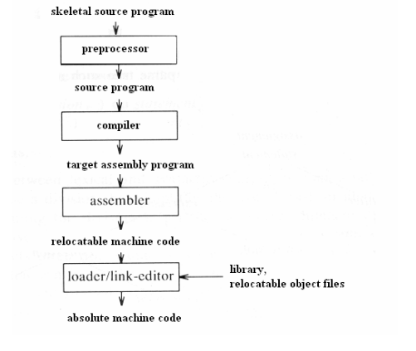

* 1. **COMPONENTS OF A COMPILER**

A typical compiler can be divided into 4 main parts:

* Lexical analyzer
* Syntax analyzer
* Semantic analyzer
* Code generator

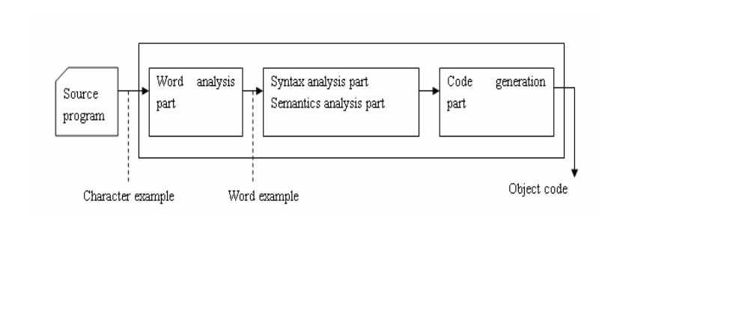

* 1. **MAIN PHASES OF COMPILING PROCESS**
* To describe more precisely, a compiler is divided into several interrelated processes, in each process, source program is translated from a specific form to another form of representation.
* A typical decomposition is illustrated in this picture: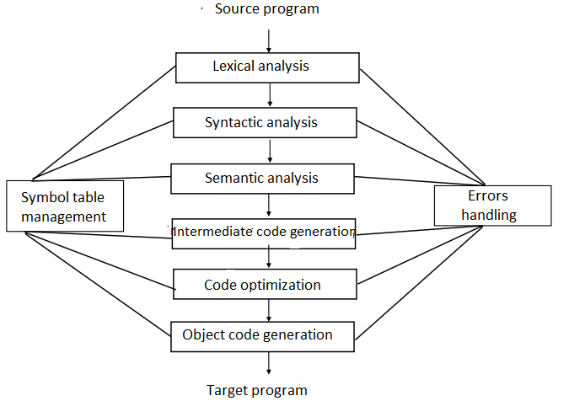

Consider an example in KPL:

Sum := initial + increment * 50 (1)

* + 1. **Lexical analysis**

Lexical analysis is the process of converting a sequence of characters into a sequence of tokens, i.e. meaningful character strings. A program or function that performs lexical analysis is called a lexical analyzer, lexer, tokenizer, or scanner, though "scanner" is also used for the first stage of a lexer.

A token is a string of one or more characters that is significant as a group. The process of forming tokens from an input stream of characters is called tokenization. The characters that form a token are called a lexeme.

(see more at http://en.wikipedia.org/wiki/Lexical_analysis)

The process of lexical analysis will occur as follows: the scanner will read character-by-character input stream to generate tokens. So the result of the example (1) will be:

1.Identifier (sum).

2.Symbol that represents assignment ( :=)

3.Identifier (initial).

4.Symbol that represents addition (+)

5.Identifier (increment).

6. Symbol that represents multiplication (*)

7.Number (50)

Note that in the process of lexical analysis, the space, tabulator, and the comments (in KPL // or /**/) will be neglected.

* + 1. **Syntactic analysis**

Syntactic analysis (also called parsing) is the process of analysing a [string](http://en.wikipedia.org/wiki/String_(computer_science)) of tokens, conforming to the rules of a [formal grammar](http://en.wikipedia.org/wiki/Formal_grammar) or not. The program that performs parsing is called the syntactic analyser or simply parser.

The output of parsing is the parse tree, or error. Parsing is based on grammar provided to build parse tree.

The most important part of building a compiler is the task of building a grammar that generates structure of a program and cannot be ambiguous. An ambiguous grammar will produce more than one parse tree, therefore must be forbidden.

The above example will produce following parse tree:

(sum := inital + increment * 50)

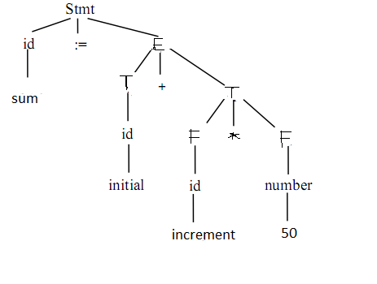

* + 1. **Semantic analysis**

Semantic analysis is the phase in which the compiler adds semantic information to the [parse tree](http://en.wikipedia.org/wiki/Parse_tree) and builds the symbol table. This phase performs semantic checks such as [type checking](http://en.wikipedia.org/wiki/Type_checking) (checking for type errors), or [object binding](http://en.wikipedia.org/wiki/Object_binding) (associating variable and function references with their definitions), or [definite assignment](http://en.wikipedia.org/wiki/Definite_assignment_analysis) (requiring all local variables to be initialized before use), rejecting incorrect programs or issuing warnings.

Semantic analysis usually requires a complete parse tree, meaning that this phase logically follows the [parsing](http://en.wikipedia.org/wiki/Parsing) phase, and logically precedes the [code generation](http://en.wikipedia.org/wiki/Code_generation_(compiler)) phase.

An important part of semantic analysis is type checking and variable scope checking. In this step, compiler will check, according to specification from source language, if operands of a operation is valid. For example, some programming language require compiler to report error whenever a floating point number is used for indexes of an array. However, some programming language allow type casting, e.g a binary operator can be applied between an integer and a floating point number. In additional, semantic analyser will use symbol table to store information about every identifier, which will generate information about the position of storing identifiers,type and scope of them in program or procedure that include them, or if an identifier is name of function or procedure, it will store information about number and type of parameters, return type, etc.

* + 1. **Intermediate code generation**

After the phase of semantic analysis, some compiler will generate an intermediate representation of source program, known as intermedia code. We can consider this representation as a program for an abstract virtual machine. They have two important properties: easy to generate, and easy to translate into object code. Moreover, intermediate code is machine-independent.

Usually, compiler use three-address codes. Three-address codes are codes that accept at most three parameters, one operator (except assignment). So before generation of these codes, compiler need rules of operator precedence, e.g * before +.

Example (1) gives the following intermediate code:

T1: = 50;

T2:= id3 * t1;

T3 := id2 + t2;

Id1:= t3;

* + 1. **Code optimization**

In this phase, code optimizator will try to optimize the intermediate code into equivalent one with faster execution.

For example, the example above (1) can be optimized as:

T1 := id3 * 50

Id1 := id2 + t1;

There is a significant difference between the amount of optimization codes done by different compiler. In some compiler called “optimize-focused compiler”, a conspicuous proportion of time devoted to this phase. However, there are also some optimization method that can decrese lots of execution time of source program without wasting too much time compiling.

* + 1. **Object code generation**

This is the final phase of compiler. Input of a object code generator is the intermediate code and output is the target program.

There are a number of factors that affect the design of an object code generator such as: memory management, resource allocation and the sequence of code execution.

* 1. **SUMMARY**

In order for a computer to understand and execute a program written in a high-level programming language, we need a compiler to translate source program to target program in object codes. This chapter has presented an overview of a compiler in general, including lexical analysis, syntactic analysis, semantic analysis, intermediate code generation, code optimization and object code generation. Output of the preceding phases are always input of the following phases, i.e, output of a scanner (tokens) will be input of the parser, output of the parser (parse tree) will be input of the semantic analyzer, etc.

**CHAPTER 2: DESIGN A LEXICAL ANALYZER FOR KPL**

In a compiler, the program that perform lexical analysis is called the scanner.

**2.1.TASK OF A SCANNER.**

-Neglect meaningless character: space, tabulalor, EOF, CR, LF, comments.

-Detect invalid symbols: @, ! (stand-alone), etc

-Detect and produce tokens: identifiers, keywords, numbers, literals, special characters, etc.

For example:

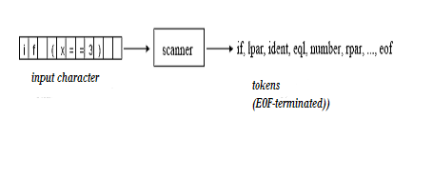

**2.2.TOKENS IN KPL**

- Identifier: variable name, constant names, type names, function names, procedure names:

* Start with letter or underscore: a-z, A-Z, ‘_’
* Others are letter, underscore or numbers

- Keywords: PROGRAM, CONST, TYPE, VAR, PROCEDURE,

FUNCTION, BEGIN, END, ARRAY, OF, INTEGER, CHAR, CALL,

IF, ELSE, WHILE, DO, FOR, TO

-*Operators*: := (assign), + (addition), - (subtraction), * (multiplication),

/ (division), = (comparison of equality), != (comparison of difference),

> (comparison of greaterness), < (comparison of lessness), >=

(comparison of greaterness or equality), <= (comparison of lessness or

equality)

-*Special characters* ; (semicolon), . (period), : (colon), , (comma),

( (left parenthesis), ) (right parenthesis), ‘ (singlequote)

(. và .) to specify indexes in arrays

//, (*, *) to indicate comments

-*Others: integer number, string literals…*

**2.3.DATA STRUCTURE IN KPL**

**typedef enum** {

CHAR_SPACE, CHAR_LETTER, CHAR_DIGIT, CHAR_PLUS,

CHAR_MINUS, CHAR_TIMES, CHAR_SLASH, CHAR_LT,

CHAR_GT, CHAR_EXCLAIMATION, CHAR_EQ, CHAR_COMMA,

CHAR_PERIOD, CHAR_COLON, CHAR_SEMICOLON,

CHAR_SINGLEQUOTE, CHAR_LPAR, CHAR_RPAR,

CHAR_UNKNOWN

} CharCode;

Data structure to store valid characters in KPL : space, letters, numbers, +, -, *, /, <, >, ! , =, , , . , : , ; , ‘ , (. , .) others are invalid characters (CHAR_UNKNOWN)

**typedef enum** {

TK_NONE, TK_IDENT, TK_NUMBER, TK_CHAR, TK_EOF,

KW_PROGRAM, KW_CONST, KW_TYPE, KW_VAR,

KW_INTEGER, KW_CHAR, KW_ARRAY, KW_OF,

KW_FUNCTION, KW_PROCEDURE,

KW_BEGIN, KW_END, KW_CALL,

KW_IF, KW_THEN, KW_ELSE,

KW_WHILE, KW_DO, KW_FOR, KW_TO,

SB_SEMICOLON, SB_COLON, SB_PERIOD, SB_COMMA,

SB_ASSIGN, SB_EQ, SB_NEQ, SB_LT, SB_LE, SB_GT, SB_GE,

SB_PLUS, SB_MINUS, SB_TIMES, SB_SLASH,

SB_LPAR, SB_RPAR, SB_LSEL, SB_RSEL

} TokenType;

Stores token types in KPL

**typedef struct** {

char string[MAX_IDENT_LEN + 1];

int lineNo, colNo; // line and column of tokens

TokenType tokenType;

int value;

} Token;

Store information about each tokens:

* string : content of token
* lineNo , colNo : position of token,
* tokenType : type of token
* value : value of token if a number.

**2.4.FUNCTIONS IN KPL**

**2.4.1 . Details about functions**

**void** *skipBlank*() : skip spaces.

**void** *skipComment*() : skip comments.

Token* *readIdentKeyword*() : read identifiers or keywords, return a pointer of Token type.

Token* *readNumber*() : read a integer number, return a pointer of Token type.

Token* *readConstChar*() : read a constant character, return a pointer of Token type.

TokenType *checkKeyword*(char *string) : check if the string is a keyword, return TOKEN_NONE if keyword.

Token* *makeToken*(TokenType tokenType, int lineNo, int colNo) : create a pointer to a token with predefined type and position.

Token* *getToken*() : read and return a token (can be invalid token: TOKEN_NONE).

Token* *getValidToken*() : read and return a valid token.

**2.4.2.Details about execution of a scanner.**

Scanner is a finite automation. Everytime it return a token, the state will be 0. When detects invalid characters, the state will be -1.

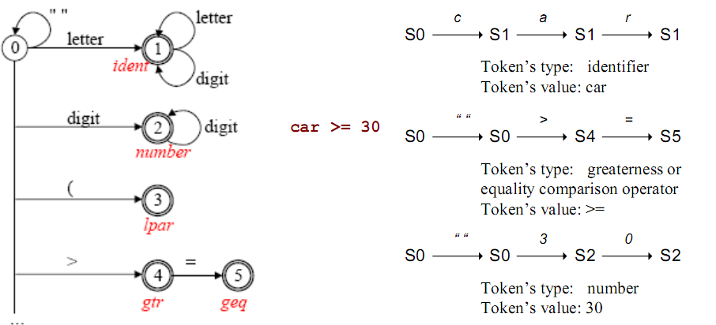

During the reading of input stream, *getToken*() will be looped until meet (EOF).

- Detect spaces (CHAR_SPACE) -> *skipBlank*(), state will be 0, -> *getToken*()…

- Every tokens read will be passed to parser for the next phase of compiling process.

Details about implementation of functions, refer to file [scanner.c](scanner/scanner.c)

**CHAPTER 3: DESIGN SYNTACTIC ANALYSER FOR KPL**

**3.1. Task of a syntatic analyser (parser)**

- Check the syntax of the program for errors.

- Produce parse tree for semantic analyser otherwise.

**3.2. Syntax diagram and BNF grammar**

**3.2.1. Syntax diagram.**

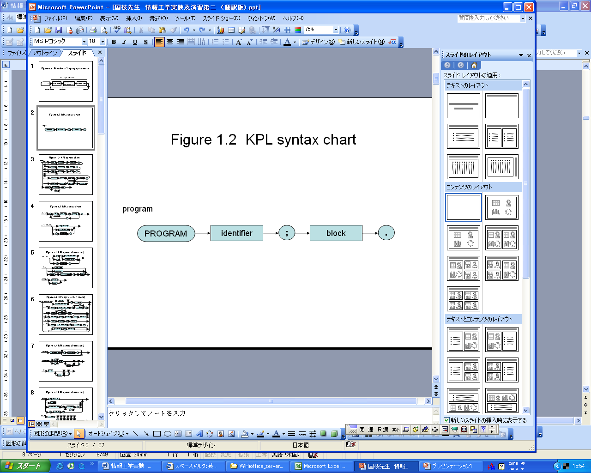

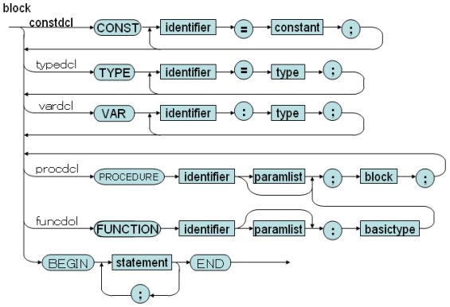

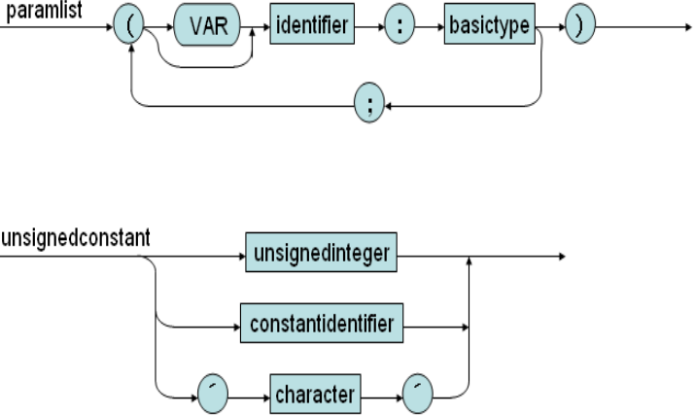

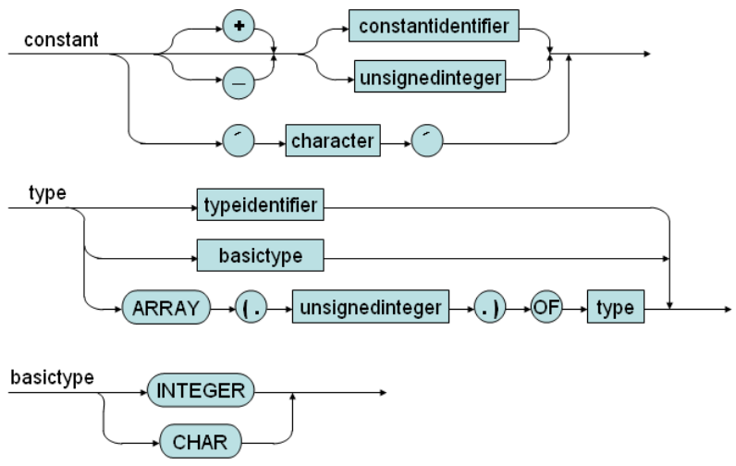

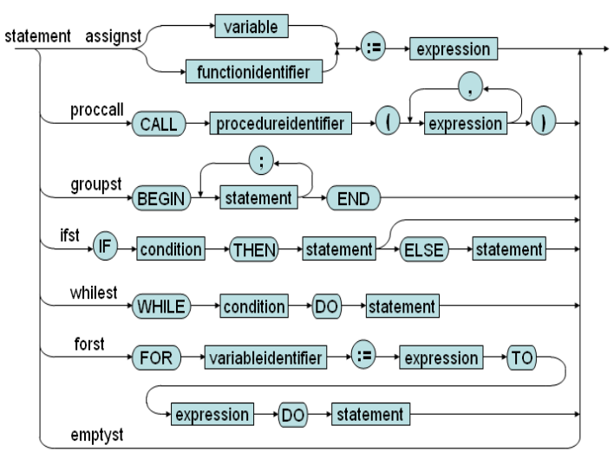

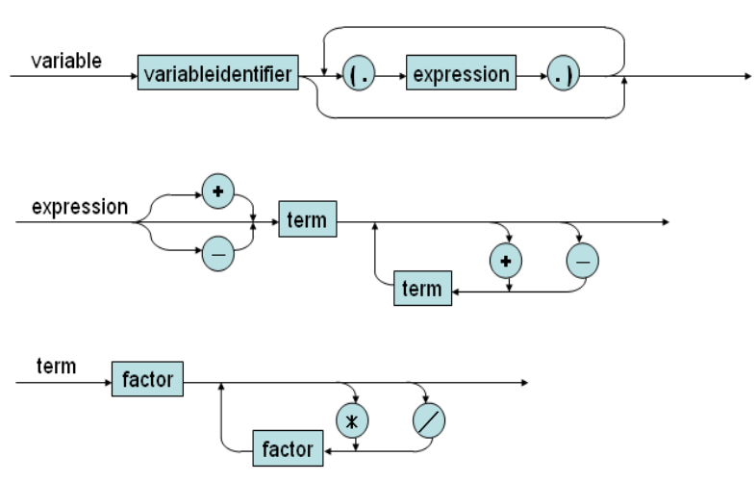

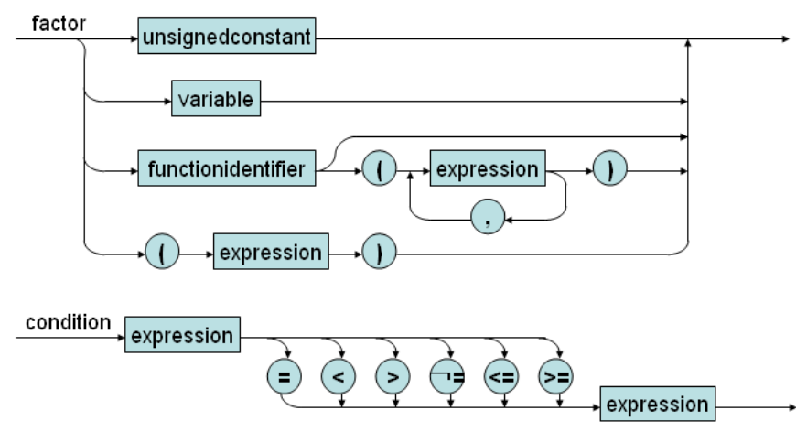

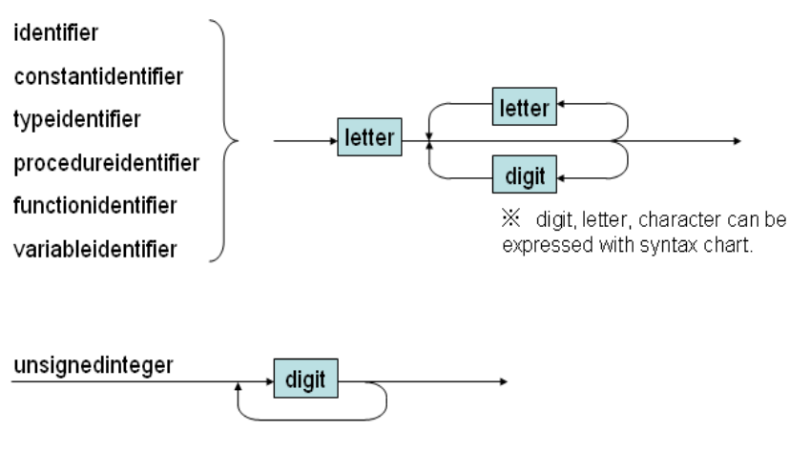

**3.2.1. BNF grammar.**

01) Prog ::= KW_PROGRAM Ident SB_SEMICOLON Block SB_PERIOD

02) Block ::= KW_CONST ConstDecl ConstDecls Block2

03) Block ::= Block2

04) Block2 ::= KW_TYPE TypeDecl TypeDecls Block3

05) Block2 ::= Block3

06) Block3 ::= KW_VAR VarDecl VarDecls Block4

07) Block3 ::= Block4

08) Block4 ::= SubDecls Block5

09) Block5 ::= KW_BEGIN Statements KW_END

10) ConstDecls::= ConstDecl ConstDecls

11) ConstDecls::= Ɛ

12) ConstDecl ::= Ident SB_EQUAL Constant SB_SEMICOLON

13) TypeDecls ::= TypeDecl TypeDecls

14) TypeDecls ::= Ɛ

15) TypeDecl ::= Ident SB_EQUAL Type SB_SEMICOLON

16) VarDecls ::= VarDecl VarDecls

17) VarDecls ::= Ɛ

18) VarDecl ::= Ident SB_COLON Type SB_SEMICOLON

19) SubDecls ::= FunDecl SubDecls

20) SubDecls ::= ProcDecl SubDecls

21) SubDecls ::= Ɛ

22) FunDecl ::= KW_FUNCTION Ident Params SB_COLON BasicType

SB_SEMICOLON Block SB_SEMICOLON

23) ProcDecl ::= KW_PROCEDURE Ident Params SB_SEMICOLON Block

SB_SEMICOLON

24) Params ::= SB_LPAR Param Params2 SB_RPAR

25) Params ::= Ɛ

26) Params2 ::= SB_SEMICOLON Param Params2

27) Params2 ::= Ɛ

28) Param ::= Ident SB_COLON BasicType

29) Param ::= KW_VAR Ident SB_COLON BasicType

30) Type ::= KW_INTEGER

31) Type ::= KW_CHAR

32) Type ::= TypeIdent

33) Type ::= KW_ARRAY SB_LSEL Number SB_RSEL KW_OF Type

34) BasicType ::= KW_INTEGER

35) BasicType ::= KW_CHAR

36) UnsignedConstant ::= Number

37) UnsignedConstant ::= ConstIdent

38) UnsignedConstant ::= ConstChar

40) Constant ::= SB_PLUS Constant2

41) Constant ::= SB_MINUS Constant2

42) Constant ::= Constant2

43) Constant ::= ConstChar

44) Constant2::= ConstIdent

45) Constant2::= Number

46) Statements ::= Statement Statements2

47) Statements2 ::= KW_SEMICOLON Statement Statement2

48) Statements2 ::= Ɛ

49) Statement ::= AssignSt

50) Statement ::= CallSt

51) Statement ::= GroupSt

52) Statement ::= IfSt

53) Statement ::= WhileSt

54) Statement ::= ForSt

55) Statement ::= Ɛ

56) AssignSt ::= Variable SB_ASSIGN Expession

57) AssignSt ::= FunctionIdent SB_ASSIGN Expression

58) CallSt ::= KW_CALL ProcedureIdent Arguments

59) GroupSt ::= KW_BEGIN Statements KW_END

60) IfSt ::= KW_IF Condition KW_THEN Statement ElseSt

61) ElseSt ::= KW_ELSE statement

62) ElseSt ::= Ɛ

63) WhileSt ::= KW_WHILE Condition KW_DO Statement

64) ForSt ::= KW_FOR VariableIdent SB_ASSIGN Expression KW_TO

Expression KW_DO Statement

65) Arguments ::= SB_LPAR Expression Arguments2 SB_RLAR

66) Arguments ::= Ɛ

67) Arguments2::= SB_COMMA Expression Arguments2

68) Arguments2::= Ɛ

68) Condition ::= Expression Condition2

69) Condition2::= SB_EQ Expression

70) Condition2::= SB_NEQ Expression

71) Condition2::= SB_LE Expression

72) Condition2::= SB_LT Expression

73) Condition2::= SB_GE Expression

74) Condition2::= SB_GT Expression

75) Expression ::= SB_PLUS Expression2

76) Expression ::= SB_MINUS Expression2

77) Expression ::= Expression2

78) Expression2 ::= Term Expression3

79) Expression3 ::= SB_PLUS Term Expression3

80) Expression3 ::= SB_MINUS Term Expression3

81) Expression3 ::= Ɛ

82) Term ::= Factor Term2

83) Term2 ::= SB_TIMES Factor Term2

84) Term2 ::= SB_SLASH Factor Term2

85) Term2 ::= Ɛ

86) Factor ::= UnsignedConstant

87) Factor ::= Variable

88) Factor ::= FunctionApptication

89) Factor ::= SB_LPAR Expression SB_RPAR

90) Variable ::= VariableIdent Indexes

91) FunctionApplication ::= FunctionIdent Arguments

92) Indexes ::= SB_LSEL Expression SB_RSEL Indexes

93) Indexes ::= Ɛ

**3.3. Recursive descent parsing**

*-Properties:*

+ LL(k) is the language that needs looking ahead k character to produce a valid production.

+used to parse LL(1) language.

+ Can be extended for LL(k), but very complex.

+Used for other grammar can lead to infinite iteration.

-Recursive descent parsing:

* A top-down parsing method.
* The term descent refers to the direction in which the parse tree is traversed (or built).
* Use a set of mutually recursive procedures (one procedure for each nonterminal symbol) Start the parsing process by calling the procedure that corresponds to the start symbol . Each production becomes one clause in procedure
* We consider a special type of recursive-descent parsing called predictive parsing . Use a lookahead symbol to decide which production.

**3.4. Data structure in parser for KPL**

Use data structure in scanner.

**3.5. Parse terminal symbols.**

**void** *eat*(TokenType tokenType);

Function will compare the passed tokenType to token type read in scanner (currentToken).

If equals, print out the token.

Otherwise, report error: “missing token” at that position.

**3.6. Parsing non-terminal symbols.**

**void** *compileProgram*(): parse main program.

**void** *compileBlock*(void): parse constant declarations then call *compileBlock2*.

**void** *compileBlock2*(void): parse type declarations then call *compileBlock3*.

**void** *compileBlock3*(void): parse variable declarations then call *compileBlock4*.

**void** *compileBlock4*(void):parse subroutines declarations then call *compileBlock5*.

**void** *compileBlock5*(void): parse statements in main function.

**void** *compileConstDecls*(void): parse constant declarations.

**void** *compileConstDecl*(void): parse a single constant declaration.

**void** *compileTypeDecls*(void): parse type declarations.

**void** *compileTypeDecl*(void): parse a single type declaration.

**void** *compileVarDecls*(void): parse variable declarations.

**void** *compileVarDecl*(void): parse a variable declaration.

**void** *compileSubDecls*(void): parse subroutines declarations.

**void** *compileFuncDecl*(void): parse function declarations.

**void** *compileProcDecl*(void): parse procedures declarations.

**void** *compileUnsignedConstant*(void): parse unsigned constants.

**void** *compileConstant*(void): parse signed constants.

**void** *compileType*(void): parse a type.

**void** *compileBasicType*(void): parse a basic type.

**void** *compileParams*(void): parse list of parameters.

**void** *compileParam*(void): parse a single parameter.

**void** *compileStatements*(void): parse all statements.

**void** *compileStatement*(void): parse a single statement.

**void** *compileAssignSt*(void): parse an assignment statement.

**void** *compileCallSt*(void): parse a call statement.

**void** *compileIfSt*(void): parse an IF statement.

**void** *compileElseSt*(void): parse an ELSE statement.

**void** *compileWhileSt*(void): parse a WHILE statement.

**void** *compileForSt*(void): parse a FOR statement.

**void** *compileArguments*(void): parse list of arguments passed to a function or procedure.

**void** *compileArguments2*(void): parse list of arguments passed to a function or procedure.

**void** *compileCondition*(void): parse conditional expression.

**void** *compileExpression*(void): parse (+,-) of an expression then call *compileExpression2*

**void** *compileExpression2*(void): parse (+, - ) operators between terms then call *compileExpression3*

**void** *compileExpression3*(void): recursive of (+, -) operators between terms.

**void** *compileTerm*(void): compile a term, which can be composed of (*, /) of compileFactor

**void** *compileTerm2*(void) recursive procedure of (*, /) between factors.

**void** *compileFactor*(void): a factor can be a number, character, identifier .

**void** *compileIndexes*(void): parse indexes of an array.

Details about implementation of functions, refer to [parser.c](parser/parser.c)

# CHAPTER 4. DESIGN SEMANTIC ANALYZER FOR KPL

* 1. **Tasks of semantic analyzer**

Import tasks of a sematic analyser:

- Produce symbol table for future references (eg. scope and type checking).

-Scope checking

-Type checking.

* 1. **Design symbol table**
     1. **Why we need symbol table**

We need a symbol table to store information needed about every identifiers in the program.

Each [identifier](http://en.wikipedia.org/wiki/Identifier) in a program's [source code](http://en.wikipedia.org/wiki/Source_code) is associated with information relating to its declaration or appearance in the source, such as its [type](http://en.wikipedia.org/wiki/Data_type), [scope](http://en.wikipedia.org/wiki/Scope_(programming)) level and its [location](http://en.wikipedia.org/wiki/Memory_address).

* + 1. **Design symbol table**

**4.2.2.1.Data structure in symbol table**

struct SymTab_ {

Object* program;

Scope* currentScope;

ObjectNode *globalObjectList;

};

The data structure to represent symbol table itself, including:

* Program: the program object.
* currentScope: current scope of symbol table.
* globalObjectList: store global objects such as functions: CALLI, WRITEI, etc.

struct Object_ {

char name[MAX_IDENT_LEN];

enum ObjectKind kind;

union {

ConstantAttributes* constAttrs;

VariableAttributes* varAttrs;

TypeAttributes* typeAttrs;

FunctionAttributes* funcAttrs;

ProcedureAttributes* procAttrs;

ProgramAttributes* progAttrs;

ParameterAttributes* paramAttrs;

};

};

To store information about each object in program, such as main program itself, a procedure or function, a variable, a constant, etc.

enum ObjectKind {

OBJ_CONSTANT,

OBJ_VARIABLE,

OBJ_TYPE,

OBJ_FUNCTION,

OBJ_PROCEDURE,

OBJ_PARAMETER,

OBJ_PROGRAM

};

Kinds of object (a variable object, a constant object, etc)

enum ParamKind {

PARAM_VALUE,

PARAM_REFERENCE

};

Kinds of parameter: value or reference type.

struct Scope_ {

ObjectNode *objList;

Object *owner;

struct Scope_ *outer;

};

To store information about a scope, including:

* objList: objects in the scope.
* Owner: function or procedure has that scope.
* Outer: the outer scope of it.

struct ObjectNode_ {

Object *object;

struct ObjectNode_ *next;

};

A linked list to represent list of objects.

struct ConstantValue_ {

enum TypeClass type;

union {

int intValue;

char charValue;

};

};

typedef struct ConstantValue_ ConstantValue;

struct Scope_;

struct ObjectNode_;

struct Object_;

struct ConstantAttributes_ {

ConstantValue* value;

};

struct VariableAttributes_ {

Type *type;

struct Scope_ *scope;

};

struct TypeAttributes_ {

Type *actualType;

};

struct ProcedureAttributes_ {

struct ObjectNode_ *paramList;

struct Scope_* scope;

};

struct FunctionAttributes_ {

struct ObjectNode_ *paramList;

Type* returnType;

struct Scope_ *scope;

};

struct ProgramAttributes_ {

struct Scope_ *scope;

};

struct ParameterAttributes_ {

enum ParamKind kind;

Type* type;

struct Object_ *function;

};

typedef struct ConstantAttributes_ ConstantAttributes;

typedef struct TypeAttributes_ TypeAttributes;

typedef struct VariableAttributes_ VariableAttributes;

typedef struct FunctionAttributes_ FunctionAttributes;

typedef struct ProcedureAttributes_ ProcedureAttributes;

typedef struct ProgramAttributes_ ProgramAttributes;

typedef struct ParameterAttributes_ ParameterAttributes;

To store typical attributes of each type: e.g a constant type must have a constant value, a function type must have a parameter list, a return type, and own a scope.

**4.2.2.2.Functions in symbol table.**

Object* createProgramObject(char *programName): create a program object.

Object* createConstantObject(char *name): create a constant object.

Object* createTypeObject(char *name): create a type object.

Object* createVariableObject(char *name): create a variable object.

Object* createFunctionObject(char *name): create a function object.

Object* createProcedureObject(char *name): create a procedure object.

Object* createParameterObject(char *name, enum ParamKind kind, Object* owner): create a parameter object.

Type* makeIntType(void): create an integer type.

Type* makeCharType(void): create a character type.

Type* makeArrayType(int arraySize, Type* elementType): create an array type.

Type* duplicateType(Type* type): copy type.

int compareType(Type* type1, Type* type2): compare type

ConstantValue* makeIntConstant(int i): create an integer constant.

ConstantValue* makeCharConstant(char ch): create a character constant.

ConstantValue* duplicateConstantValue(ConstantValue* v): copy a constant.

Scope* createScope(Object* owner, Scope* outer): create a scope.

Object* findObject(ObjectNode *objList, char *name): find object with specific name in an object list.

* 1. **Verify scoping rules**
     1. **Checking fresh identifier**

We determine if an identifier is not declared yet, by function void checkFreshIdent(char *name)

void checkFreshIdent(char *name) {

if (findObject(symtab->currentScope->objList, name) != NULL)

error(ERR_DUPLICATE_IDENT, currentToken->lineNo, currentToken->colNo);

}

If the identifier is already declared, findObject function will return an non-null value.

* + 1. **Checking declared identifier**

Object* checkDeclaredIdent(char *name): check declared identifiers: (identifier is already declared or not. If declared return identifier object, else return null.)

Object* checkDeclaredConstant(char *name): check declared constants.

Object* checkDeclaredType(char *name): check declared identifiers.

Object* checkDeclaredVariable(char *name): check declared variables.

Object* checkDeclaredFunction(char *name): check declared functions.

Object* checkDeclaredProcedure(char *name): check declared procedure.

Object* checkDeclaredLValueIdent(char *name): check declared LValue.

* 1. **Type checking**
     1. **Checking the consistency between declaration and usage of identifiers.**

void checkIntType(Type* type): check if type is integer

void checkCharType(Type* type): check if type is character

void checkArrayType(Type* type): check if type is array type.

void checkBasicType(Type* type): check if type is basic type.

void checkTypeEquality(Type* type1, Type* type2): check for equality of types, if not, report an error message.

**4.4.2. Checking specific requirements in some statement (e.g. LValue in assign statement.**