**Question 4**: What is the IP address of your 2 machines? How to ping each other?

Answer:

We setting Networking in setting of machine to Bridged Adapter.

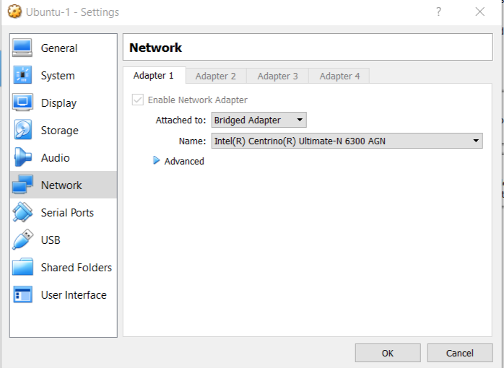

And then open terminal, type: ifconfig to get IP adress !

Now, for my practice, I get 2 IP address on 2 virtual machine:  
192.168.1.153 and 192.168.1.16  
To ping each other, I use command: ping 192.168.1.16 or ping 191.168.1.153

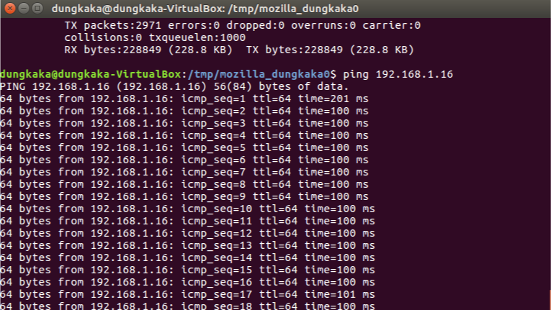

**Question 5**: Can you watch the video in the client machine? Evaluate the quality of the video streaming service.

Answer:

I can watch the video in client machine, And quality of video streaming is the same between client and server.

**Question 6**: What is the result of the ping test? Can you see an increase of 100 milliseconds?

Answer: Yes, the time field increase of 100 ms !

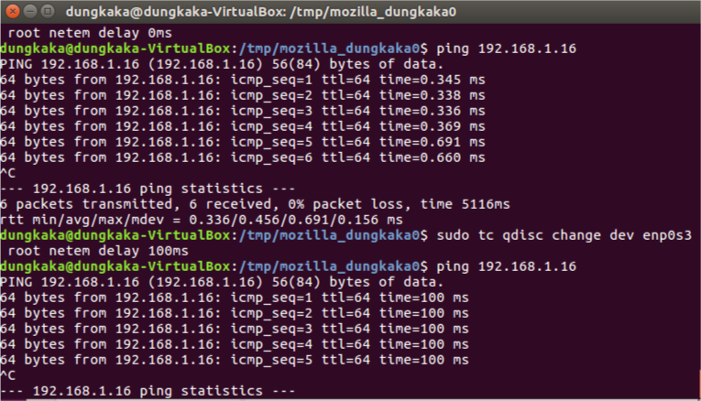

**Question 7**: Evaluate the video quality at the Client machine. How can you conclude the impact of fix delay on video streaming service?

Answer:

No impact of delay on video streamming service compare to quality of video streaming without delay.

**Question 8**: Evaluate the video quality at the Client machine. How can you conclude the impact of delay variation on video streaming service?  
Answer:

The variation in video is caused with the variable delay introduced in combination with fixed delay. Fixed delay introduces constant delay on video sequences and has no significant impact on the video quality. Variable delay, for instance 100ms±10ms introduces delay between 90 and 110 which has higher impact on video quality.

And, for testing on client machine, I saw some noise sometime on video streamming.

**Question 9**: Evaluate the video quality at the Client machine. How can you conclude the impact of fix loss rate on video streaming service? Try to increase the value of loss rate to see the impact more clear.

Answer:

When amount of packet lost increases, result shows that MOS suffers an exponential decay. Many people were able to observe that the videos were poor as the percentages of losses peaks to the maximum allowable loss percentage for my testing.

**Question 10**: Evaluate the video quality at the Client machine. How can you conclude the impact of loss rate variation on video streaming service? Try to increase this value to see the impact more clear.

Answer:

Low rate variances of packet losses are observed to be low for all videos and packet sizes. When increase loss rate varition, these results could be translated as how difficult is for viewers to make decision on the videos they watch in the range between 0.3% and 1% of packets. But, low values variance for a range between 3% and 10% shows that viewers were easily able to decide on whether the video is bad or good.

**Question 11**: Evaluate the video quality at the Client machine. How can you conclude the impact of packet duplication on video streaming service? Try to increase this value to see the impact more clear.

Answer:

In my test, I can not see clearly effect of packet duplication.

**Question 12**: Evaluate the video quality at the Client machine. How can you conclude the impact of packet corruption on video streaming service?

Answer:

In my test, I can not see clearly effect of packet corruption.