**Report Capture Youtube Ads**

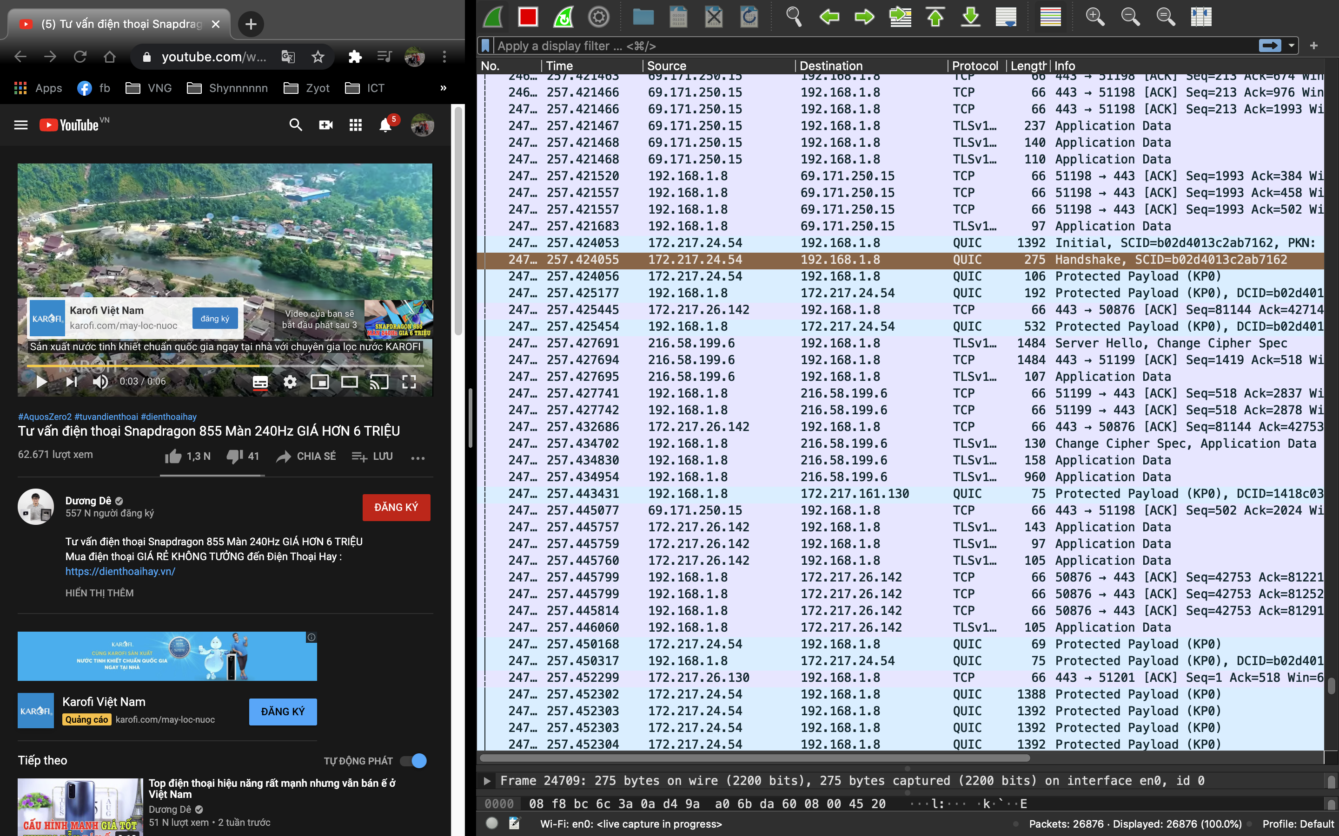

IP client: 192.168.1.8

IP destination: 172.217.24.54