Requirement Analysis

Group [SoftwareDevelopment.ITSS.20191-04](https://bitbucket.org/Thanh98hy/softwaredevelopment.itss.20191-04/)

* Đào Ngọc Thành
* Nguyễn Đức Dũng
* Trần Bích Ngọc
* Vũ Thanh Tùng

# Use case diagram

## General use case diagram

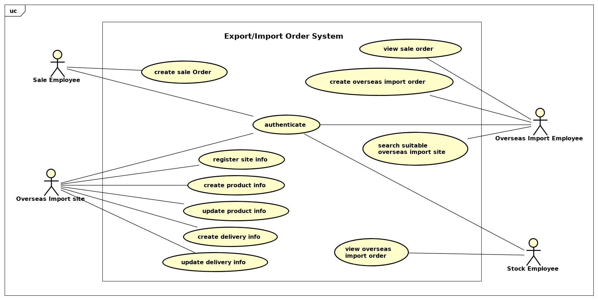

# Use case specification

## UC “Create overseas import order list”

|  |  |  |  |
| --- | --- | --- | --- |
| **UC Code** | UC008 | **Use case name** | Create overseas import order list |
| **Actor** | Overseas Import Employee, Import Site | | |
| **Precondition** | Search Suitable Overseas Import Site | | |
| **Main flow of event (success)** | |  |  |  | | --- | --- | --- | | **#** | **Doer** | **Action** | |  | Employee | Click create new order list | |  | System | Display all merchandise from sales order & corresponding suitable import site | |  | Employee | Select merchandise code needed to import | |  | System | Add this merchandise to order list | |  | Employee | Click button create | |  | System | Send order information to chosen sites | |  | System | Display order created successfully | | | |
| **Alternative flow of event** | |  |  |  | | --- | --- | --- | | **#** | **Doer** | **Action** | | | |
| **Post condition** | None | | |

## UC “View overseas import order list”

|  |  |  |  |
| --- | --- | --- | --- |
| **UC Code** | UC009 | **Use case name** | View overseas import order list |
| **Actor** | Stock employee | | |
| **Precondition** | Receive goods from sites | | |
| **Main flow of event (success)** | |  |  |  | | --- | --- | --- | | **#** | **Doer** | **Action** | |  | Stock employee | Click view order list | |  | System | Display list of all merchandise in order | |  | Stock employee | Select a merchandise in list | |  | System | Display merchandise information in order list and received list | |  | System | Compare quantity btw required and received | |  | System | Display result | |  | Stock employee | Send confirmatiton message | |  | System | Write merchandise information to stock | |  | System | Display completed transaction | | | |
| **Alternative flow of event** | |  |  |  | | --- | --- | --- | | **#** | **Doer** | **Action** | | 6a. | System | Notifie “missing quantity in merchandise code xxx from site yyy ” | | 7a. | Stock employee | Send error message when ordered quantity and received one are different | | 8a. | System | Write merchandise information in incompleted section : code, missing quantity, site name,…. | | | |
| **Post condition** | None | | |

## UC “Authenticate for stock employee ”

|  |  |  |  |
| --- | --- | --- | --- |
| **UC Code** | UC010 | **Use case name** | Create overseas import order list |
| **Actor** | Stock employee | | |
| **Precondition** | none | | |
| **Main flow of event (success)** | |  |  |  | | --- | --- | --- | | **#** | **Doer** | **Action** | | 1 | Employee | Click login button | | 2 | System | Display login screen | | 3 | Employee | Type username and password | | 4 | System | Verify username & password | | 5 | System | Turn to main screen | | | |
| **Alternative flow of event** | |  |  |  | | --- | --- | --- | | **#** | **Doer** | **Action** | | 1.a | Employee | Click register button if dont have account | | 2.a | System | Display register screen | | 3.a | Employee | Type registration information | | 4.a | System | Save user information and create account | | 5.a | System | Notifies “Wrong password” if user type wrong password | | 5.b | System | Notifies “Username does not exist! Dont have any account? Create account.” if user type wrong username | | | |
| **Post condition** | None | | |

# Glossary

Introduction to Glossary…

# Supplementary specification

## Functionality

## Performance

## Reliability