Requirement Analysis

Group [SoftwareDevelopment.ITSS.20191-04](https://bitbucket.org/Thanh98hy/softwaredevelopment.itss.20191-04/)

* Đào Ngọc Thành
* Nguyễn Đức Dũng
* Trần Bích Ngọc
* Vũ Thanh Tùng

**1. Use case diagram**

1.1 General use case

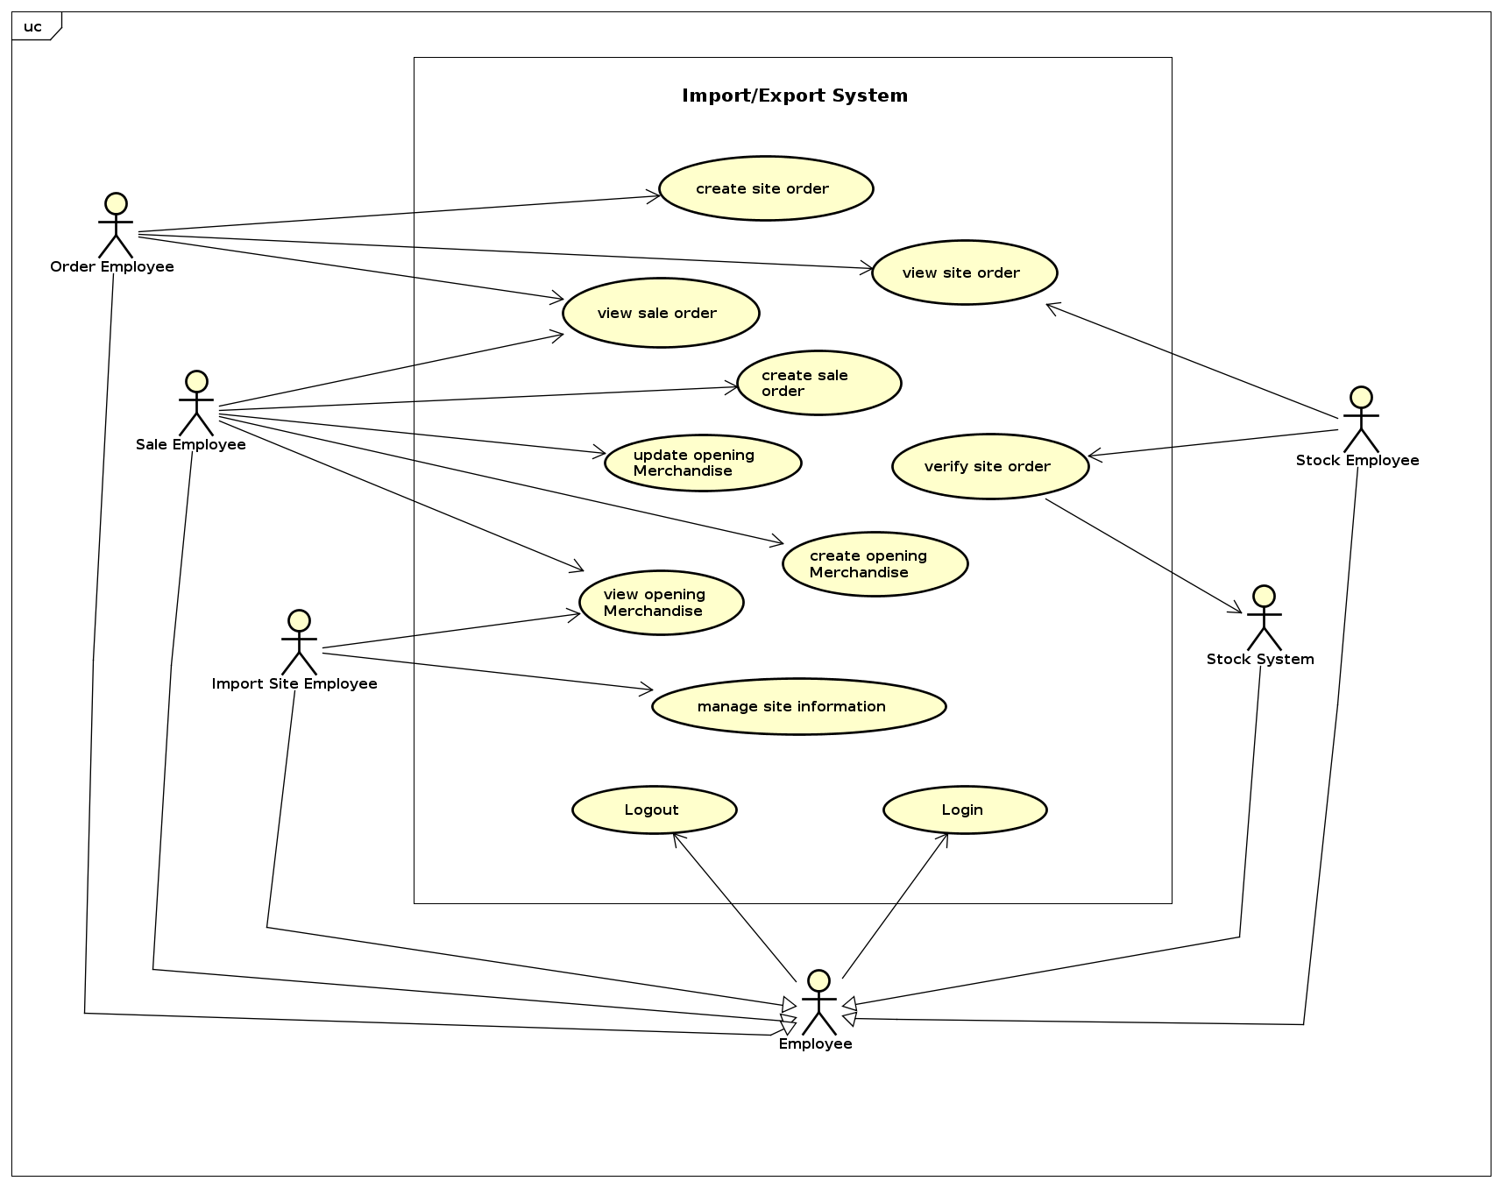

Use case 1: General diagram

1.2 Use case for “Manage Import Site Information”

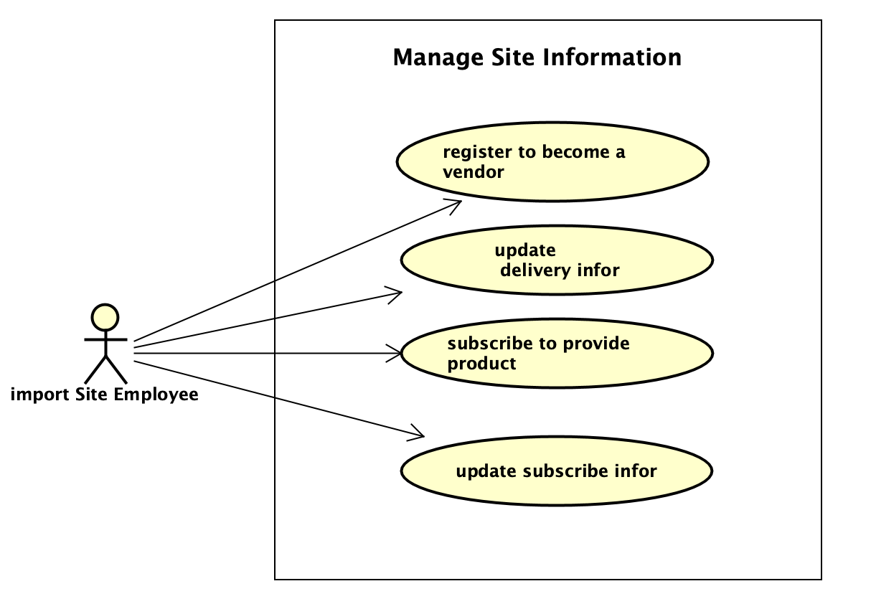

Use case 2: Manage site information use case

# **2. Use case specification**

**2.1 Use case specification for “Create Sale Order”**

|  |  |  |  |
| --- | --- | --- | --- |
| UC Code | UC001 | Use case name | Create Sale Order |
| Actor | Sale Employee | | |
| Precondition | successful login and in create sale order | | |
| Main flow of event (success) | |  |  |  | | --- | --- | --- | | # | Doer | Action | |  | Sale Employee | Enter merchandise code, quantity ordered, Unit, Desired delivery date and click button Save | |  | System | checks the validation of information | |  | System | If all information is valid, save the site order, then displays a success notification | | | |
| Alternative flow of event | |  |  |  | | --- | --- | --- | | # | Doer | Action | | 3.a | System | Warning error “Invalid quantity” if the quantity ordered is fewer than 1 | | 3.b | System | Warning error “Invalid unit” if the unit doesn’t fit | | 4.c | System | Warning error “Invalid date” if the desired delivery date is not valid | | | |
| Post condition | None | | |

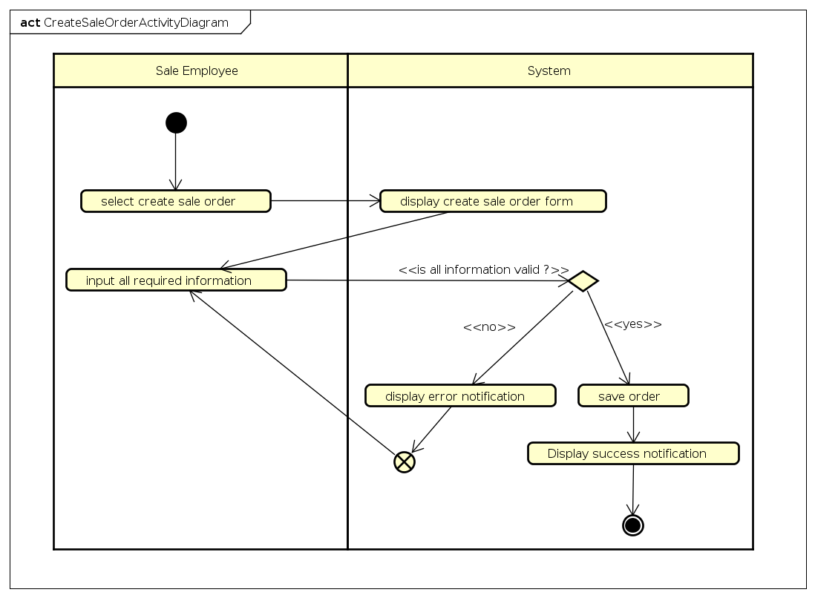  
ActivityDiagram: Create Sale Order

**2.2 Use case specification for “Create Site Order”**

|  |  |  |  |
| --- | --- | --- | --- |
| UC Code | UC001 | Use case name | Create Site Order |
| Actor | Order Employee | | |
| Precondition | successful login and in create site order section | | |
| Main flow of event (success) | |  |  |  | | --- | --- | --- | | # | Doer | Action | | 1. | Order Employee | Select a sale order and press create order button | | 2. | System | Process and display a recommend site orders | | 3. | Order Employee | If the recommend order is resonable, click submit | | 4. | System | Send order to each site in the order | | 5. | System | Display success notification | | | |
| Alternative flow of event | |  |  |  | | --- | --- | --- | | # | Doer | Action | | 3a.1 | Order Employee | If the recommend is not resonable, order employee click to edit button | | 3a.2 | System | Display all possible import site and these merchandises information | | 3a.3 | Order Employee | Create site order manual, then click submit | | 3a.4 | System | Verify the order | | 3a.5.1 | System | Display success notification, if the order is valid | | 3a.5.2 | System | Display error notification, if there any error in the order | | | |
| Post condition | None | | |

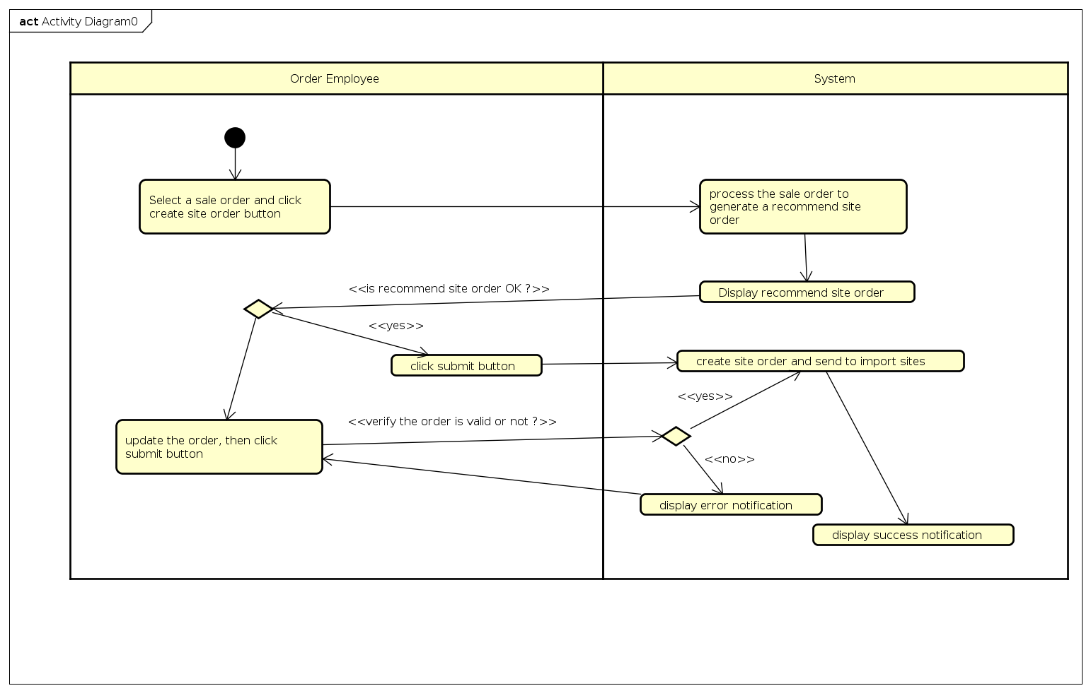  
1. Activity: Create Site Order

**2.3 Use case specification for “****subscribe to provide product”**

|  |  |  |  |
| --- | --- | --- | --- |
| **UC Code** | UC007 | **Use case name** | Subscribe to provide product |
| **Actor** | Import Site Employee | | |
| **Precondition** | View opening product | | |
| **Main flow of event (success)** | |  |  |  | | --- | --- | --- | | **#** | **Doer** | **Action** | | 1 | ISE | Click subscribe button under opening products list | | 2 | System | Display form (name, code, quantity,...) | | 3 | ISE | Select product can provide from list | | 4 | System | Add product selected into form | | 5 | ISE | Edit quantity can be provided, shipping method | | 6 | ISE | Click save | | 7 | System | Check validation | | 8 | System | Save information | | 9 | System | Notify create successfully | | 10 | System | Return to list of opening products screen | | | |
| **Alternative flow of event** | |  |  |  | | --- | --- | --- | | **#** | **Doer** | **Action** | | 6a. | ISE | Choose other products | | 7a. | System | Add product into form | | 6b. | ISE | Delete product | | 7b. | System | Delete this product from form | | 6c. | ISE | Cancel | | 7c. | System | Return to list of opening products screen | | | |
| **Post condition** | None | | |

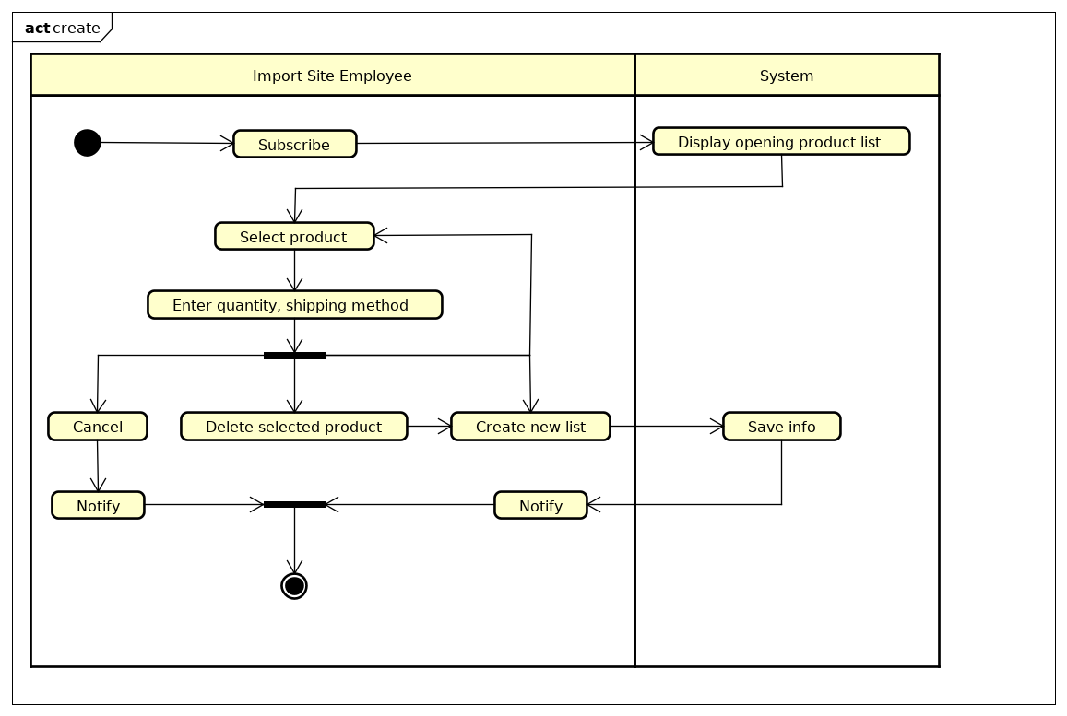  
Activity diagram

**2.4 Use case specification for “****update subscribe information”**

|  |  |  |  |
| --- | --- | --- | --- |
| **UC Code** | UC007 | **Use case name** | update subscribe information |
| **Actor** | Import Site Employee | | |
| **Precondition** | Subscribe to provide product | | |
| **Main flow of event (success)** | |  |  |  | | --- | --- | --- | | **#** | **Doer** | **Action** | | 1 | ISE | Click into subscribe form | | 2 | System | Display all products in form (name, code, quantity,...) | | 3 | ISE | Select product want to update | | 4 | System | Display detail information of this product | | 5 | ISE | Edit quantity, shipping method, v.v.. | | 6 | ISE | Click save | | 7 | System | Check validation | | 8 | System | Save information | | 9 | System | Notify update successfully | | 10 | System | Turn to form screen | | | |
| **Alternative flow of event** | |  |  |  | | --- | --- | --- | | **#** | **Doer** | **Action** | | 6a. | ISE | Cancel | | 7a. | System | Turn to form screen | | | |
| **Post condition** | None | | |

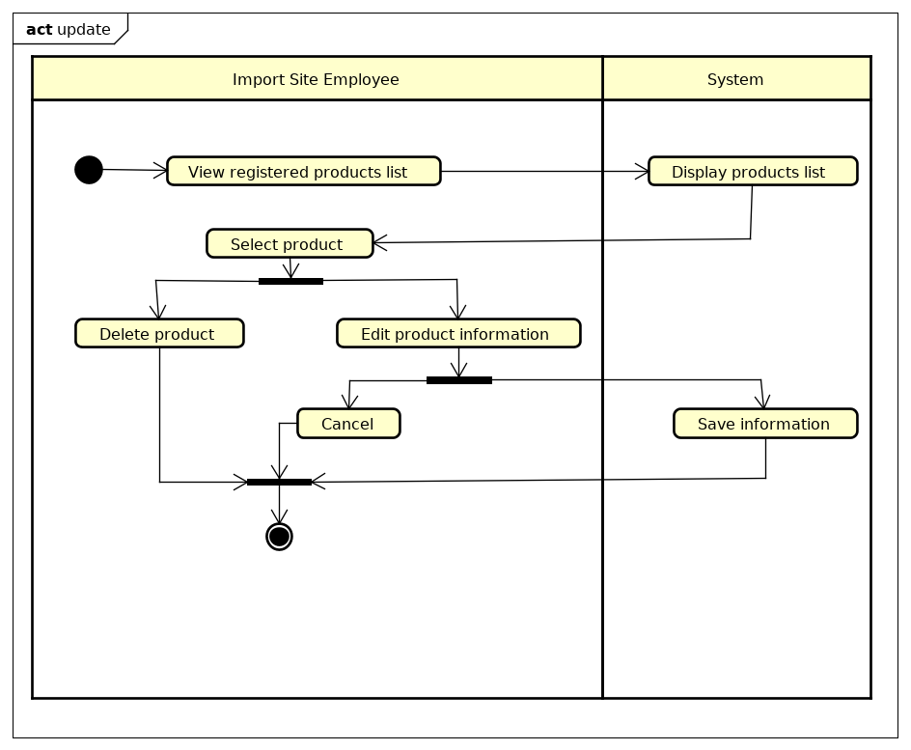  
Activity diagram

**2.5 Use case specification for “Register to be a Vendor”**

|  |  |  |  |
| --- | --- | --- | --- |
| UC Code | UC001 | Use case name | Register vendor |
| Actor | Import Site Employee | | |
| Precondition | None | | |
| Main flow of event (success) | |  |  |  | | --- | --- | --- | | # | Doer | Action | | 1. | Import Site Employee | Clicks “Register vendor” button | | 2. | System | Displays “Register vendor” screen | | 3. | Import Site Employee | Enters register form | | 4. | Import Site Employee | Clicks “Register” after filling the form | | 5. | System | Checks if all the necessary fields are filled | | 6. | System | Checks if the email is existed | | 7. | System | Notifies that register successfully | | | |
| Alternative flow of event | |  |  |  | | --- | --- | --- | | # | Doer | Action | | 4a | Import Site Employee | Clicks “Cancel” button whenever filling form, system will display confirm dialog | | 5a | System | Displays “Invalid Input” message if there is any needed field that is not satisfied | | 6a | Import Site Employee | Displays “Existed email” message if the email is existed | | | |
| Post condition | None | | |

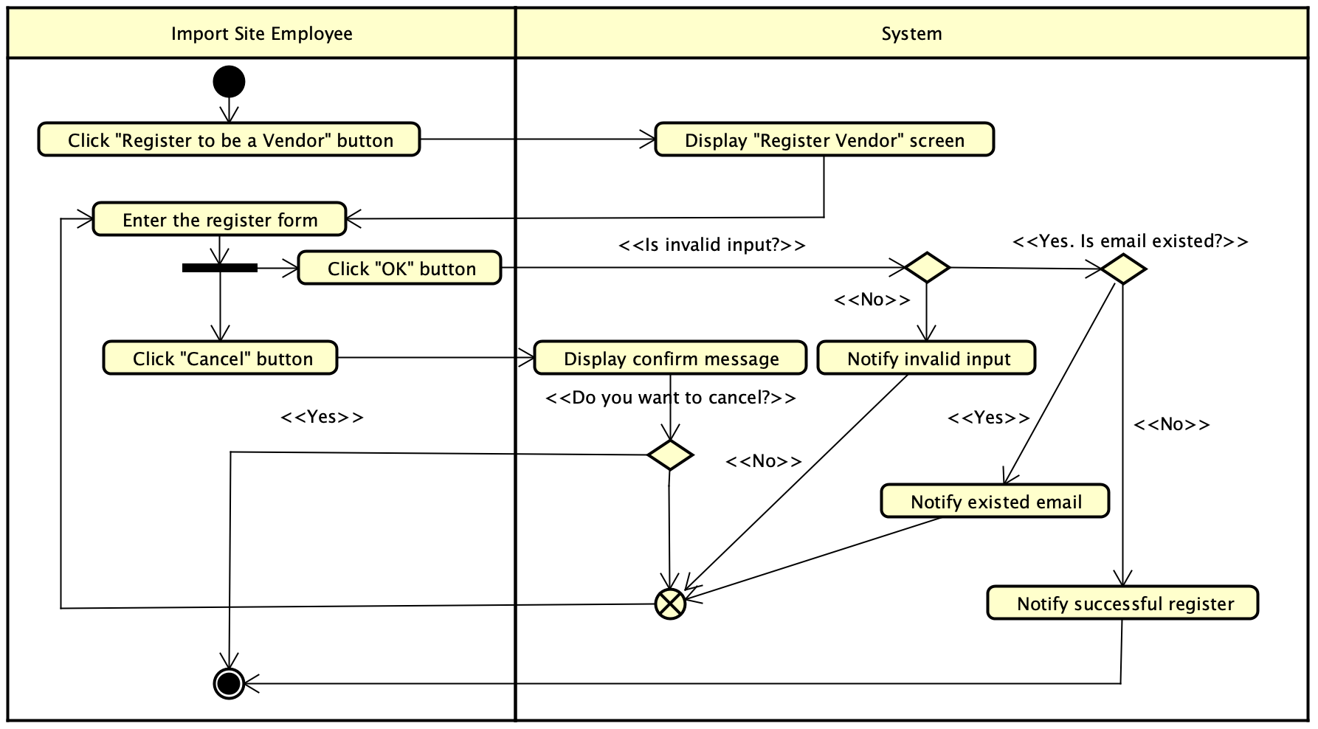

Figure 1: Register vendor activity diagram

**2.6 Use case specification for “Update site basic information”**

|  |  |  |  |
| --- | --- | --- | --- |
| UC Code | UC001 | Use case name | Update site basic information |
| Actor | Import Site Employee | | |
| Precondition | Successful login | | |
| Main flow of event (success) | |  |  |  | | --- | --- | --- | | # | Doer | Action | | 1. | Import Site Employee | Clicks “Update basic information” button | | 2. | System | Displays “Manage basic information” screen | | 3. | Import Site Employee | Edit information | | 4. | Import Site Employee | Clicks “Update” button | | 5. | System | Checks if the changes are satisfied | | 6. | System | Notifies successful update | | | |
| Alternative flow of event | |  |  |  | | --- | --- | --- | | # | Doer | Action | | 4a. | Import Site Employee | Clicks “Cancel” button whenever filling form, the system will display confirm dialog | | 5a. | System | Display “Invalid Input” message if there is any field that is not satisfied | | | |
| Post condition | None | | |

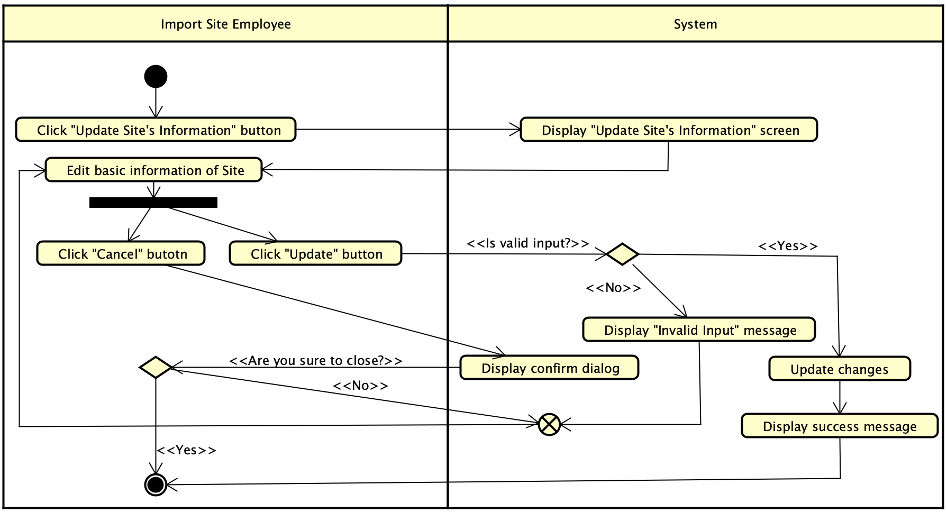

Figure 2: Update Site basic information activity diagram

**2.7 Use case specification for “Create data of merchandise”**

|  |  |  |  |
| --- | --- | --- | --- |
| UC Code | UC001 | Use case name | Create data |
| Actor | Sale Employee | | |
| Precondition | Successful login | | |
| Main flow of event (success) | |  |  |  | | --- | --- | --- | | # | Doer | Action | | 1. | Sale Employee | Clicks “Create new data” button | | 2. | System | Displays a data sheet screen | | 3. | Sale Employee | Fulfil new data | | 4. | Sale Employee | Click OK button | | 5. | System | Check if the data is valid | | 6. | System | Add new data to database | | 7. | System | Return success message to screen | | 8. | System | Ask Sale Employee if he wants to continue adding new data | | | |
| Alternative flow of event | |  |  |  | | --- | --- | --- | | # | Doer | Action | | 4a. | Sale Employee | Clicks “Cancel” button whenever filling form, the system will display confirm dialog | | 5a. | System | Display “Invalid Input” message if the data is invalid | | | |

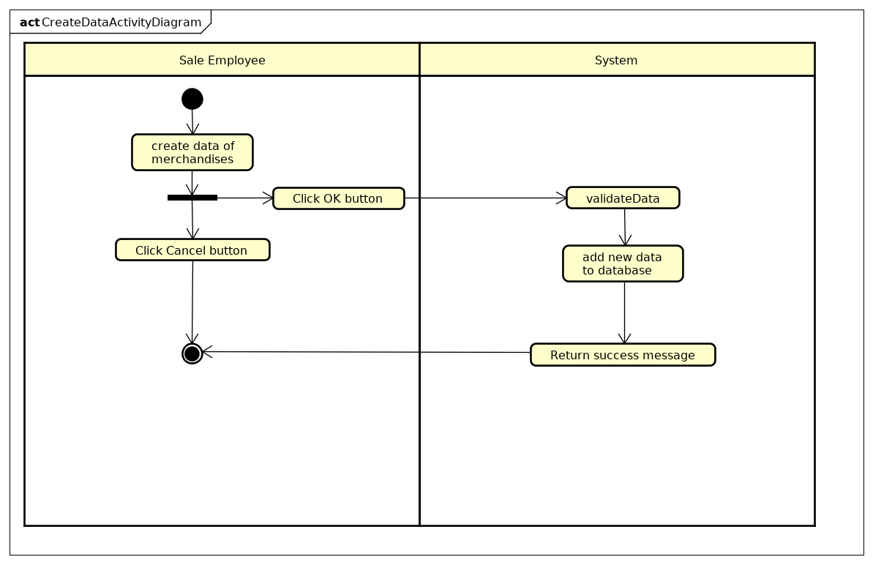Activity Diagram: Create data of merchandises

**2.8 Update data of merchandises**

|  |  |  |  |
| --- | --- | --- | --- |
| UC Code | UC001 | Use case name | Update data |
| Actor | Sale Employee | | |
| Precondition | Successful login | | |
| Main flow of event (success) | |  |  |  | | --- | --- | --- | | # | Doer | Action | | 1. | Sale Employee | Clicks “Update data” button | | 2. | System | Displays “Manage data” screen | | 3. | Sale Employee | Modify the data | | 4. | Sale Employee | Clicks “Submit” button | | 5. | System | Checks if the data is valid | | 6. | System | Update data and return success message | | | |
| Alternative flow of event | |  |  |  | | --- | --- | --- | | # | Doer | Action | | 4a. | Sale Employee | Clicks “Cancel” button whenever filling form, the system will display confirm dialog | | 5a. | System | Display “Invalid data” if the new data is not satisfied | | | |

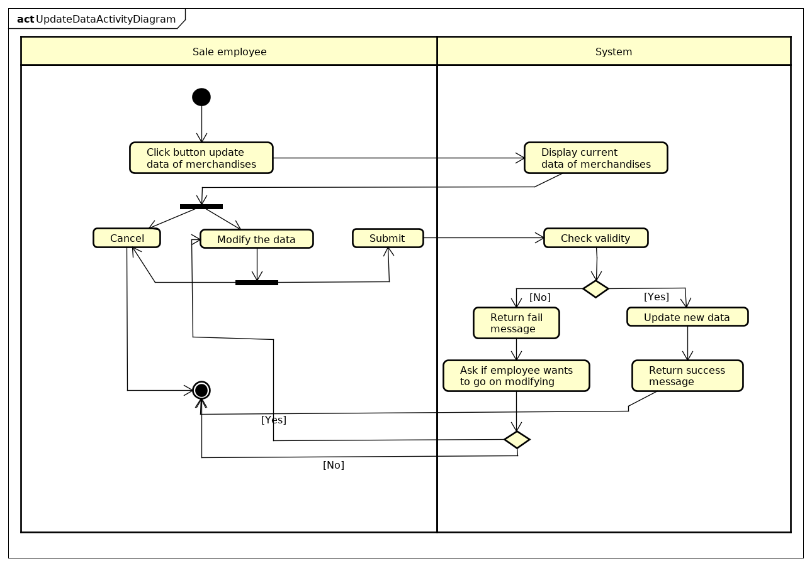Activity diagram : Update data of merchandises

**3. Use-Case** **Realization**

**3.1 Use case Realization for “Create Site Order”**

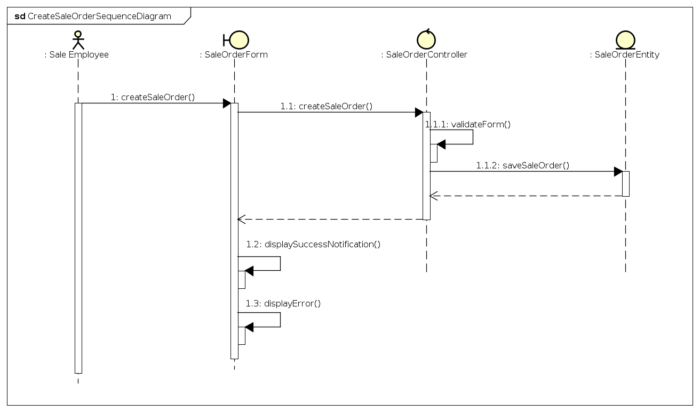  
SequenceDiagram: Create Sale Order

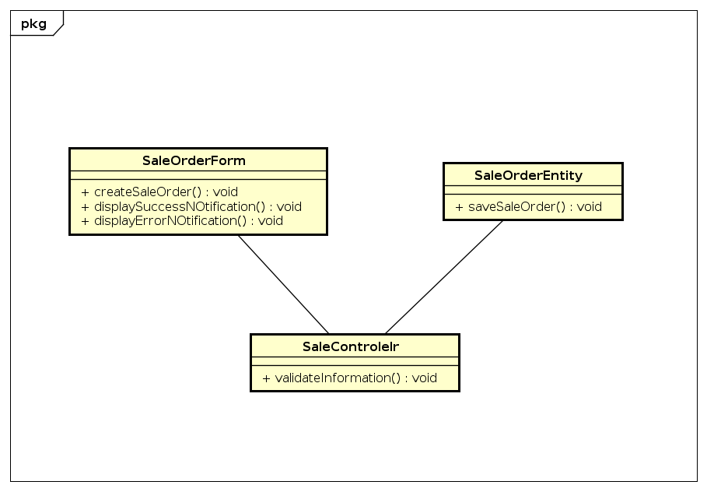  
ClassDiagram: Create Sale Order

3.2 Use case “Register vendor”

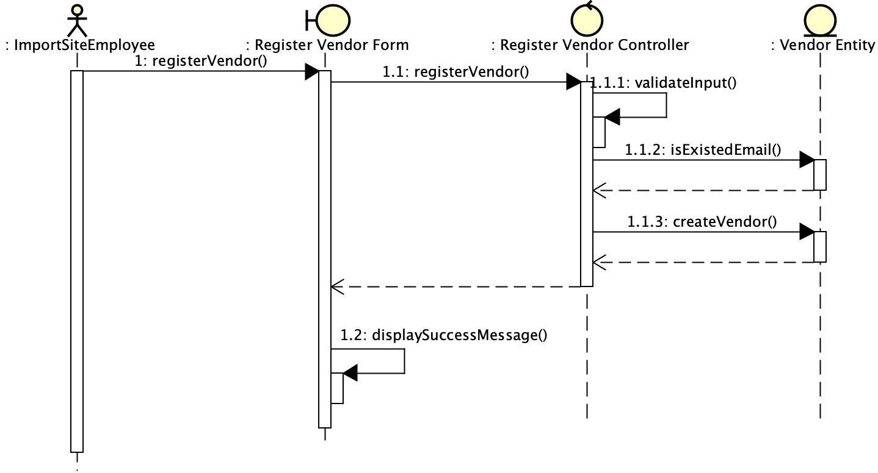

Sequence Diagram 1: Main flow of register vendor

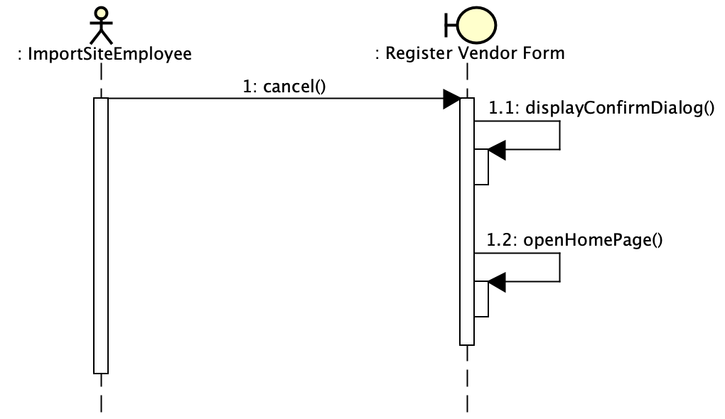

Sequence Diagram 2: Cancel action of register vendor

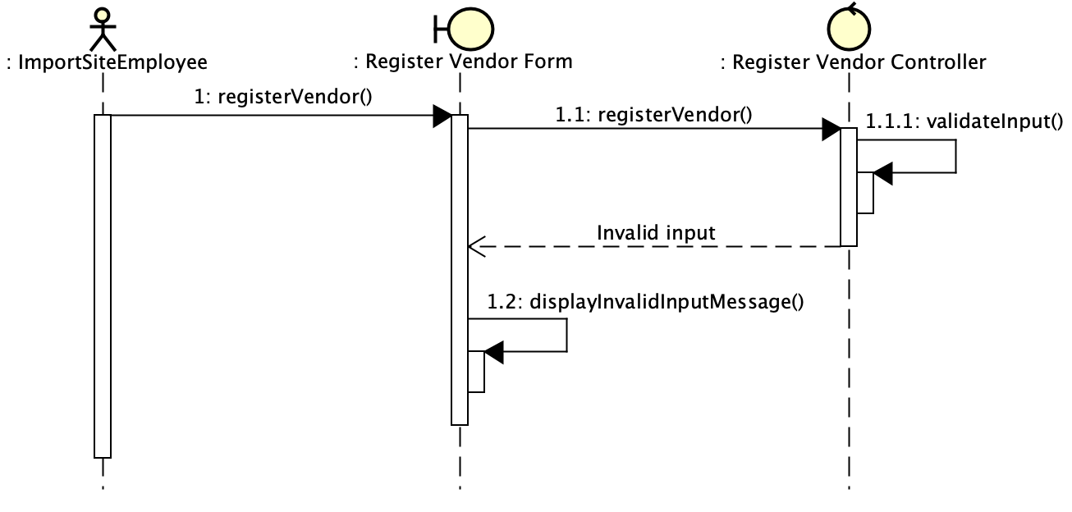

Sequence Diagram 3: Invalid input flow of register vendor

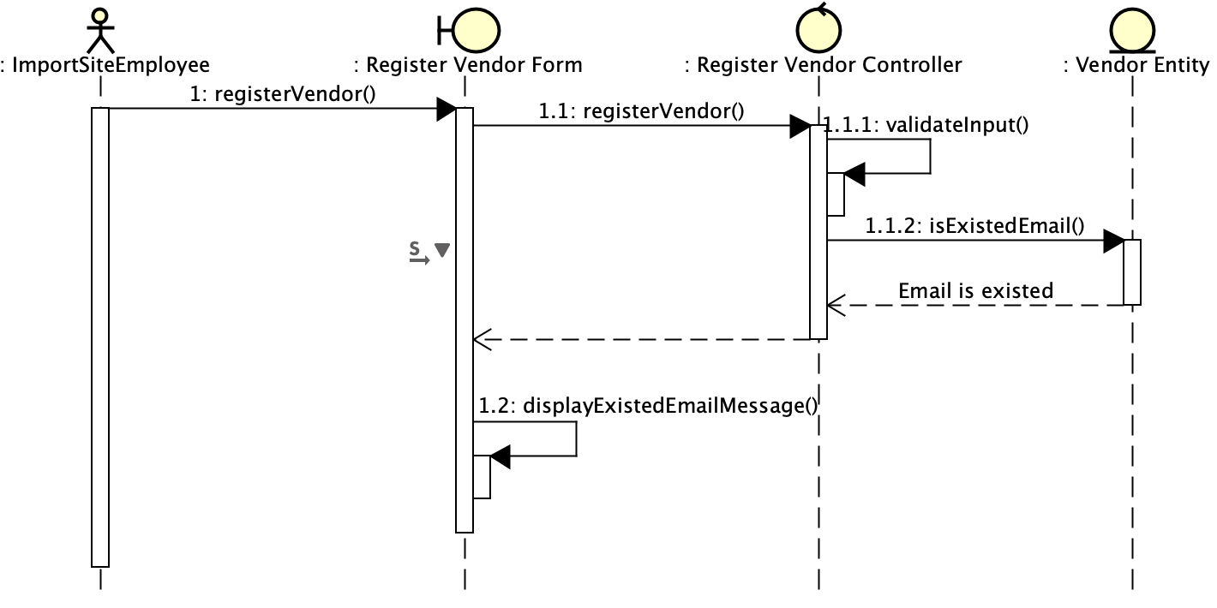

Sequence Diagram 4: Existed email flow of register vendor

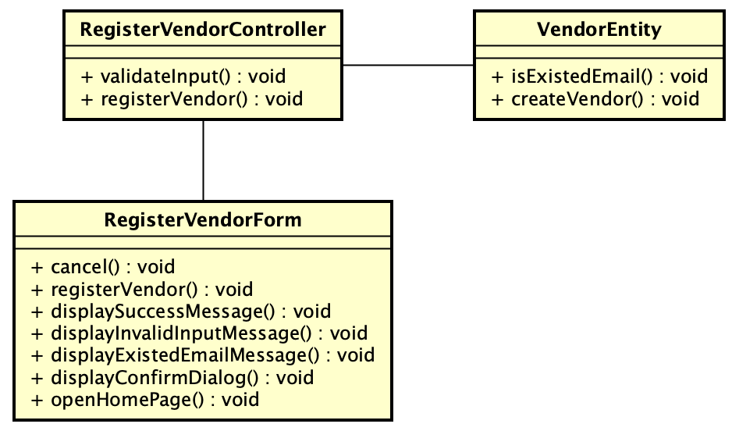

Figure 3: Class diagram

**3.3 Use case “Update Site basic**

**information”**

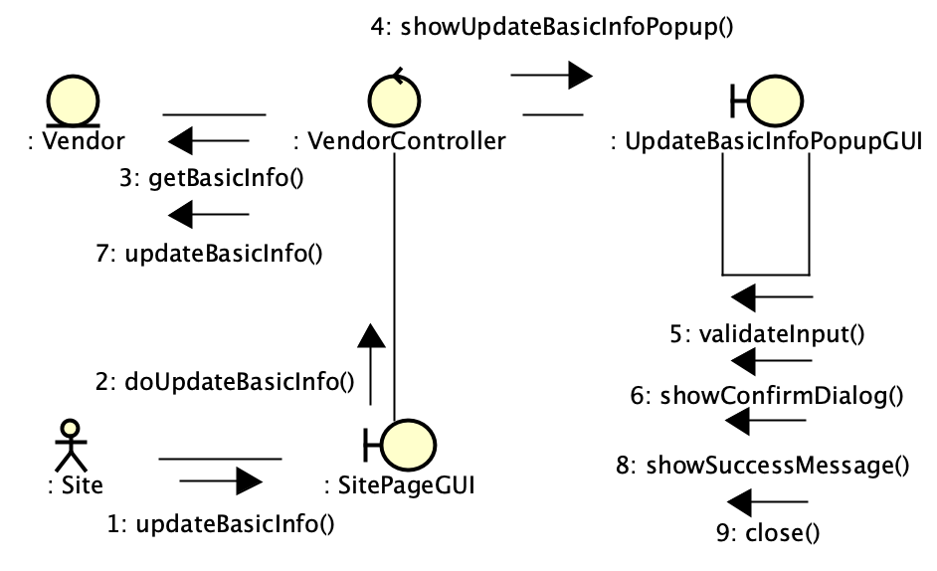

Sequence Diagram 5: Main flow of update delivery

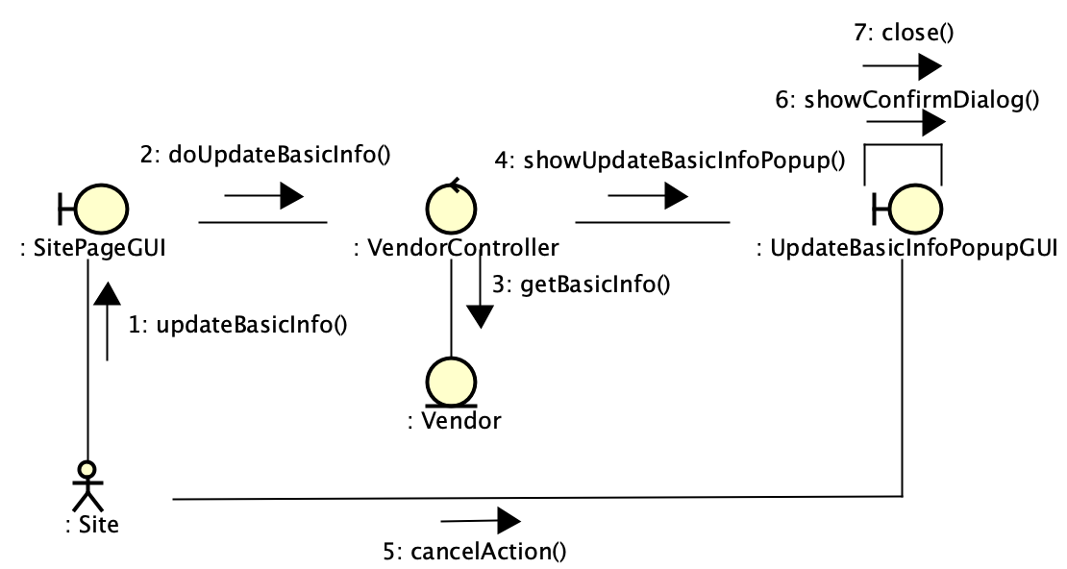

Sequence Diagram 6: Cancel action of update delivery

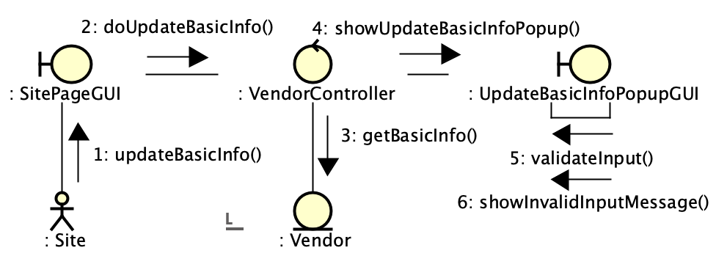

Sequence Diagram 7: Invalid input flow of update delivery

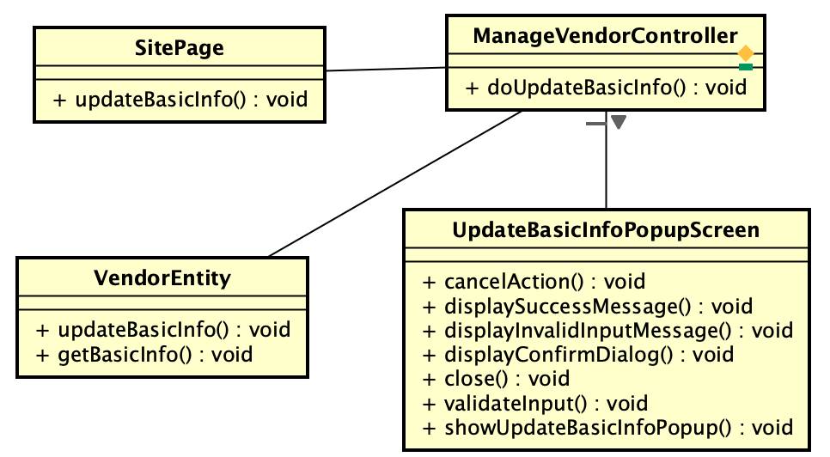

Figure 4: Class diagram

**3.4 Use case “****subscribe to provide product”**

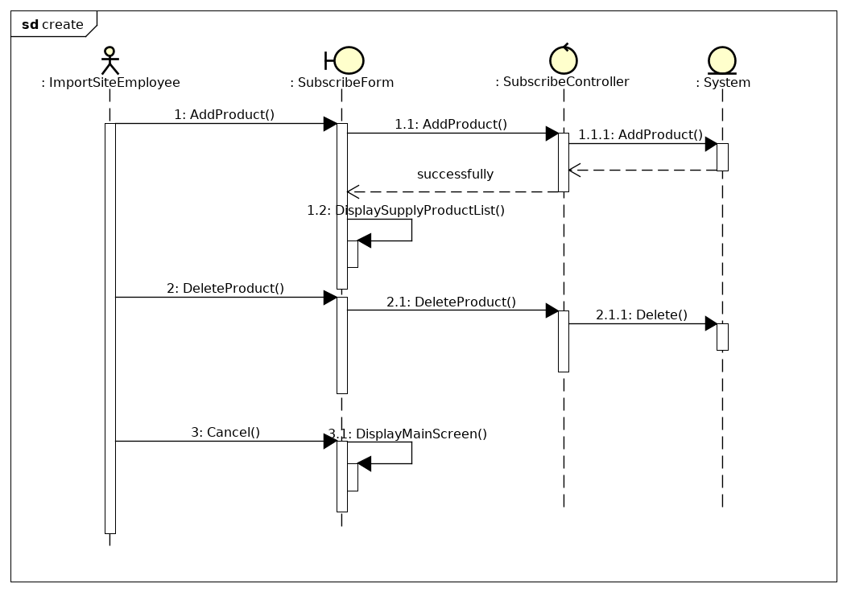  
Sequence diagram

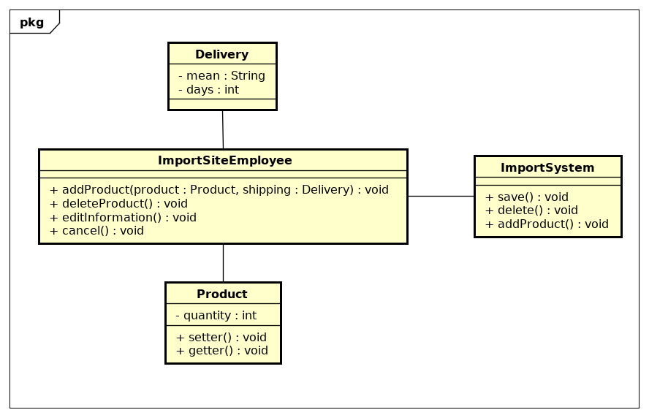

**3.5 Use case “update subscribe information”**

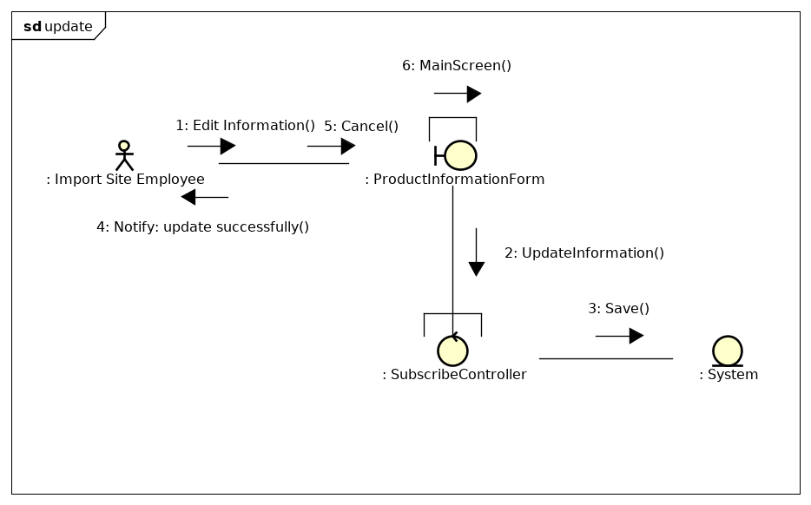Communication diagram

  
 Class diagram

**3.6 Use case “Create data of merchandises”**

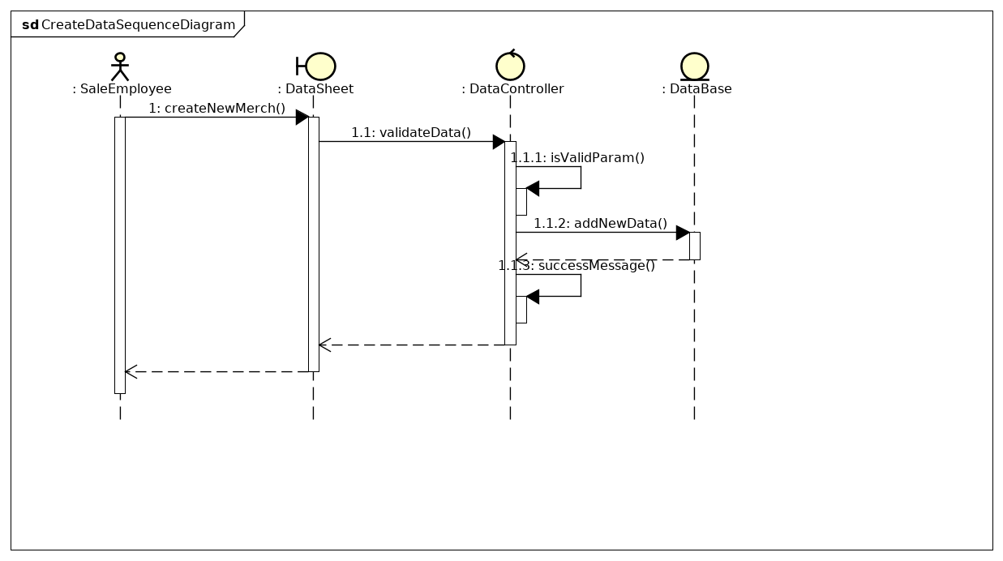 Sequence diagram : Create data of merchandises

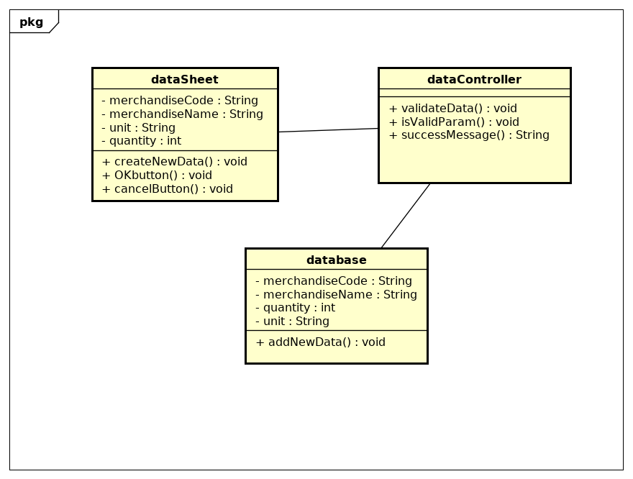 Class diagram: Create data of merchandises

**3.7 Use case for “Update data of merchandises”**

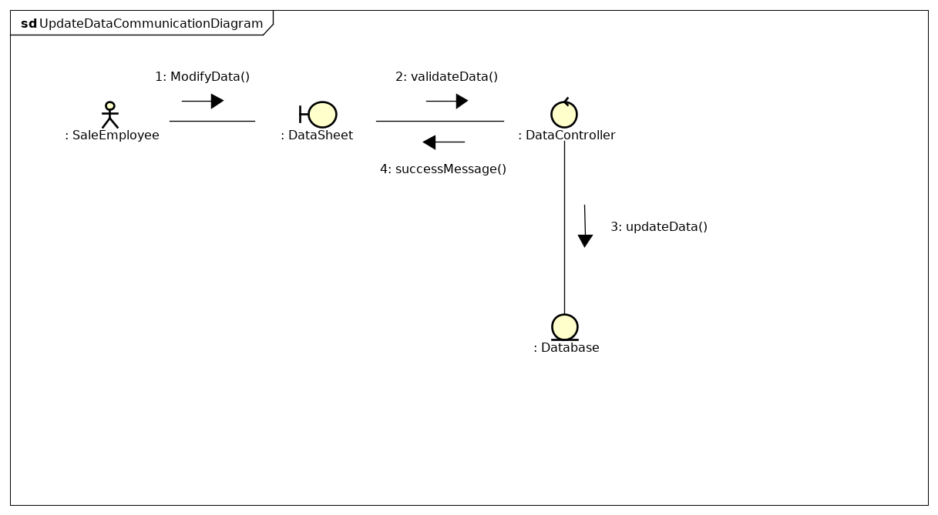 Communication diagram: Update data of merchandises

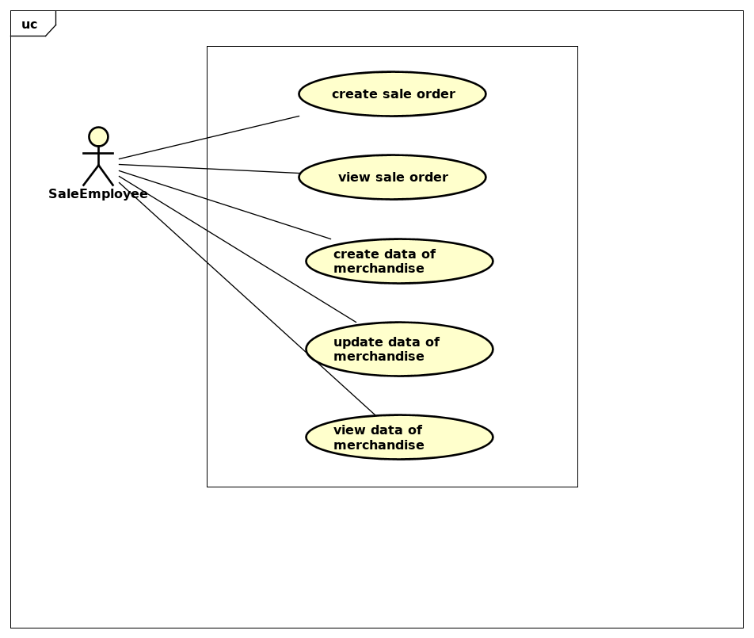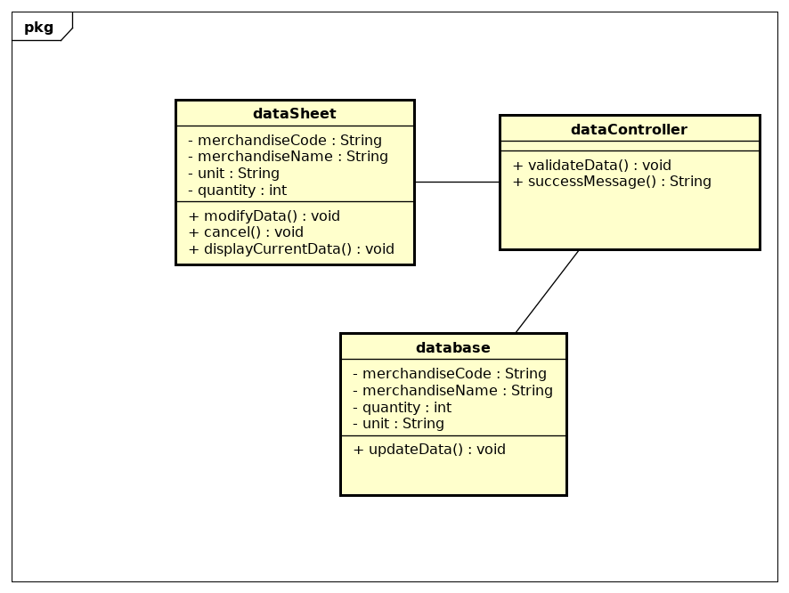 Class diagram: Update data of merchandises