Requirement Analysis

Group [SoftwareDevelopment.ITSS.20191-04](https://bitbucket.org/Thanh98hy/softwaredevelopment.itss.20191-04/)

* Đào Ngọc Thành
* Nguyễn Đức Dũng
* Trần Bích Ngọc
* Vũ Thanh Tùng

**1. Use case diagram**

1.1 General use case

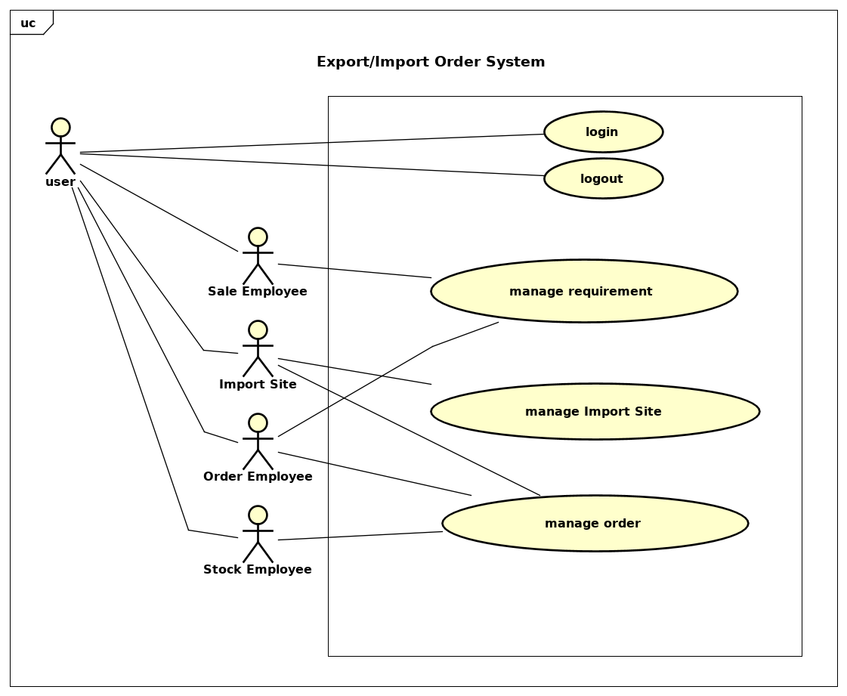

1.2 Use case for “Manage Requirements”

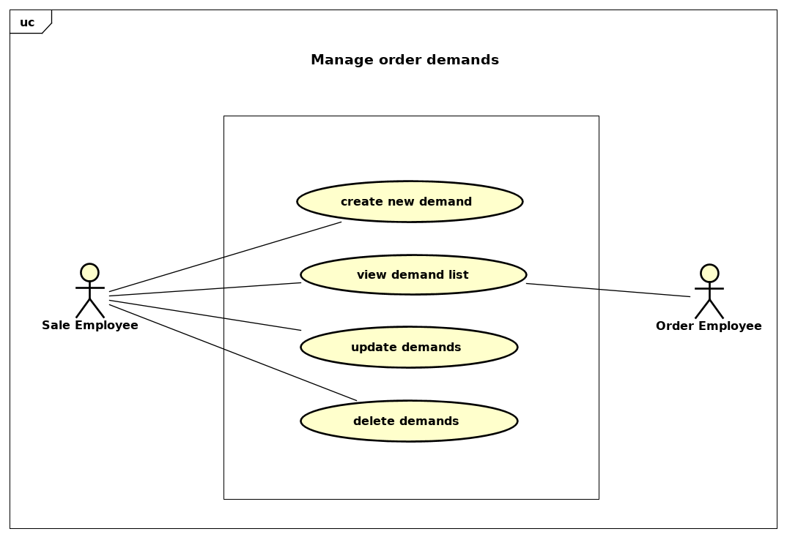

1.3 Use case for “Manage Orders”

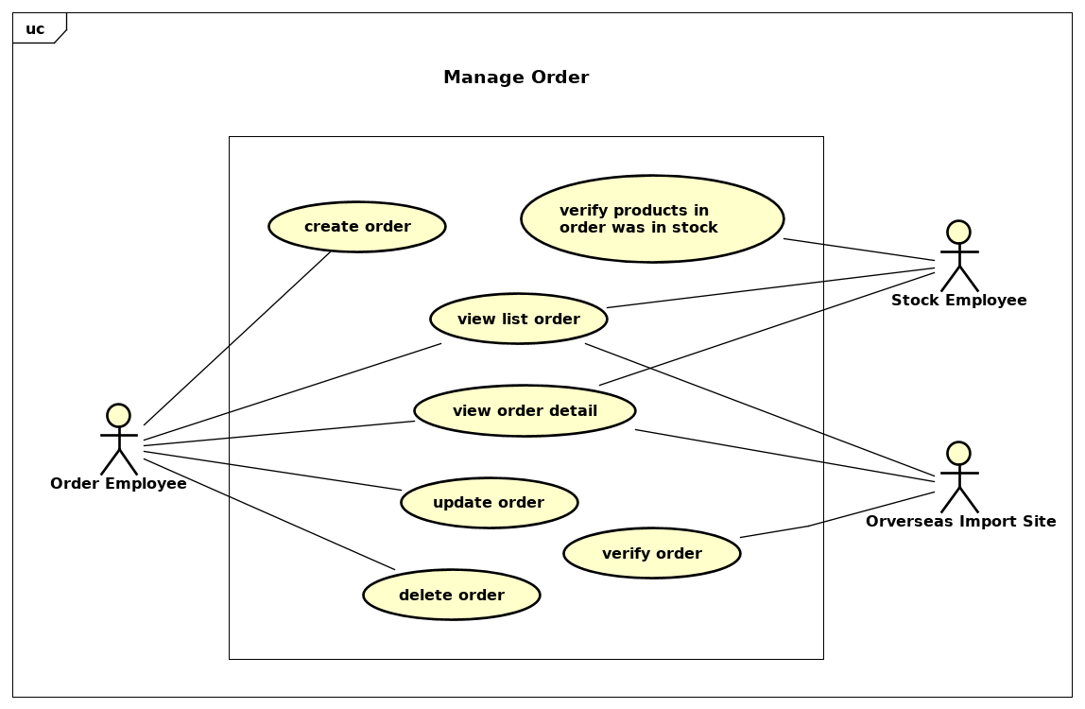

1.4 Use case for “Manage Import Site”

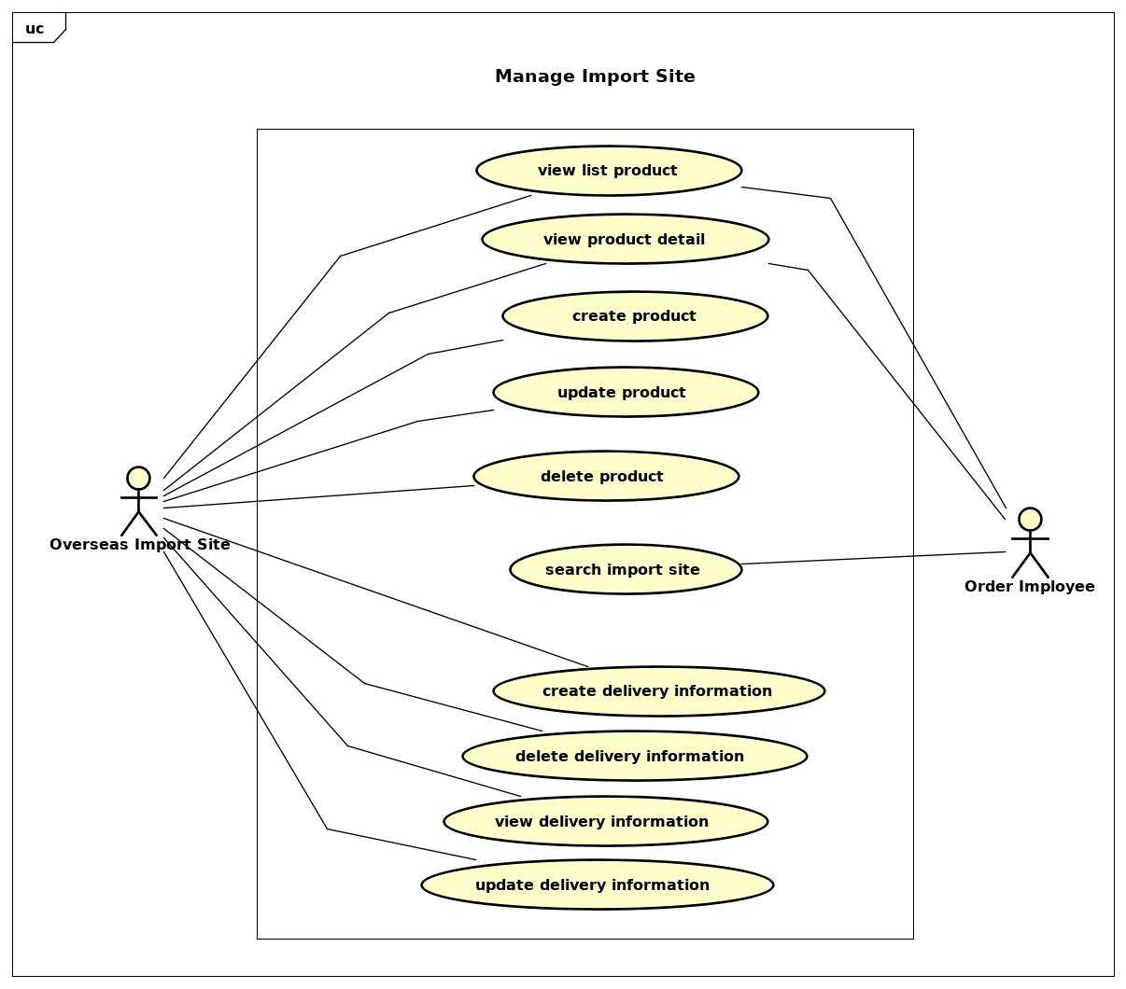

**2. Use case specification**

**2.1 Use case specification for “Create Demand”**

|  |  |  |  |
| --- | --- | --- | --- |
| UC Code | UC001 | Use case name | Create Demand |
| Actor | Sale Employee | | |
| Precondition | successful login and in create demand section | | |
| Main flow of event (success) | |  |  |  | | --- | --- | --- | | # | Doer | Action | |  | Sale Employee | Enter merchandise code, quantity ordered, Unit, Desired delivery date and click button Save | |  | System | checks the validation of information | |  | System | Wait 1 day for any update requirements from customers | |  | System | Save order demand in database | | | |
| Alternative flow of event | |  |  |  | | --- | --- | --- | | # | Doer | Action | | 1. | System | Warning error “Invalid merchandise code” if the code doesn’t exist in database | | 2. | System | Warning error “Invalid quantity” if the quantity ordered is fewer than 1 | | 3. | System | Warning error “Invalid unit” if the unit doesn’t fit | | 4. | System | Warning error “Invalid date” if the desired delivery date is not valid | | | |
| Post condition | None | | |

**2.2 Use case specification for “Update demand”**

|  |  |  |  |
| --- | --- | --- | --- |
| UC Code | UC002 | Use case name | Update Demand |
| Actor | Sale Employee | | |
| Precondition | successful login and in create order section | | |
| Main flow of event (success) | |  |  |  | | --- | --- | --- | | # | Doer | Action | | 1 | Sale Employee | Click update order demands | | 2 | System | Show up the list of order demands | | 3 | Sale Employee | Modify the properties of order demands | | 4 | System | Check validity of new properties | | 5 | System | Save updates into database | | | |
| Alternative flow of event | |  |  |  | | --- | --- | --- | | # | Doer | Action | | 1. | System | Warning error “Invalid merchandise code” if the code doesn’t exist in database | | 2. | System | Warning error “Invalid quantity” if the quantity ordered is fewer than 1 | | 3. | System | Warning error “Invalid unit” if the unit doesn’t fit | | 4. | System | Warning error “Invalid date” if the desired delivery date is not valid | | | |
| Post condition | None | | |

**2.3 Use case specification for “Create Order”**

|  |  |  |  |
| --- | --- | --- | --- |
| UC Code | UC001 | Use case name | Create Order |
| Actor | Order Employee | | |
| Precondition | successful login and in create order section | | |
| Main flow of event (success) | |  |  |  | | --- | --- | --- | | # | Doer | Action | |  | Order Employee | Enter information about product code and quantity then hit submit button | |  | System | checks if the information is valid | |  | System | create and save order in database | |  | System | send “Order create Success” message | | | |
| Alternative flow of event | |  |  |  | | --- | --- | --- | | # | Doer | Action | | 3a. | System | notifies error “Invalid informations” if there any information is invalid. | | 4a. | System | notifies error “Create Order error” if there any error in create order process | | | |
| Post condition | None | | |

**2.4 Use case specification for “Update Order”**

|  |  |  |  |
| --- | --- | --- | --- |
| UC Code | UC001 | Use case name | Create Order |
| Actor | Order Employee | | |
| Precondition | successful login and in view order detail section | | |
| Main flow of event (success) | |  |  |  | | --- | --- | --- | | # | Doer | Action | |  | Order Employee | Enter information about product code and quantity then hit submit button | |  | System | checks if the information is valid | |  | System | create and save order in database | |  | System | send “Order create Success” message | | | |
| Alternative flow of event | |  |  |  | | --- | --- | --- | | # | Doer | Action | | 3a. | System | notifies error “Invalid informations” if there any information is invalid. | | 4a. | System | notifies error “Create Order error” if there any error in create order process | | | |
| Post condition | None | | |

**2.5 Use case specification “ Update product”**

|  |  |  |  |
| --- | --- | --- | --- |
| **UC Code** | UC005 | **Use case name** | Update product |
| **Actor** | Overseas Import Site | | |
| **Precondition** | Create product | | |
| **Main flow of event (success)** | |  |  |  | | --- | --- | --- | | **#** | **Doer** | **Action** | | 1 | OIS | Choose product needed to update | | 2 | OIS | Click on Update button | | 3 | System | Display editable fields | | 4 | OIS | Edit product information | | 5 | OIS | Click on Save button | | 6 | System | Check validation for inputed fields | | 7 | System | Save those new information | | 8 | System | Notify product is updated successfully | | 9 | System | Return to product information screen | | | |
| **Alternative flow of event** | |  |  |  | | --- | --- | --- | | **#** | **Doer** | **Action** | | 5a. | OIS | Click Cancel button | | 6a. | System | Return to information screen | | 7a. | System | Notify for invalid input fields: invalid format, invalid quantity,.... | | 8a. | OIS | Re-edit invalid fields or cancel update | | | |
| **Post condition** | None | | |

**2.6 Use case specification “ Create delivery information”**

|  |  |  |  |
| --- | --- | --- | --- |
| **UC Code** | UC006 | **Use case name** | Create delivery information |
| **Actor** | Overseas Import Site | | |
| **Precondition** | View order details | | |
| **Main flow of event (success)** | |  |  |  | | --- | --- | --- | | **#** | **Doer** | **Action** | | 1 | OIS | Click Create button | | 2 | System | Display form to add new delivery information | | 3 | OIS | Fill all required fields | | 4 | OIS | Click Save button | | 5 | System | Check validation for inputed fields | | 6 | System | Check duplicate delivery information | | 7 | System | Create new delivery information | | 8 | System | Notify successful message | | 9 | System | Turn to new delivery information screen | | | |
| **Alternative flow of event** | |  |  |  | | --- | --- | --- | | **#** | **Doer** | **Action** | | 4a. | OIS | Click Cancel button | | 5a. | System | Return to list delivery information screen | | 6a. | System | Notify for invalid input fields: invalid format, invalid quantity,.... | | 7a. | System | Notify delivery is already existed | | 7b. | OIS | Edit invalid fields or cancel create action | | | |
| **Post condition** | None | | |

**2.7 Use case specification “Update delivery information”**

|  |  |  |  |
| --- | --- | --- | --- |
| **UC Code** | UC007 | **Use case name** | Update delivery manner information |
| **Actor** | Overseas Import Site | | |
| **Precondition** | Successful Login | | |
| **Main flow of event (success)** | |  |  |  | | --- | --- | --- | | **#** | **Doer** | **Action** | | 1. | Overseas Import Site | chooses the delivery information need to be updated | | 2. | System | displays update delivery information screen | | 3. | Overseas Import Site | changes the fields that need to be updated | | 4. | System | checks if the way of delivery is existed | | 5. | System | checks if the number of days is not positive | | 6. | System | notifies “The delivery information is updated successfully” | | | |
| **Alternative flow of event** | |  |  |  | | --- | --- | --- | | **#** | **Doer** | **Action** | |  | Overseas Import Site | choose cancel update delivery. Then system closes update delivery screen. | | 4a. | System | notifies “The way of delivery is existed” if the kind of transportation is used. | | 5a. | System | notifies “The number of days for delivery must be greater than 0!” if the number of days is negative. | | | |
| **Post condition** | None | | |

**2.8 Use case specification “Create product information”**

|  |  |  |  |
| --- | --- | --- | --- |
| **UC Code** | UC001 | **Use case name** | Create product information |
| **Actor** | Overseas Import Site | | |
| **Precondition** | Successful Login | | |
| **Main flow of event (success)** | |  |  |  | | --- | --- | --- | | **#** | **Doer** | **Action** | | 1. | Overseas Import Site | chooses create product | | 2. | System | displays product creation screen | | 3. | Overseas Import Site | enters and submits the product information | | 4. | System | checks if the needed fields are filled | | 5. | System | checks if the quantity is not negative | | 6. | System | checks if the product is existed | | 7. | System | notifies that the product is added successfully | | | |
| **Alternative flow of event** | |  |  |  | | --- | --- | --- | | **#** | **Doer** | **Action** | |  | Overseas Import Site | choose cancel create product. Then system closes create product screen. | | 4a. | System | notifies “All the fields with red star must be filled” if there is any needed field is blank. | | 5a. | System | notifies “The quantity of product in stock mustn’t be negative” if the value of quantity is smaller than 0. | | 6a. | System | notifies “This product is existed!” if the product name is existed. | | | |
| **Post condition** | None | | |

**3. Diagram**

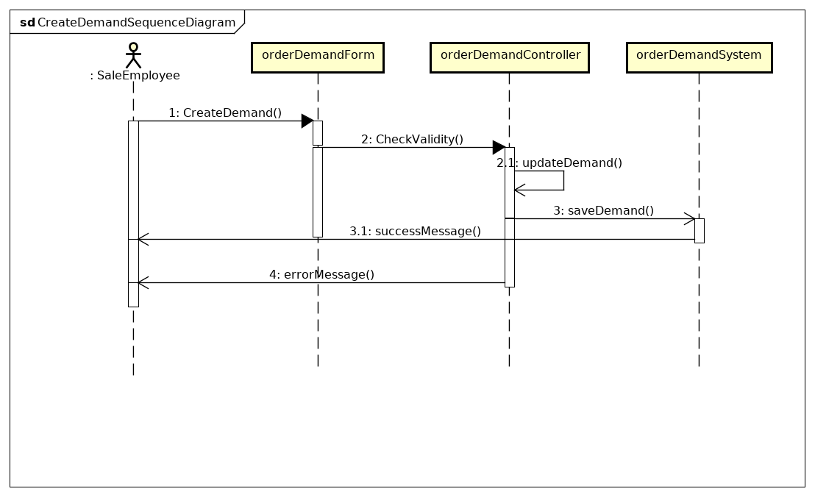**3.1 diagram for “Create demand”**

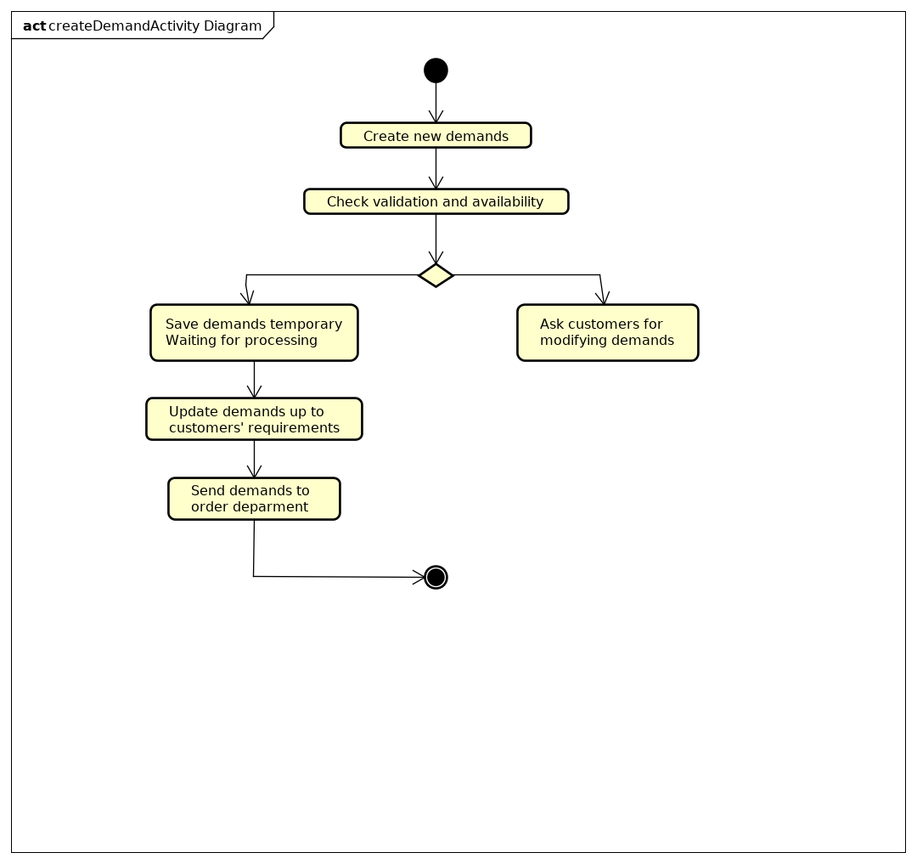

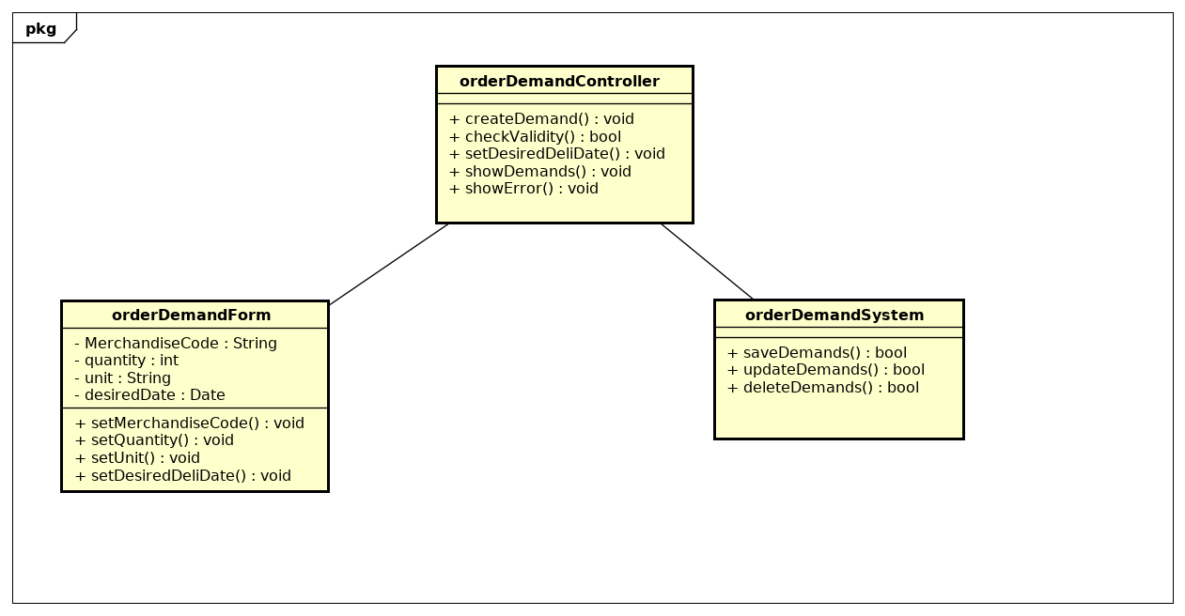

**3.2 diagram for “Update demand”**

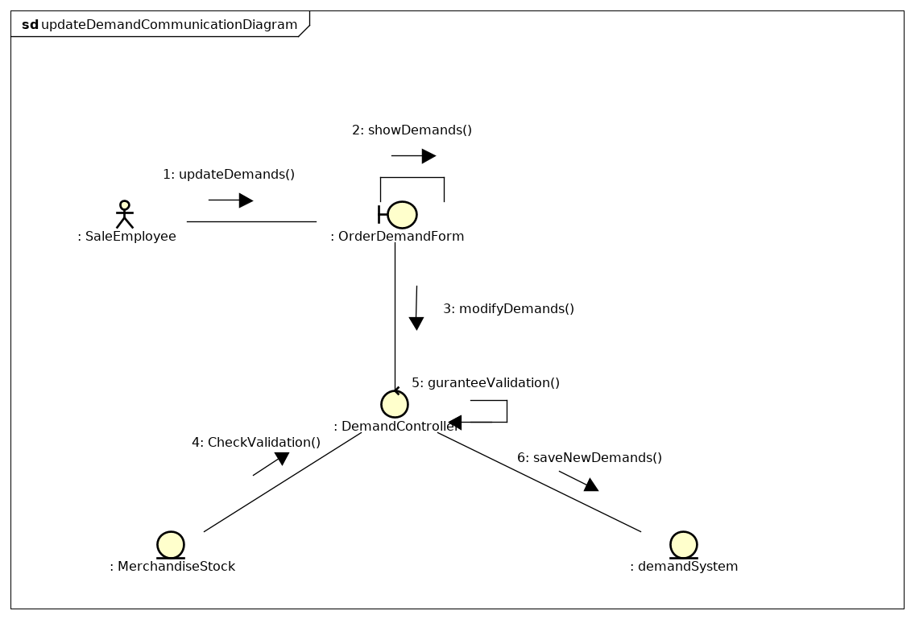

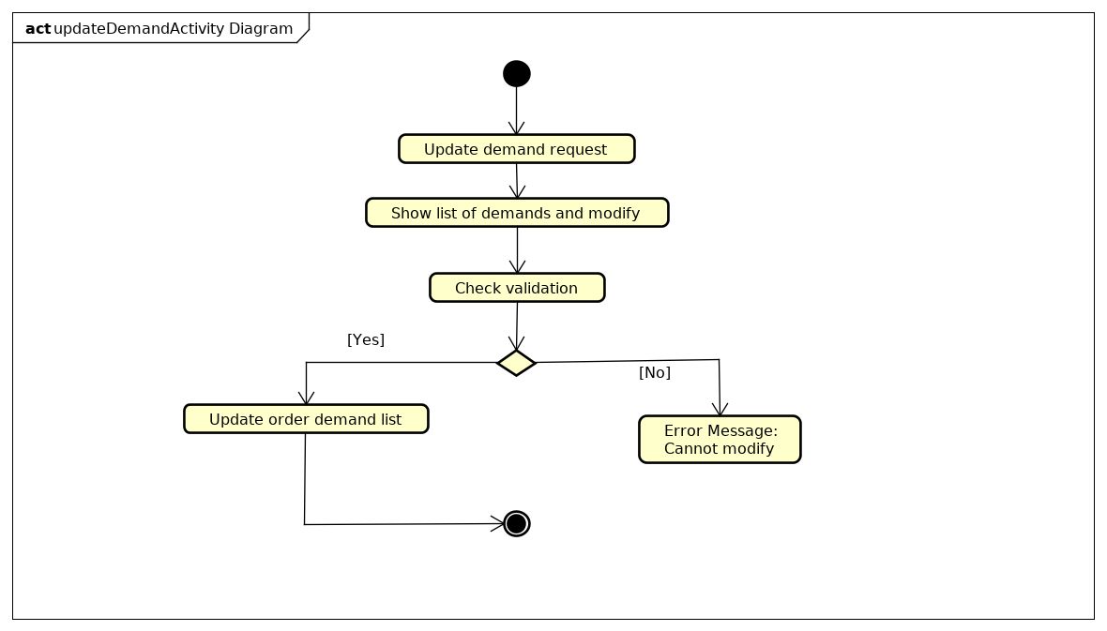

**3.3 diagram for “Create Order”**

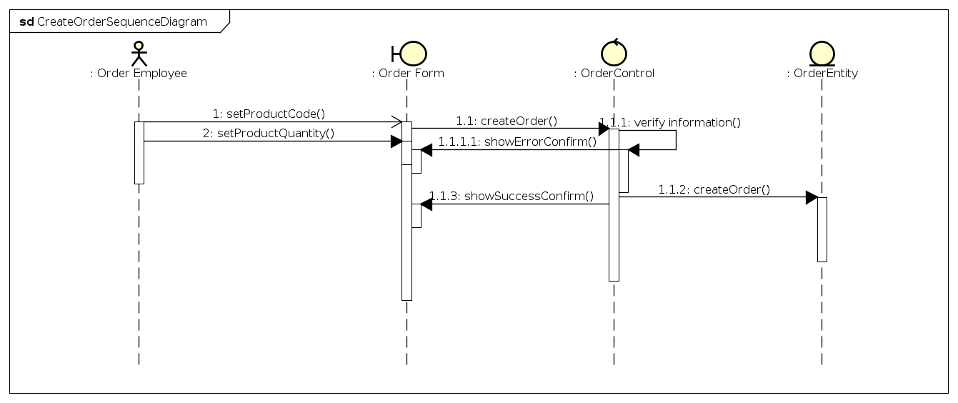

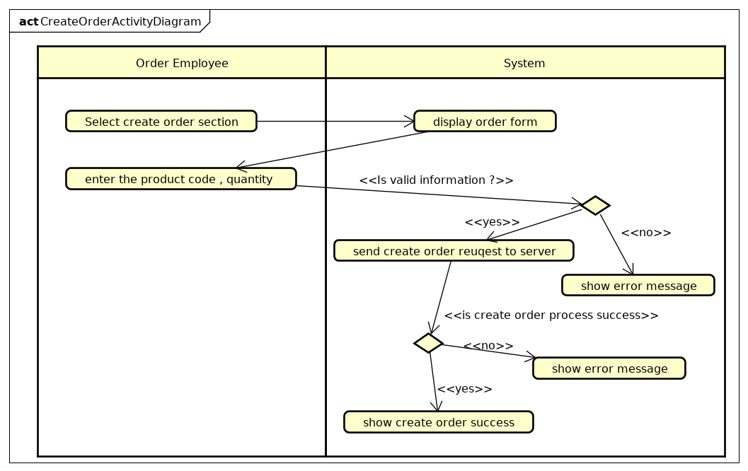

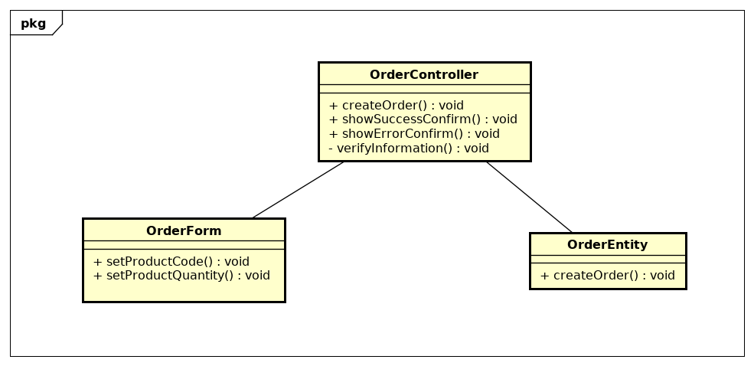

**3.4 diagram for “Update Order”**

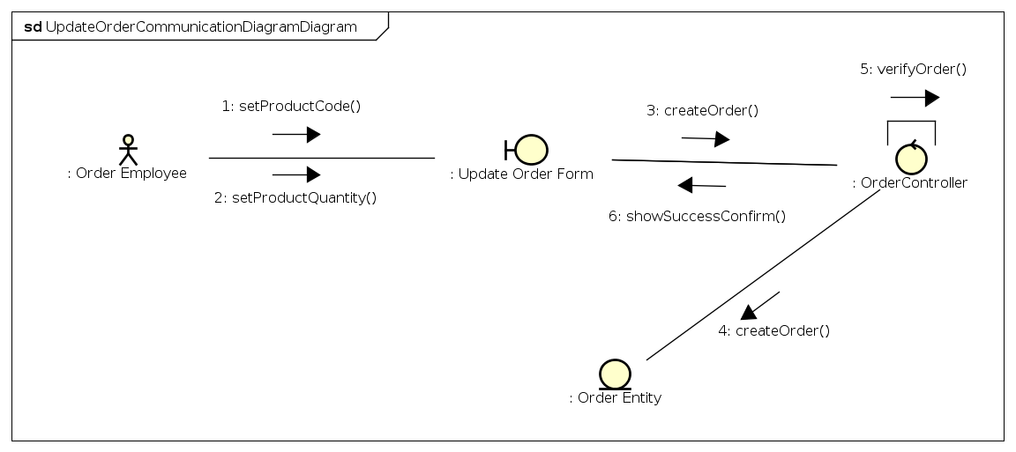

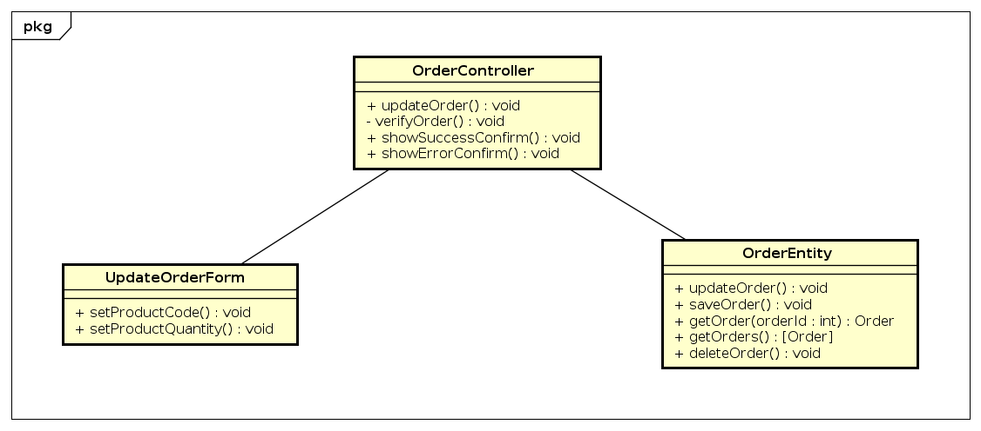

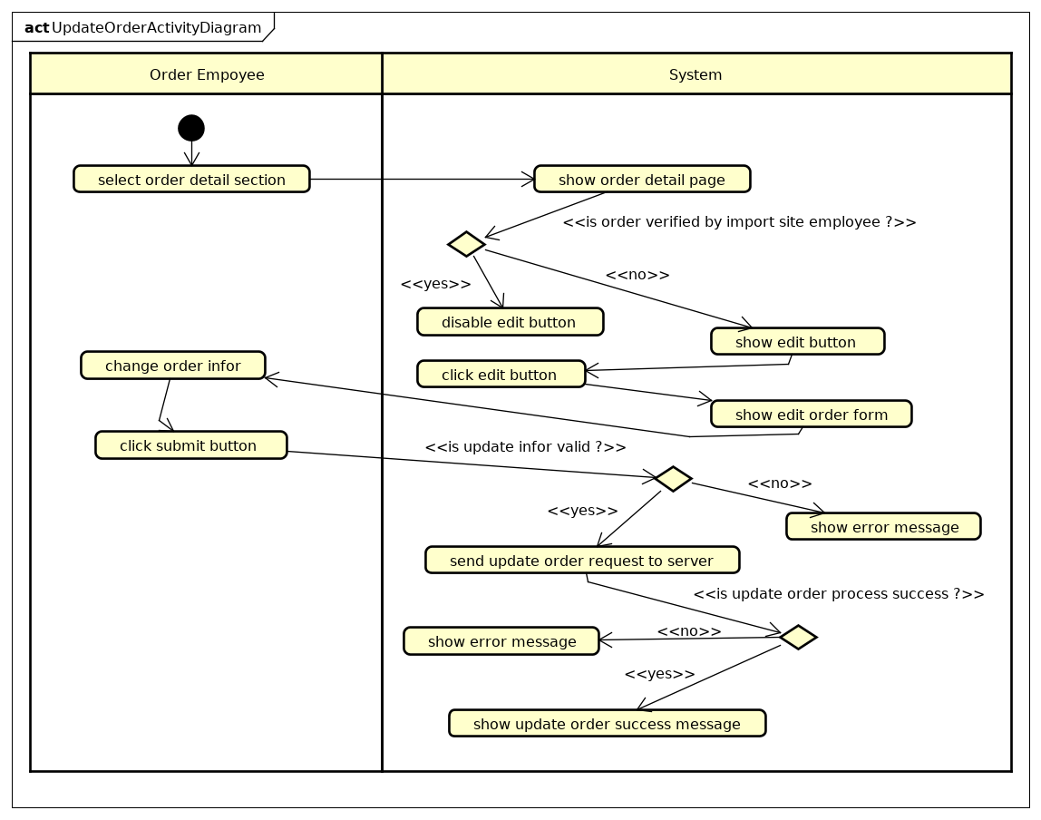

**3.5 Diagram for “Update product”**

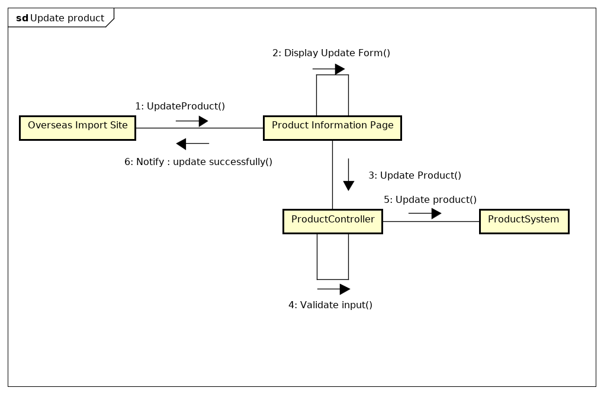

Communication diagram

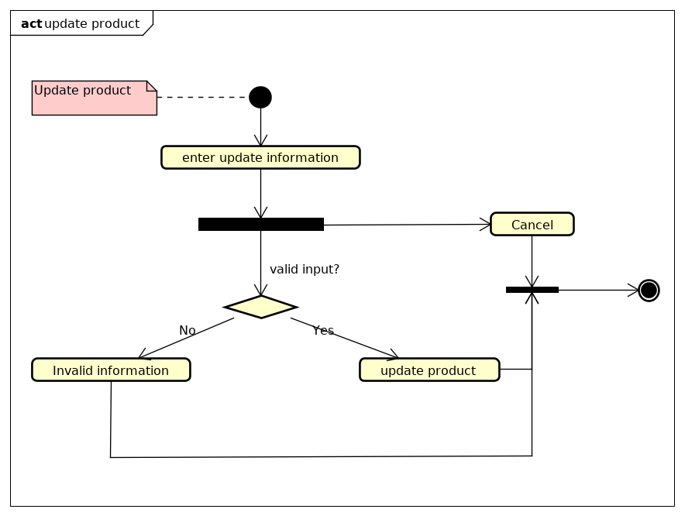

Activity diagram

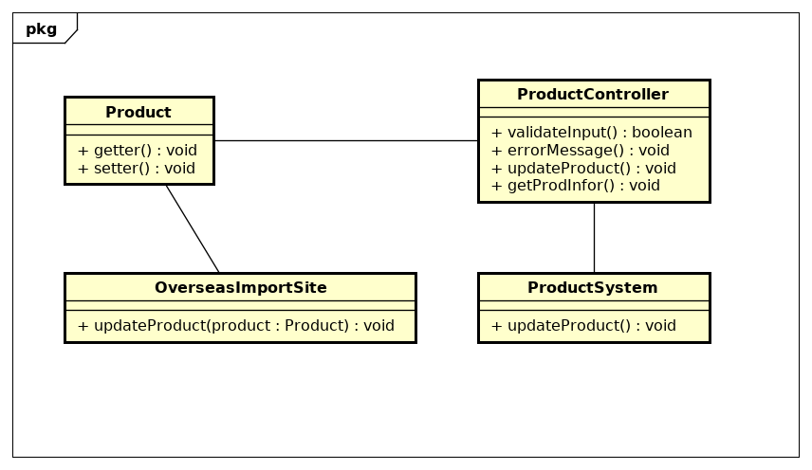  
Class Diagram

**3.6 Diagram for “Create Delivery Information”**

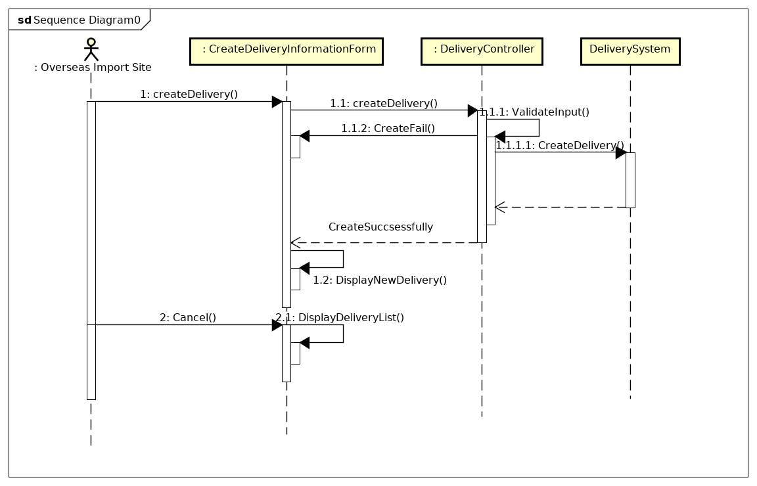

Sequence diagram

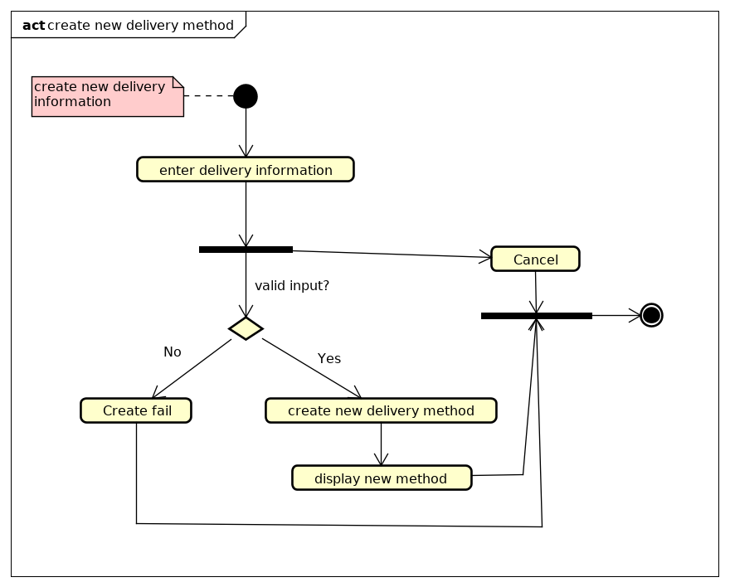  
Activity diagram

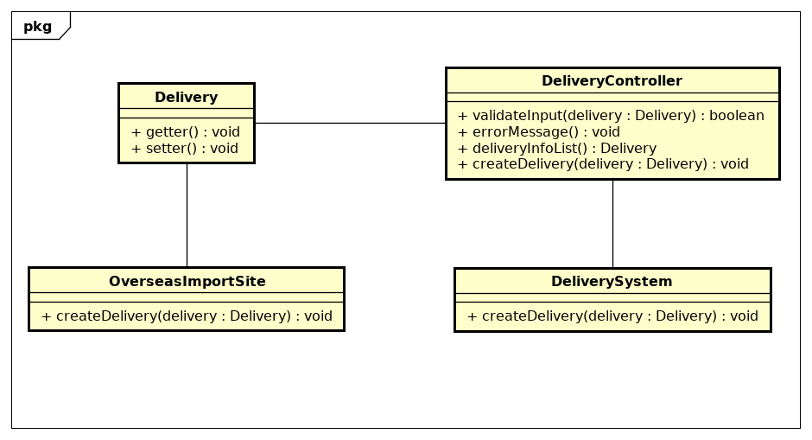  
Class diagram

**3.7 Diagram for “Update Delivery Information”**

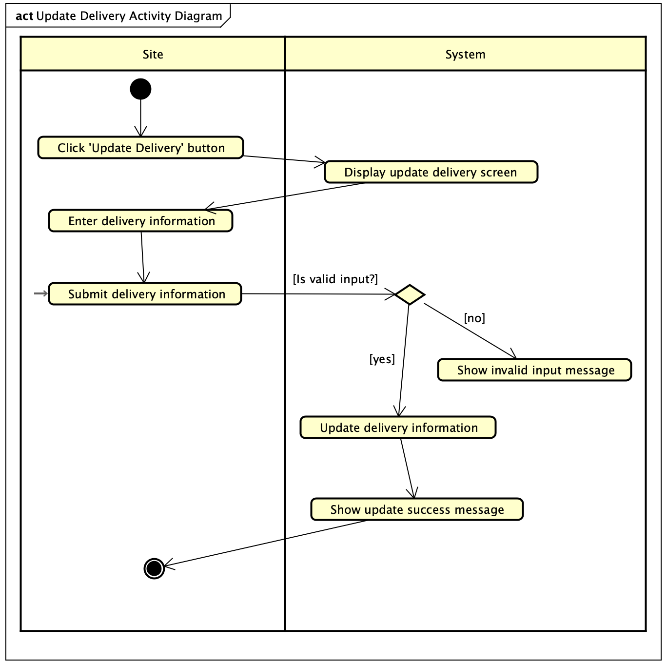

Activity diagram

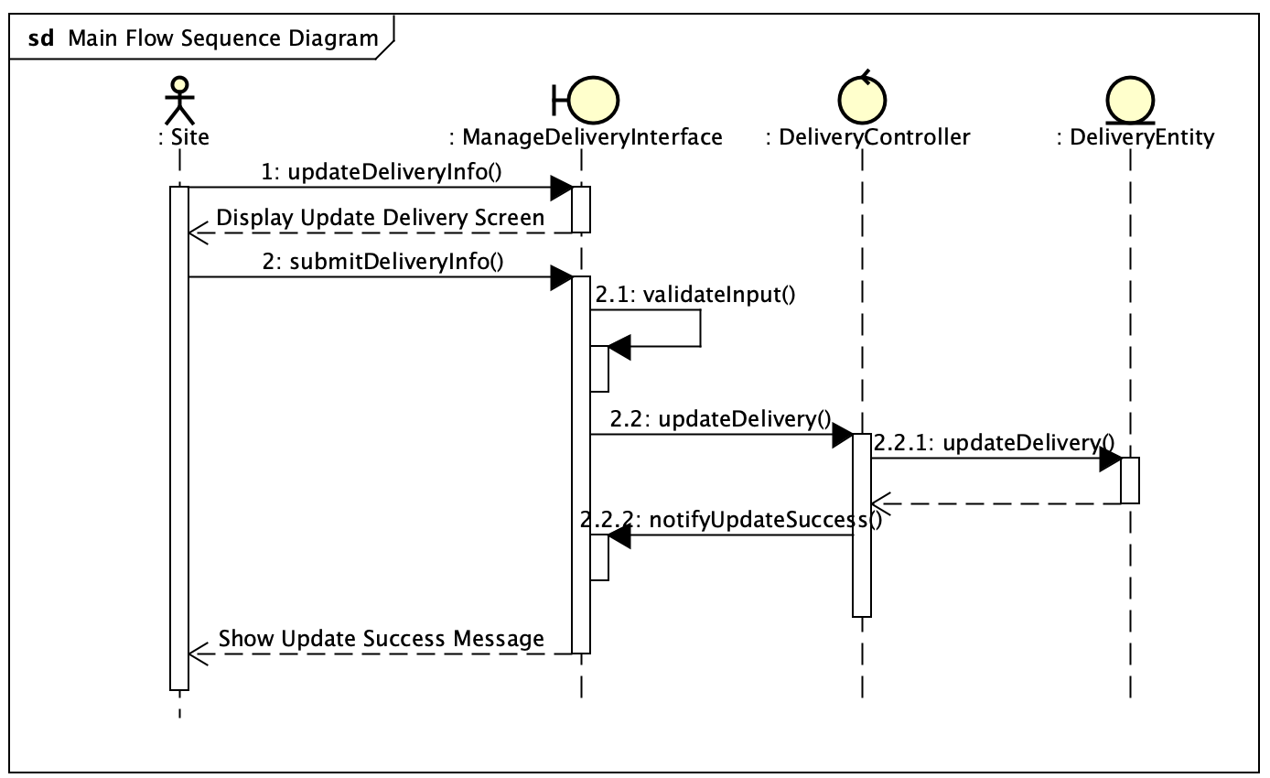

Main flow update delivery sequence diagram

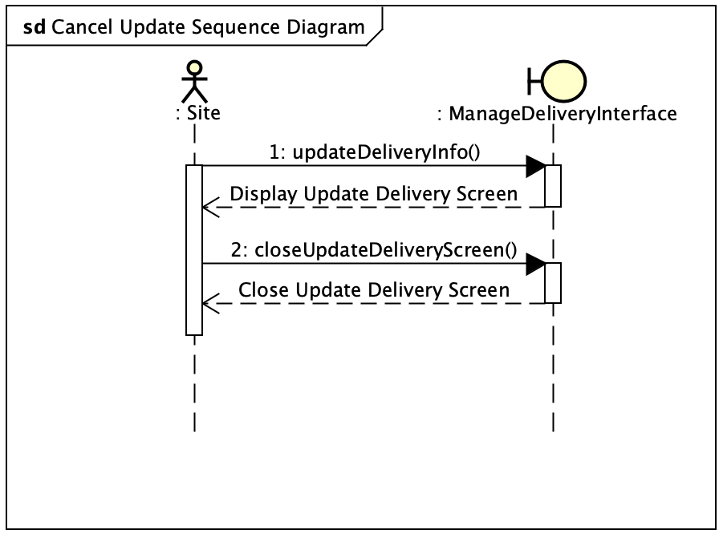

Cancel update flow sequence diagram

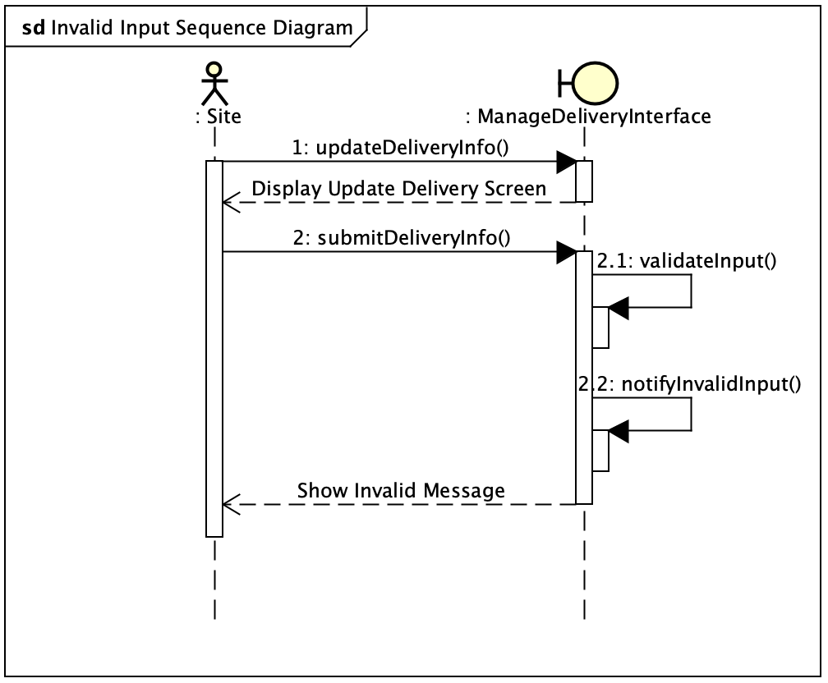

Invalid delivery information flow sequence diagram

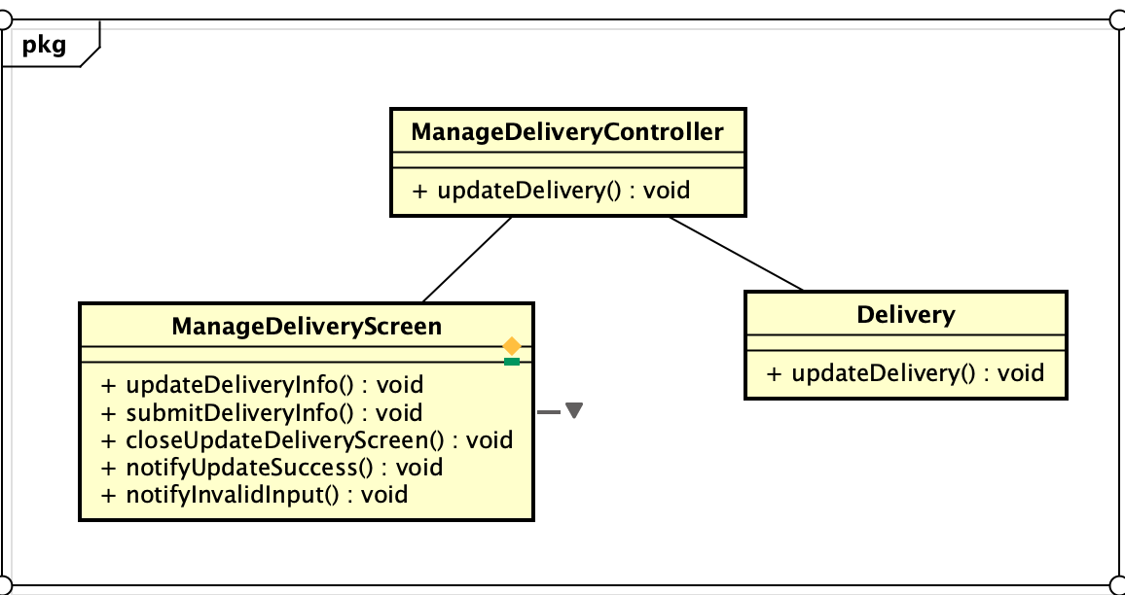

Class diagram

**3.8 Diagram for “Create Product Information”**

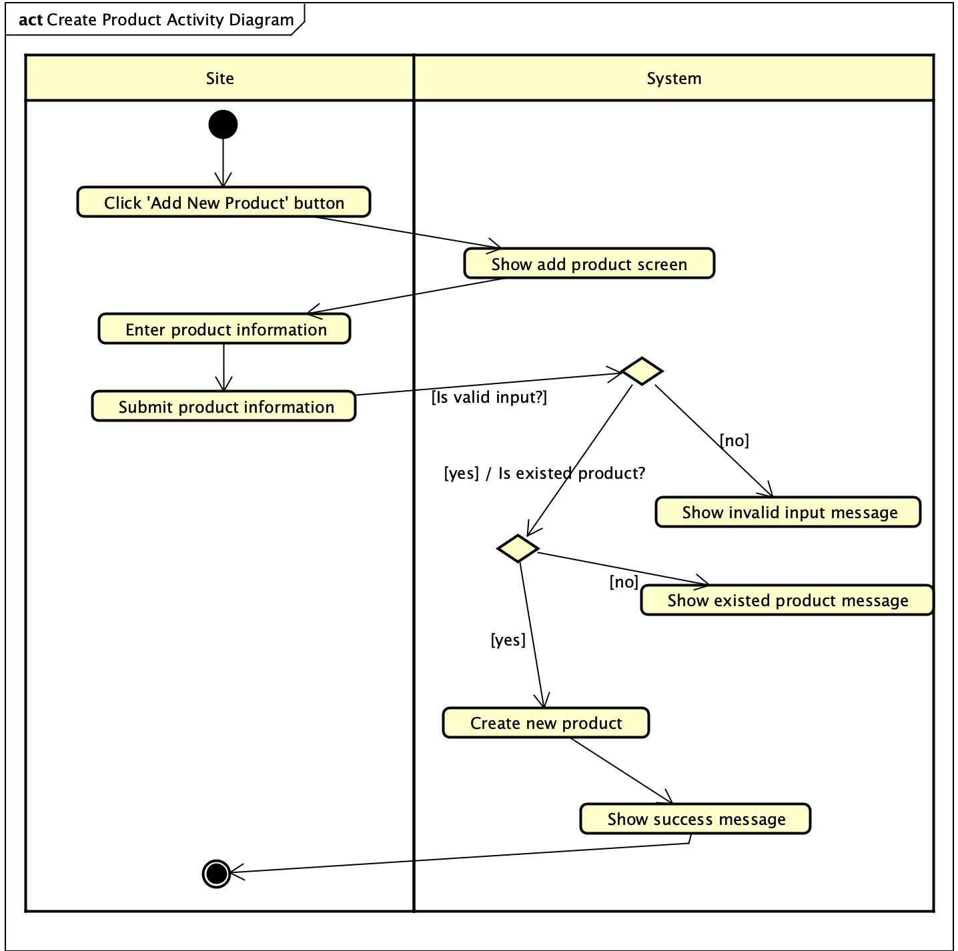

Activity diagram

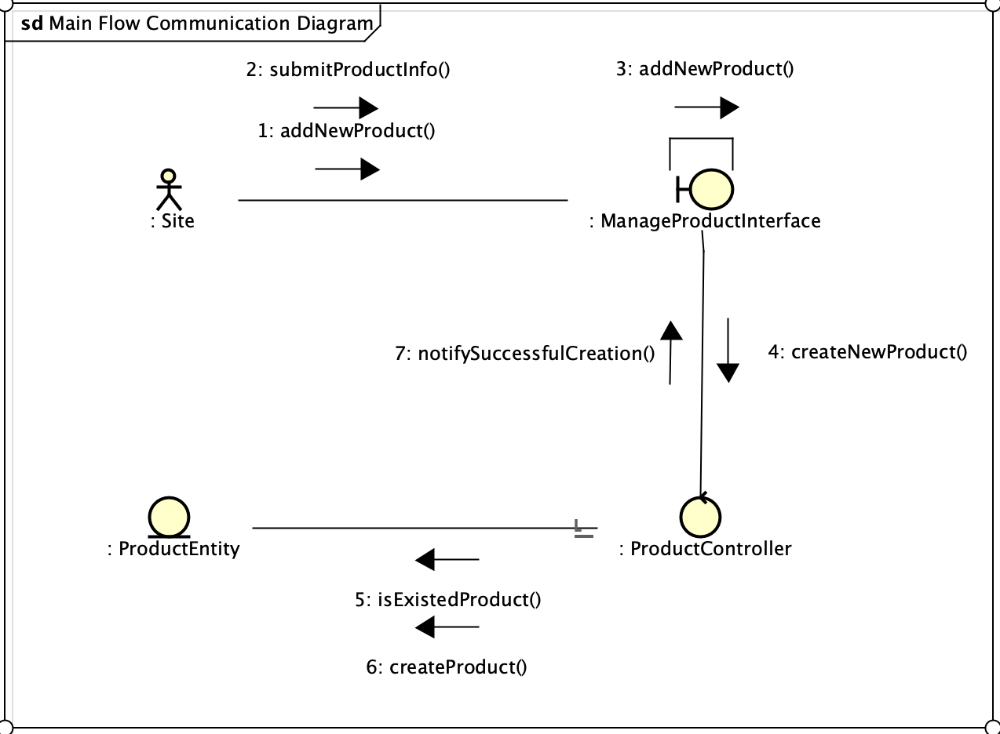

Main flow create product communication diagram

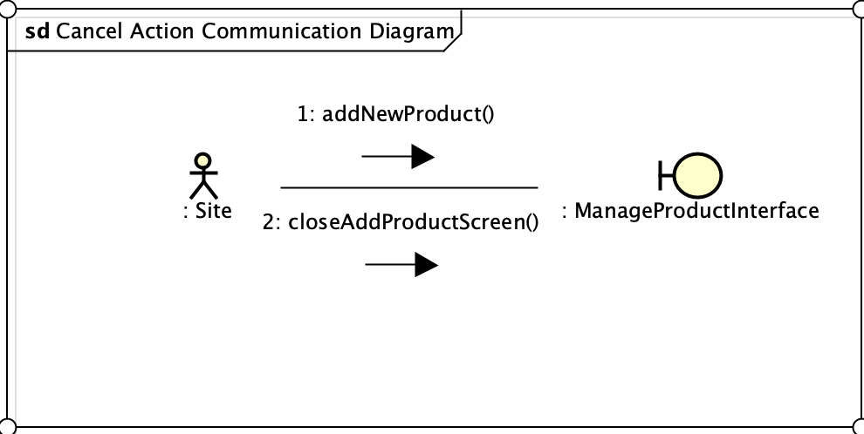

Cancel create product flow communication diagram

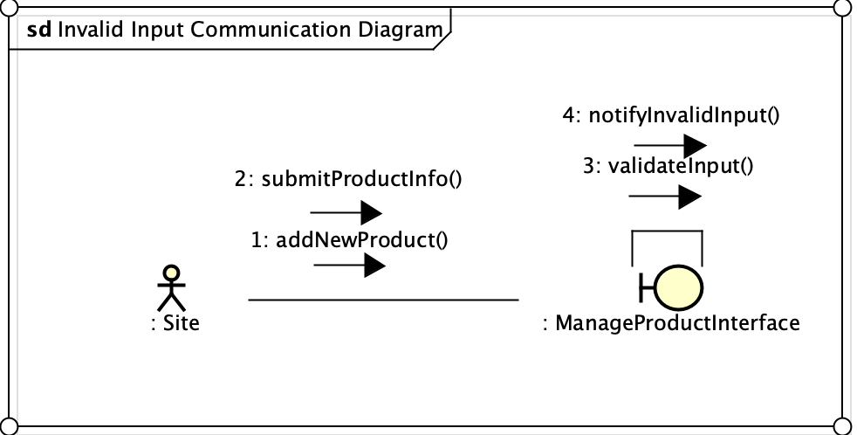

Invalid product information flow communication diagram

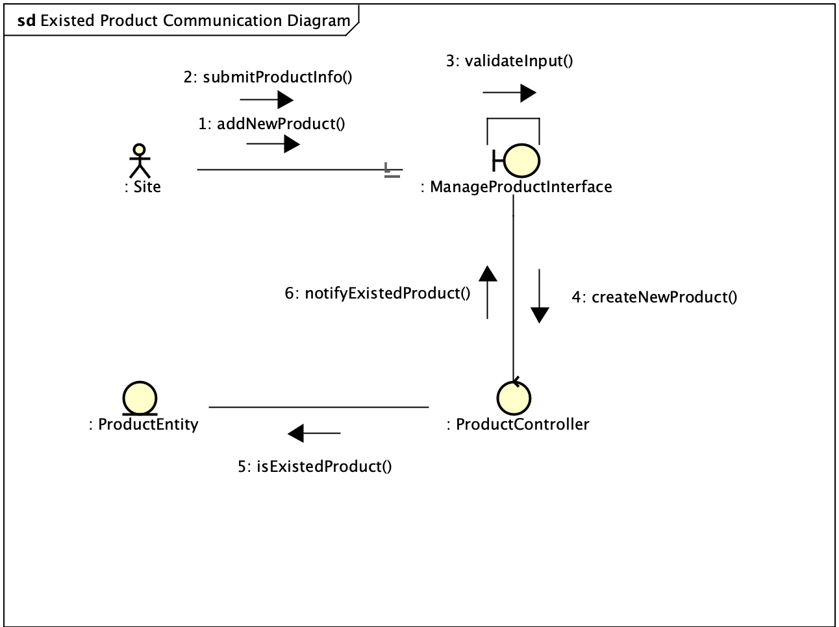

Existed product flow communication diagram

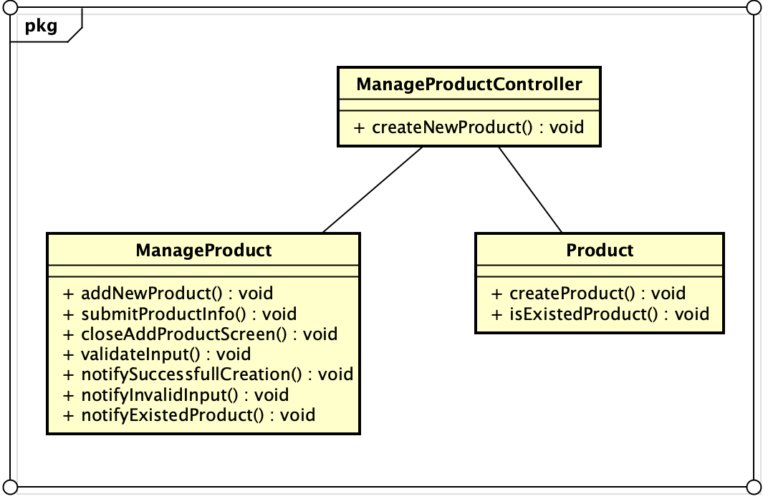

Class diagram