Requirement Analysis

Group [SoftwareDevelopment.ITSS.20191-04](https://bitbucket.org/Thanh98hy/softwaredevelopment.itss.20191-04/)

* Đào Ngọc Thành
* Nguyễn Đức Dũng
* Trần Bích Ngọc
* Vũ Thanh Tùng

**1. Use case diagram**

1.1 General use case

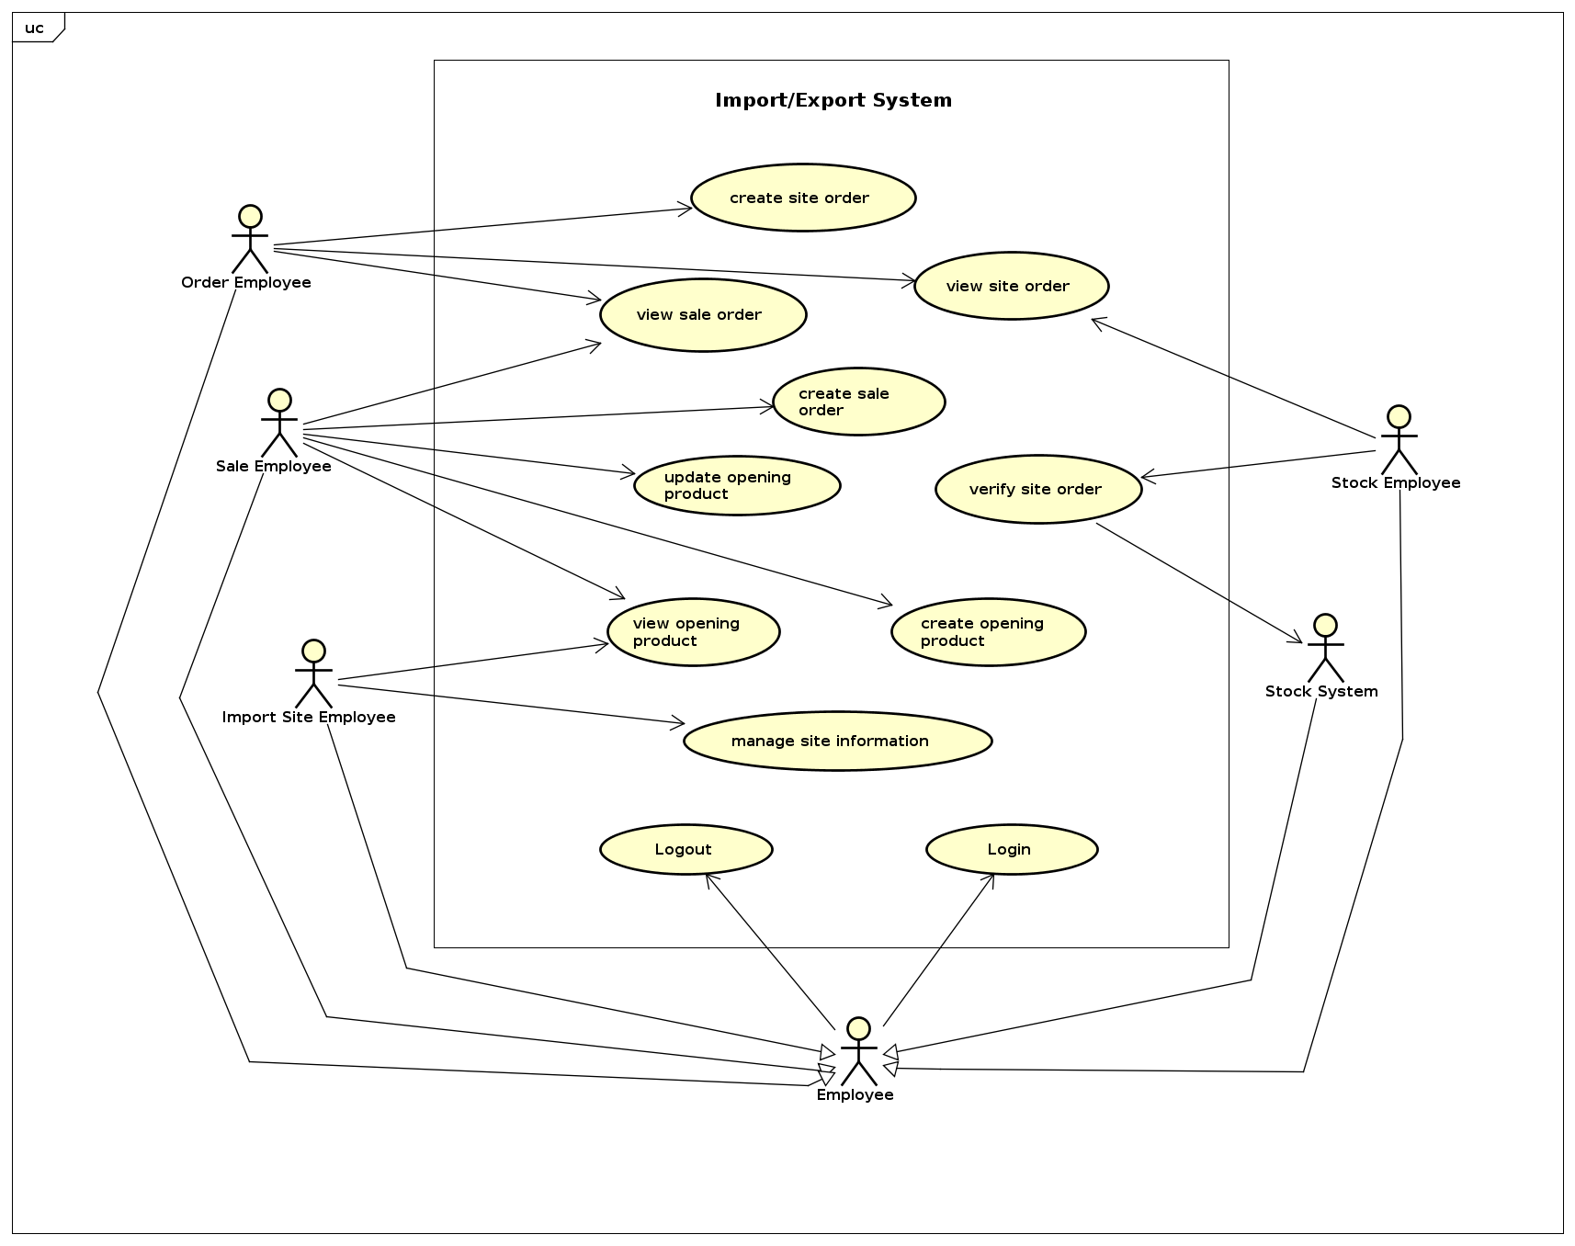

1.2 Use case for “Manage Import Site Information”

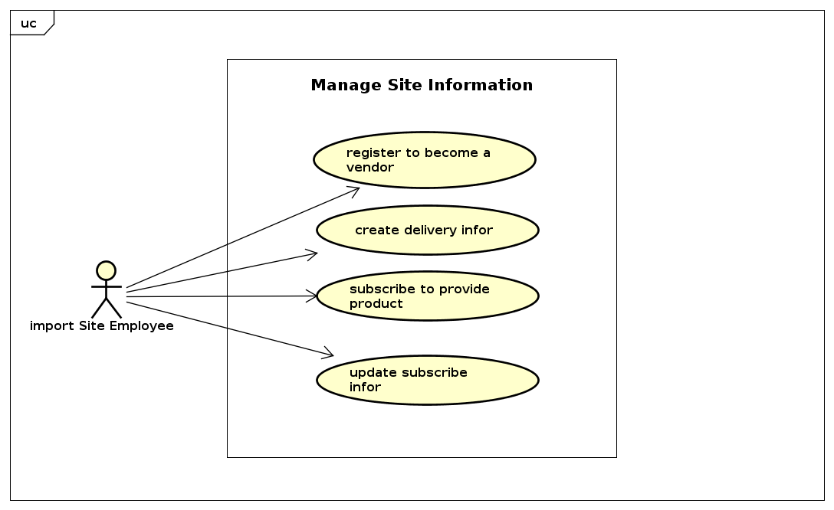

# **2. Use case specification**

**UC “** **subscribe to provide product”**

|  |  |  |  |
| --- | --- | --- | --- |
| **UC Code** | UC007 | **Use case name** | Subscribe to provide product |
| **Actor** | Import Site Employee | | |
| **Precondition** | View opening product | | |
| **Main flow of event (success)** | |  |  |  | | --- | --- | --- | | **#** | **Doer** | **Action** | | 1 | ISE | Click subscribe button under opening products list | | 2 | System | Display form (name, code, quantity,...) | | 3 | ISE | Select product can provide from list | | 4 | ISE | Edit quantity can be provided | | 5 | ISE | Click save | | 6 | System | Check validation | | 7 | System | Save information | | 8 | System | Notify create successfully | | 9 | System | Return to list of opening products screen | | | |
| **Alternative flow of event** | |  |  |  | | --- | --- | --- | | **#** | **Doer** | **Action** | | 5a. | ISE | Choose other products | | 6a. | System | Add product | | 5b. | ISE | Delete product | | 6b. | System | Delete this product information from form | | 5c. | ISE | Cancel | | 6c. | System | Return to list of opening products screen | | | |
| **Post condition** | None | | |

**UC “ update subscribe information”**

|  |  |  |  |
| --- | --- | --- | --- |
| **UC Code** | UC007 | **Use case name** | update subscribe information |
| **Actor** | Import Site Employee | | |
| **Precondition** | Subscribe to provide product | | |
| **Main flow of event (success)** | |  |  |  | | --- | --- | --- | | **#** | **Doer** | **Action** | | 1 | ISE | Click into subscribe form | | 2 | System | Display all products in form (name, code, quantity,...) | | 3 | ISE | Select product want to update | | 4 | ISE | Edit quantity, shipping method, v.v.. | | 5 | ISE | Click save | | 6 | System | Check validation | | 7 | System | Save information | | 8 | System | Notify update successfully | | 9 | System | Turn to form screen | | | |
| **Alternative flow of event** | |  |  |  | | --- | --- | --- | | **#** | **Doer** | **Action** | | 5a. | ISE | Cancel | | 6a. | System | Turn to form screen | | | |
| **Post condition** | None | | |

**3. Use-Case Realization**