Personal Report

Requirement Analysis

Group [SoftwareDevelopment.ITSS.20191-04](https://bitbucket.org/Thanh98hy/softwaredevelopment.itss.20191-04/)

**1.General use case  
**

Figure 1: general use case

**2. Use case specification**

|  |  |  |  |
| --- | --- | --- | --- |
| UC Code | UC001 | Use case name | Create Supplier Order |
| Actor | Order Employee | | |
| Precondition | successful login and in create site order section | | |
| Main flow of event (success) | |  |  |  | | --- | --- | --- | | # | Doer | Action | | 1. | Order Employee | Click process button in Sale Order detail to create Sipplier Order for this sale order. | | 2. | System | Display “Create Supplier Order Screen” | | 3. | Order Employee | Select a sale order line in sale order table and click “ADD SUPPLIER” to select suppler and quantity for this sale order line | | 4. | System | Save the user input to model if the information is valid | | 5. | Order Employee | Repeat step 3 for each sale order line | | 6. | Order Employee | Click “Submit” button | | 7. | System | Display success popup if all information is valid | | | |
| Alternative flow of event | |  |  |  | | --- | --- | --- | | # | Doer | Action | | 3a | Order Employee | If there is no reasonable provided merchandise for the sale order line. Click “Cancel” button. | | 4a | System | Display an error popup if there’re any problem (user choose a wrong supplier, or input wrong quantity) | | 7a | System | Display a error popup if there’re any problem (all sale order line are not fulfill) | | | |
| Post condition | None | | |

Figure 2 Use case specification for “Create Supplier Order”

Figure 3: Create Supplier Order (Activity Diagram)

|  |  |  |  |
| --- | --- | --- | --- |
| UC Code | UC002 | Use case name | View Supplier Order |
| Actor | Order Employee | | |
| Precondition | successful login | | |
| Main flow of event (success) | |  |  |  | | --- | --- | --- | | # | Doer | Action | | 1. | Order Employee | Click View Supplier Order button in home screen. | | 2. | System | Display Site Order List. | | 3. | Order Employee | Click Detail button in a row of table. | | 4. | System | Display the supplier order detail. | | | |
| Alternative flow of event | |  |  |  | | --- | --- | --- | | # | Doer | Action | | 2a | System | Display there none order list message, if there is no order list at all. | | | |
| Post condition | None | | |

Figure 4 Use case specification for “View Supplier Order”

Figure 5: View Supplier Order (Activity Diagram)

**3. Use-Case** **Realization**

**3.1 Use case Realization for “Create Supplier Order”**

Figure 6: Create Supplier Order (Sequence Diagram)

Figure 7: Create Supplier Order (error flow)

**3.2 Use case Realization for “View Supplier Order”**

Figure 8 Sequence Diagram: View Supplier Order List

**3.2 Analysis Class Diagram**

Figure 9 Class Diagram: Create Supplier Order

Figure 10 Class Diagram: View Supplier Order

**4. UI**

Figure 11: Screen Transitions

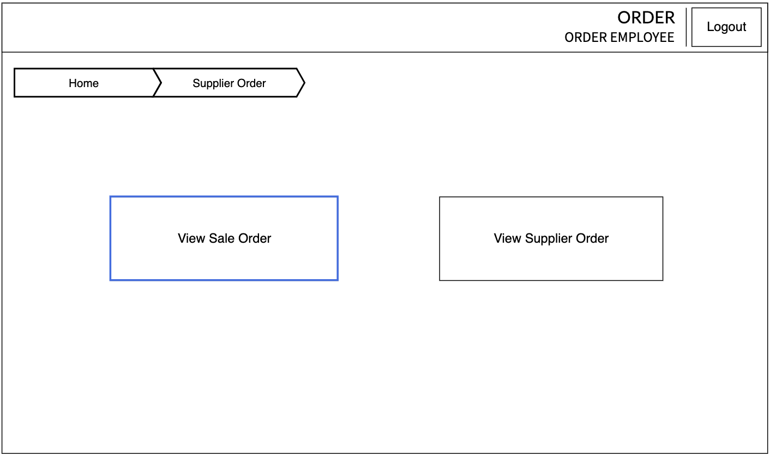

Figure 12: Supplier Order Home Screen

|  |  |  |  |
| --- | --- | --- | --- |
| **No.** | **Control** | **Operation** | **Function** |
| 1 | Area for displaying Supplier order list | Initial | Display in a table information meetings supplier order field |
| 2 | View Supplier Order Button | Click | Go to view supplier order list screen |
| 3 | View Sale Order Button | Click | Go to view sale order list scren |
| 4 | Logout Button | Click | Logout and go to Login Screen |

Table 1: Screen specification for supplier order home screen

**4.1 UI for “View Supplier Order USECASE”  
**

Figure 13: View Supplier Order List Screen

|  |  |  |  |
| --- | --- | --- | --- |
| **No.** | **Control** | **Operation** | **Function** |
| 1 | Area for displaying Supplier order list | Initial | Display in a table information meetings supplier order field |
| 2 | Back Button | Click | Go to home screen of current account |
| 3 | Detail Button | Click | Go to detail page of selected row in the table |
| 4 | Logout Button | Click | Logout and go to Login Screen |

Table 2: screen specification for view supplier order screen

Figure 14: Supplier Order Detail

|  |  |  |  |
| --- | --- | --- | --- |
| **No.** | **Control** | **Operation** | **Function** |
| 1 | Area for displaying Supplier order detail | Initial | Display in a table information meetings supplier order detail field |
| 2 | Back Button | Click | Go to supplier order list screen |
| 3 | Logout Button | Click | Logout and go to Login Screen |

Table 3: screen specification for supplier order detail screen

**

Figure 15: Create Supplier Order Screen

|  |  |  |  |
| --- | --- | --- | --- |
| **No.** | **Control** | **Operation** | **Function** |
| 1 | Area for displaying Sale Order detail and supplier order detail | Initial | Display in a table information meetings supplier order and sale order detail field |
| 2 | Logout Button | Click | Logout and go to Login Screen |
| 3 | Submit Button | Click | Submit the supplier order if all data is valid |
| 4 | Cancel Button | Click | Cancel create supplier order process |
| 5 | Add supplier button | Click | Select a supplier and quantity for a merchandise in Sale Order |

Table 4: screen specification for create supplier order screen

**5. Design Class Diagram**

Figure 16: Design class