­

Report

ITSS Software Development

Group [SoftwareDevelopment.ITSS.20191-04](https://bitbucket.org/Thanh98hy/softwaredevelopment.itss.20191-04/)

**1. Use case diagram**

1.1 General use case

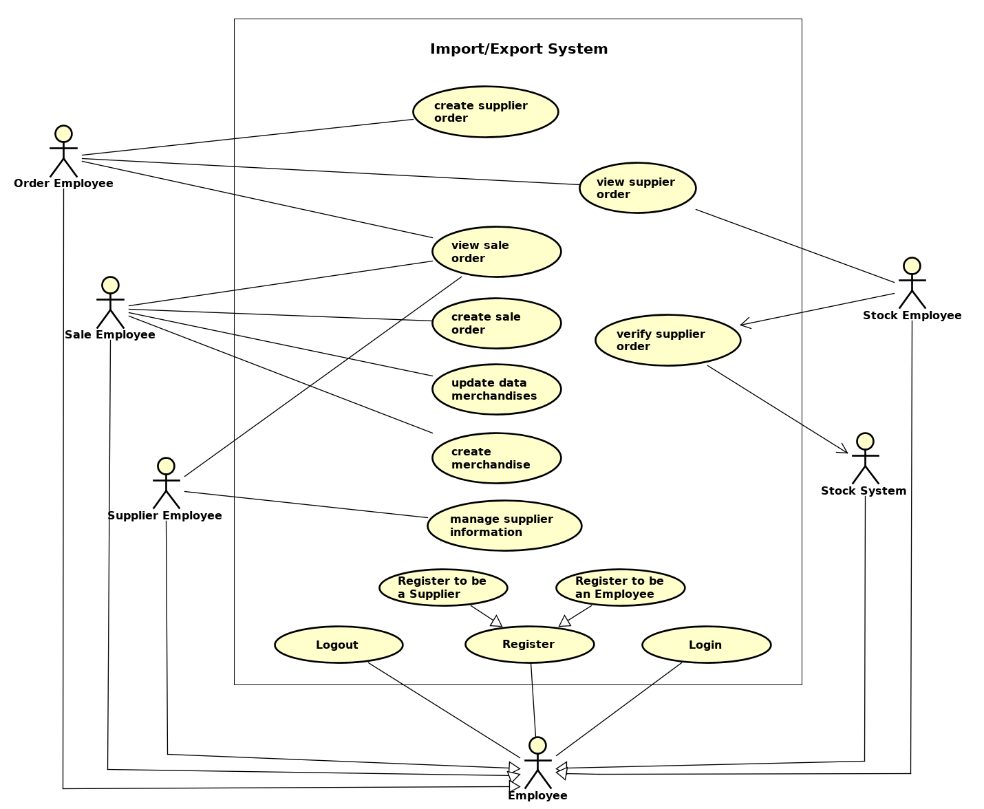Figure 1: General use case

1.2 Use case for “Manage Supplier Information”

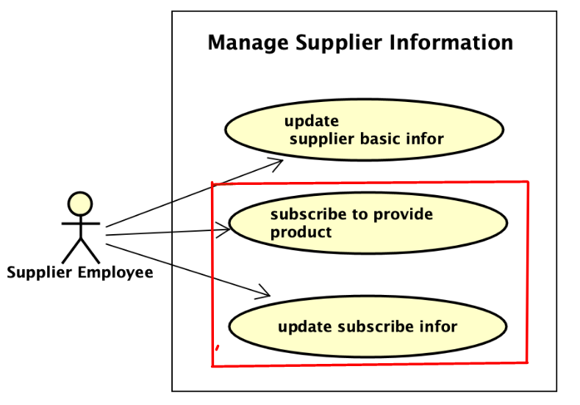  
Figure 2: Manage Supplier Information

# **2. Use case specification**

**UC “** **subscribe to provide product”**

|  |  |  |  |
| --- | --- | --- | --- |
| **UC Code** | UC007 | **Use case name** | Subscribe to provide product |
| **Actor** | Supplier Employee | | |
| **Precondition** | View sale order lines | | |
| **Main flow of event (success)** | |  |  |  | | --- | --- | --- | | **#** | **Doer** | **Action** | | 1 | SE | Choose sale order | | 2 | SE | Click subscribe to provide products button | | 3 | System | Display order lines details (name, code, ordered quantity,...) | | 4 | SE | Select order line can provide from list | | 5 | SE | Edit quantity & price can be provided | | 6 | SE | Click Add button | | 7 | System | Check input validation | | 8 | System | Change status of order line to ‘Subscribed’ | | 9 | SE | Click Save button | | 10 | System | Save information | | 11 | System | Notify create successfully | | 12 | System | Return to supplier home screen | | | |
| **Alternative flow of event** | |  |  |  | | --- | --- | --- | | **#** | **Doer** | **Action** | | 9a. | SE | Choose other products | | 10a. | SE | Edit quantity & price then Add | | 8a. | System | Found error in submit merchandise | | 9a. | System | Popup error message | | 9b. | SE | Cancel | | 10b. | System | Return to supplier home screen | | | |
| **Post condition** | None | | |

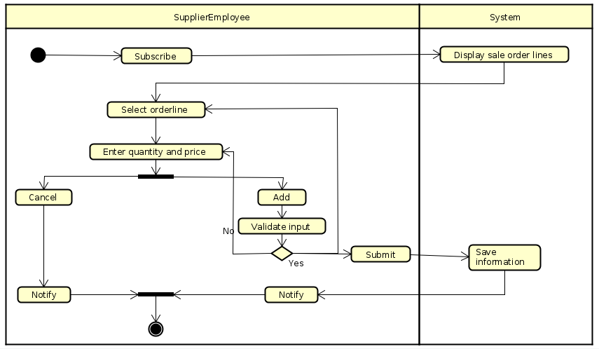  
Activity Diagram 1: Subscribe to provide products

**UC “ update subscribe information”**

|  |  |  |  |
| --- | --- | --- | --- |
| **UC Code** | UC007 | **Use case name** | update subscribe information |
| **Actor** | Supplier Employee | | |
| **Precondition** | Login as supplier employee | | |
| **Main flow of event (success)** | |  |  |  | | --- | --- | --- | | **#** | **Doer** | **Action** | | 1 | SE | Click update subscribe information button | | 2 | System | Display all merchandise in form (name, code, quantity,...) | | 3 | SE | Select merchandise want to update | | 4 | SE | Edit quantity, price, v.v.. | | 5 | SE | Click save | | 6 | System | Check validation | | 7 | System | Save information | | 8 | System | Notify update successfully | | 9 | System | Turn to supplier home screen | | | |
| **Alternative flow of event** | |  |  |  | | --- | --- | --- | | **#** | **Doer** | **Action** | | 5a. | SE | Cancel | | 6a. | System | Turn to supplier home screen | | 4a. | SE | Click Detete button | | 4b | System | Change status of this merchandise to ‘closed’ | | | |
| **Post condition** | None | | |

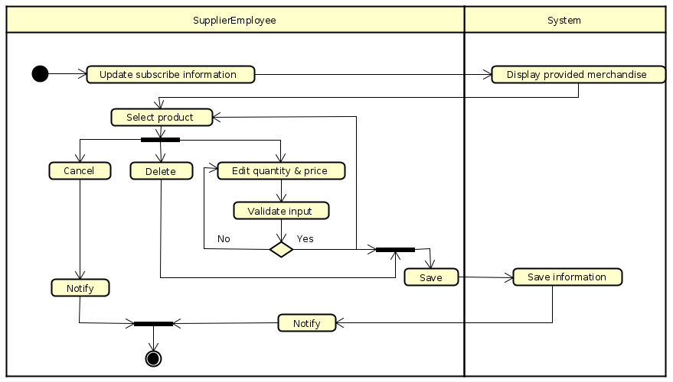  
Activity Diagram 2: Update subscribe information

**3. Use-Case Realization**

3.1 UC “ Subscribe to provide product”

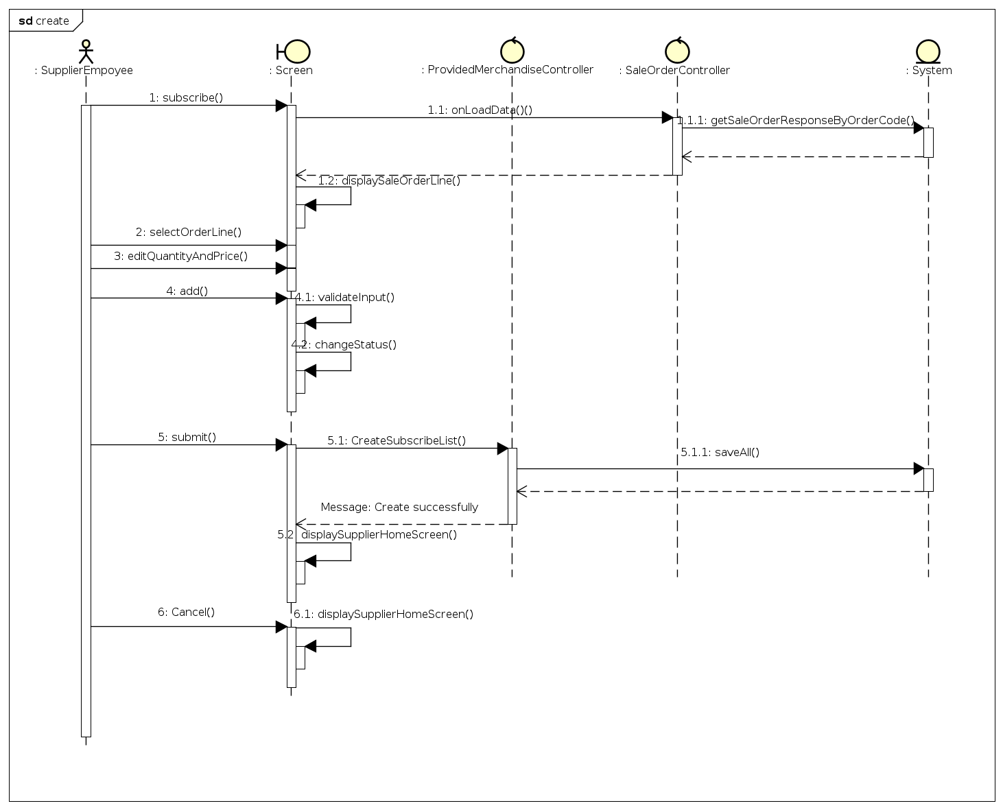  
Sequence Diagram 1: Subscribe to provide products

3.2 UC “ Update subscribe information”

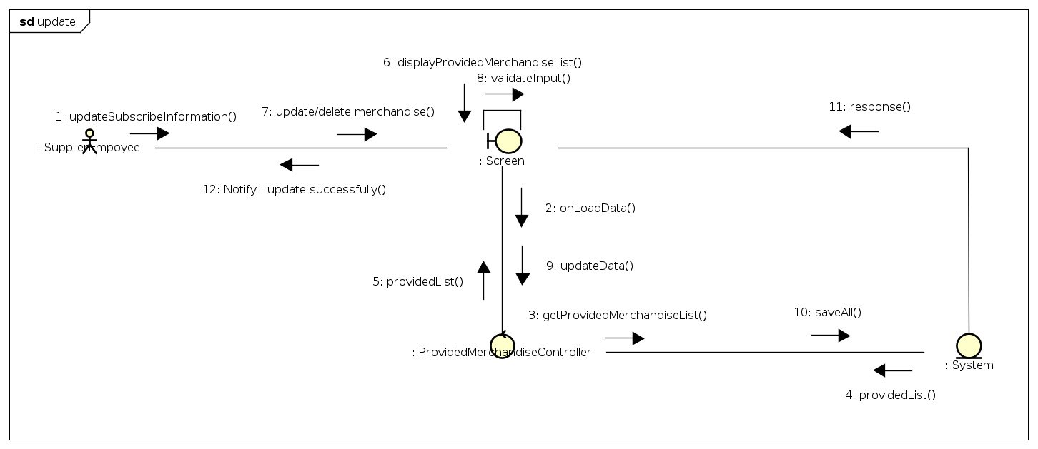  
Communication Diagram 1: Update subscribe information

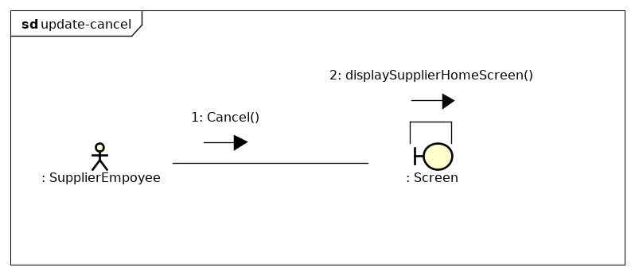  
Communication Diagram 2: Update subscribe information - cancel flow

**4. Interface Design**

4.1 Subscribe to provide products screen

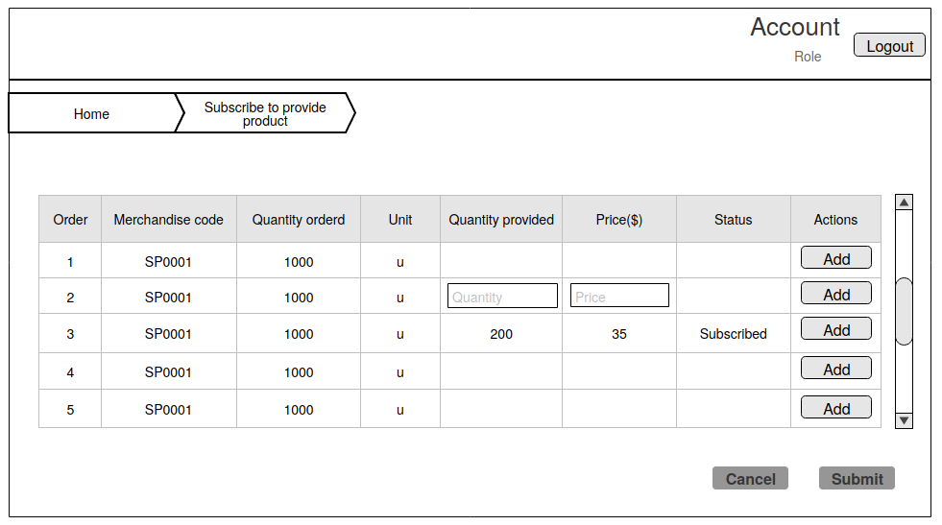

Screen specification

|  |  |  |
| --- | --- | --- |
| **Control** | **Operation** | **Function** |
| Area for displaying account information | Initial | - Display name, role |
| Logout button | Click | - Turn to supplier home screen |
| Area for displaying detail table | Initial | - Display merchandise information  - Display button Add  - Display text field |
| Button Add | click | - Change status to subscribed if user fill valid quantity and price |
| Menu | click | - Turn screen |
| Button Submit | click | - Complete and save provided merchandise  - Display popup created successfully |
| Button Cancel | click | - Display popup cancel  - Turn to supplier home screen |

4.2 Update subscribe information screen

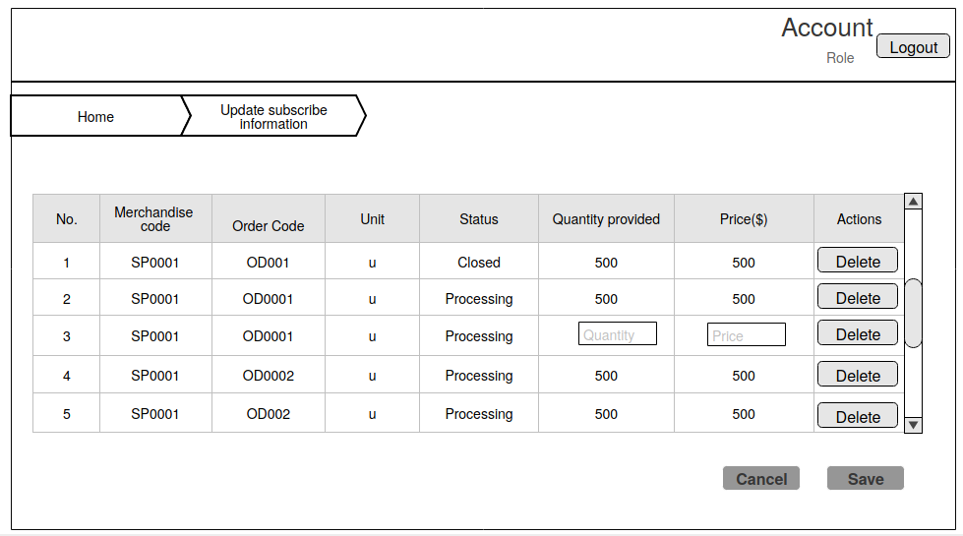

Screen specification

|  |  |  |
| --- | --- | --- |
| **Control** | **Operation** | **Function** |
| Area for displaying account information | Initial | - Display name, role |
| Logout button | Click | - Turn to supplier home screen |
| Area for displaying detail table | Initial | - Display merchandise information  - Display icon delete  - Display text field |
| Icon delete | click | - Change status of merchandise to closed |
| Button Save | click | - Complete and save provided form  - Display popup update successfully |
| Button Cancel | click | - Display popup to cancel |

4.3 Success popup

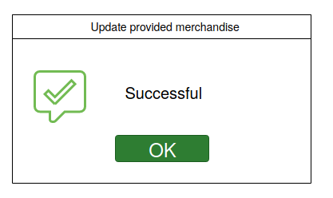

Screen specification

|  |  |  |
| --- | --- | --- |
| **Control** | **Operation** | **Function** |
| Icon success | Initial | - Display success icon |
| Text | Initial | - Display message |
| Button OK | click | - Confirm to understand this message |

4.4 Error popup

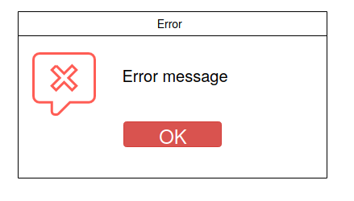

Screen specification

|  |  |  |
| --- | --- | --- |
| **Control** | **Operation** | **Function** |
| Icon error | Initial | - Display error icon |
| Text | Initial | - Display message |
| Button OK | click | - Confirm to understand this message |

4.5 Confirm popup

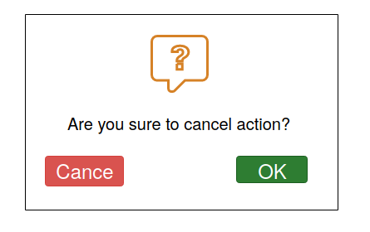

Screen specification

|  |  |  |
| --- | --- | --- |
| **Control** | **Operation** | **Function** |
| Icon error | Initial | - Display question icon |
| Text | Initial | - Display message |
| Button OK | click | - Turn to supplier home screen |
| Button Cancel | click | - Keep current screen |

**5. Class Design**

5.1 Class diagram analysis

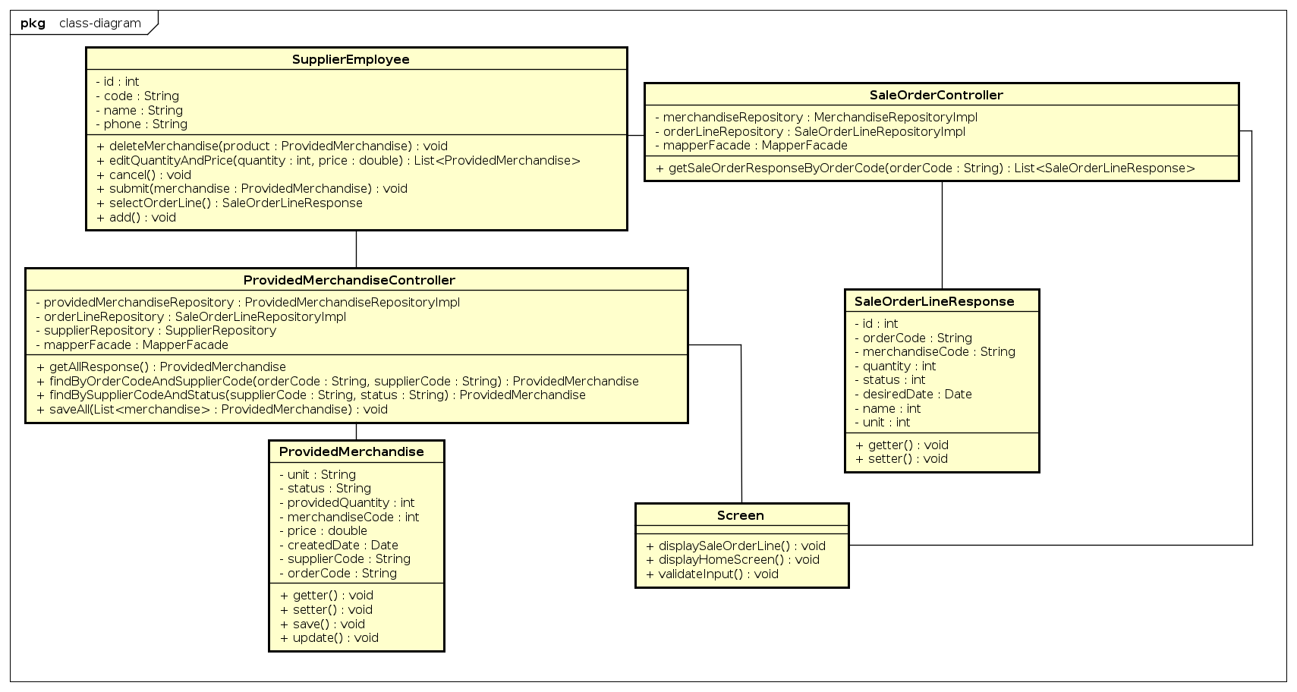  
Figure 3: Class diagram (Subscribe and update subscribe information)

5.2 Class design

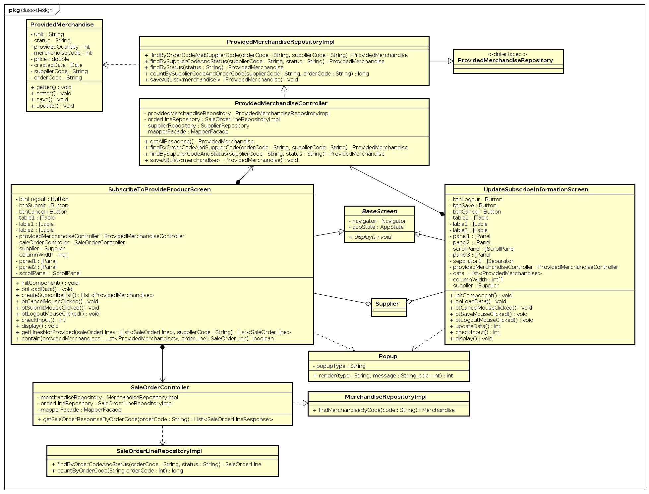  
Figure 4: Class design ( Subscribe and update subscribe information)

5.3 Screen transition

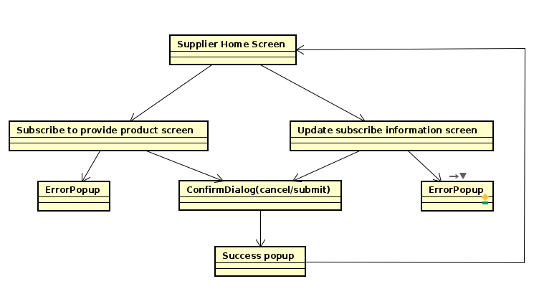  
Figure 5: Screen transition

**6. Glossary**

* Merchandise : [goods that are bought and sold](https://dictionary.cambridge.org/vi/dictionary/english/sold)
* Supplier : a [company](https://dictionary.cambridge.org/vi/dictionary/english/company), etc. that [provides](https://dictionary.cambridge.org/vi/dictionary/english/provide) things that [people](https://dictionary.cambridge.org/vi/dictionary/english/people) [want](https://dictionary.cambridge.org/vi/dictionary/english/want) or need, [especially](https://dictionary.cambridge.org/vi/dictionary/english/especially) over a [long](https://dictionary.cambridge.org/vi/dictionary/english/long) [period](https://dictionary.cambridge.org/vi/dictionary/english/period) of [time](https://dictionary.cambridge.org/vi/dictionary/english/time)