**ITSS Software Development Report**

**Sale Employee Use Case Specification**

**1. Sale Employee Use Case Diagram**

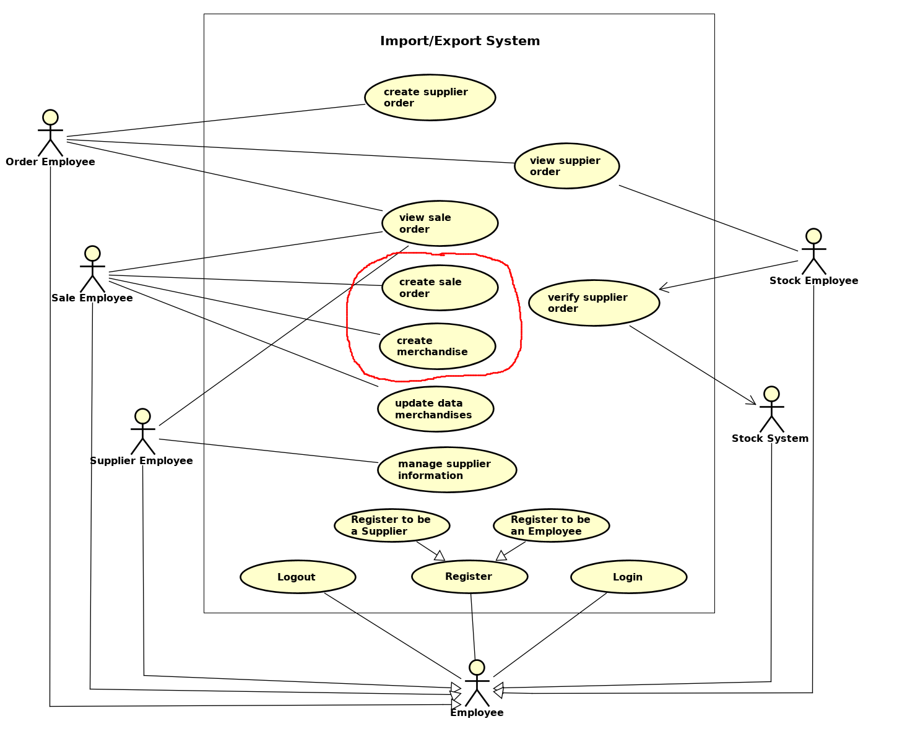

Figure 1: Sale Employee Rule in General Use case Diagram

**NOTE**: - In this report is the design of two use cases ‘Create Sale Order’ and ‘Create Merchandise’, ‘View Sale Order’ and ‘Update Data Merchandise’ are also executed in application but documents are not included in this report

1.1 Sale Employee Class Diagram

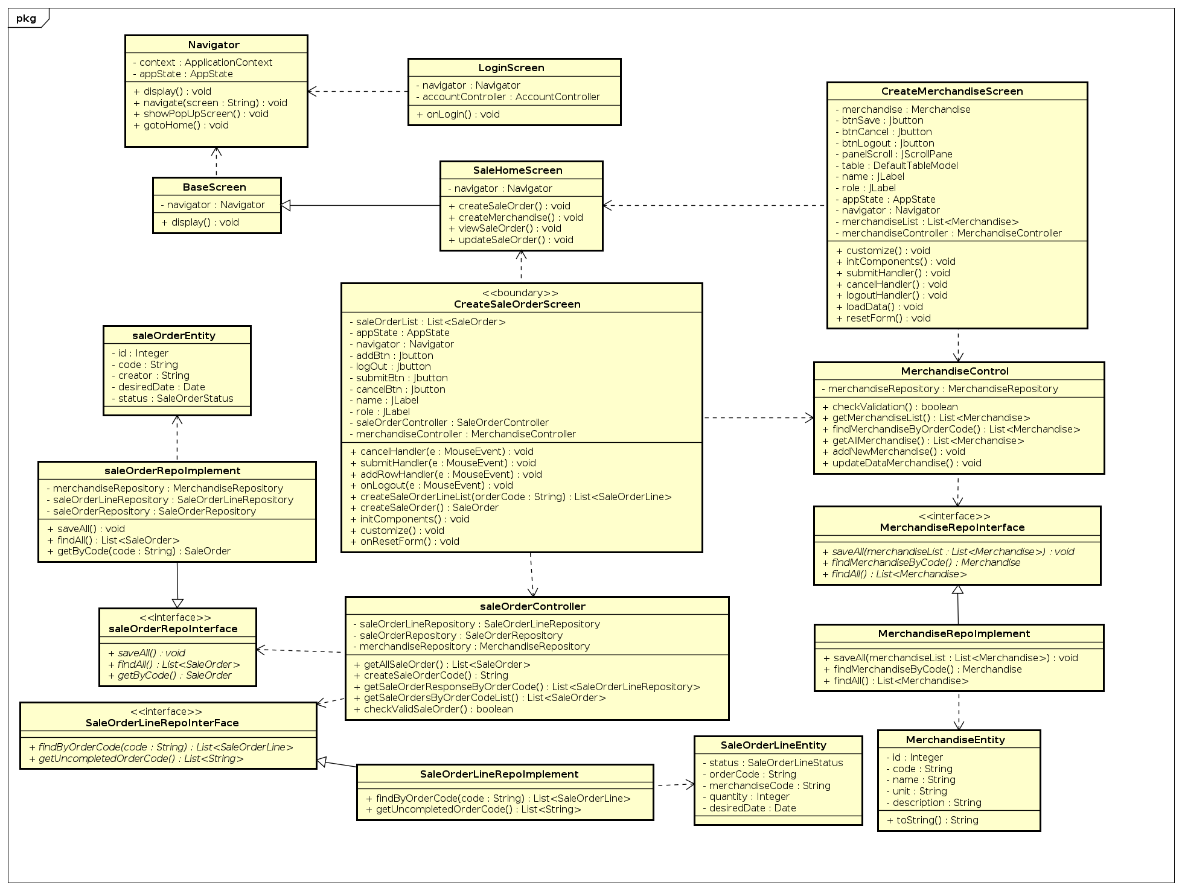

Figure 2. Sale Employee Class Diagram

1.2 Screen Transition

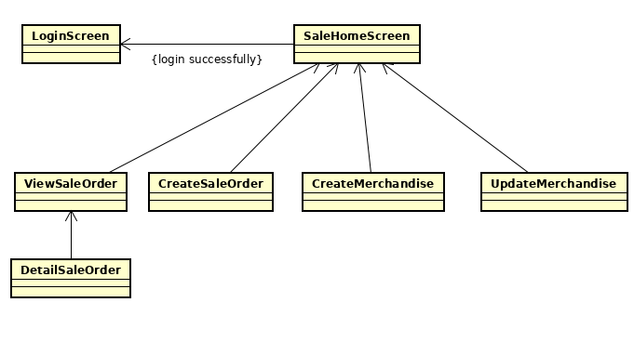

Figure 3. Screen Transition

**2. Create Sale Order Use case Specification**

2.1 Specification

|  |  |  |  |
| --- | --- | --- | --- |
| UC Code | UC001 | Use case name | Create Sale Order |
| Actor | Sale Employee | | |
| Precondition | successful login | | |
| Main flow of event (success) | |  |  |  | | --- | --- | --- | | # | Doer | Action | |  | Sale Employee | Click ‘Create sale order’ button | |  | System | Load data and display create sale order form | |  | Sale Employee | Fulfill all the information | |  | Sale Employee | Click ‘Submit’ button | |  | System | Validate data | |  | System | Generate sale order code save into sale order database | |  | System | Return successful message and come back to the previous screen | | | |
| Alternative flow of event | |  |  |  | | --- | --- | --- | | # | Doer | Action | | 1. | Sale Employee | Click ‘Cancel button’ to come back the previous screen | | 2. | System | Display PopUp Confirm Screen and click ‘Yes’ to back the previous screen | | 3. | System | Notifies error when anyfield is empty | | 4. | System | Notifies ‘Quantity must be larger than 1’ if the quantity value is fewer than 1 or ‘Quantity is not in number format’ if quantity is not in number format | | 5. | System | Notifies ‘Invalid date’ if the date is not valid | | 6. | System | Notifies ‘There’s something went wrong’ if sale order is submitted unsuccessfully to the database | | | |
| Post condition | None | | |

Figure 4. Create Sale Order Use Case Specification

2.2 Create Sale Order Activity Diagram

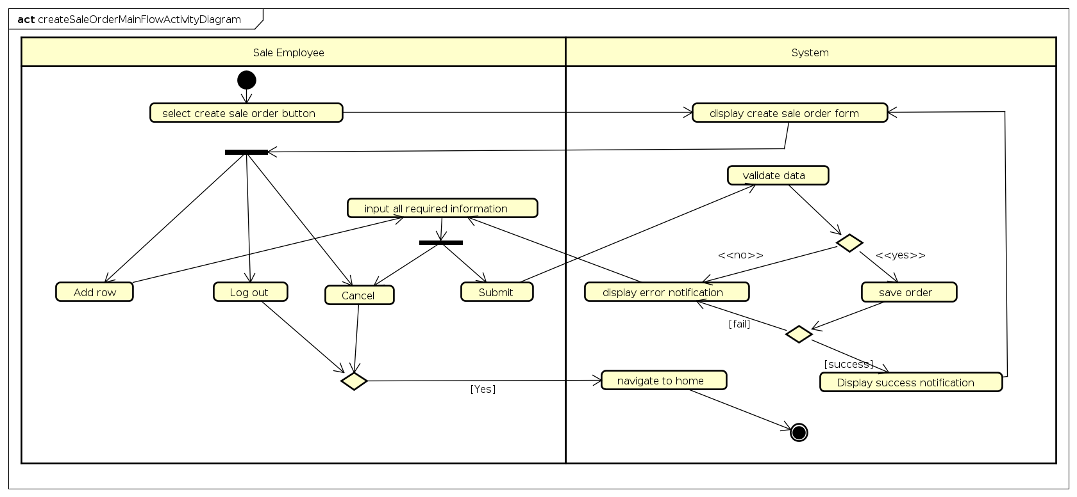

Figure 5. Create sale order activity diagram

2.3 Create Sale Order Main flow Sequence Diagram

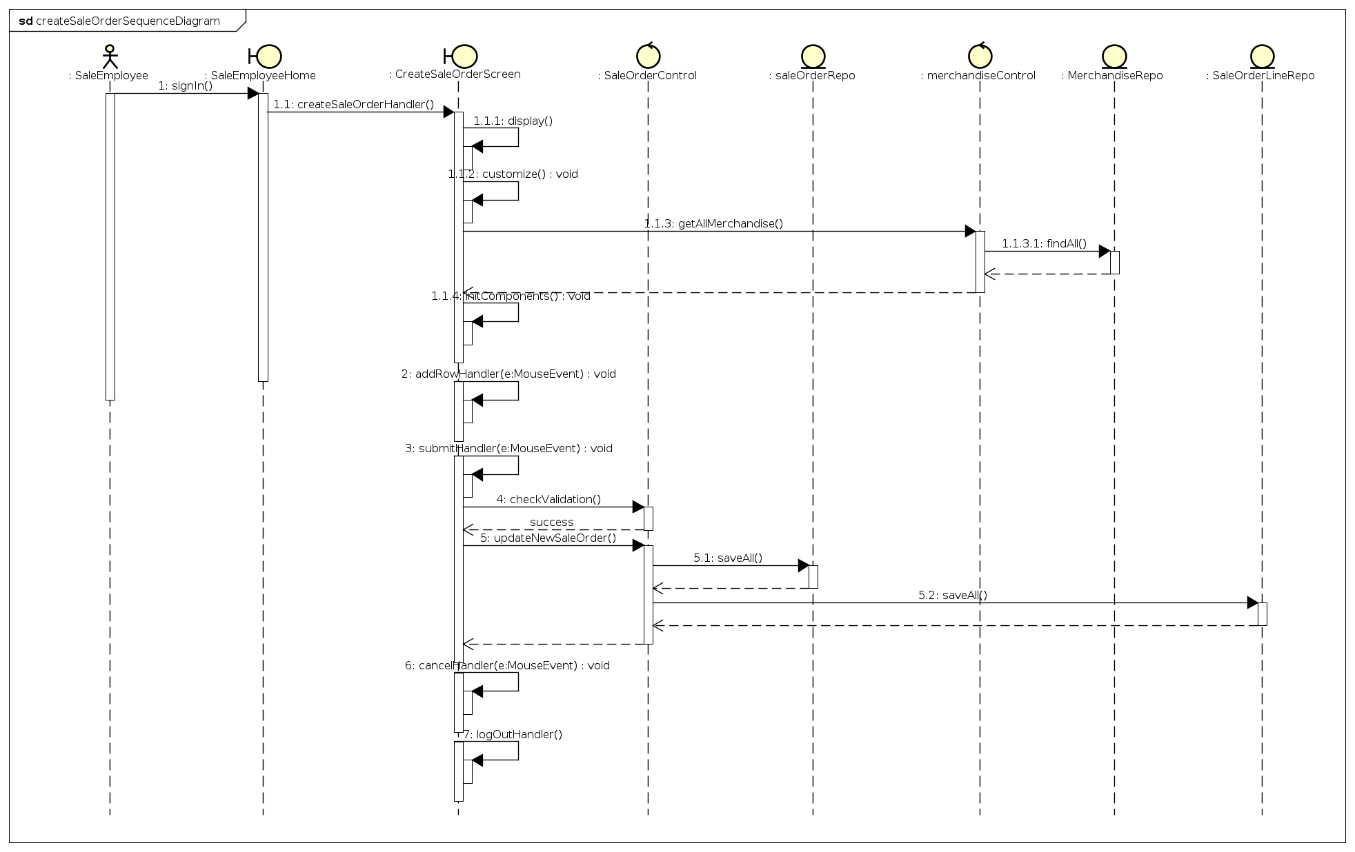

Figure 6. Create sale order main flow sequence diagram

2.4 Create Sale Order Class Diagram

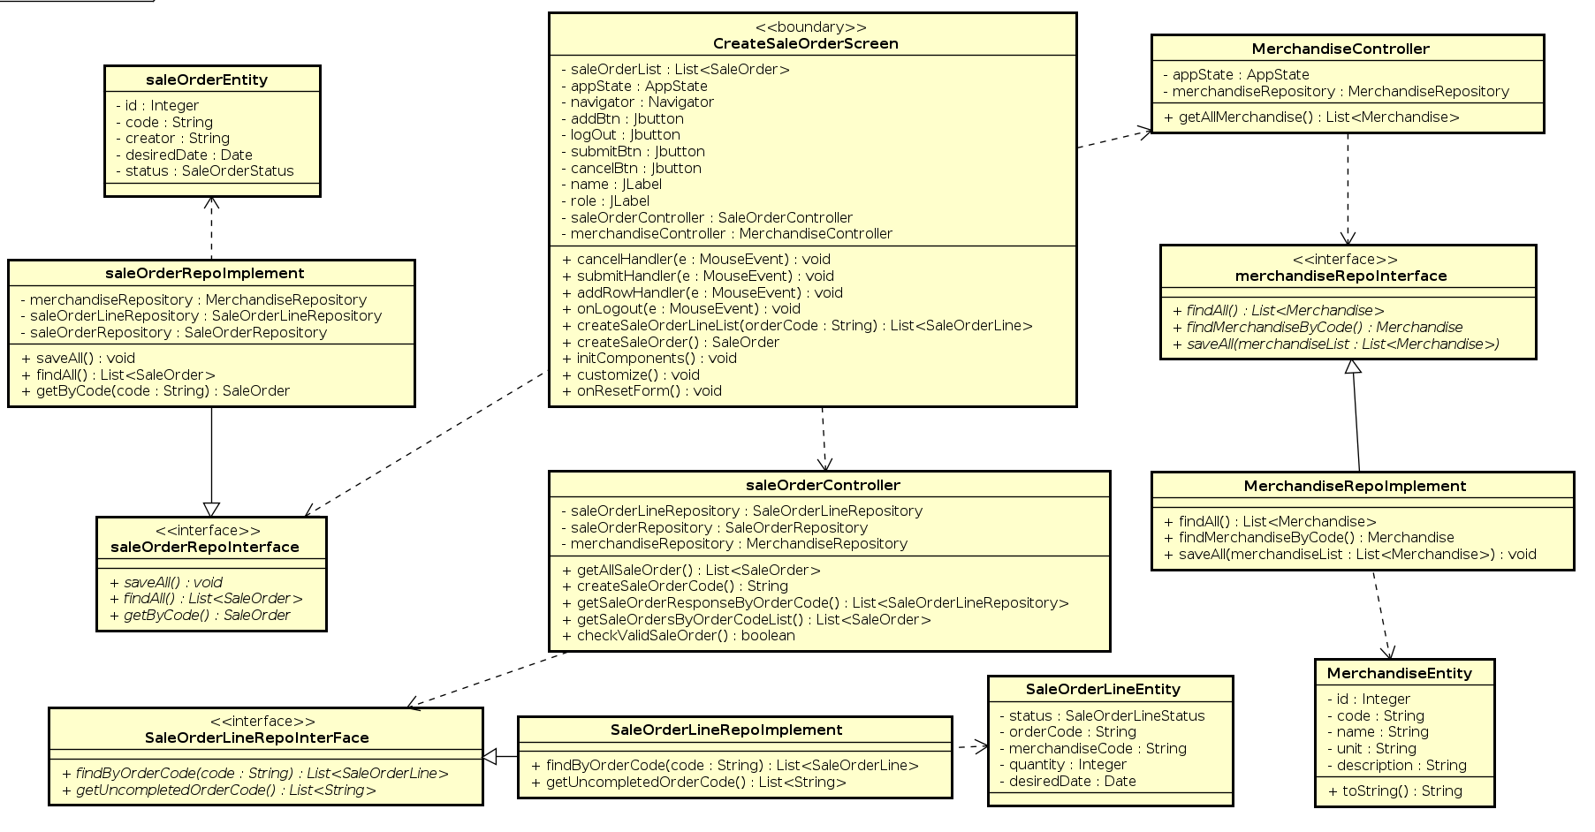

Figure 7. Create Sale Order Class Diagram

2.5 Create Sale Order Screen

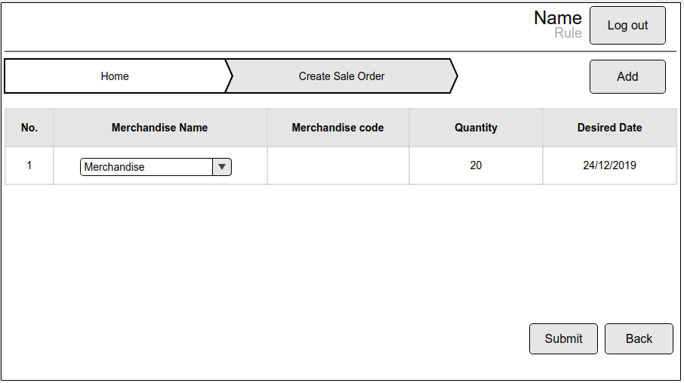

Figure 8. Create Sale Order Screen

2.6 Screen specification

|  |  |  |
| --- | --- | --- |
| Control | Operation | Function |
| Area for displaying sale order form | Initial | Display the sale order form for user to fulfill information |
| Add button | Click | Create new row for information of merchandise |
| Submit button | Click | Display Confirm dialog then submit information to sale order database |
| Cancel button | Click | Display Confirm dialog then display the previous screen |
| Merchandise name editor | Click and Choose | Show the list of merchandises to choose |
| Log out button | Click | Navigate to login screen |

Figure 9. Screen specification table

**3. Create merchandise use case specification**

3.1 Create Merchandise Specification

|  |  |  |  |
| --- | --- | --- | --- |
| UC Code | UC002 | Use case name | Create Merchandise |
| Actor | Sale Employee | | |
| Precondition | successful login | | |
| Main flow of event (success) | |  |  |  | | --- | --- | --- | | # | Doer | Action | | 1 | Sale Employee | Click ‘Create Merchandise’ button | | 2 | System | Show the merchandise form | | 3 | Sale Employee | Fulfill information | | 4 | Sale Employee | Click ‘Submit’ button | | 5 | System | Validate data | | 6 | System | Display submitted successful dialog and come back the previous screen | | | |
| Alternative flow of event | |  |  |  | | --- | --- | --- | | # | Doer | Action | | 1. | Sale Employee | Click ‘Cancel button’ to come back the previous screen | | 2. | Sale Employee | Click ‘Log out’ to navigate to login screen | | 2. | System | Notifies fulfill the mandatory fields when users leave some required fields empty | | 3. | System | Notifies errors when saving data unsuccessfully | | | |
| Post condition | None | | |

Figure 10. Create merchandise use case specification

3.2 Create merchandise activity Diagram

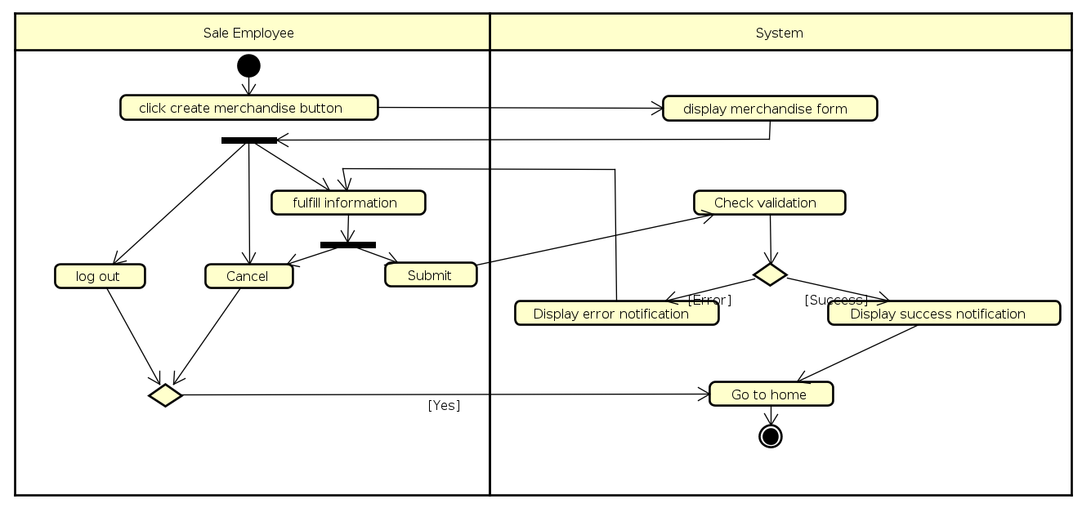

Figure 11. Create merchandise activity diagram

3.3 Create Merchandise Main flow Communication diagram

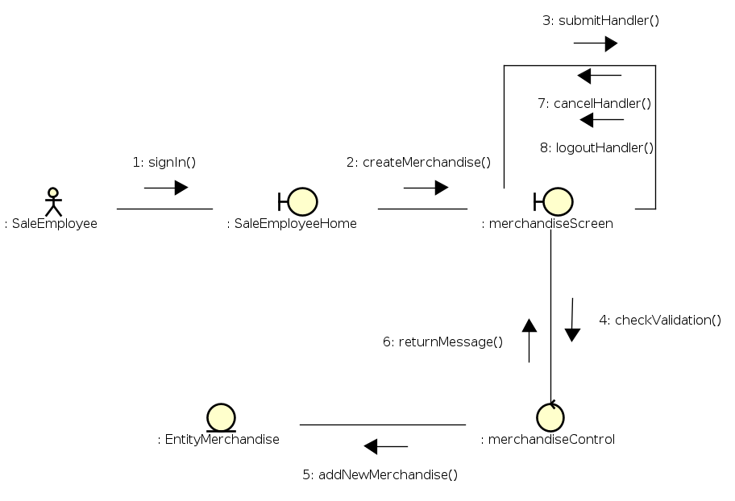

Figure 12. Create merchandise main flow communication diagram

3.4 Create Merchandise Class Diagram

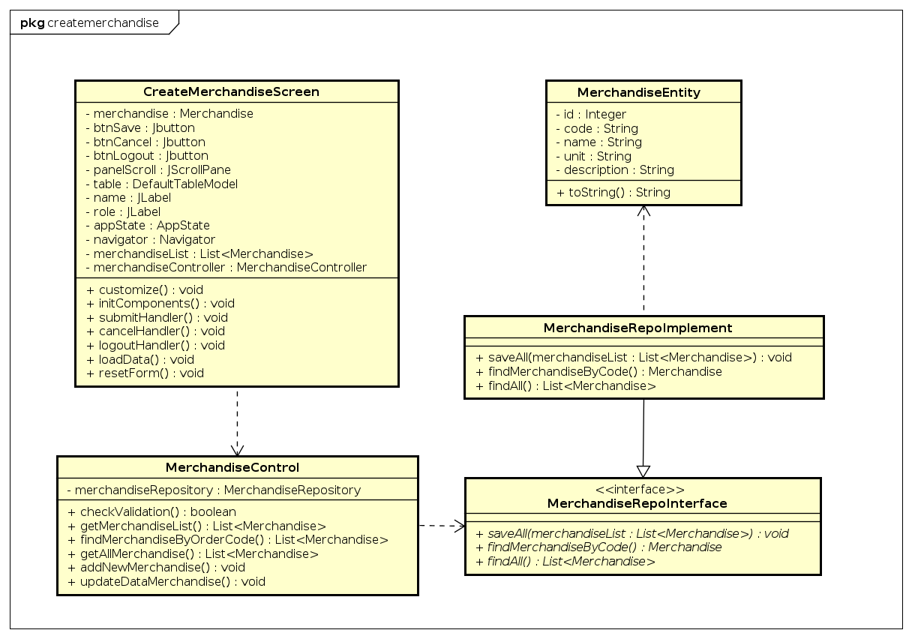

Figure 13. Create merchandise class diagram

3.5 Create data merchandise Screen

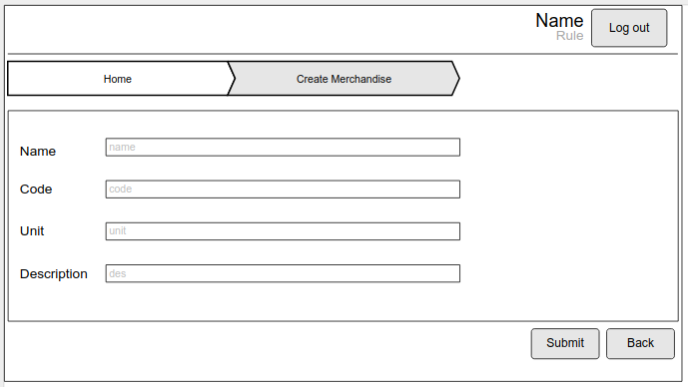

Figure 14. Create merchandise screen

3.6 Create merchandise screen specification

|  |  |  |
| --- | --- | --- |
| Control | Operation | Function |
| Area for displaying new data form | Initial | Field for user to fulfill data of merchandises based on sale orders |
| Submit button | Click | Display Confirm dialog then submit information to data of merchandise database |
| Cancel button | Click | Display Confirm dialog then display the previous screen |
| Log out button | Click | Navigate to login screen |

Figure 15. Create merchandise screen specification

**4. Popup Screen**

4.1 Confirm Dialog

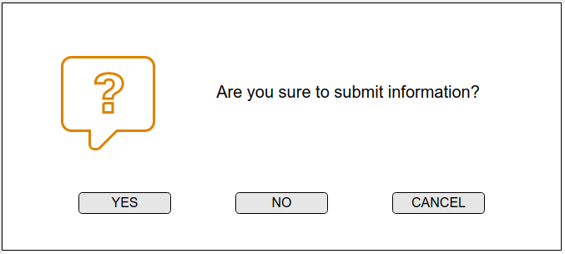

|  |  |  |
| --- | --- | --- |
| Control | Operation | Function |
| Yes button | Click | Submit information |
| No button | Click | Cancel submitting and stay at current screen |
| Cancel button | Click | Cancel submitting and stay at current screen |

4.2 Success Notification

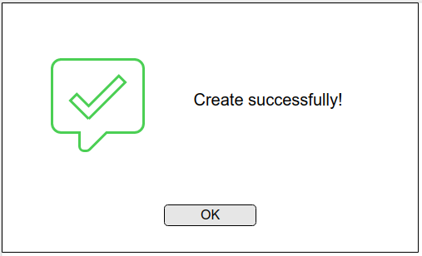

4.3 Error Notification

