Requirement Analysis
Group SoftwareDevelopment.ITSS.20191-04
- Đào Ngọc Thành
- Nguyễn Đức Dũng
- Trần Bích Ngọc
- Vũ Thanh Tùng

Use case diagram
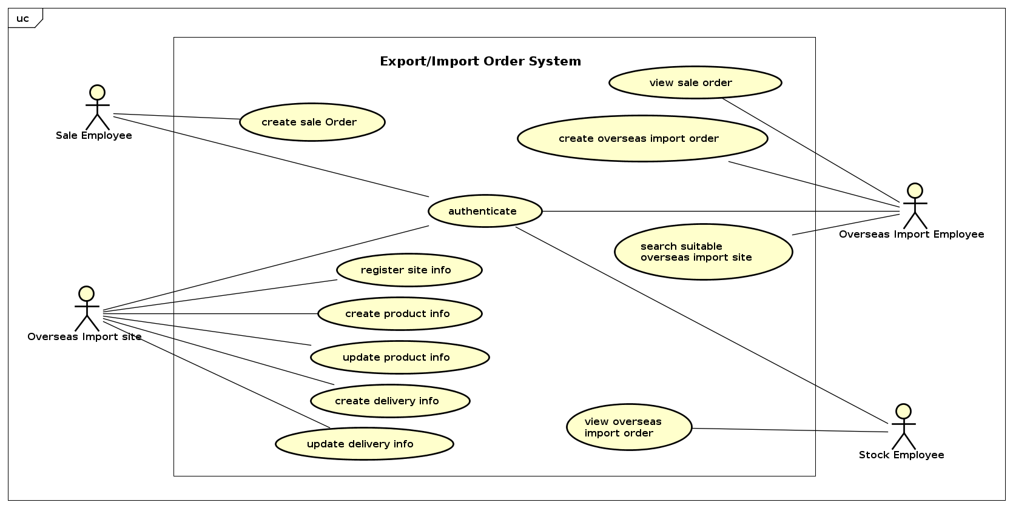

Use case specification

UC “View Sales Order”

UC Code | UC001 | Use case name | View Sales Order
Actor | Overseas import employee (OIE)
Precondition | Successful Login with Overseas import employee Role
Main flow of event (success)
  # | Doer | Action
   | OIE | Click to View Sales Order section
   | System | Display all available order to the screen
   | OIE | Choose one order in list
   | System | Display order detail
Alternative flow of event
  # | Doer | Action
  2a. | System | If there is no order available, so the system will display a null order message
Post condition | None

UC “Search Suitable Overseas Import Site”

UC Code | UC002 | Use case name | Suitable Overseas Import Site
Actor | Overseas import employee (OIE)
Precondition | Successful Login with Overseas import employee Role
Main flow of event (success)
  # | Doer | Action
   | OIE | Click on search Overseas Import Site section.
   | System | Display all import site information with filter area.
   | OIE | Enter name and quantity that the order need to the filter
   | System | Display suitable import site
   | OIE | Choose import sites
   | System | displays successfully deposit
Alternative flow of event
  # | Doer | Action
  4a. | System | If there is no suitable import site, so the system will display a null message
Post condition | None

UC “Authenticate”

UC Code | UC002 | Use case name | Authenticate
Actor | Overseas import employee (OIE), Stock employee, Import Site,  Sale Employee
Precondition | Have not logined
Main flow of event (success)
  # | Doer | Action
  1. | user | Click on Login Section
  2. | System | Display login on Screen
  3. | user | Enter username and password then click login
  4. | System | Take user to the home screen
Alternative flow of event
  # | Doer | Action
  1a.1 | user | If the user have not had a account, he/she can click Register button to register a new account
  1a.2 | System | Display the register form
  1a.3 | user | Enter all the required information.
  1a.4 | System | Verification the information and take user to the home screen
Post condition | None

UC “Create product information”

UC Code | UC001 | Use case name | Create product information
Actor | Overseas Import Site
Precondition | Successful Login
Main flow of event (success)
  # | Doer | Action
  1. | Overseas Import Site | chooses create product
  2. | System | displays product creation screen
  3. | Overseas Import Site | enters and submits the product information
  4. | System | checks if the needed fields are filled
  5. | System | checks if the quantity is not negative
  6. | System | checks if the product is existed
  7. | System | notifies that the product is added successfully
Alternative flow of event
  # | Doer | Action
  4a. | System | notifies “All the fields with red star must be filled” if there is any needed field is blank.
  5a. | System | notifies “The quantity of product in stock mustn’t be negative” if the value of quantity is smaller than 0.
  6a. | System | notifies “This product is existed!” if the product name is existed.

UC “Update product information

UC Code | UC002 | Use case name | Update product information
Actor | Overseas Import Site
Precondition | Successful Login
Main flow of event (success)
  # | Doer | Action
  1. | Overseas Import Site | chooses the product that need to be updated
  2. | System | displays update product screen
  3. | Overseas Import Site | changes the fields that need to be updated
  4. | System | checks if the needed fields are filled
  5. | System | checks if the quantity is not negative
  6. | System | checks if the product is existed
  7. | System | notifies that the product is updated successfully
Alternative flow of event
  # | Doer | Action
  4a. | System | notifies “All the fields with red star must be filled” if there is any needed field is blank.
  5a. | System | notifies “The quantity of product in stock mustn’t be negative” if the value of quantity is smaller than 0.
  6a. | System | notifies “This product is existed!” if the product name is existed (when the product name is changed).
Post condition | None

UC “Create delivery manner information”

UC Code | UC003 | Use case name | Create delivery manner information
Actor | Overseas Import Site
Precondition | Successful Login
Main flow of event (success)
  # | Doer | Action
  1. | Overseas Import Site | chooses create delivery manner information
  2. | System | displays create delivery manner screen
  3. | Overseas Import Site | enters and submits delivery information form
  4. | System | checks if the way of delivery is existed
  5. | System | checks if the number of days is not positive
  6. | System | notifies “The delivery information is added successfully”
Alternative flow of event
  # | Doer | Action
  4a. | System | notifies “The way of delivery is existed” if the kind of transportation is used.
  5a. | System | notifies “The number of days for delivery must be greater than 0!” if the number of days is negative.
Post condition | None

UC “Update delivery manner information”
UC Code | UC004 | Use case name | Update delivery manner information
Actor | Overseas Import Site
Precondition | Successful Login
Main flow of event (success)
  # | Doer | Action
  1. | Overseas Import Site | chooses the delivery information need to be updated
  2. | System | displays update delivery information screen
  3. | Overseas Import Site | changes the fields that need to be updated
  4. | System | checks if the way of delivery is existed
  5. | System | checks if the number of days is not positive
  6. | System | notifies “The delivery information is updated successfully”
Alternative flow of event
  # | Doer | Action
  4a. | System | notifies “The way of delivery is existed” if the kind of transportation is used.
  5a. | System | notifies “The number of days for delivery must be greater than 0!” if the number of days is negative.
Post condition | None

UC “Update delivery manner information”

UC Code | UC001 | Use case name | Create order list
Actor | Sale employees (SE)
Precondition | Successful Login
Main flow of event (success)
  # | Doer | Action
   | SE | Click button to create a new order list
   | System | Display the format of information which is writable
   | SE | Fulfill the information and click Send
   | System | Check validity of merchandise code, date and ensure order information completed
   | System | Save the order information to database of Overseas import department
Alternative flow of event
  # | Doer | Action
  1. | System | Notifying error “Unavailable merchandise code” if the merchandise code doesn’t exist
  2. | System | Notifying error “Invalid date” if the date doesn’t exist
  3. | System | Notifying error “The ordered quantity must be greater than 0” if the ordered quantity is fewer than 1
  4. | System | Notifying error “There must be no blank information in order” if any information is not fulfilled
Post condition | None

UC “Register Overseas import site information”

UC Code | UC002 | Use case name | RegisterSite Information
Actor | Overseas Import Site (OIS)
Precondition | None
Main flow of event (success)
  # | Doer | Action
   | OIS | Click register site member button
   | System | Display register form with given unique site code
   | OIS | Fulfill the form with merchandise name, in-stock quantity, unit
   | System | Automatically create new code for merchandise which didn’t exist before
   | System | Automatically assign merchandise name by merchandise code
   | System | Save to Overseas Import Site database
Alternative flow of event
  # | Doer | Action
  1. | System | Notifying error “Every information must be not empty” when the site isn’t filled completedly
  2. | System | Notifying error “The quantity must be an integer greater than 0” if the in-stock quantity is fewer than 1
  3. | System
Post condition | None

UC “Register Overseas import site information”

UC Code | UC008 | Use case name | Create overseas import order list
Actor | Overseas Import Employee, Import Site
Precondition | Search Suitable Overseas Import Site
Main flow of event (success)
  # | Doer | Action
   | Employee | Click create new order list
   | System | Display all merchandise from sales order & corresponding suitable import site
   | Employee | Select merchandise code needed to import
   | System | Add this merchandise to order list
   | Employee | Click button create
   | System | Send order information to chosen sites
   | System | Display order created successfully
Alternative flow of event
  # | Doer | Action
Post condition | None

UC “View overseas import order list”

UC Code | UC009 | Use case name | View overseas import order list
Actor | Stock employee
Precondition | Receive goods from sites
Main flow of event (success)
  # | Doer | Action
   | Stock employee | Click view order list
   | System | Display list of all merchandise in order
   | Stock employee | Select a merchandise in list
   | System | Display merchandise information in order list and received list
   | System | Compare quantity btw required and received
   | System | Display result
   | Stock employee | Send confirmatiton message
   | System | Write merchandise information to stock
   | System | Display completed transaction
Alternative flow of event
  # | Doer | Action
  6a. | System | Notifie “missing quantity in merchandise code xxx from site yyy ”
  7a. | Stock employee | Send error message when ordered quantity and received one are different
  8a. | System | Write merchandise information in incompleted section : code, missing quantity, site name,….
Post condition | None

Glossary

Sale Order
Order that created by sale employee whenever have any requirement to import. Order include product code, quantity, units and date.

Import Site Order
Order created by overseas import site employee

Overseas Import Site

Overseas import site

Supplementary specification

Functionality

Performance

Reliability

- All passwords are encrypted

